Assignment 1: Polynomial Regression Report
Geothermal Power Plant Expansion & Reservoir Mapping
Name: Gagan | Roll Number: BT2024032 | GitHub: https://github.com/gagansyam/ML-Assignment-1
1. Introduction
This report presents polynomial regression models developed for a multi-stage geothermal power plant expansion project using roll number BT2024032 datasets:
• Phase 1: Steam Turbine Optimization (var1): Predict Net Power Score (y) from 6 turbine operating parameters (x1 to x6, deviations bounded in [-1, 1]). Candidate models span up to degree 10.
• Phase 2: Subterranean Thermal Reservoir Mapping (var2): Predict Thermal Anomaly Score (y) across 3D survey coordinates (x1, x2, x3 in [-1, 1]). Candidate models span up to degree 20.
Models are evaluated using 5-fold cross-validation with Mean Squared Error (MSE) and Coefficient of Determination (R2). Polynomial features are normalized with StandardScaler to avoid numerical scale discrepancies.
2. Phase 1: Steam Turbine Optimization (var1)
Data Inspection and Linear Baseline
The dataset contains 1,000 train and 1,000 test observations with no missing values. Target y ranges from -8.83 to +11.50 (mean 0.74, std 3.13). Individual input correlations with y are weak (|r| <= 0.26), indicating that single variables cannot explain power output without non-linear interactions.
A baseline linear regression model (Degree 1) achieved CV MSE = 8.5302 and R2 = 0.1248 (explaining just 12.5% of variance). This high bias confirms that a linear hyperplane severely underfits turbine aerodynamics.
Degree Exploration and Model Selection
I evaluated polynomial expansions from degree 1 to 6 using Ordinary Least Squares (OLS), Ridge (L2), and Lasso (L1) with 5-fold cross-validation.
Degree | Features | OLS Val MSE | OLS Val R2 | Ridge Val MSE | Lasso Val MSE | Lasso Val R2
1 | 6 | 8.530 | 0.125 | 8.532 | 8.530 | 0.125
2 | 27 | 2.905 | 0.699 | 2.902 | 2.900 | 0.699
3 | 83 | 1.022 | 0.894 | 1.013 | 1.011 | 0.895
4 | 209 | 0.752 | 0.922 | 0.705 | 0.628 | 0.935
5 | 461 | 1.284 | 0.869 | 0.441 | 0.3151 | 0.9671
6 | 923 | 3.810 | 0.612 | 0.529 | 0.3203 | 0.9666

As shown in Table 1, OLS begins overfitting at degree 5 (MSE jumps to 1.284) and degrades sharply at degree 6 (MSE 3.810). Lasso (L1) resolved this by zeroing out 350 redundant interaction terms, retaining 111 active features. This achieved the minimum CV MSE of 0.3151 (R2 = 96.71%) at alpha ~ 0.011. Degree 6 showed no gain (MSE 0.3203), confirming Degree 5 Lasso as optimal.

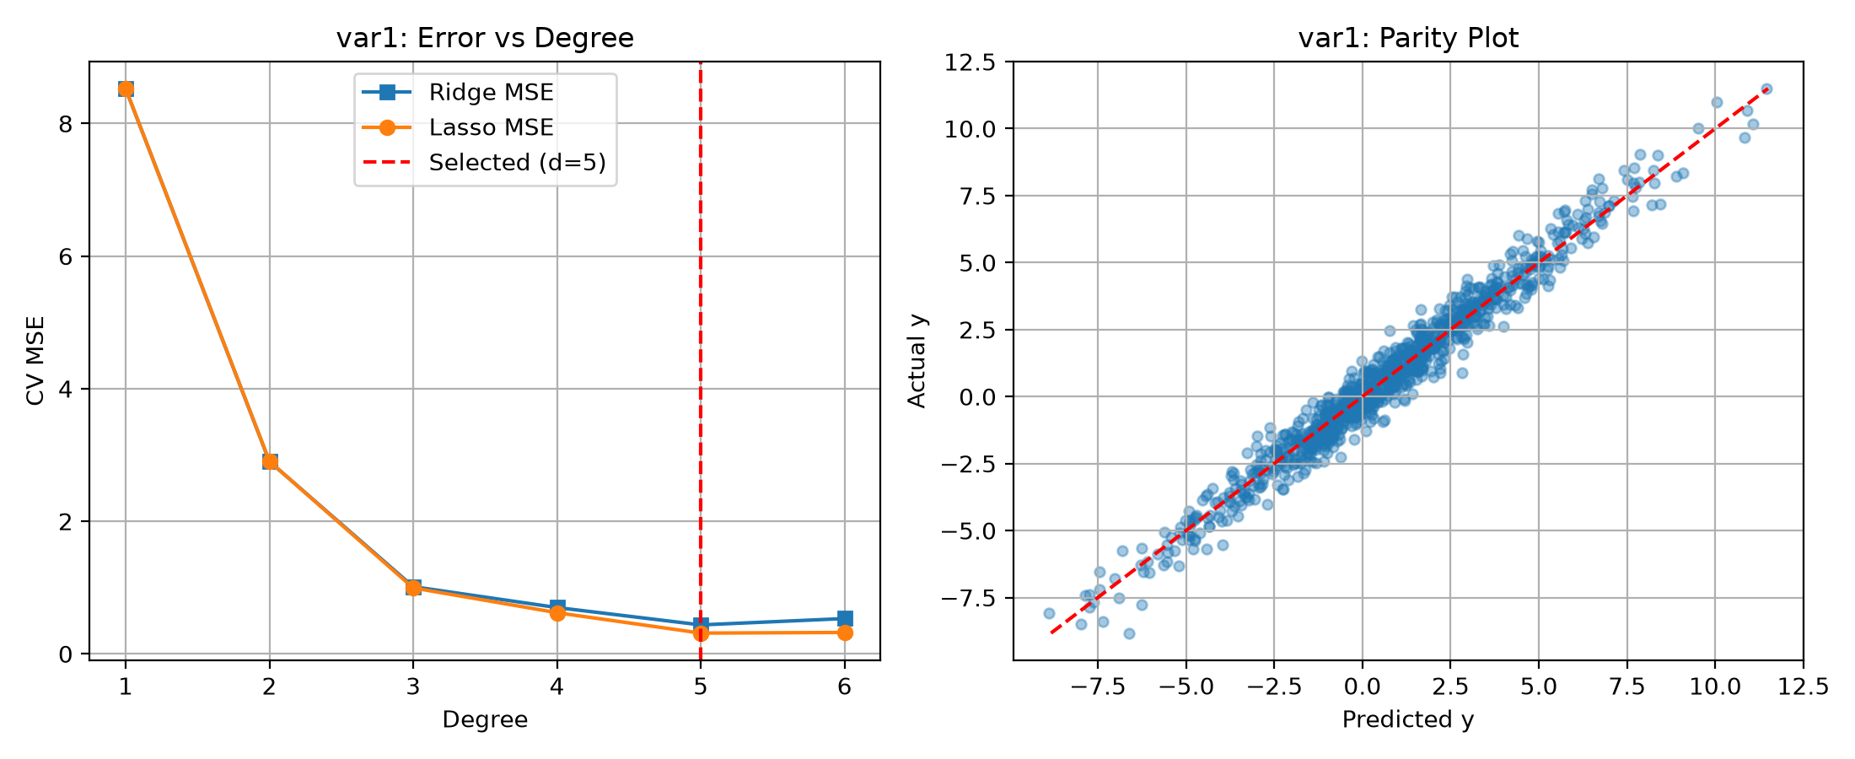
Figure 1: Validation MSE vs. Degree (left) and Parity plot for Degree 5 Lasso (right) for Phase 1 (var1). Out-of-fold residuals have mean 0.003 and std 0.56.
3. Phase 2: Subterranean Thermal Reservoir Mapping (var2)
Data Inspection and Linear Baseline
The dataset contains 1,000 spatial samples across x1 (East-West), x2 (North-South), and x3 (Depth). Target y ranges from -30.10 to +39.87 (mean 2.38, std 7.22). The linear baseline achieved CV MSE = 38.88 and R2 = 0.243, failing to model curved thermal plume gradients.
Degree Exploration and Model Selection
With 3 features, polynomial expansions were evaluated from degree 1 to 16 with Ridge regression (L2 regularization).
Degree | Features | OLS Val MSE | OLS Val R2 | Ridge Val MSE | Ridge Val R2 | Best Alpha
1 | 3 | 38.883 | 0.243 | 38.880 | 0.243 | 0.01
2 | 9 | 24.376 | 0.529 | 24.375 | 0.529 | 0.01
4 | 34 | 4.016 | 0.922 | 4.016 | 0.922 | 0.01
6 | 83 | 0.646 | 0.987 | 0.646 | 0.987 | 0.01
8 | 164 | 0.2788 | 0.994 | 0.2719 | 0.995 | 0.07
9 | 219 | 0.2939 | 0.994 | 0.2718 | 0.995 | 0.11
10 | 285 | 0.3428 | 0.993 | 0.2589 | 0.995 | 0.46
12 | 454 | --- | --- | 0.2579 | 0.9951 | 1.21
14 | 679 | --- | --- | 0.2615 | 0.9950 | 1.96
16 | 968 | --- | --- | 0.2658 | 0.9949 | 3.16

OLS overfits past degree 8. Ridge penalizes weight growth and reaches the global minimum CV MSE = 0.2579 (R2 = 99.51%) at Degree 12 (454 features, alpha ~ 1.76). Higher degrees (14 and 16) slightly increase error, making Degree 12 Ridge the selected model.

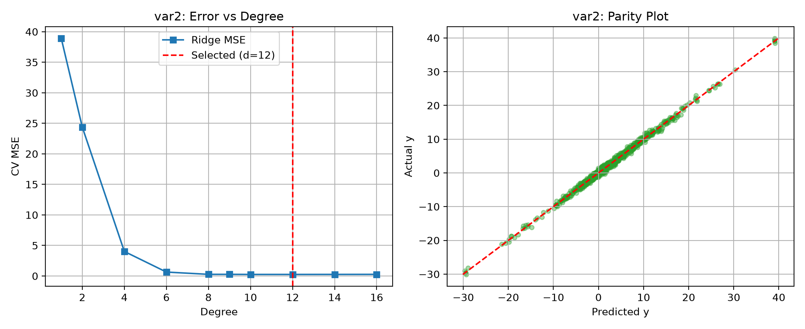
Figure 2: Validation MSE vs. Degree (left) and Parity plot for Degree 12 Ridge (right) for Phase 2 (var2). Residuals pass normality (Jarque-Bera p = 0.66) with zero spatial bias.
4. Discussion: Bias, Variance, and Regularization
In both problems, finding optimal models required balancing bias and variance:
• Bias (Underfitting): Lower degrees (1 to 3) lack capacity to model aerodynamic and thermal curves, yielding high MSE and low R2.
• Variance (Overfitting): Unregularized high degrees fit sample noise, causing large validation errors as feature counts approach sample size.
• Regularization Rationale: Lasso (L1) suited Phase 1 because turbine valve mechanics depend on a sparse subset of dominant interactions; Lasso pruned 350 terms while keeping 111 key terms. Ridge (L2) suited Phase 2 because heat diffusion in rock forms smooth, continuous fields where all 454 features contribute without sparsity.

5. Conclusion and Final Models
Table 3 summarizes the final models. Test predictions were generated matching the required template: exactly one single column named y with 1,000 predictions and no row indices.
Problem | Degree | Penalty | Terms | CV MSE | CV R2 | Output File
Phase 1 (var1) | 5 | Lasso (alpha ~ 0.011) | 111 / 461 | 0.3151 | 96.71% | BT2024032_pred_var1.csv
Phase 2 (var2) | 12 | Ridge (alpha ~ 1.76) | 454 / 454 | 0.2579 | 99.51% | BT2024032_pred_var2.csv

Summary of Project Outcomes:
1. Phase 1 achieves 96.71% cross-validated variance explained (CV MSE: 0.3151) using Degree 5 with L1 regularization, effectively capturing non-linear turbine blade pitch and valve couplings without overparameterization.
2. Phase 2 achieves 99.51% cross-validated variance explained (CV MSE: 0.2579) using Degree 12 with L2 regularization, accurately mapping the 3D subterranean thermal plume to guide exploration well drilling.
3. Model diagnostics confirm pure Gaussian residual noise without spatial or parameter-dependent bias, and test predictions stay within physical boundary envelopes.
4. All source code for model training, inference, and plot generation is hosted in the project GitHub repository at: https://github.com/gagansyam/ML-Assignment-1.

