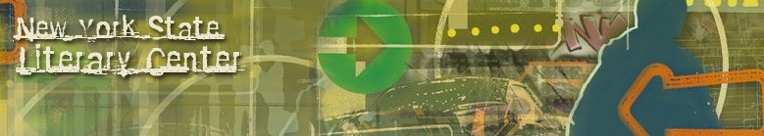

**New York State Literary Center**

**BOOKS BY FAMILIES DEALING WITH INCARCERATION**

**Incarceration: Its Impact on Children and Families**

**Compiled by Dale Davis**

Mariame Kaba. *Missing Daddy*. AK Press, 2019.

<https://www.akpress.org/missing-daddy.html>

Jonae, Jesse, Layonnie, and Kahliya of Reach Incorporated. *Deena Misses Her Mom*. Shout Mouse Press, 2017.

<http://www.shoutmousepress.org/cart1/deena-misses-her-mom>

Pat Pratt. “Ex-Inmate Writes Book to Help Children Cope with Absence.” *Boonville Daily News*, April 8, 2019.

<https://www.boonvilledailynews.com/news/20190408/ex-inmate-writes-book-to-help-children-cope-with-absence?template=ampart>

*Incarceration*. Social Justice Books. A Teaching for Change Project.

<https://socialjusticebooks.org/booklists/incarceration/>

Jacqueline Woodson. *Visiting Day*. Penguin Random House, 2015.

<https://www.penguinrandomhouse.com/books/317982/visiting-day-by-jacqueline-woodson-illustrated-by-james-ransome/9780147516084/>

© 2019 New York State Literary Center All Rights Reserved