# **Company-CRUD**

## **Company CRUD with AngularJs for the FrontEnd and Java SpringBoot for the BackEnd**

## **1. Requirements**

**- Java version 1.8.0**

**- AngularJs version 1.7.5**

## **2. DB Settings**

**This is the DataBase settings used when creating this project**

**DB username : root**

**DB password :**

## **3. Create Empty DataBase**

**- Open terminal**

**- type "mysql -u {YOUR_DB_USERNAME} -p"**

**- then type "CREATE DATABASE company;"**

## **3. BackEnd application.properties settings**

**spring.datasource.url=jdbc:mysql://localhost/company?useSSL=false&serverTimezone=UTC**

**spring.datasource.username={YOUR_DB_USERNAME}**

**spring.datasource.password={YOUR_DB_PASSWORD}**

**spring.jpa.properties.globally_quoted_identifiers=true**

**server.port=8080**

**spring.jpa.hibernate.ddl-auto=update**

**spring.jpa.show-sql=true**

## **4. How to run Java Spring Boot BackEnd**

**#NOTE:You Must Use DB Username "Root" and DB Password "" or Blank to do below steps**

**- Open terminal inside /BackEnd/target folder**

**- Type "java -jar valentino-0.1.jar"**

## **5. How to Auto Populate Employee & Position Table**

**- Open terminal**

**- Type "mysql -u {YOUR_DB_USERNAME} -p company < "company.sql"**

## **6. How to run AngularJs FrontEnd**

**- Open terminal inside /FrontEnd folder**

**- Type "npm run start"**

**Screenshot Front End View**

1. **Index Page**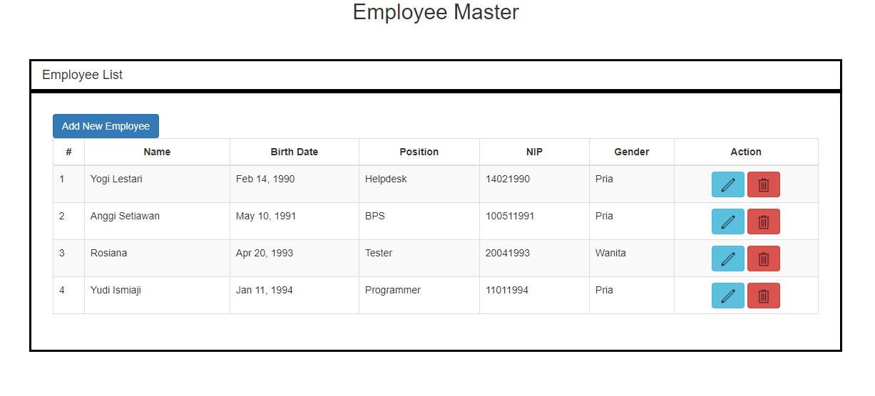
2. **Add Employee Page**

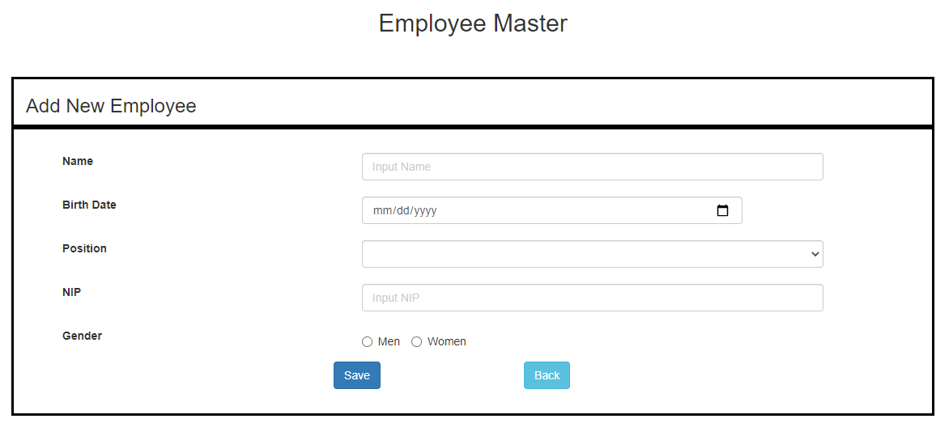

1. **Edit Employee Page**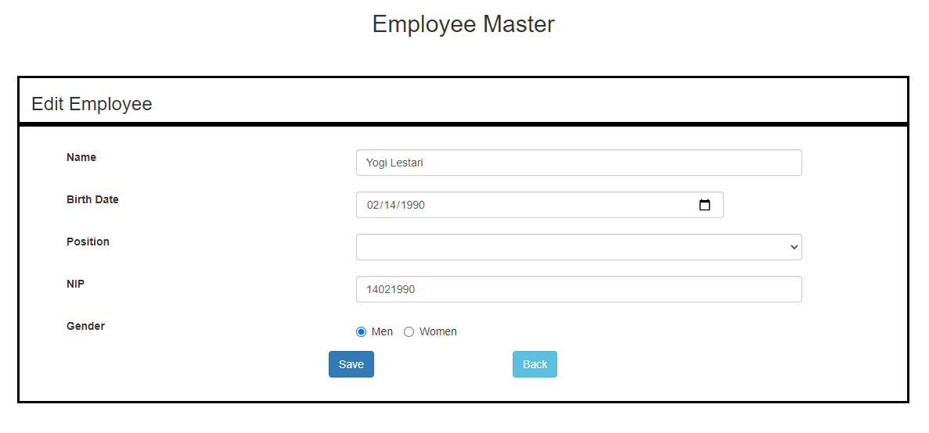
2. **Add Employee Confirmation**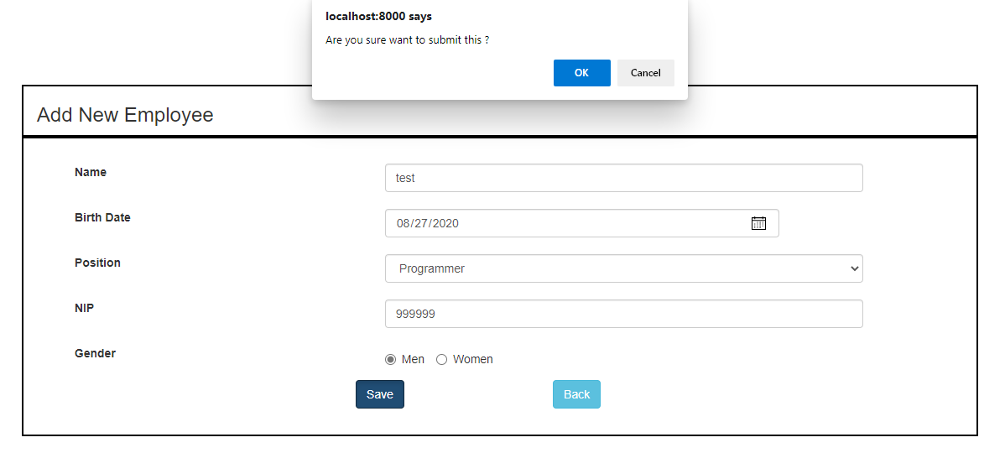
3. **Edit Employee Confirmation**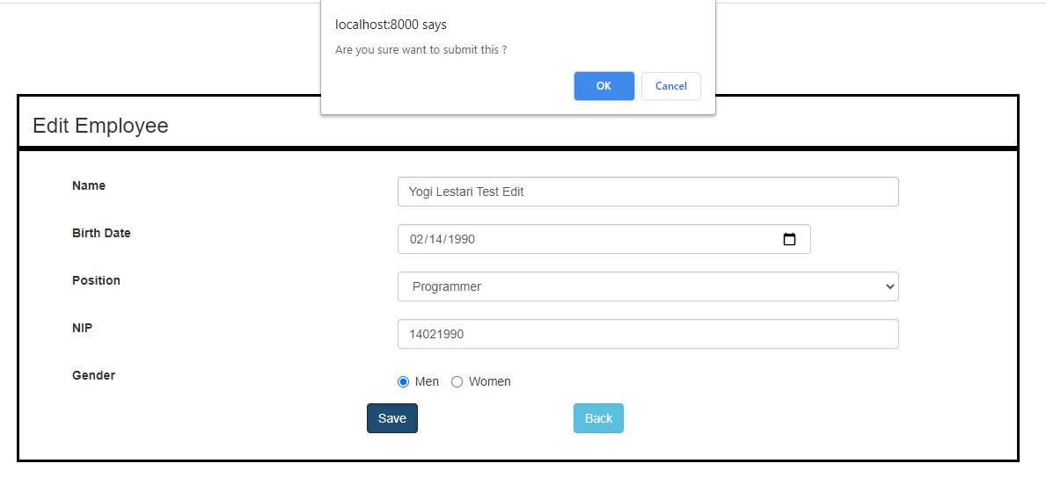
4. **Delete Employee Confirmation**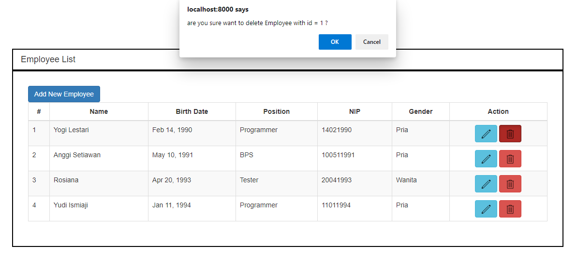
5. **Error When Adding New Employee With Duplicate NIP**