

**Experiment 1.5**

**Student Name:** Gagnesh Kakkar **UID:** 23BCS11196

**Branch:** B.E-C.S.E **Section/Group:** 23BCS_KRG-2B

**Semester:** 5th **Date of Performance:** 24 Sept, 2025

**Subject Name:** ADBMS **Subject Code:** 23CSP-333

MEDIUM - LEVEL

1. **Problem Title:** Views: Performance Benchmarking : Normal View vs. Materialized View

1. **Procedure (Step-by-Step):**

1. Create a large dataset:

- Create a table names transaction_data (id , value) with 1 million records.

- take id 1 and 2, and for each id, generate 1 million records in value column

- Use Generate_series () and random() to populate the data.

2. Create a normal view and materialized view to for sales_summary, which includes total_quantity_sold, total_sales, and total_orders with aggregation.  
  
3. Compare the performance and execution time of both.

1. **SQL Commands:**

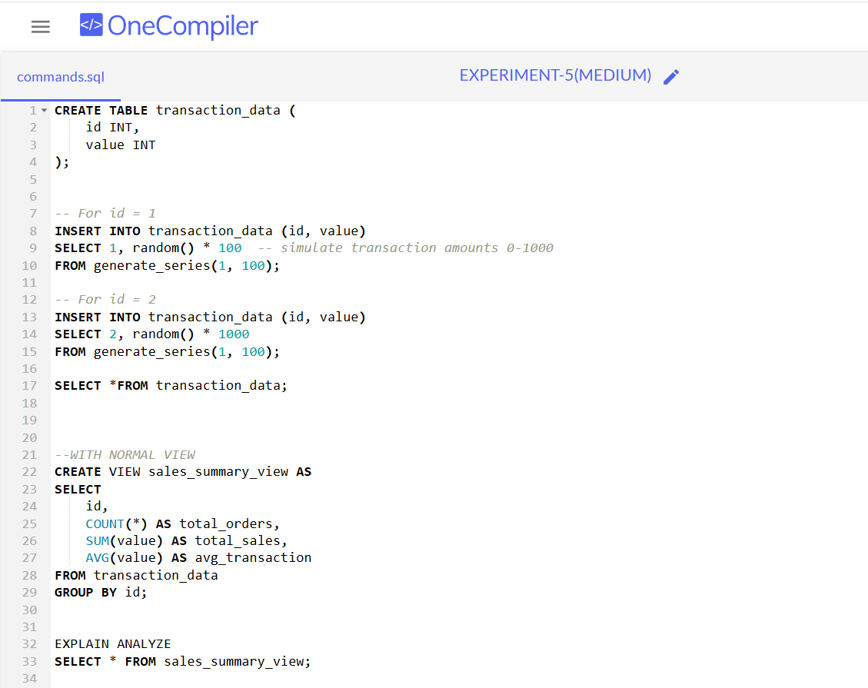

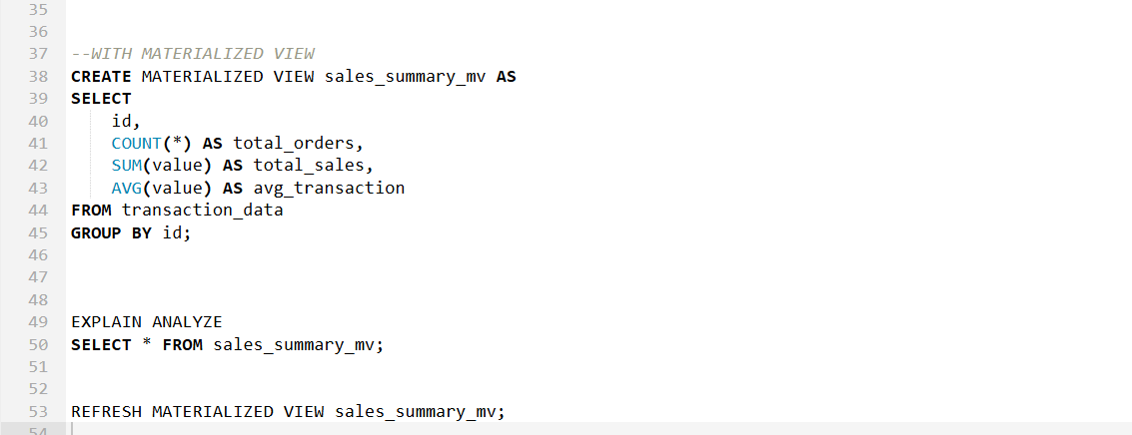

5. **Output:**

HARD - LEVEL

1. **Problem Title:** Views: Securing Data Access with Views and Role-Based Permissions

1. **Procedure (Step-by-Step):**

The company **TechMart Solutions** stores all sales transactions in a central database.  
A new reporting team has been formed to analyze sales but **they should not have direct access to the base tables** for security reasons.  
The database administrator has decided to:

1. Create **restricted views** to display only summarized, non-sensitive data.
2. Assign access to these views to specific users using **DCL commands** (GRANT, REVOKE).

1. **SQL Commands:**

1. **Output:**

