

**Experiment 1.6**

**Student Name:** Gagnesh Kakkar **UID:** 23BCS11196

**Branch:** B.E-C.S.E **Section/Group:** 23BCS_KRG-2B

**Semester:** 5th **Date of Performance:** 24 Sept, 2025

**Subject Name:** ADBMS **Subject Code:** 23CSP-333

MEDIUM - LEVEL

1. **Problem Title:** HR-Analytics: Employee count based on dynamic gender passing

1. **Procedure (Step-by-Step):**

TechSphere Solutions, a growing IT services company with offices across India, wants to **track and monitor gender diversity** within its workforce. The HR department frequently needs to know the **total number of employees by gender** (Male or Female) .

To solve this problem, the company needs an **automated database-driven solution** that can instantly return the count of employees by gender through a stored procedure that:  
  
1. Create a PostgreSQL stored procedure that:

2. Takes a **gender** (e.g., 'Male' or 'Female') as input.

3. Calculates the **total count of employees** for that gender.

4. Returns the result as an **output parameter**.

5. Displays the result clearly for HR reporting purposes.

1. **SQL Commands:**

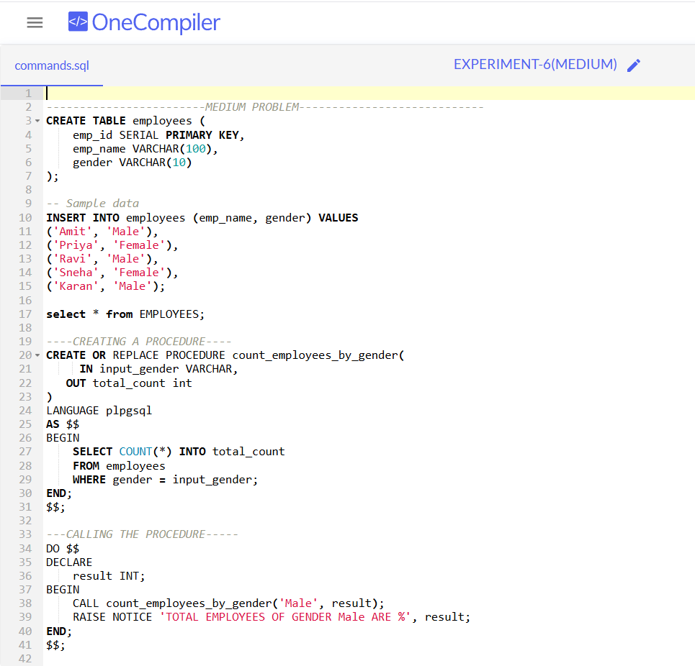

4. **Output:**

HARD - LEVEL

1. **Problem Title:** SmartStore Automated Purchase System

1. **Procedure (Step-by-Step):**

SmartShop is a modern retail company that sells electronic gadgets like smartphones, tablets, and laptops.  
The company wants to **automate its ordering and inventory management process**.

Whenever a customer places an order, the system must:  
1. **Verify stock availability** for the requested product and quantity.

2. If sufficient stock is available:  
 - **Log the order** in the sales table with the ordered quantity and total price.

- **Update the inventory** in the products table by reducing quantity_remaining and increasing quantity_sold.

- Display a **real-time confirmation message**: "Product sold successfully!“  
3. If there is **insufficient stock**, the system must:

- **Reject the transaction** and display: Insufficient Quantity Available!"

1. **SQL Commands:**

1. **Output:**

