

**Experiment-8**

**Student Name:** Gagnesh Kakkar **UID:** 23BCS11196

**Branch:** B.E-C.S.E **Section/Group:** 23BCS_KRG-2B

**Semester:** 5th **Date of Performance:** 08 October, 2025

**Subject Name:** ADBMS **Subject Code:** 23CSP-333

HARD - LEVEL

1. **Problem Title:** Design a robust PostgreSQL transaction system for the students table where multiple student records are inserted in a single transaction.

If any insert fails due to invalid data, only that insert should be rolled back while preserving the previous successful inserts using savepoints.

The system should provide clear messages for both successful and failed insertions, ensuring data integrity and controlled error handling.

1. **SQL Commands:**

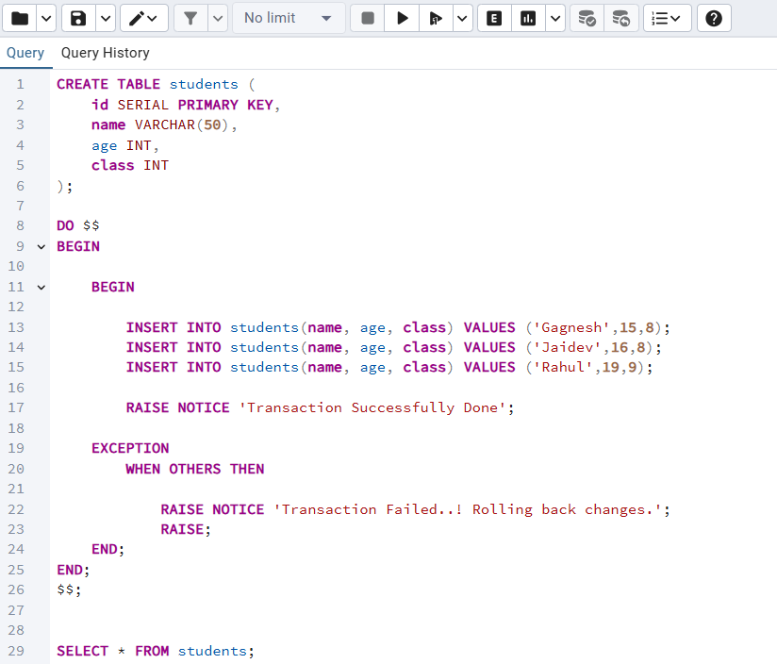

1. **Output:**



