Experiment-2.3
Student Name: Gagnesh Kakkar UID: 23BCS11196
Branch: B.E-C.S.E Section/Group: 23KRG-2B
Semester: 5th Date of Performance: 06/10/2025
Subject Name: DAA Subject Code: 23CSH-301

- Aim: Develop a program and analyze complexity to implement 0-1 Knapsack using Dynamic Programming.

- Objective: To implement 0-1 Knapsack using Dynamic Programming.

- Input/Apparatus Used: In order to fill knapsack, we can pick only complete item not in fraction.

- Procedure/Algorithm: Pseudocode:

In the Dynamic programming we will work considering the same cases as mentioned in the recursive approach. In a DP[][] table let‟s consider all the possible weights from „1‟ to „W‟ as the
● Fill „wi‟ in the given column.
● Do not fill „wi‟ in the given column.
Now we have to take a maximum of these two possibilities, formally if we do not fill „ith‟weight in „jth‟ column then DP[i][j] state will be same as DP[i-1][j] but if we fill the weight, DP[i][j] will be equal to the value of „wi‟+ value of the column weighing „j-wi‟ in the previous row. So we take the maximum of these two possibilities to fill the current state.

- Code:

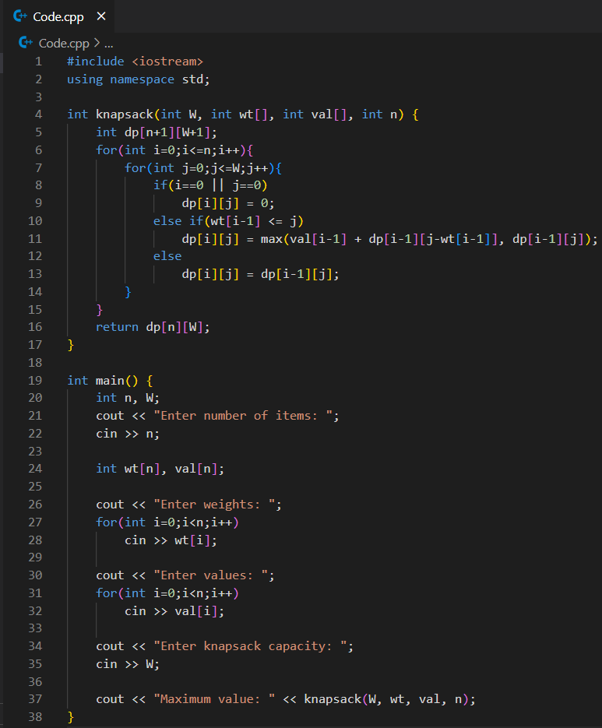

- Output:
