Experiment-3.2
Student Name: Gagnesh Kakkar UID: 23BCS11196
Branch: B.E-C.S.E Section/Group: 23KRG-2B
Semester: 5th Date of Performance: 24/10/2025
Subject Name: DAA Subject Code: 23CSH-301

- Aim: Develop a program and analyze complexity to find all occurrences of a pattern P in a given stringS.

- Objective: Analyze to find all occurrences of a pattern P in a given string S
- Input/Apparatus Used: String is taken as input in order to find pattern from it.

- Procedure/Algorithm: Pseudocode:

1. We will first create the LPS array.
2. Initialize two variables - „strIdx‟ and „patIdx‟ to iterate over the string and the pattern, respectively.
3. If „pat[patIdx]‟ equals „str[strIdx]‟, we will increment both the indexes.
4. When „patIdx‟ equals the length of the pattern, this means that the pattern is found in the string. Therefore we print the index and set „patIdx‟ = LPS[patIdx-1].
5. If „pat[patIdx]‟ is not equal to „str[strIdx]‟, we update the patIdx witht he last index that matches with „str[strIdx]‟ using the LPS array.
Doing this, we will find all occurrences of the pattern in the string.

- Code:

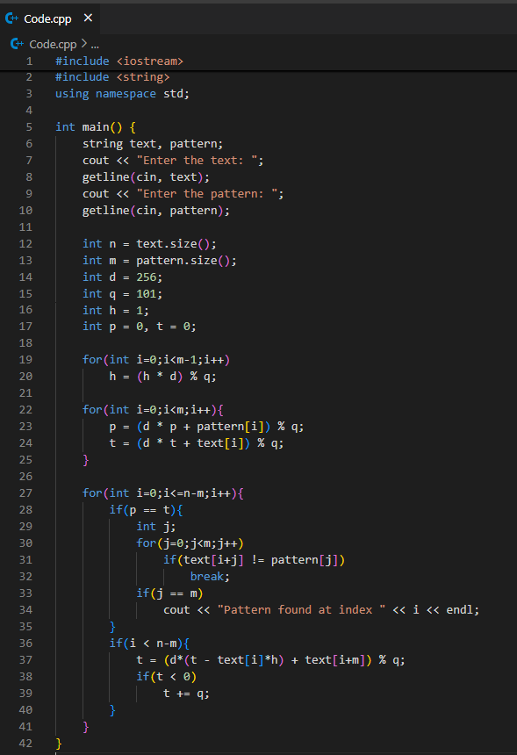

- Output:
