Experiment-2.2
Student Name: Gagnesh Kakkar UID: 23BCS11196
Branch: B.E-C.S.E Section/Group: 23KRG-2B
Semester: 5th Date of Performance: 18/09/2025
Subject Name: DAA Subject Code: 23CSH-301

- Aim: Develop a program and analyze complexity to implement subset-sum problem using Dynamic Programming.

- Objective: Objective is to implement subset-sum problem using Dynamic programming.

- Input/Apparatus Used: Standard sum value is taken in order to find subsets of that sum using dynamic programming.

- Procedure/Algorithm: Pseudocode:

So we will create a 2D array of size (arr.size() + 1) * (target + 1) of type boolean. The state DP[i][j] will be true if there exists a subset of elements from A[0….i] with sum value = „j‟. The approach for the problem is:
if (A[i-1] > j) DP[i][j]
= DP[i-1][j]
else
DP[i][j] = DP[i-1][j] OR DP[i-1][j-A[i-1]]
1. This means that if current element has value greater than „current sum value‟ we will copy the answer for previous cases
2. And if the current sum value is greater than the „ith‟ element we will see if any of previous states have already experienced the sum=‟j‟ OR any previous states experienced a value „j
– A[i]‟ which will solve our purpose.

- Code:

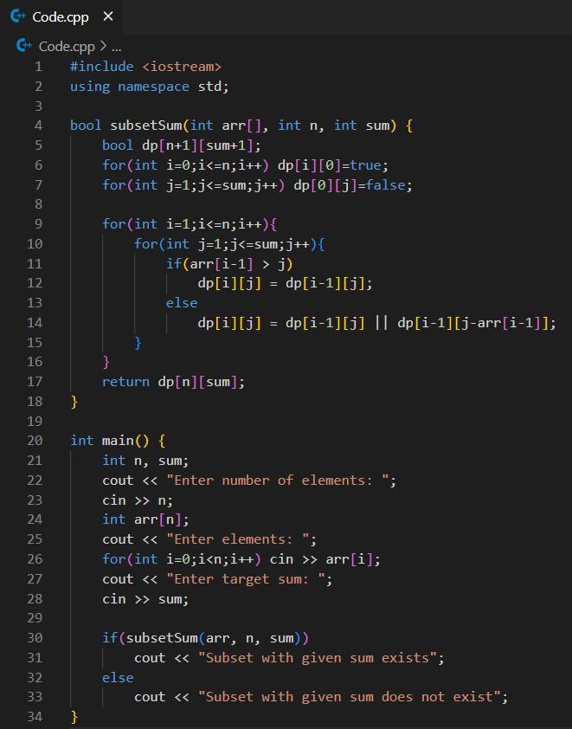

- Output:
