Experiment-3.1
Student Name: Gagnesh Kakkar UID: 23BCS11196
Branch: B.E-C.S.E Section/Group: 23KRG-2B
Semester: 5th Date of Performance: 15/10/2025
Subject Name: DAA Subject Code: 23CSH-301

- Aim: Develop a program and analyze complexity to find shortest paths in a graph with positive edgeweights using Dijkstra‟s algorithm.

- Objective: Code and analyze to find shortest paths in a graph with positive edge weights using Dijkstra‟s

- Input/Apparatus Used: Graph ( G =(V,E) ) is taken as input for this problem.

- Procedure/Algorithm: Pseudocode:

Follow the steps below to solve the problem:
● Create a set sptSet (shortest path tree set) that keeps track of vertices included in the shortest- path tree, i.e., whose minimum distance from the source is calculated and finalized. Initially, this set is empty.
● Assign a distance value to all vertices in the input graph. Initialize all distance values as INFINITE. Assign the distance value as 0 for the source vertex so that it is picked first.
● While sptSet doesn‟t include all vertices
● Pick a vertex u which is not there in sptSet and has a minimum distance value.
● Include u to sptSet.
● Then update distance value of all adjacent vertices of u.
● To update the distance values, iterate through all adjacent vertices.
● For every adjacent vertex v, if the sum of the distance value of u (fromsource) and weight of edge u-v, is less than the distance value of v, then update the distance value of v.
Note: We use a boolean array sptSet[] to represent the set of vertices included in SPT. If avalue sptSet[v] is true, then vertex v is included in SPT, otherwise not. Array dist[] is used to store the shortest distance values of all vertices.

- Code:

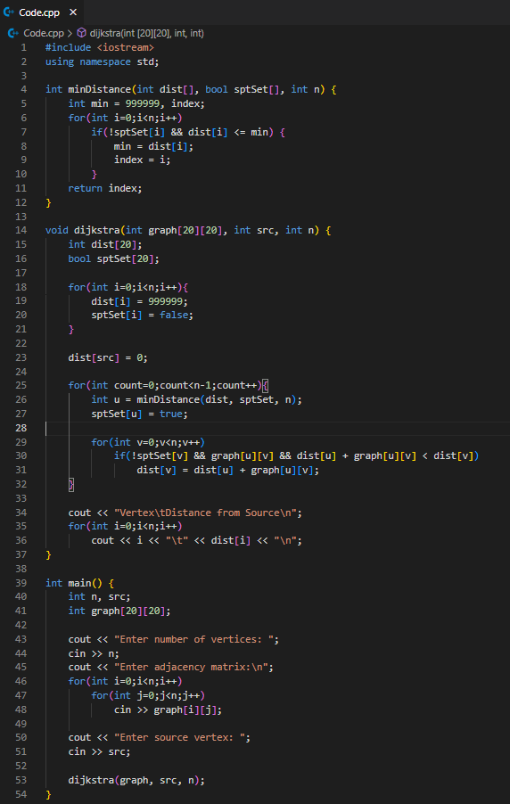

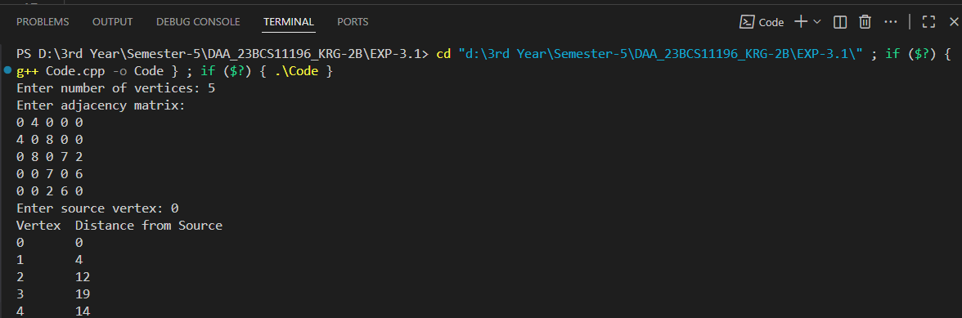
- Output:

