

**Course: CSE 102**

**Structured Programming Language Sessional**

**Project: Travel Adviser**

**Ghagra Salem Debnath**

**2205181**

[**GITHUB**](https://github.com/gagradebnath/TravelAdviser) **|** [**YOUTUBE**](https://youtu.be/lJKKsO85W70)

**(click) (click)**

**Supervised by**

**Fatima Nawmi**

**Lecturer**

**Department of Computer Science and Engineering,**

**Bangladesh University of Engineering and Technology**

**1. Motivation:**

To develop a travel planning tool called Travel Adviser is meant to make your trip easy and pleasurable. Travel Adviser has an easy-to-use interface and a number of functions to meet all of your travel requirements.

**2. Project Overview**

1. **Login:** Securely login with your account. New users can easily create an account to access all features.
2. **Chat Bot / Discover:** Get instant assistance and recommendations from the AI chat bot. Discover the vast unknown with our very own friendly bot.
3. **Trip Planning:** Plan your trips based on your desired destination and intended activities. Design your travel plan with your preferences.
4. **Budget Simulation:** Estimate the cost of your trip with options to include transport, accommodation, and other expenses. Stay within your budget while enjoying your journey.
5. **Tour Guide:**  Hire experienced tour guides to enhance your travel experience.
6. **Booking:** Browse and book accommodations and dining options. Enjoy the convenience of managing your bookings through the app.
7. **Transport:** Book and manage your transportation with ease. Choose from options like bikes, private cars, buses, and more to suit your travel style.

**3. Architecture/Functionality:**

**3.1 authentication and user accounts**

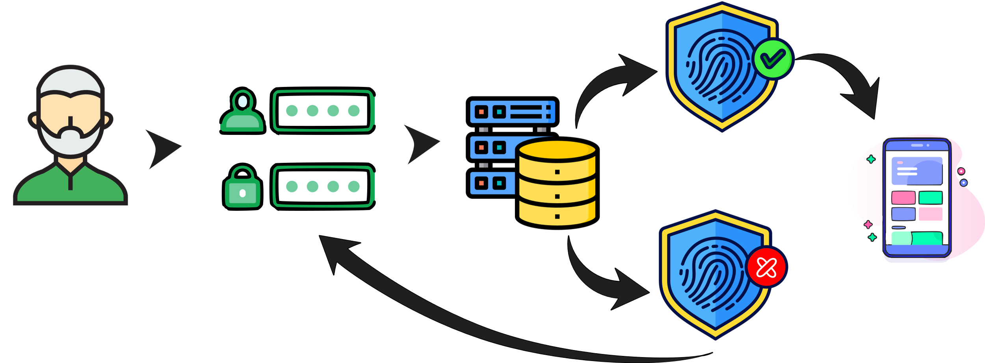

Fig. Authentication

After the user inputs his credentials the database is checked and if authenticated then he will be redirected to the home page. If the credentials do not match any records in the database, the authentication fails, and the user is redirect to the account recovery page as login attempt was unsuccessful.

|  |  |  |
| --- | --- | --- |
| **Account creation** | **Login** | **Account recovery.** |
|  |  |  |
| The user must input  1. Email  2. password  3. security question | The user must input  1. Email  2. password | The user must input  1. Email  2. New password  3. security question |
|  |  |  |

**3.2 Shifting pages and executing functions**

|  |  |
| --- | --- |
| 1. Function iDraw()  2. If intro_index is not 39  3. Call intro()  4. Else  5. Switch on page variable  6. Case 0: Call user_type()  7. Case 1: Call login_page()  8. ……………………………..  9. …………………………….  10. Case 14: Call booking()  11. Case 15: Call ai_chat_bot()  12. End Switch  13. End If  14. If authenticated  15. Display "Press <F1> to Sign Out"  16. End If  17. End Function | Every page is allocated a unique number and has a certain function.   When a button is pressed, the value of the variable "page" changes, the corresponding function is called, and as a result, the desired action is carried out and the page is updated. |

**3.3 AI chat bot:**

|  |  |  |
| --- | --- | --- |
|  | This chat bot can assist with any query of the user.  The system's LM Studio is used to execute the PHI 2 model, which is hosted locally.  The user provides the input, which is saved in a text file. The artificial intelligence model receives the user answer and outputs a response that is saved in a separate text file.  Next, the response is shown from the text file. | |
| 1. Function chat_bot()  2. Instantiate configuration  3. set config = new OpenAIConfig  4.  5. // Read system message from file  6. set system_message = readFile("system_message.txt")  7. ……..  8. // Readuser message from file  9. set user_input = readFile("user_input.txt")  10. ………  11. set model_response = initiateConversation(user_input,system_message)  12. //Write ai response to file  13. writeFile("bot_response.txt", model_response)  14. end function | |  |

**3.4 Budget prediction**

The user can choose desired travel plan and once the user selects their desired travel plan, the system utilizes a predictive model to forecast various aspects of the trip.The goal is to help the user make an informed decision and enhance their travel experience by anticipating and preparing for potential scenarios.

**3.5 Planinng trip**

|  |  |  |  |
| --- | --- | --- | --- |
|  |  |  |  |
|  |  |  |  |
| **Step-1**  **Choose Destination** | **Step-2**  **Choose Accommodation** | **Step-3**  **Choose days to stay** | **Step-4**  **Choose transport** |
|  |  |  |  |
|  |  |  |  |
| **Step-5**  **Choosing tour guide** | **Step-6**  **Enter the budget** | **Step-7**  **Confirming order** | **Step-8**  **Order Confirmed** |
|  |  |  |  |

**3.6 Managing trip**

|  |  |
| --- | --- |
|  | In the application, users have the ability to view their pending orders. This feature is accessible through a dedicated section, , where users can see the details of each order that has not yet been fulfilled or shipped. Alongside each pending order, there is usually an option to cancel the order. When a user chooses to cancel an order, the system prompts them to confirm their decision |
|  |  |
|  |  |

**4. Challenges**

• Since there aren't many online resources for iGraphics, setting up the project was the first challenge.   
After several attempts at reinstalling and running through the process, it eventually worked.

• I had to complete the animations and other tasks frame by frame, which was a difficult challenge.

• It was difficult to take text input since scanf or other similar tools could not be utilized.

• It was rather tough to set up the AI chatbot; running a local LLM is not easy. **I attempted several models, including Mischief, LAMA, and others, but my system did not support any of them. Finally, I was able to access PHI 2**, a pre-trained model. However, it did not support C/C++.

After making several attempts, I finally wrote a Python script to interact with the model's local server. My written C code then runs the Python script, producing an output text file that is shown on the screen.

**5. Conclusion**

To sum up, the "Travel Adviser" project is a feature-rich application made to make users' journey planning easier.

The program meets a range of traveler needs with features like booking management, tour guide hiring, budget simulation, AI-powered chatbot support, login authentication, and transportation options. The AI chatbot's integration with a local LLM exemplifies the creative technique used in its development. Even if setup and execution presented some difficulties, the project's successful completion enhances the developer's commitment and problem-solving abilities.