Name – Gayathri Sanjeev

Date -09/30/18

**Indian Premier League Database**

**Project Summary**:

IPL is an Indian Premier League cricket tournament held in India every year. Players from all over the world are chosen to represent teams in India. Each team consists of eleven players and the team names are unique. In this database, I’m only going to highlight the matches played in the year 2017. Match days consist of one or more matches played in different venues. IPL would like to record the Season Year (the year when the match was held), name of the teams who competed against each other in a match (team 1 vs team 2), Toss Winner, Toss Decision, Match Winner, Match Date, by how many runs the match was won, by how many wickets the match was won and the best player of the match in their database. Matches are held in venues all over India. IPL would like to record the venue name, venue city and country. A match must be played by two teams and a team can play many matches. Each venue hosts one or more matches and each match is played in a venue.

IPL would like this database to answer the following questions:

1. Which team won the most number of matches in a year?
2. Which player has won the most ‘player of the match’ awards in the IPL tournament?
3. Which venue has held the most number of matches?

SQL code provided in this document answers the above questions through the views and functions. And my GUI screens were developed in MS Access to answer the same questions.

**ERD Diagram:**

**A screenshot of a cell phone

Description generated with high confidence**

**Updated Logical Diagram:**

**A screenshot of a cell phone

Description generated with high confidence**

**SQL CODE:**

/*

Author - Gayathri Sanjeev

Course - IST659 M400

Term - June 2018

Title - IPL Matches Data Project

*/

IF EXISTS (SELECT * FROM INFORMATION_SCHEMA.TABLES WHERE TABLE_NAME = 'Team')

BEGIN

DROP TABLE Team

END

GO

IF EXISTS (SELECT * FROM INFORMATION_SCHEMA.TABLES WHERE TABLE_NAME = 'TeamPlayers')

BEGIN

DROP TABLE TeamPlayers

END

GO

IF EXISTS (SELECT * FROM INFORMATION_SCHEMA.TABLES WHERE TABLE_NAME = 'Venue')

BEGIN

DROP TABLE Venue

END

GO

IF EXISTS (SELECT * FROM INFORMATION_SCHEMA.TABLES WHERE TABLE_NAME = 'Matches')

BEGIN

DROP TABLE Matches

END

GO

-- Creating the table Team

CREATE TABLE Team (

-- columns for the Team table

TeamID int identity,

TeamName varchar(30) not null

--Constraints on the Team Table

CONSTRAINT PK_Team PRIMARY KEY (TeamID),

CONSTRAINT U1_Team UNIQUE(TeamName)

)

-- End Creating the Team table

-- Creating the table TeamPlayers

CREATE TABLE TeamPlayers (

-- columns for the TeamPlayers table

PlayerID int identity,

PlayerFirstName varchar(15) not null,

PlayerLastName varchar(20) not null,

TeamID int not null

-- constraints on the TeamPlayers table

CONSTRAINT PK_TeamPlayers PRIMARY KEY (PlayerID),

CONSTRAINT FK_TeamPlayers FOREIGN KEY (TeamID) REFERENCES Team(TeamID)

)

-- End Creating the TeamPlayers table

-- Creating the Venue Table

CREATE TABLE Venue (

-- columns for the Venue table

VenueID int identity,

VenueName char(50) not null,

VenueCity char(20),

VenueCountry char(15)

-- Constraints on the Venue table

CONSTRAINT PK_Venue PRIMARY KEY (VenueID),

CONSTRAINT U1_Venue UNIQUE (VenueName)

)

-- End creating the Venue table

-- Creating the Matches table

CREATE TABLE Matches (

-- columns for the Matches table

MatchID int identity,

TossWinner int not null,

TossDecision char(10) not null,

MatchDate datetime not null,

SeasonYear datetime not null,

MatchWinner int not null,

Team1_home int not null,

Team2_away int not null,

Match_won_by_runs int not null,

Match_won_by_wickets int not null,

MatchResults char(10),

VenueID int not null,

Player_Match int not null

--Constraints on the Matches Table

CONSTRAINT PK_Matches PRIMARY KEY (MatchID),

CONSTRAINT FK1_Matches FOREIGN KEY (VenueID) REFERENCES Venue(VenueID),

CONSTRAINT FK3_Matches FOREIGN KEY (TossWinner) REFERENCES Team(TeamID),

CONSTRAINT FK4_Matches FOREIGN KEY (MatchWinner) REFERENCES Team(TeamID),

CONSTRAINT FK5_Matches FOREIGN KEY (Team1_home) REFERENCES Team(TeamID),

CONSTRAINT FK6_Matches FOREIGN KEY (Team2_away) REFERENCES Team(TeamID),

CONSTRAINT FK7_Matches FOREIGN KEY (Player_Match) REFERENCES TeamPlayers(PlayerID)

)

-- End Creating the Matches table

-- Adding Team names to the Team table

INSERT INTO Team

(TeamName)

VALUES

('Delhi Daredevils'),

('Royal Challengers Bangalore'),

('Gujarat Lions'),

('Mumbai Indians'),

('Sunrisers Hyderabad'),

('Kings XI Punjab'),

('Kolkata Knight Riders'),

('Rising Pune Supergiants')

-- Adding Venue names to the Venue table

INSERT INTO Venue

(VenueName, VenueCity, VenueCountry)

VALUES

('Eden Gardens','Kolkata','India'),

('Feroz Shah Kotla','New Delhi','India'),

('Green Park','New Delhi','India'),

('Holkar Cricket Stadium','Indore','India'),

('M Chinnaswamy Stadium','Bangalore',''),

('Maharashtra Cricket Association Stadium','Pune','India'),

('Punjab Cricket Association IS Bindra Stadium', 'Mohali', ''),

('Rajiv Gandhi International Stadium','Hyderabad','India'),

('Saurashtra Cricket Association Stadium','Rajkot','India'),

('Wankhede Stadium','Mumbai','India')

-- Adding names of the players to the TeamPlayers table

INSERT INTO TeamPlayers

(PlayerFirstName, PlayerLastName, TeamID)

VALUES

('Zaheer','Khan','1'),

('Angelo','Mathews','1'),

('Corey','Anderson','1'),

('Kagiso','Rabada','1'),

('Pat','Cummins','1'),

('Ankit','Bawne','1'),

('Aditya','Tare','1'),

('Murugan','Ashwin','1'),

('Navdeep','Saini','1'),

('Shashank','Singh','1'),

('Mohammed','Shami','1'),

('Shahbaz','Nadeem','1'),

('Jayant','Yadav','1'),

('Amit','Mishra','1'),

('Shreyas','Iyer','1'),

('Sam','Billings','1'),

('Sanju','Samson','1'),

('Chris','Morris','1'),

('Carlos','Brathwaite','1'),

('Karun','Nair','1'),

('Rishabh','Pant','1'),

('Chama','Milind','1'),

('Khaleel','Ahmed','1'),

('Pratyush','Singh','1'),

('Ben','Hilfenhaus','1'),

('Marlon','Samuels','1'),

('Virat','Kohli','2'),

('ABD','Villiers','2'),

('Chris','Gayle','2'),

('Yuzvendra','Chahal','2'),

('Harshal','Patel','2'),

('Mandeep','Singh','2'),

('Adam','Milne','2'),

('Sarfaraz','Khan','2'),

('Sreenath','Aravind','2'),

('Kedar','Jadhav','2'),

('Shane','Watson','2'),

('Stuart','Binny','2'),

('Samuel','Badree','2'),

('Iqbal','Abdulla','2'),

('Travis','Head','2'),

('Sachin','Baby','2'),

('Avesh','Khan','2'),

('Tabraiz','Shamsi','2'),

('Pawan','Negi','2'),

('Tymal','Mills','2'),

('Praveen','Dubey','2'),

('Aniket','Choudhary','2'),

('Billy','Stanlake','2'),

('Vishnu','Vinod','2'),

('Harpreet','Singh','2'),

('Suresh','Raina','3'),

('Ravindra','Jadeja','3'),

('James','Faulkner','3'),

('Brendon','McCullum','3'),

('Aaron','Finch','3'),

('Dwayne','Smith','3'),

('Dinesh','Karthik','3'),

('Dhawal','Kulkarni','3'),

('Praveen','Kumar','3'),

('Andrew','Tye','3'),

('Ishan','Kishan','3'),

('Pradeep','Sangwan','3'),

('Shadab','Jakati','3'),

('Jaydev','Shah','3'),

('Manpreet','Gony','3'),

('Nathu','Singh','3'),

('Jason','Roy','3'),

('Munaf','Patel','3'),

('Chirag','Suri','3'),

('Akshdeep','Nath','3'),

('Basil','Thampi','3'),

('Shubham','Agarwal','3'),

('Tejas','Baroka','3'),

('Pratham','Singh','3'),

('Shelley','Shaurya','3'),

('Ankit','Soni','3'),

('Irfan','Pathan','3'),

('Rohit','Sharma','4'),

('Kieron','Pollard','4'),

('Lasith','Malinga','4'),

('Harbhajan','Singh','4'),

('Ambati','Rayudu','4'),

('Jasprit','Bumrah','4'),

('Shreyas','Gopal','4'),

('Lendl','Simmons','4'),

('Vinay','Kumar','4'),

('Parthiv','Patel','4'),

('Mitchell','McClenaghan','4'),

('Nitish','Rana','4'),

('Siddhesh','Lad','4'),

('Jagadeesha','Suchith','4'),

('Hardik','Pandya','4'),

('Jos','Buttler','4'),

('Tim','Southee','4'),

('Jitesh','Sharma','4'),

('Krunal','Pandya','4'),

('Deepak','Punia','4'),

('Saurabh','Tiwary','4'),

('Nicholas','Pooran','4'),

('Mitchell','Johnson','4'),

('Karn','Sharma','4'),

('Asela','Gunaratne','4'),

('Krishnappa','Gowtham','4'),

('Kulwant','Khejroliya','4'),

('Shikhar','Dhawan','5'),

('Bhuvneshwar','Kumar','5'),

('David','Warner(c)','5'),

('Moises','Henriques','5'),

('Naman','Ojha','5'),

('Ricky','Bhui','5'),

('Kane','Williamson','5'),

('Siddarth','Kaul','5'),

('Bipul','Sharma','5'),

('Yuvraj','Singh','5'),

('Ben','Cutting','5'),

('Abhimanyu','Mithun','5'),

('Mustafizur','Rahman','5'),

('Barinder','Sran','5'),

('Deepak','Hooda','5'),

('Vijay','Shankar','5'),

('Chris','Jordan','5'),

('Mohammad','Nabi','5'),

('Eklavya','Dwivedi','5'),

('Rashid','Khan','5'),

('Pravin','Tambe','5'),

('Ben','Laughlin','5'),

('Tanmay','Agarwal','5'),

('Mohammed','Siraj','5'),

('David','Miller','6'),

('Manan','Vohra','6'),

('Axar','Patel','6'),

('Glenn','Maxwell','6'),

('Gurkeerat','Singh','6'),

('Anureet','Singh','6'),

('Sandeep','Sharma','6'),

('Shaun','Marsh','6'),

('Wriddhiman','Saha','6'),

('Nikhil','Naik','6'),

('Mohit','Sharma','6'),

('Marcus','Stoinis','6'),

('KC','Cariappa','6'),

('Armaan','Jaffer','6'),

('Pardeep','Sahu','6'),

('Swapnil','Singh','6'),

('Hashim','Amla','6'),

('Varun','Aaron','6'),

('Eoin','Morgan','6'),

('Matt','Henry','6'),

('Rahul','Tewatia','6'),

('Martin','Guptill','6'),

('Daren','Sammy','6'),

('Rinku','Singh','6'),

('T','Natarajan','6'),

('Ishant','Sharma','6'),

('Gautam','Gambhir','7'),

('Sunil','Narine','7'),

('Kuldeep','Yadav','7'),

('Manish','Pandey','7'),

('Suryakumar','Yadav','7'),

('Piyush','Chawla','7'),

('Robin','Uthappa','7'),

('Shakib','Al','7'),

('Chris','Lynn','7'),

('Umesh','Yadav','7'),

('Yusuf','Pathan','7'),

('Sheldon','Jackson','7'),

('Ankit','Rajpoot','7'),

('Trent','Boult','7'),

('Nathan','Coulter-Nile','7'),

('Darren','Bravo','7'),

('Rishi','Dhawan','7'),

('Chris','Woakes','7'),

('Rovman','Powell','7'),

('Ishank','Jaggi','7'),

('Sayan','Ghosh','7'),

('Ramsingh','Yadav','7'),

('Colin','Grandhomme','7'),

('MS','Dhoni','8'),

('Ajinkya','Rahane','8'),

('Steven','Smith','8'),

('Faf','Plessis','8'),

('Ashok','Dinda','8'),

('Ankush','Bains','8'),

('Rajat','Bhatia','8'),

('Ankit','Sharma','8'),

('Ishwar','Pandey','8'),

('Adam','Zampa','8'),

('Jaskaran','Singh','8'),

('Baba','Aparajith','8'),

('Deepak','Chahar','8'),

('Usman','Khawaja','8'),

('Mayank','Agarwal','8'),

('Ben','Stokes','8'),

('Manoj','Tiwary','8'),

('Jaydev','Unadkat','8'),

('Rahul','Chahar','8'),

('Daniel','Christian','8'),

('Lockie','Ferguson','8'),

('Saurabh','Kumar','8'),

('Milind','Tandon','8'),

('Rahul','Tripathi','8'),

('Shardul','Thakur','8'),

('Imran','Tahir','8'),

('Washington','Sundar','8')

-- Adding data into the matches table

INSERT INTO Matches

(TossWinner, TossDecision, MatchDate, SeasonYear, MatchWinner, Team1_home, Team2_away, Match_won_by_runs, Match_won_by_wickets, MatchResults, VenueID, Player_Match)

VALUES

('2','field','4/5/2017','2017','5','5','2','35','0','normal','8','115'),

('8','field','4/6/2017','2017','8','4','8','0','7','normal','6','181'),

('7','field','4/7/2017','2017','7','3','7','0','10','normal','9','164'),

('6','field','4/8/2017','2017','6','8','6','0','6','normal','4','133'),

('2','bat','4/8/2017','2017','2','2','1','15','0','normal','5','36'),

('5','field','4/9/2017','2017','5','3','5','0','9','normal','8','125'),

('4','field','4/9/2017','2017','4','4','4','0','4','normal','10','90'),

('2','bat','4/10/2017','2017','6','2','6','0','8','normal','4','132'),

('8','field','4/11/2017','2017','1','1','8','97','0','normal','6','17'),

('4','field','4/12/2017','2017','4','5','4','0','4','normal','10','84'),

('7','field','4/13/2017','2017','7','6','7','0','8','normal','1','157'),

('4','field','4/14/2017','2017','4','2','4','0','4','normal','5','80'),

('3','field','4/14/2017','2017','3','8','3','0','7','normal','9','61'),

('5','field','4/15/2017','2017','7','7','5','17','0','normal','1','162'),

('1','bat','4/15/2017','2017','1','1','6','51','0','normal','2','3'),

('4','field','4/16/2017','2017','4','3','4','0','6','normal','10','90'),

('2','field','4/16/2017','2017','8','8','2','27','0','normal','5','194'),

('1','bat','4/17/2017','2017','7','1','7','0','4','normal','3','170'),

('6','field','4/17/2017','2017','5','5','6','5','0','normal','8','107'),

('3','field','4/18/2017','2017','2','2','3','21','0','normal','9','29'),

('5','bat','4/19/2017','2017','5','5','1','15','0','normal','8','112'),

('4','field','4/20/2017','2017','4','6','4','0','8','normal','4','94'),

('3','field','4/21/2017','2017','3','7','3','0','4','normal','1','52'),

('1','field','4/22/2017','2017','4','4','1','14','0','normal','10','89'),

('8','field','4/22/2017','2017','8','5','8','0','6','normal','6','179'),

('3','field','4/23/2017','2017','6','6','3','26','0','normal','9','146'),

('2','field','4/23/2017','2017','7','7','2','82','0','normal','1','170'),

('4','field','4/24/2017','2017','8','8','4','3','0','normal','10','194'),

('7','field','4/26/2017','2017','7','8','7','0','7','normal','6','162'),

('3','field','4/27/2017','2017','3','2','3','0','7','normal','5','61'),

('7','field','4/28/2017','2017','7','1','7','0','7','normal','1','156'),

('6','field','4/28/2017','2017','5','5','6','26','0','normal','7','125'),

('2','field','4/29/2017','2017','8','8','2','61','0','normal','6','199'),

('3','bat','4/29/2017','2017','4','3','4','0','0','tie','9','97'),

('6','field','4/30/2017','2017','6','1','6','0','10','normal','7','136'),

('7','field','4/30/2017','2017','5','5','7','48','0','normal','8','108'),

('2','bat','5/1/2017','2017','4','2','4','0','5','normal','10','79'),

('8','field','5/1/2017','2017','8','3','8','0','5','normal','6','194'),

('1','field','5/2/2017','2017','1','5','1','0','6','normal','2','11'),

('8','field','5/3/2017','2017','8','7','8','0','4','normal','1','202'),

('1','field','5/4/2017','2017','1','3','1','0','7','normal','2','21'),

('2','field','5/5/2017','2017','6','6','2','19','0','normal','5','136'),

('5','field','5/6/2017','2017','8','8','5','12','0','normal','8','196'),

('1','field','5/6/2017','2017','4','4','1','146','0','normal','2','86'),

('7','field','5/7/2017','2017','7','2','7','0','6','normal','5','157'),

('3','field','5/7/2017','2017','3','6','3','0','6','normal','7','57'),

('4','bat','5/8/2017','2017','5','4','5','0','7','normal','8','106'),

('7','field','5/9/2017','2017','6','6','7','14','0','normal','7','140'),

('1','field','5/10/2017','2017','1','3','1','0','2','normal','3','15'),

('4','field','5/11/2017','2017','6','6','4','7','0','normal','10','138'),

('1','bat','5/12/2017','2017','1','1','8','7','0','normal','2','20'),

('5','field','5/13/2017','2017','5','3','5','0','8','normal','3','129'),

('7','field','5/13/2017','2017','4','4','7','9','0','normal','1','83'),

('8','field','5/14/2017','2017','8','6','8','0','9','normal','6','196'),

('2','bat','5/14/2017','2017','2','2','1','10','0','normal','2','31'),

('4','field','5/16/2017','2017','8','8','4','20','0','normal','10','205'),

('7','field','5/17/2017','2017','7','5','7','0','7','normal','5','170'),

('4','field','5/19/2017','2017','4','7','4','0','6','normal','5','102'),

('4','bat','5/21/2017','2017','4','4','8','1','0','normal','8','97')

GO

/* Creating a function to count the number of matches played by a team*/

CREATE FUNCTION MatchesCount (@TeamID int)

RETURNS int AS -- COUNT() is an integer value, so return it as an int

BEGIN

DECLARE @returnValue int -- matches the function's return type

/* Get the count of the matches won for the provided TeamID and assign

that value to @returnValue. Note that we use the @TeamID parameter in

the WHERE clause to limit our count to that team's winning records*/

SELECT @returnValue = COUNT(MatchWinner) FROM Matches

WHERE Matches.MatchWinner = @TeamID

-- return @returnValue to the calling code

RETURN @returnValue

END

GO

/* Selecting and viewing the top 10 records of the MatchesCount function and merging it with the columns from the team table*/

CREATE VIEW most_matches_won_by_team AS

SELECT TOP 10

*,

dbo.MatchesCount(TeamID) as MatchesCount

FROM Team

ORDER BY MatchesCount DESC

GO

SELECT * FROM most_matches_won_by_team

GO

/* Creating a function to count the number of Player of the match awards won by a player*/

CREATE FUNCTION PlayerOfMatch (@PlayerID int)

RETURNS int AS -- COUNT() is an integer value, so return it as an int

BEGIN

DECLARE @returnValue int -- matches the function's return type

/* Get the count of the awards won for the provided PlayerID and assign

that value to @returnValue. Note that we use the @PlayerID parameter in

the WHERE clause to limit our count to that player's awards*/

SELECT @returnValue = COUNT(Player_Match) FROM Matches

WHERE Matches.Player_Match = @PlayerID

-- return @returnValue to the calling code

RETURN @returnValue

END

GO

/* Selecting and viewing the top 10 records of the PlayerOfMatch function

and merging it with the columns from the TeamPlayers table*/

CREATE VIEW Player_of_Match AS

SELECT TOP 10

*,

dbo.PlayerOfMatch(PlayerID) as PlayerOfTheMatchAwards

FROM TeamPlayers

ORDER BY PlayerOfTheMatchAwards DESC

GO

SELECT * FROM Player_of_Match

GO

/* Creating a function to count the number of matches played in a venue*/

CREATE FUNCTION VenueMatches (@venueID int)

RETURNS int AS -- COUNT() is an integer value, so return it as an int

BEGIN

DECLARE @returnValue int -- matches the function's return type

/* Get the count of the matches played for the provided VenueID and assign

that value to @returnValue. Note that we use the @venueID parameter in

the WHERE clause to limit our count to that venue's matches*/

SELECT @returnValue = COUNT(VenueID) FROM Matches

WHERE Matches.VenueID = @venueID

RETURN @returnValue -- return @returnValue to the calling code

END

GO

/* Selecting and viewing the top 5 records of the VenueMatches function

and merging it with the columns from the Venue table*/

CREATE VIEW Venue_Most_Matches AS

SELECT TOP 5

*,

dbo.VenueMatches(VenueID) as VenueWithTheMostNoOfMatches

FROM Venue

ORDER BY VenueWithTheMostNoOfMatches DESC

GO

SELECT * FROM Venue_Most_Matches

GO

**GUI :**

Below view in Access shows No. of matches won by each team:

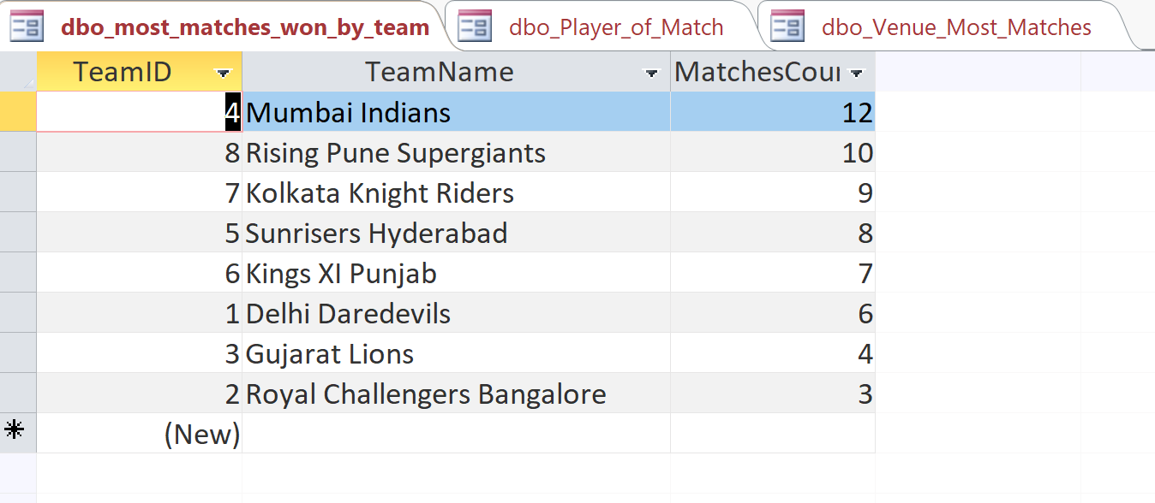

2. Below view in Access shows No. of awards(Player of the Match) won by players:

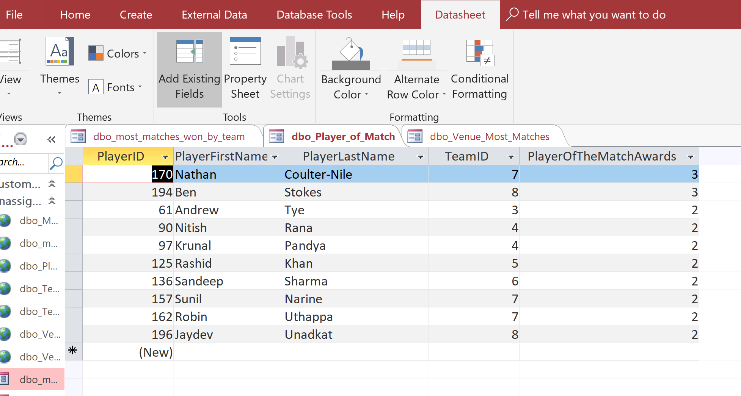

1. Below view in Access shows No. of matches played in every Venue:

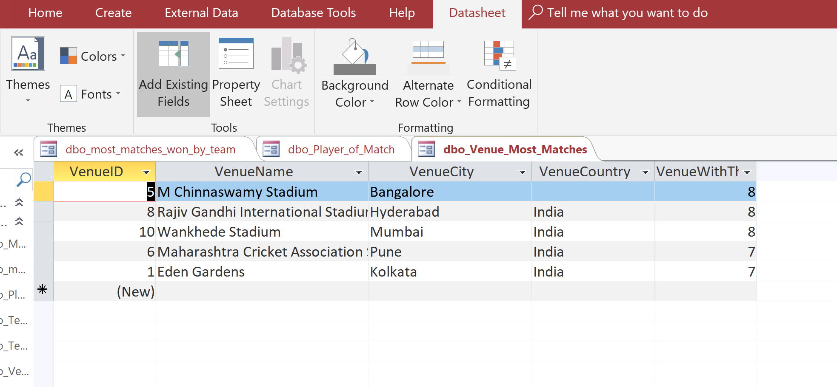

**CONCLUSION**:

At the beginning of this project, I had a lot of questions about how each and every step of the process in database modeling is going to be implemented in my project. I didn’t know about a structure to follow like ERD model, logical model and then the physical model. But, going through the steps one by one and cycling through the different layers of the model throughout the process helped to make my database cleaner and more relatable to the end product I had in mind.

The next time I do this, I would like to dwelve more into the GUI aspect of the project and see how I can make better GUI screens.