WEEK – 4
DAA LAB ASSIGNMENT
NAME – SUJAL GAHLAWAT
SAPID- 590021805

Q1. Write a C program to solve the Activity Selection Problem using the Greedy approach, so that the maximum number of non-overlapping activities is chosen.
#include <stdio.h>
#include <stdlib.h>
typedef struct { int id, start, finish; } Activity;
int cmp(const void *a, const void *b) {
return ((Activity *)a)->finish - ((Activity *)b)->finish;
}
int main() {
Activity a[] = {{1,1,4},{2,3,5},{3,0,6},{4,5,7},{5,3,9},{6,5,9},
{7,6,10},{8,8,11},{9,8,12},{10,2,14},{11,12,16}};
int n = sizeof(a) / sizeof(a[0]), last = 0, count = 1;
qsort(a, n, sizeof(Activity), cmp);
printf("Selected activities:\n");
printf("A%d (%d, %d)\n", a[0].id, a[0].start, a[0].finish);
for (int i = 1; i < n; i++)
if (a[i].start >= a[last].finish) {
printf("A%d (%d, %d)\n", a[i].id, a[i].start, a[i].finish);
last = i; count++;
}
printf("Total activities selected: %d\n", count);
return 0;
}

PS C:\Users\gahlawat\Desktop\daa\week4\output> & .\'act1.exe'
Selected activities:
A1 (1, 4)
A4 (5, 7)
A8 (8, 11)
A11 (12, 16)
Total activities selected: 4

Working of the program
The program stores each activity as a structure holding its id, start time and finish time. Eleven sample activities are sorted in increasing order of finish time with qsort(), and the greedy rule is then applied in a single pass.
- The first activity (the one finishing earliest) is always selected.
- For every following activity, if its start time is greater than or equal to the finish time of the last selected activity, it is selected.
- Otherwise it overlaps with the chosen activity and is skipped.
Role of the comparator function
int cmp(const void *a, const void *b) {
return ((Activity *)a)->finish - ((Activity *)b)->finish;
}
qsort() relies on this function to arrange the activities in increasing order of finish time. The void * arguments are cast to Activity *, and the finish times are compared using the -> operator.
Selecting the activity that finishes earliest leaves the maximum possible time for the remaining activities. This greedy choice is what makes the algorithm optimal, giving four activities (A1, A4, A8 and A11) for the sample input.
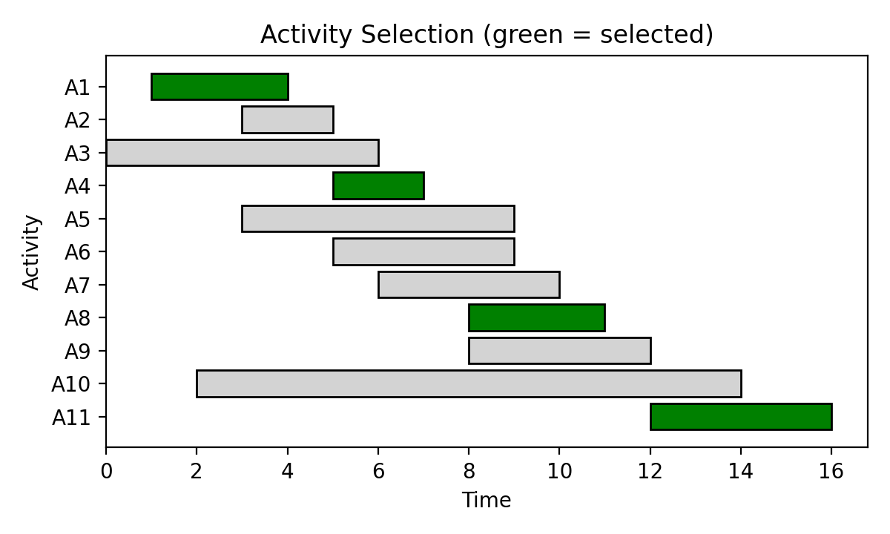

Q2. Generate sets of random activities of increasing size and measure how long the Activity Selection algorithm takes to run, then plot the results using Python.
#include <stdio.h>
#include <stdlib.h>
#include <time.h>
#define REP 100
typedef struct { int start, finish; } Activity;
int cmp(const void *a, const void *b) {
return ((Activity *)a)->finish - ((Activity *)b)->finish;
}
int select_act(Activity a[], int n) {
int last = 0, count = 1;
for (int i = 1; i < n; i++)
if (a[i].start >= a[last].finish) { last = i; count++; }
return count;
}
int main() {
int sizes[] = {1000, 5000, 10000, 50000, 100000};
srand(time(0));
for (int k = 0; k < 5; k++) {
int n = sizes[k], count = 0;
Activity *a = malloc(n * sizeof(Activity)), *b = malloc(n * sizeof(Activity));
for (int i = 0; i < n; i++) {
a[i].start = rand() % 10000;
a[i].finish = a[i].start + 1 + rand() % 50;
}
clock_t s = clock();
for (int r = 0; r < REP; r++) {
for (int i = 0; i < n; i++) b[i] = a[i];
qsort(b, n, sizeof(Activity), cmp);
count = select_act(b, n);
}
printf("N = %6d Selected = %4d Time = %.6f sec\n", n, count,
(double)(clock() - s) / CLOCKS_PER_SEC / REP);
free(a); free(b);
}
return 0;
}

PS C:\Users\gahlawat\Desktop\daa\week4\output> & .\'act2.exe'
N = 1000 Selected = 358 Time = 0.000052 sec
N = 5000 Selected = 791 Time = 0.000373 sec
N = 10000 Selected = 1146 Time = 0.000971 sec
N = 50000 Selected = 2507 Time = 0.004614 sec
N = 100000 Selected = 3515 Time = 0.009195 sec

Each activity is given a random start time and a finish time slightly after it. For each input size the sort and selection steps are repeated 100 times and the average is reported, since a single run on a small input is too fast to measure reliably with clock().
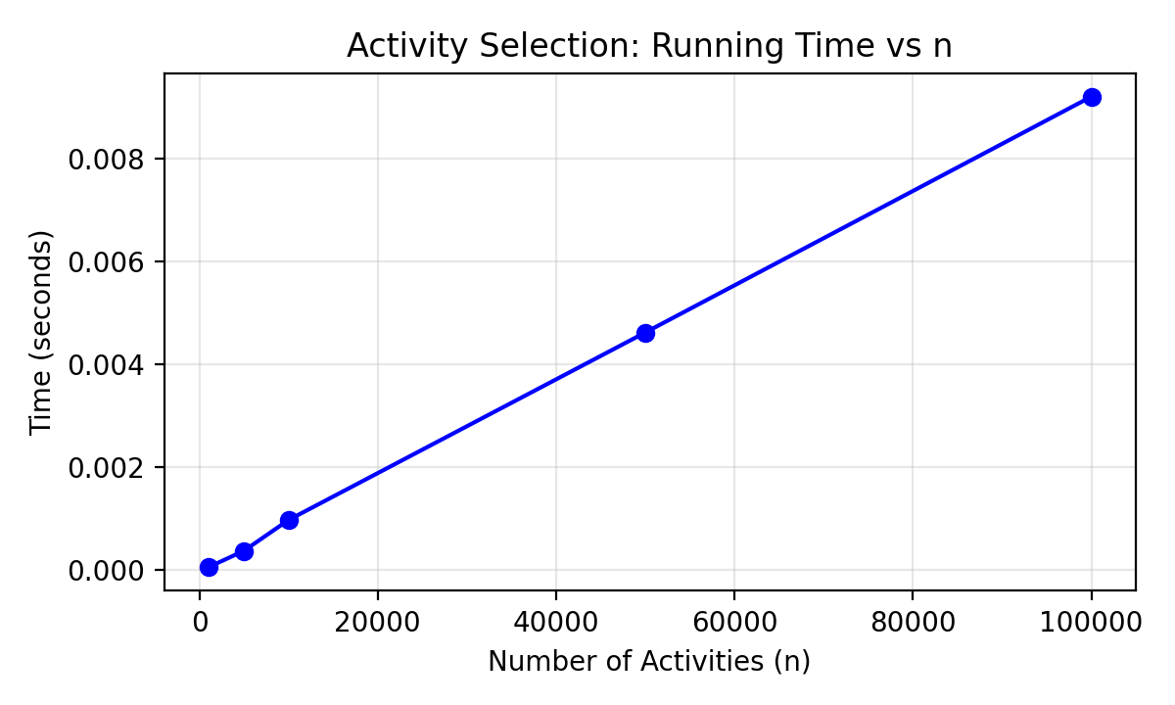
Time Complexity Analysis
Step | Time Complexity | Space Complexity
Sorting by finish time | O(n log n) | O(1)
Greedy selection pass | O(n) | O(1)
Total | O(n log n) | O(1)

Conclusion
The Greedy approach solves the Activity Selection Problem efficiently and optimally. Sorting the activities by finish time takes O(n log n), and the selection pass that follows takes only O(n), so the overall time complexity is O(n log n). The measured times grow slightly faster than linearly as n increases, which matches this result. Only a few extra variables are needed, apart from the array itself, so the space complexity is O(1).

