Project Final Report

Team 19: Gahyun Song, Wensheng Xu

Application: **Restaurant Rating Application**

Video Demostration Link : <https://youtu.be/gE8pa0Prq_w>

Code and database dump: <https://github.com/gahyun8876/CSE412>

User Manual For Restaurant Rating Application

There are 2 parts of main functions.

1. Searching a restaurant function
2. Users can search for a restaurant by several conditions.

* Restaurant Name
* Restaurant Address
* Food Type
* Average Rating
* Average Cost
* Food Name

1. Users also can search for restaurants with more than one condition.
2. Users can search for restaurants with keywords instead of the full name of the restaurant food.
3. After users type information on the section that they want to search with, click the ‘Search a restaurant’ button.
4. Users have to enter their phone number when searching if they want to rate a restaurant.
5. Rating a restaurant function
   1. Users have to select a restaurant.
   2. Users select a score in order to rate a restaurant.

* Scale : (Poor) 1 - 5 (Wonderful)
  1. Users click the ‘Submit Review’ button.
  2. If a user rates a restaurant multiple times, the latest record will be used to calculate the average rating of the restaurant and older records will be deleted.
  3. The new user’s phone number will be added to the users list when they rate a restaurant.

< Searching >

* Search by using single condition:

- > Search with Restaurant Name

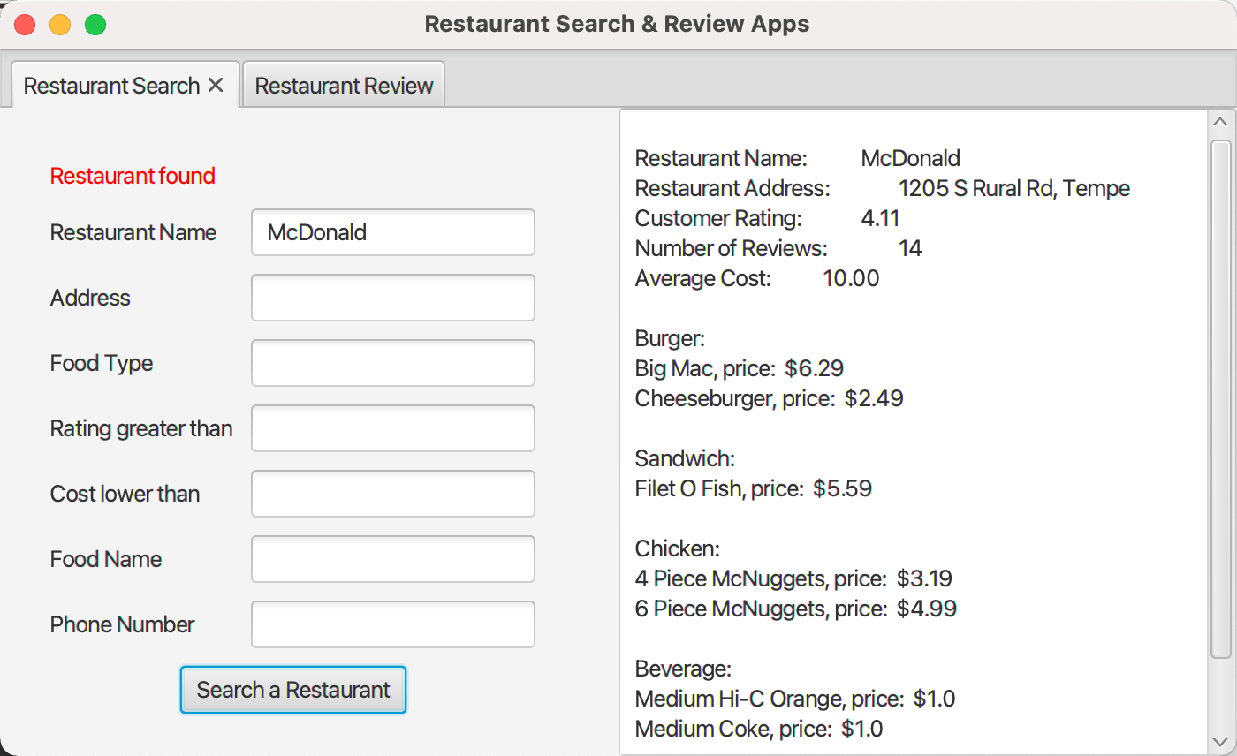

- > Search with Restaurant Address

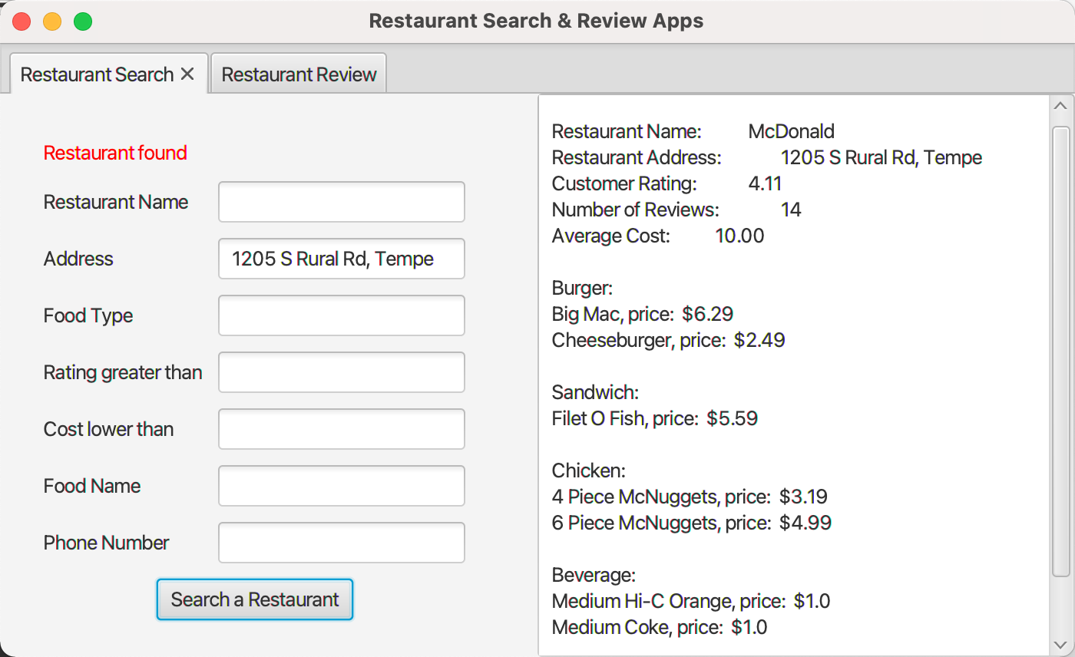

- > Search with Food Type

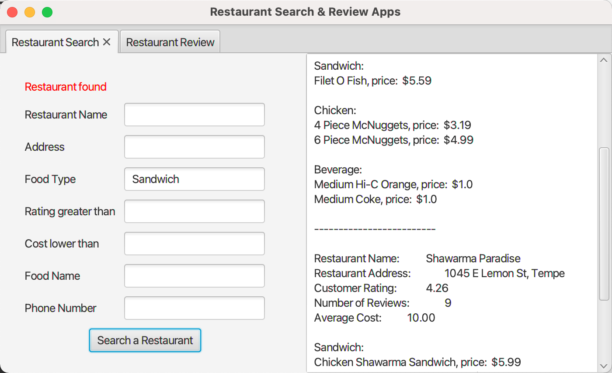

- > Search with average rating of a restaurant

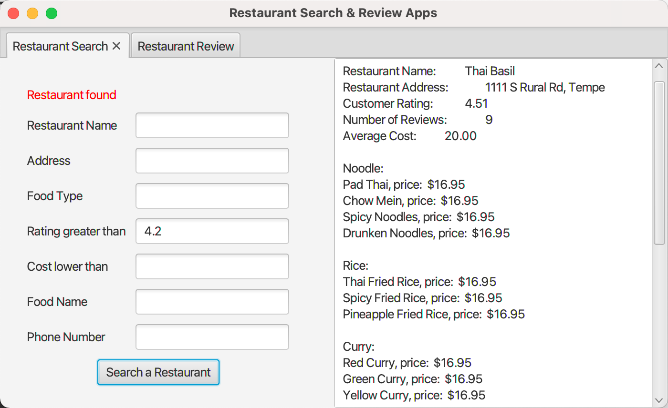

- > Search with average cost of food

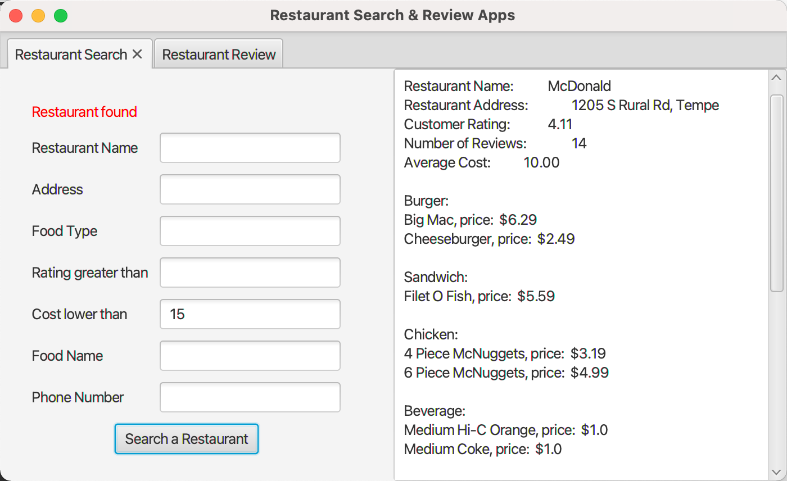

- > Search with Food Name

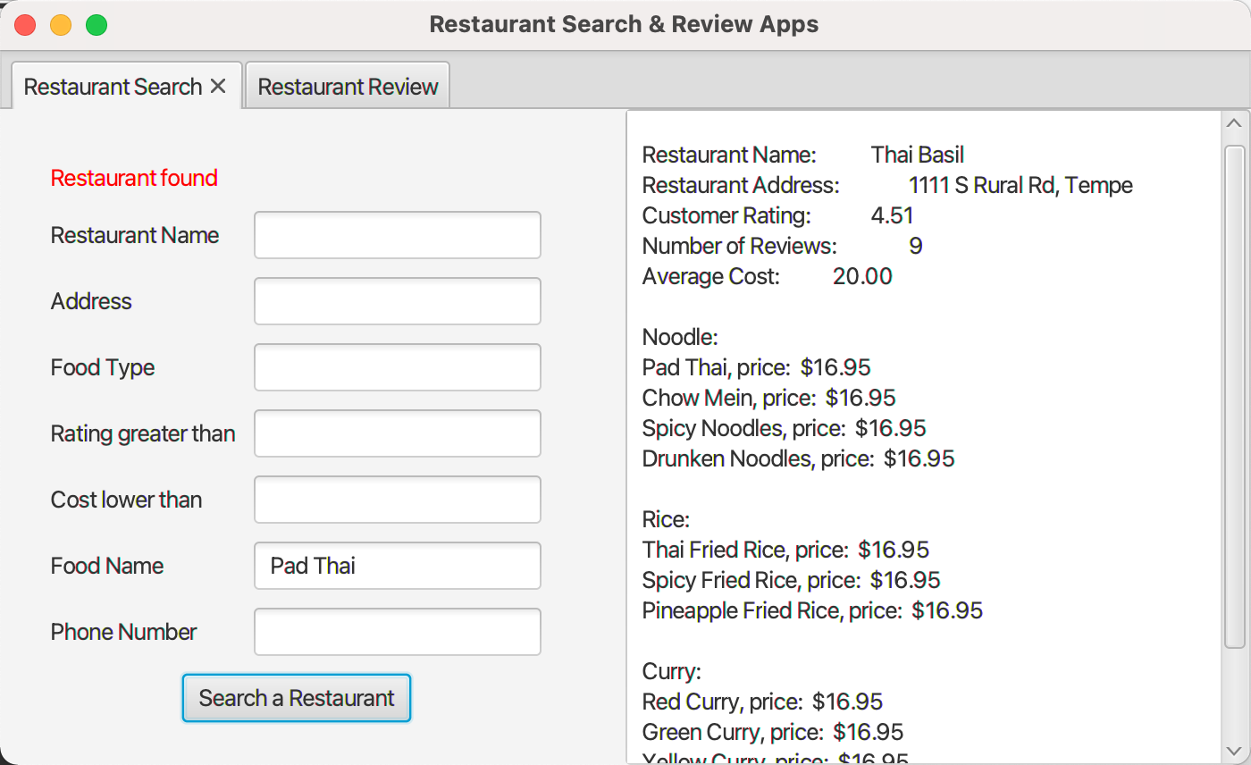

* Search by using keywords:

- > Search with name of a restaurant

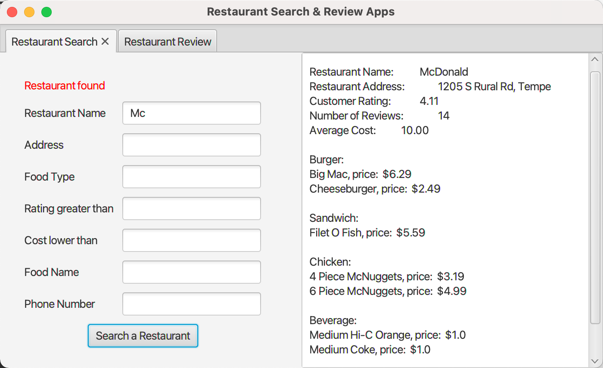

- > Search with name of food name

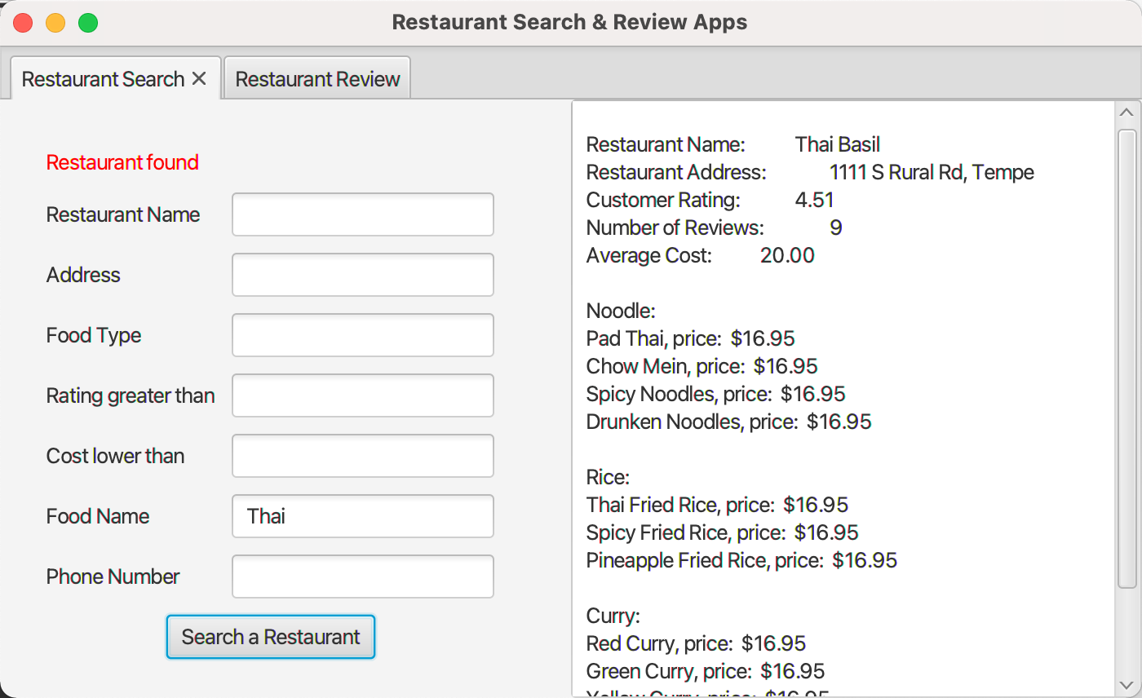

* Search by using multiple conditions:

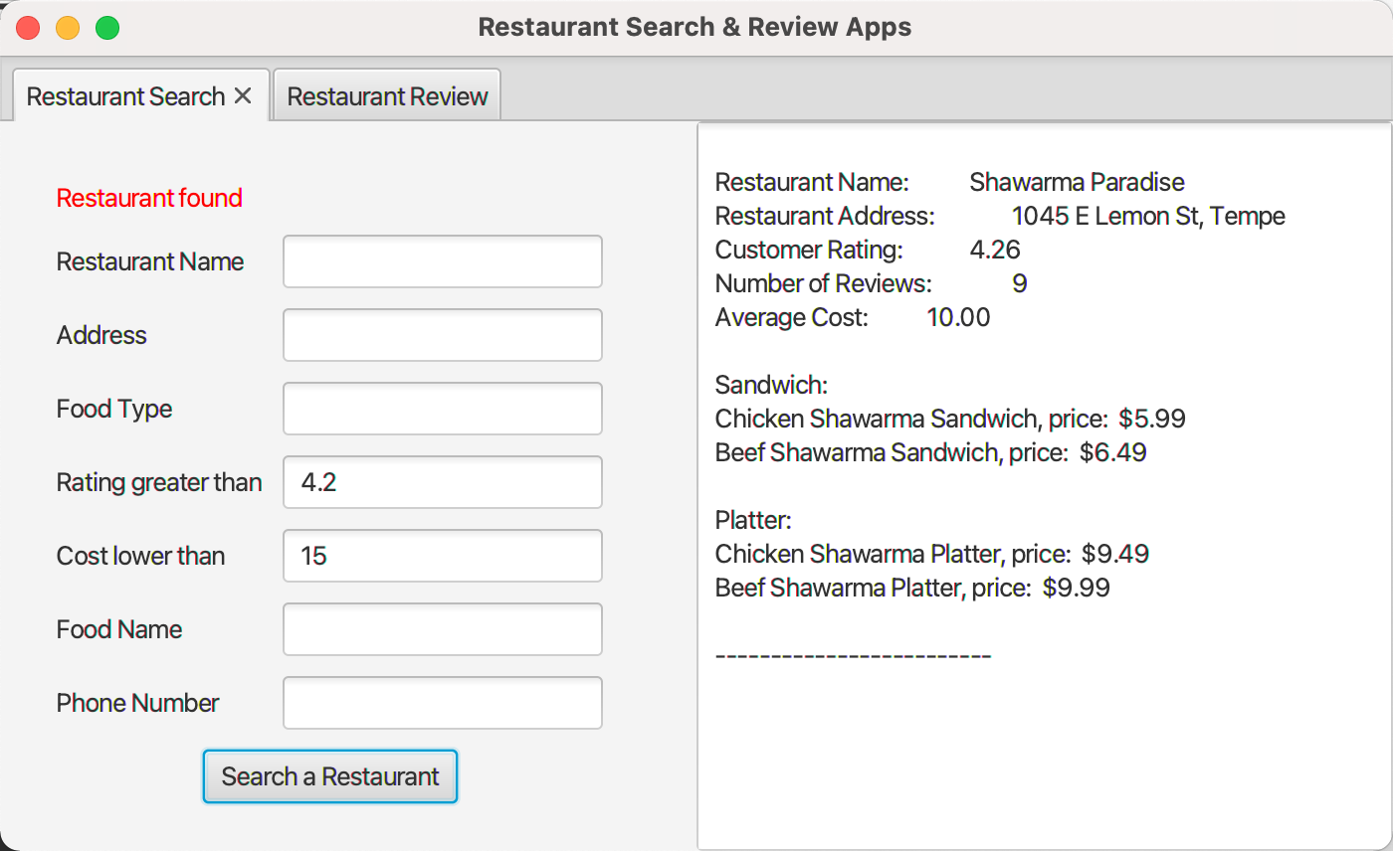

< Rating >

-> Before rating:

* Type information in one of the following conditions you want to search and your phone number.

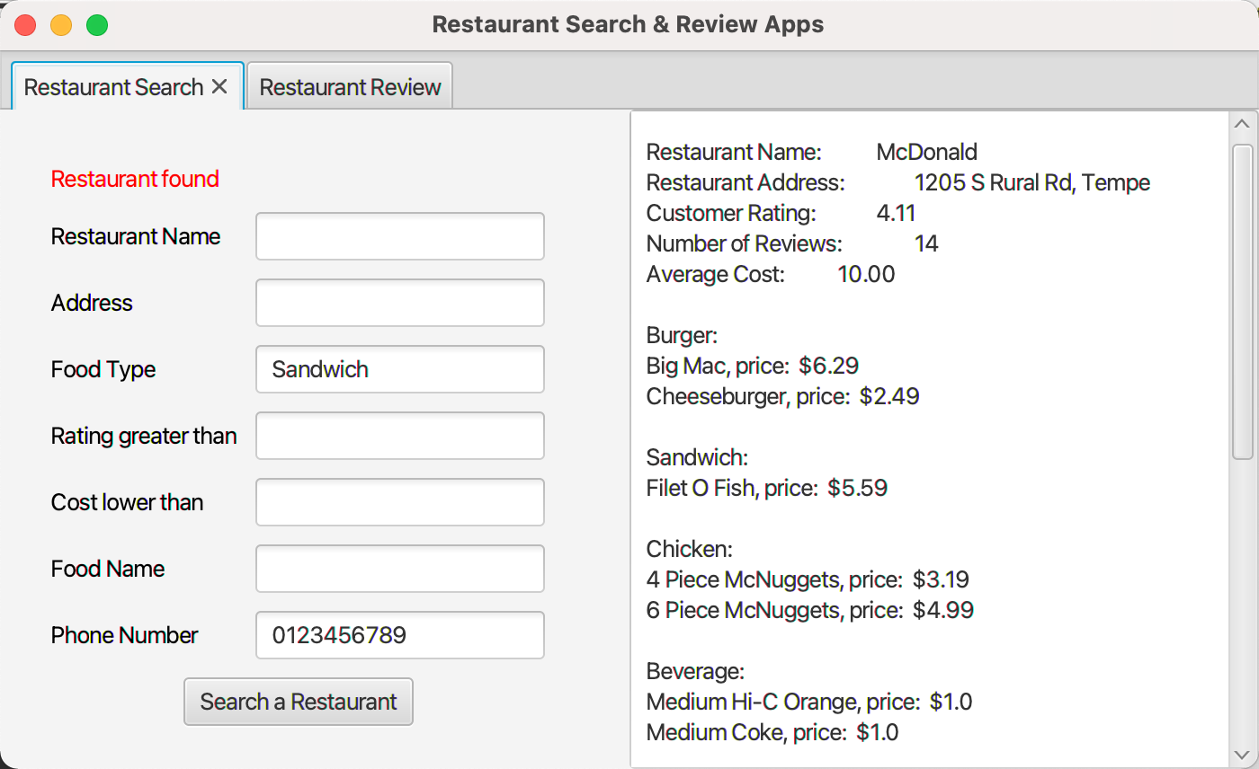

* Go to ‘Restaurant Review’ page, select restaurant and score, and click ‘Submit Review’ button.

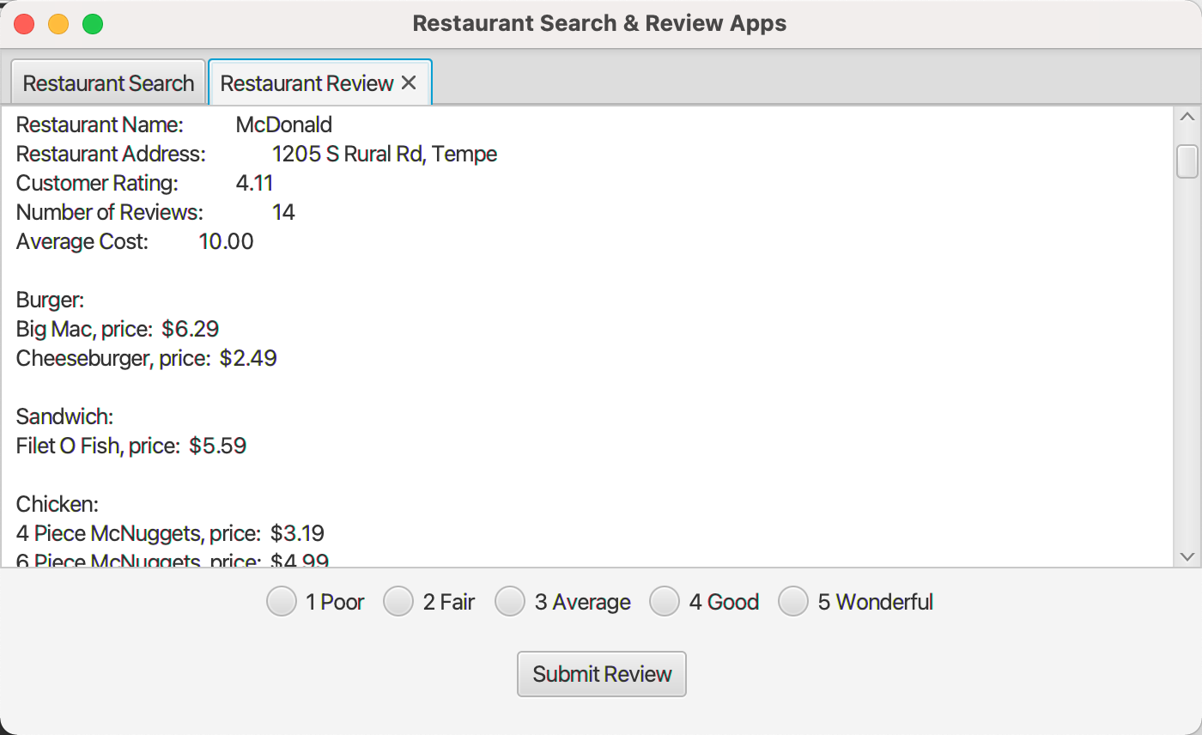

-> After rating: ‘Number of Review’ is increased by 1 and ‘Customer Rating’ is recalculated.

