Project Final Report

**Team members**: Gahyun Song, Wensheng Xu

**Application**:Restaurant Rating Application

**Video Demostration Link** : <https://youtu.be/gE8pa0Prq_w>

**Code and database dump**: <https://github.com/gahyun8876/CSE412>

**Queries used for searching**: (bold and underlined parts are user inputs)

**Search for restaurant**:

SELECT DISTINCT restaurant.restaurant_id, restaurant.restaurant_name, restaurant.address, restaurant.average_cost, restaurant.customer_rating

FROM restaurant INNER JOIN (menu INNER JOIN food ON menu.menu_id = food.menu_id AND menu.restaurant_id = food.restaurant_id) ON restaurant.restaurant_id = menu.restaurant_id AND restaurant.restaurant_id = food.restaurant_id AND menu.menu_id = food.menu_id

WHERE restaurant.restaurant_name LIKE ‘%**Restaurant Name**%’

AND restaurant.address LIKE ‘%**Restaurant Address**%’

AND menu.food_type LIKE ‘%**Food Type**%’

AND restaurant.customer_rating > **Rating**

AND restaurant.average_cost < **Average Cost**

AND food.food_name ‘%**Food Name**%’;

**Get average rating**:

SELECT AVG(score) FROM rating WHERE rating.restaurant_id = ‘**Restaurant ID**’;

**Count rating**:

SELECT COUNT(DISTINCT phone_number) FROM rating WHERE rating.restaurant_id = ‘**Restaurant ID**’;

**Queries used for updates**: (bold and underlined parts are user inputs)

**Delete existing rating**:

DELET FROM rating WHERE phone_number = ‘**Phone Number**’ AND restaurant_id = ‘**Restaurant ID**’;

Add new rating:

INSERT INTO rating(phone_number, restaurant_id, score) VALUES(‘**Phone Number**’, ‘**Restaurant ID**’, **Score**);

**Update average rating for restaurant**:

With subquery AS (

SELECT AVG(score) AS average FROM rating INNER JOIN restaurant

ON rating.restaurant_id = restaurant.restaurant_id

WHERE rating.restaurant_id = ‘**Restaurant ID**’)

UPDATE restaurant SET customer_rating = subquery.average FROM subquery

WHERE restaurant_id = ‘**Restaurant ID**’;

**Add new user**:

INSERT INTO users(phone_number) VALUES(‘**Phone Number**’);

User Manual For Restaurant Rating Application

There are 2 parts of main functions.

1. Searching a restaurant function
2. Users can search for a restaurant by several conditions.

* Restaurant Name
* Restaurant Address
* Food Type
* Average Rating
* Average Cost
* Food Name

1. Users also can search for restaurants with more than one condition.
2. Users can search for restaurants with keywords instead of the full name of the restaurant food.
3. After users type information on the section that they want to search with, click the ‘Search a restaurant’ button.
4. Users have to enter their phone number when searching if they want to rate a restaurant.
5. Rating a restaurant function
   1. Users have to select a restaurant.
   2. Users select a score in order to rate a restaurant.

* Scale : (Poor) 1 - 5 (Wonderful)
  1. Users click the ‘Submit Review’ button.
  2. If a user rates a restaurant multiple times, the latest record will be used to calculate the average rating of the restaurant and older records will be deleted.
  3. The new user’s phone number will be added to the users list when they rate a restaurant.

< Searching >

* Search by using single condition:

- > Search with Restaurant Name

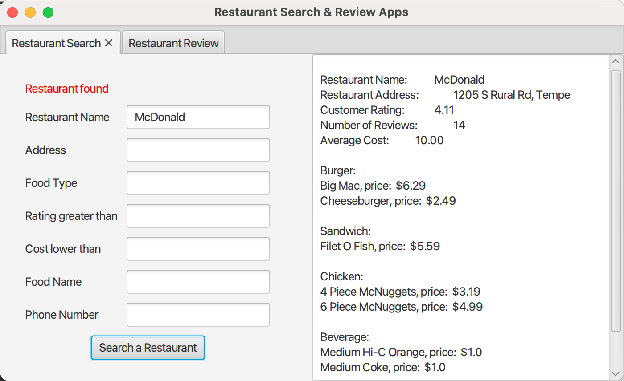

- > Search with Restaurant Address

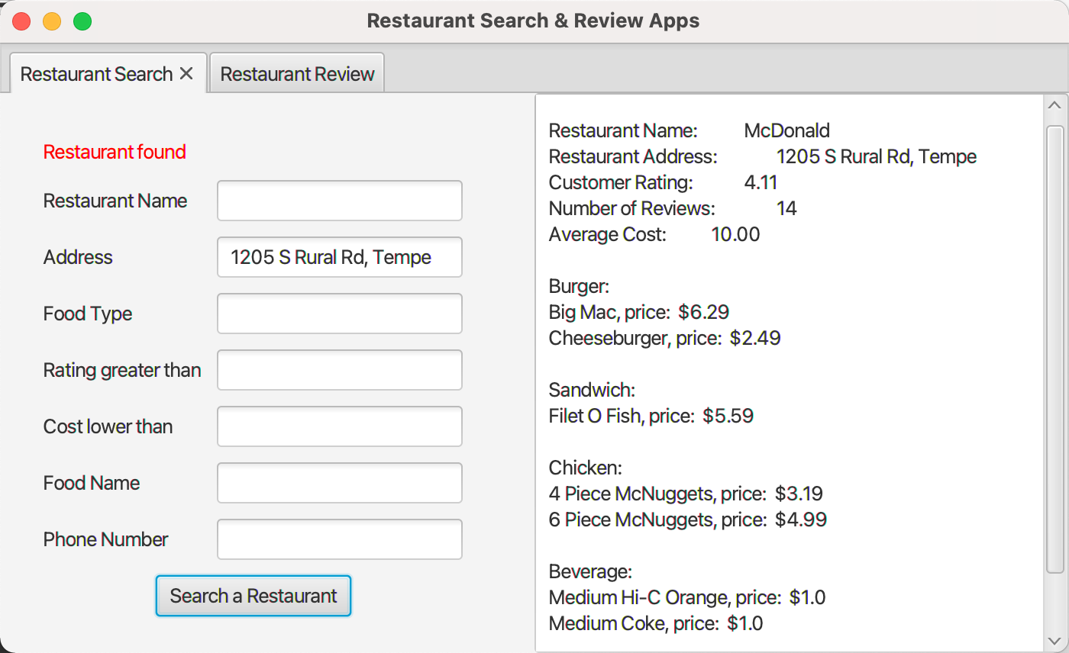

- > Search with Food Type

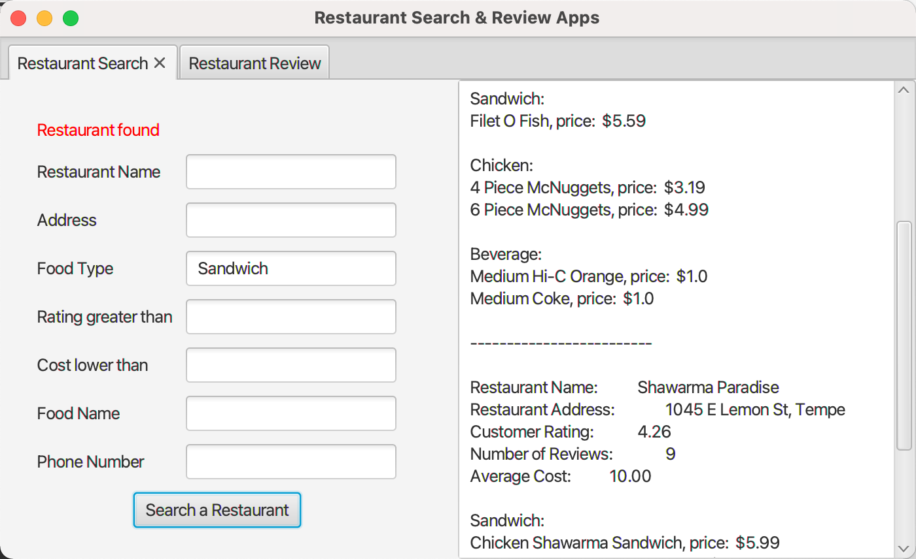

- > Search with average rating of a restaurant

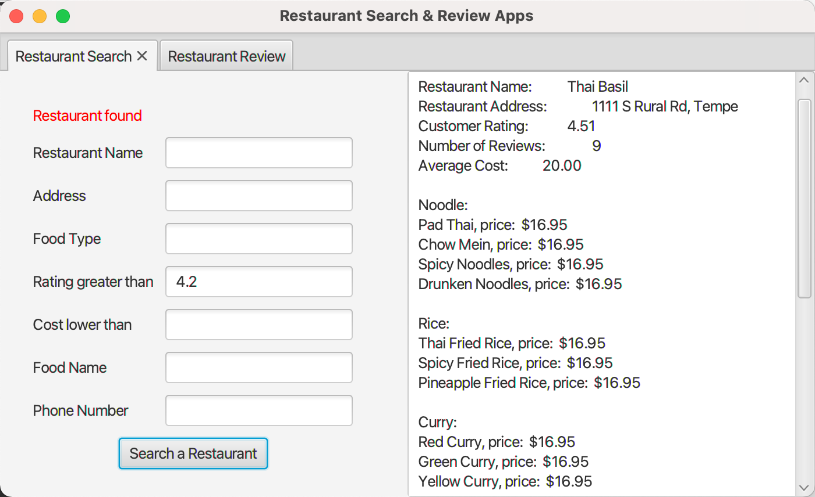

- > Search with average cost of food

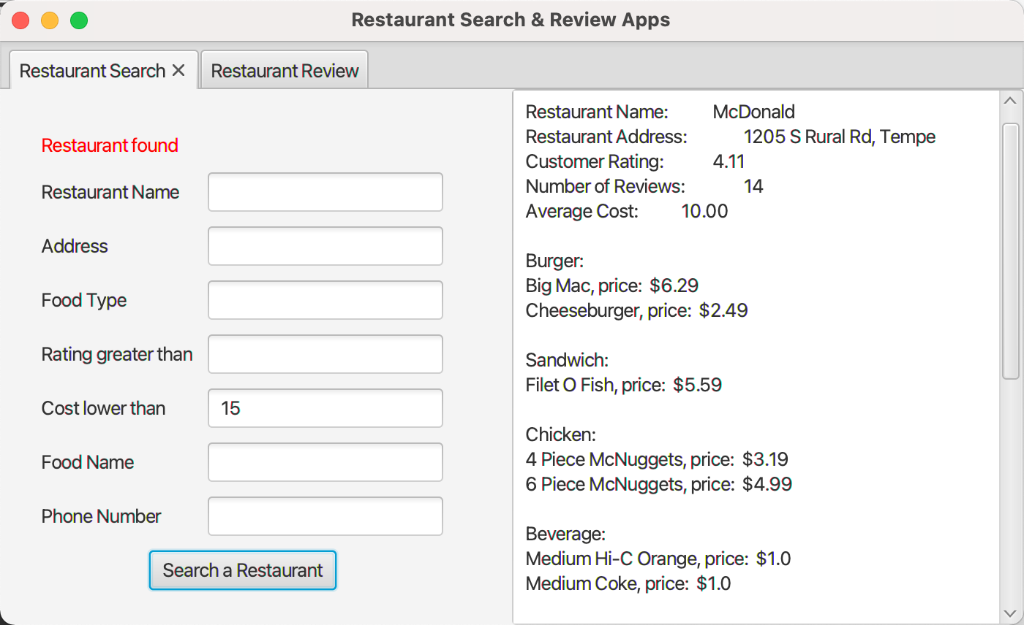

- > Search with Food Name

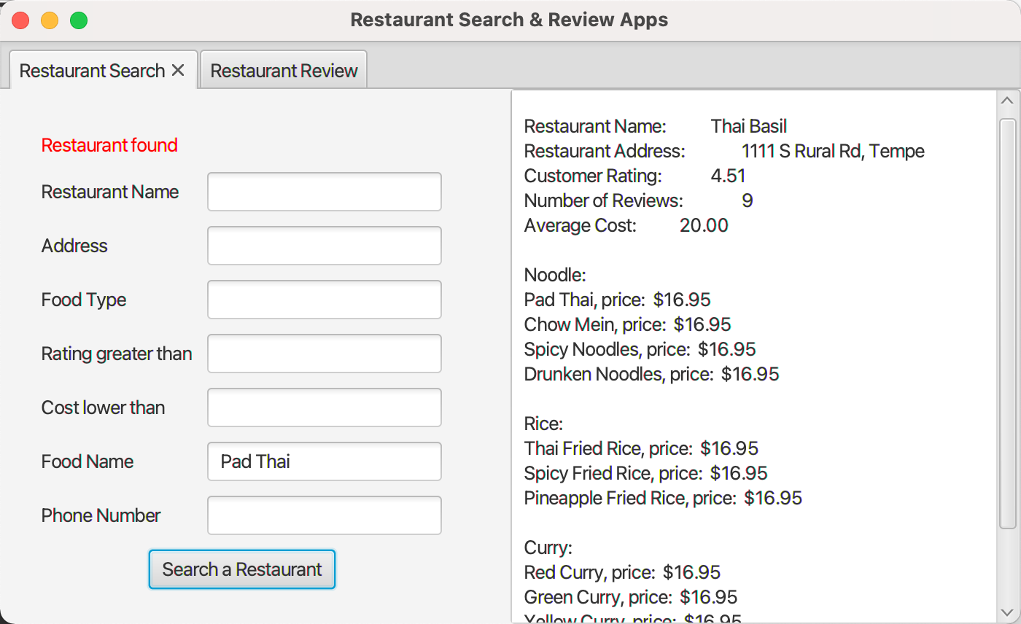

* Search by using keywords:

- > Search with name of a restaurant

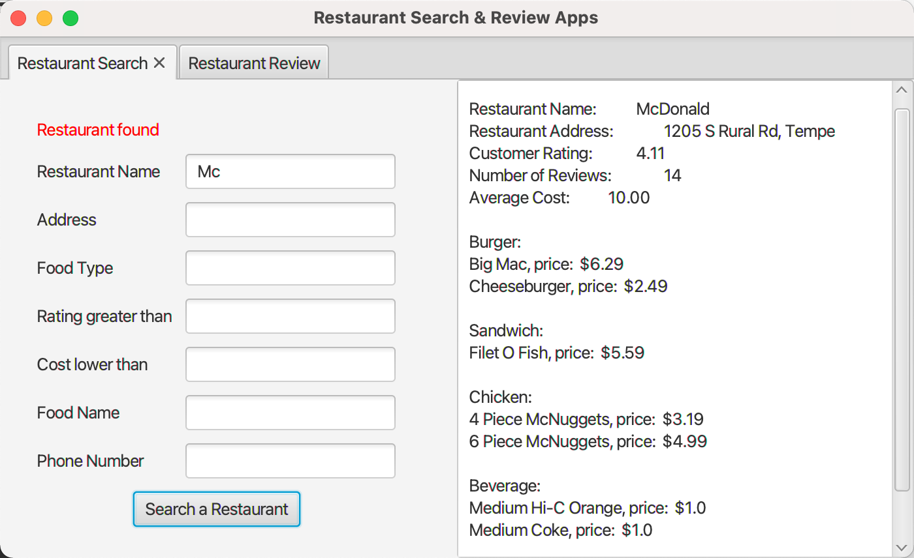

- > Search with name of food name

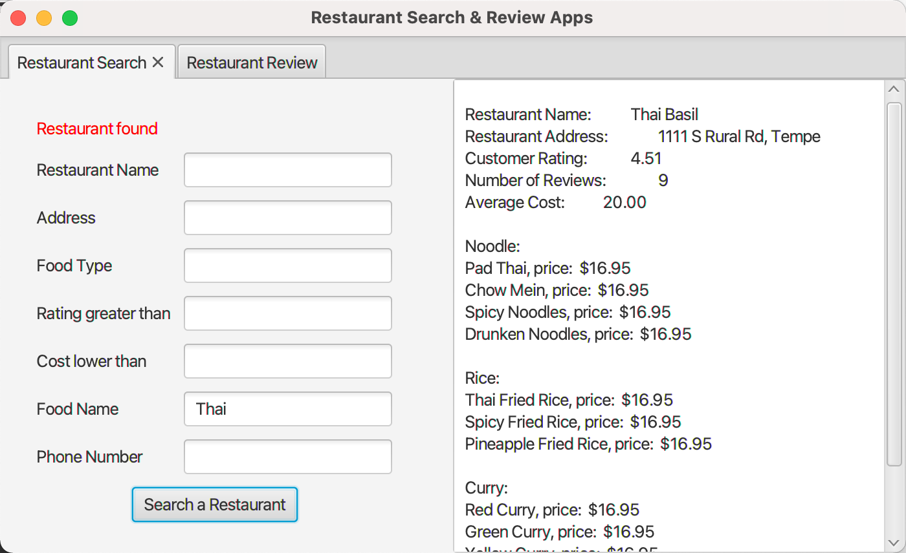

* Search by using multiple conditions:

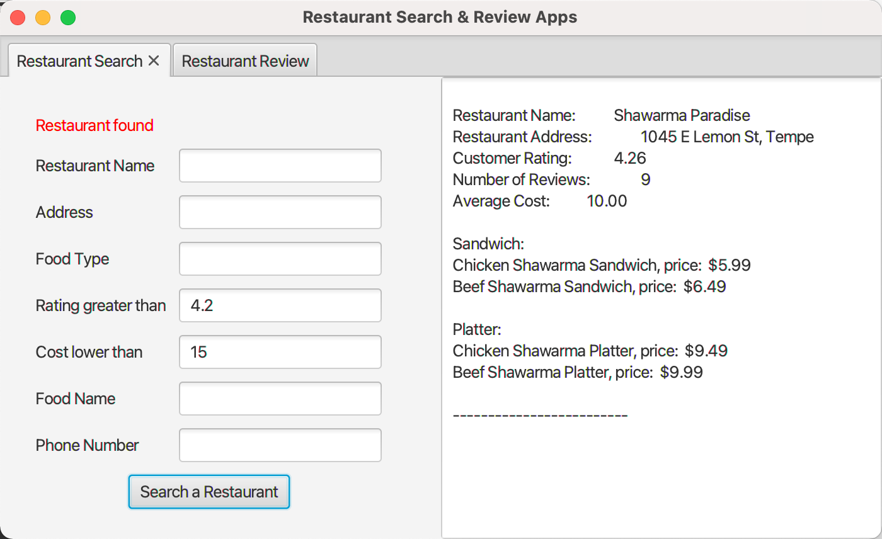

< Rating >

-> Before rating:

* Type information in one of the following conditions you want to search and your phone number.

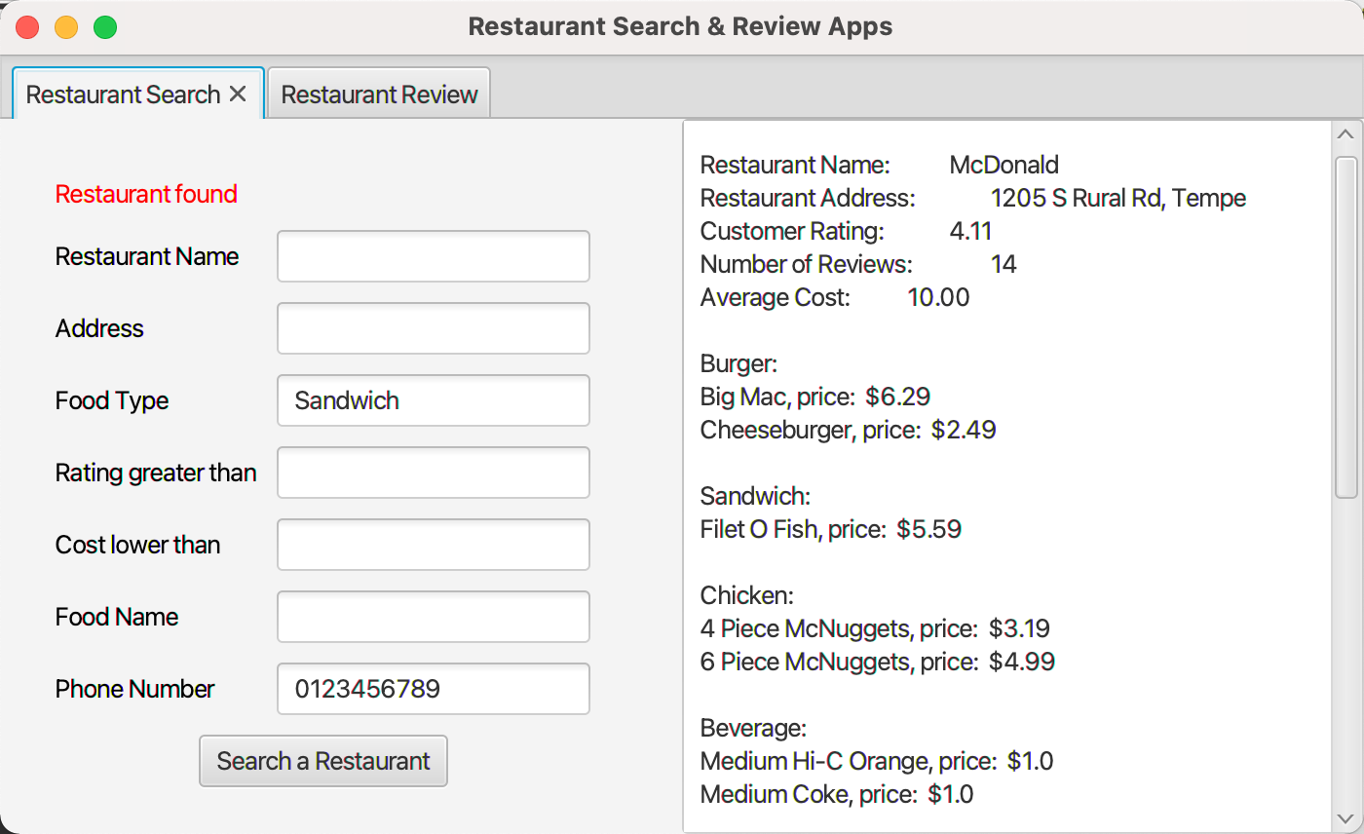

* Go to ‘Restaurant Review’ page, select restaurant and score, and click ‘Submit Review’ button.

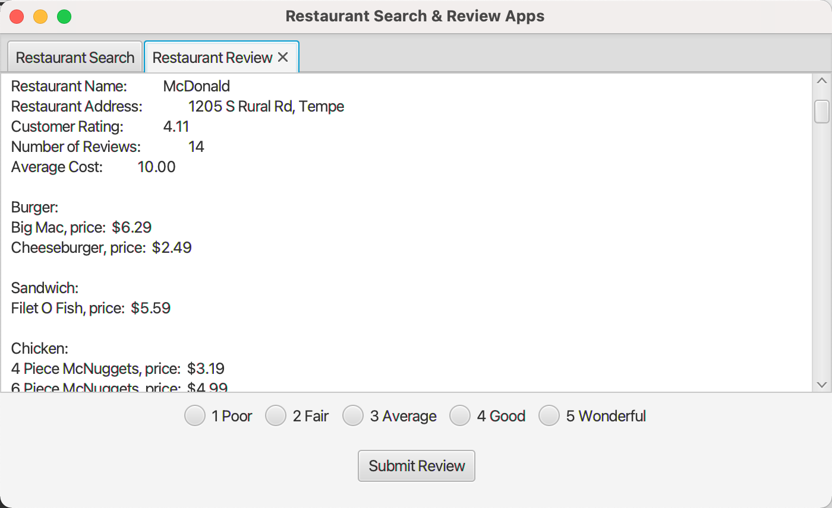

-> After rating: ‘Number of Review’ is increased by 1 and ‘Customer Rating’ is recalculated.

