The Rain Ledger
by Anna Sample
© 2026 Anna Sample. All rights reserved.
For everyone who writes things down.

Chapter One
The Keeper
Every evening at six, Mara climbed the ninety-one steps of the lighthouse and wrote the weather into a book that nobody had ever asked to read. The ledger was older than she was, and it smelled of salt and lamp oil.
Her predecessor had kept it in a tidy, slanted hand. Fog. Wind from the west. Then, one morning, a line that was not about the weather at all: Someone is answering.
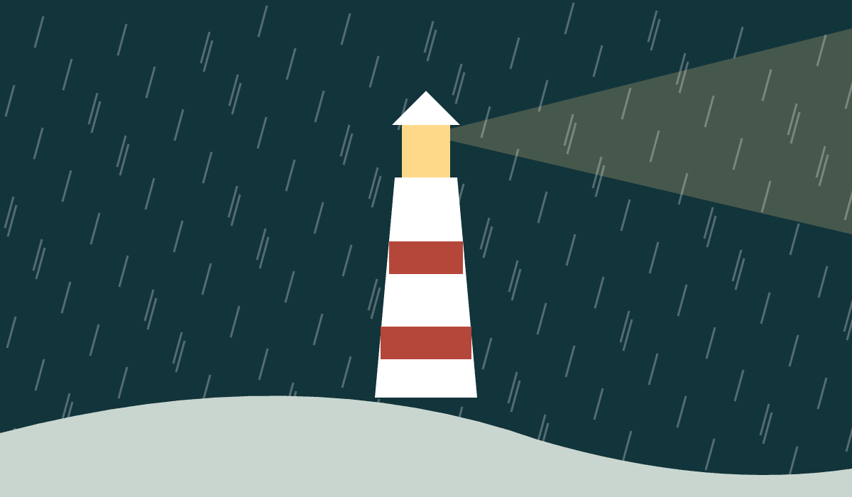

The Margin
Mara found the answers in the margins. They were small, neat and always written in pencil. Whenever the old keeper had noted rain, a second hand had added how much of it had fallen on the far side of the bay, where nobody had lived for forty years.

She read them all that night, every one, until the lamp needed trimming and the first gulls began to argue on the gallery rail.

Chapter Two
The Far Shore
She took the rowing boat out on the first still morning of spring. The water lay flat and grey, and the lighthouse shrank behind her until she could cover it with one thumb.
On the far shore stood a hut with a tin roof, a rain gauge on a post, and a table with a single sharpened pencil on it. There was no dust on the table.

The Last Entry
Mara sat down, opened the ledger and wrote the only honest thing she could think of.
Rain expected. Still here. Still writing.
M., the far shore

The lamp burned paraffin until the station was electrified, a change the ledger records in one word: Brighter.
A rain gauge collects rainfall so that it can be measured, usually in millimetres.

