GaiaFTCL Release Verification Bundle
C4 Matrix Verdict: VERIFIED
State: CALORIE | Uniformity: UNIFORM | Failed steps: 0

Release Report (Markdown Witness)
# GaiaFTCL Closure Battery Report
- ts_utc: 20260406T124751Z
- root: /Users/richardgillespie/Documents/FoT8D/GAIAOS
- head_ip: 77.42.85.60
- ssh_key: /Users/richardgillespie/.ssh/ftclstack-unified
## S4 Secret Gate
S4_SECRET_GATE: PASS
SELF_HEAL_POLICY: /Users/richardgillespie/Documents/FoT8D/GAIAOS/services/gaiaos_ui_web/spec/self-healing-map.json
## Devportal apps inventory
```bash
npm run playwright:devportal:list-apps
```
> gaiaos_ui_web@0.1.0 playwright:devportal:list-apps
> sh -c 'mkdir -p "$HOME/.playwright-discord" && unset CI 2>/dev/null; DISCORD_DEVPORTAL_LIST_APPS=1 DISCORD_PLAYWRIGHT_PROFILE=devportal_gaiaftcl npx playwright test --config=playwright.devportal.config.ts --grep "list applications"'
Running 1 test using 1 worker
CALORIE: wrote 13 apps → /Users/richardgillespie/.playwright-discord/discovered_portal_apps.json
(node:86339) Warning: The 'NO_COLOR' env is ignored due to the 'FORCE_COLOR' env being set.
(Use `node --trace-warnings ...` to show where the warning was created)
✓ 1 [chromium] › tests/discord/discord_devportal_list_apps.spec.ts:34:7 › Developer Portal — list applications (DOM) › scrape application ids (3.9s)
1 passed (5.4s)
RESULT: PASS
## Discord forest env validate (head)
```bash
ssh -n -o BatchMode=yes -i /Users/richardgillespie/.ssh/ftclstack-unified root@77.42.85.60 python3 /opt/gaia/GAIAOS/scripts/validate_discord_forest_full_deploy.py --repo-root /opt/gaia/GAIAOS --env-file /etc/gaiaftcl/discord-forest.env
```
ok 25 required DISCORD_* keys set
RESULT: PASS
## Mother bring-up + health (head)
```bash
ssh -n -o BatchMode=yes -i /Users/richardgillespie/.ssh/ftclstack-unified root@77.42.85.60 docker compose --env-file /etc/gaiaftcl/discord-forest.env -f /opt/gaia/GAIAOS/services/discord_frontier/docker-compose.discord-forest.yml up -d discord-frontier-mother && docker ps --format '{{.Names}} {{.Status}}' | awk '/^discord-frontier-mother / {print; found=1} END{exit found?0:1}'
```
Container discord-frontier-mother Running
discord-frontier-mother Up 15 hours
RESULT: PASS
## Discord game-room + embed validation
```bash
env INTEGRATION_DISCORD_DEVPORTAL_EMBED=1 bash /Users/richardgillespie/Documents/FoT8D/GAIAOS/scripts/validate_discord_game_rooms.sh
```
=== DISCORD GAME ROOMS VALIDATION ===
Repo root: /Users/richardgillespie/Documents/FoT8D/GAIAOS
OK: 16 game_room(s), 8 operational, 13 mesh mailbox slots covered
BLOCKED: mesh peer registry not reachable at http://localhost:8821 (optional check; set MESH_PEER_REGISTRY_URL)
BLOCKED: NATS receipt probe skipped (set NATS_URL and install nats CLI for optional live check)
=== Developer Portal Embed Debugger (Playwright) ===
> gaiaos_ui_web@0.1.0 playwright:devportal:validate-embed
> sh -c 'mkdir -p "$HOME/.playwright-discord" && unset CI 2>/dev/null; DISCORD_DEVPORTAL_EMBED_VALIDATE=1 DISCORD_PLAYWRIGHT_PROFILE=devportal_gaiaftcl npx playwright test --config=playwright.devportal.config.ts --grep "Embed Debugger"'
Running 1 test using 1 worker
✓ 1 [chromium] › tests/discord/discord_devportal_embed_debugger.spec.ts:43:7 › Developer Portal — Embed Debugger › generate embed (validate) (2.4s)
1 passed (3.6s)
Onboarding flow: set INTEGRATION_DISCORD_ONBOARDING_FLOW=1 to run /moor -> /getmaccellfusion validation
Playwright: set INTEGRATION_DISCORD_PLAYWRIGHT=1 to run tests/discord_frontier/playwright (optional DISCORD_PLAYWRIGHT_STORAGE_STATE + DISCORD_WEB_TEST_GUILD_URL)
RESULT: PASS
## Playwright onboarding /moor -> /getmaccellfusion
```bash
npm run test:e2e:discord:onboarding
```
> gaiaos_ui_web@0.1.0 test:e2e:discord:onboarding
> bash ../../scripts/playwright_discord_onboarding_wrap.sh
CALORIE: Discord witness OK — /Users/richardgillespie/.playwright-discord/storage-gaiaftcl.json (48232 bytes, cookies key present)
Running 1 test using 1 worker
- 1 [chromium] › tests/discord/discord_onboarding_dmg_flow.spec.ts:65:7 › Discord onboarding + DMG command › moor command discoverable, dmg command responds
1 skipped
RESULT: PASS
## Playwright GaiaFTCL lane
```bash
npm run test:e2e:discord:gaiaftcl
```
> gaiaos_ui_web@0.1.0 test:e2e:discord:gaiaftcl
> bash ../../scripts/playwright_discord_test_wrap.sh gaiaftcl 1
CALORIE: Discord witness OK — /Users/richardgillespie/.playwright-discord/storage-gaiaftcl.json (48232 bytes, cookies key present)
Running 2 tests using 1 worker
✓ 1 [chromium] › tests/discord/discord_membrane_tier_b.spec.ts:36:7 › Discord membrane Tier B › logged-in channel surface (4.6s)
- 2 [chromium] › tests/discord/discord_onboarding_dmg_flow.spec.ts:65:7 › Discord onboarding + DMG command › moor command discoverable, dmg command responds
1 skipped
1 passed (6.7s)
RESULT: PASS
## Playwright FOM lane
```bash
npm run test:e2e:discord:fom
```
> gaiaos_ui_web@0.1.0 test:e2e:discord:fom
> bash ../../scripts/playwright_discord_test_wrap.sh face_of_madness 0
CALORIE: Discord witness OK — /Users/richardgillespie/.playwright-discord/storage-face-of-madness.json (48208 bytes, cookies key present)
Running 2 tests using 1 worker
✓ 1 [chromium] › tests/discord/discord_membrane_tier_b.spec.ts:36:7 › Discord membrane Tier B › logged-in channel surface (5.4s)
- 2 [chromium] › tests/discord/discord_onboarding_dmg_flow.spec.ts:65:7 › Discord onboarding + DMG command › moor command discoverable, dmg command responds
1 skipped
1 passed (7.7s)
RESULT: PASS
## Fusion battery
```bash
env GAIA_ROOT=/Users/richardgillespie/Documents/FoT8D/GAIAOS npm run test:fusion:all
```
> gaiaos_ui_web@0.1.0 test:fusion:all
> bash ../../scripts/preflight_mcp_gateway.sh && bash ../../scripts/test_fusion_discord_tier_a.sh && bash ../../scripts/test_fusion_mesh_mooring_stack.sh && npm run test:unit:fusion && npm run test:e2e:fusion && npm run test:e2e:discord:gaiaftcl && npm run test:e2e:discord:fom
curl: (7) Failed to connect to 127.0.0.1 port 8803 after 2 ms: Couldn't connect to server
OK gateway fallback http://77.42.85.60:8803/health (local http://127.0.0.1:8803 unreachab

Language Games

Screenshots (Validated Before Embed)
Validated screenshots: 7 / 7 (failed: 0)
/Users/richardgillespie/Documents/FoT8D/GAIAOS/evidence/discord/dual_user/20260406T130618Z/user-a-moorer.png
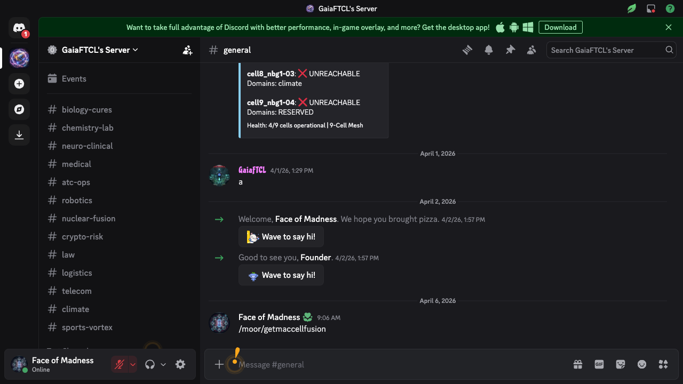
/Users/richardgillespie/Documents/FoT8D/GAIAOS/evidence/discord/dual_user/20260406T130618Z/user-b-observer.png
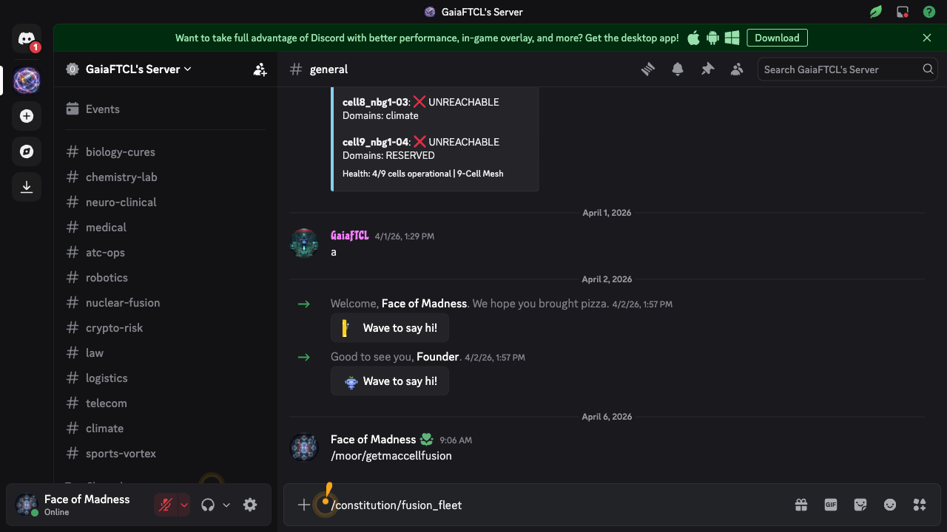
/Users/richardgillespie/Documents/FoT8D/GAIAOS/evidence/discord/dual_user/20260406T130725Z/user-a-moorer.png
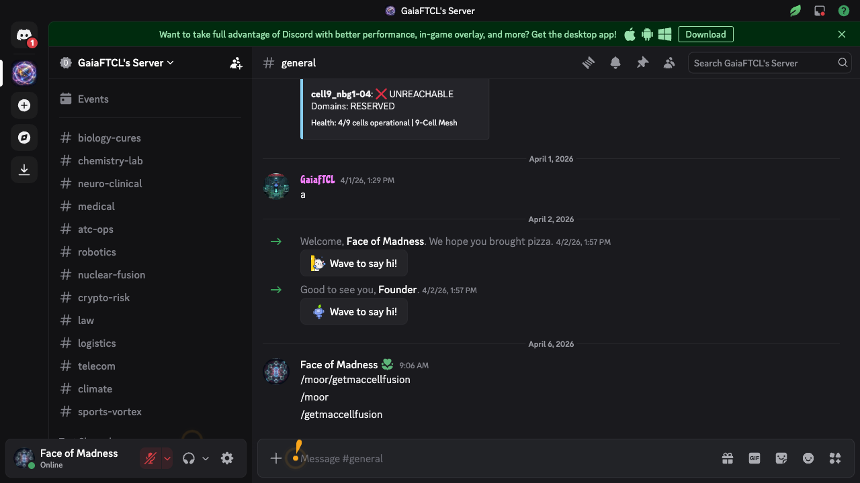
/Users/richardgillespie/Documents/FoT8D/GAIAOS/evidence/discord/dual_user/20260406T130725Z/user-b-observer.png
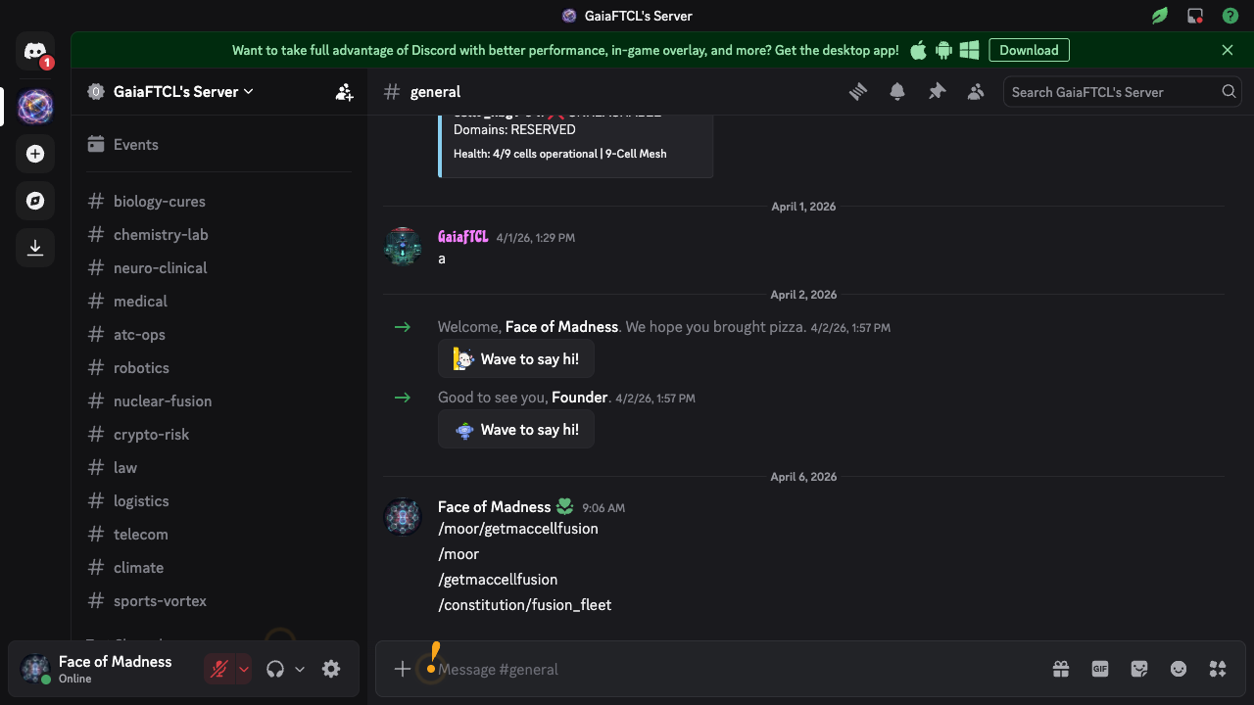
/Users/richardgillespie/Documents/FoT8D/GAIAOS/evidence/discord/dual_user/20260406T131721Z/user-a-moorer.png
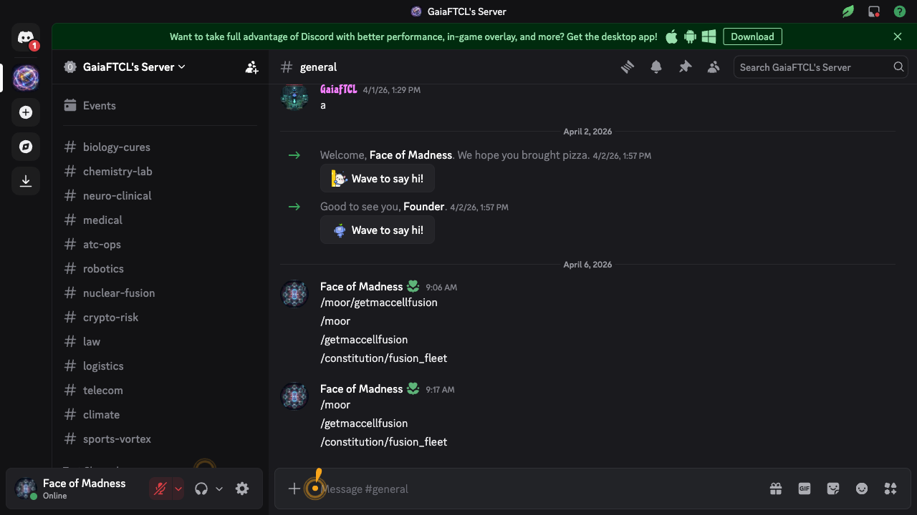
/Users/richardgillespie/Documents/FoT8D/GAIAOS/evidence/discord/dual_user/20260406T131721Z/user-b-observer.png
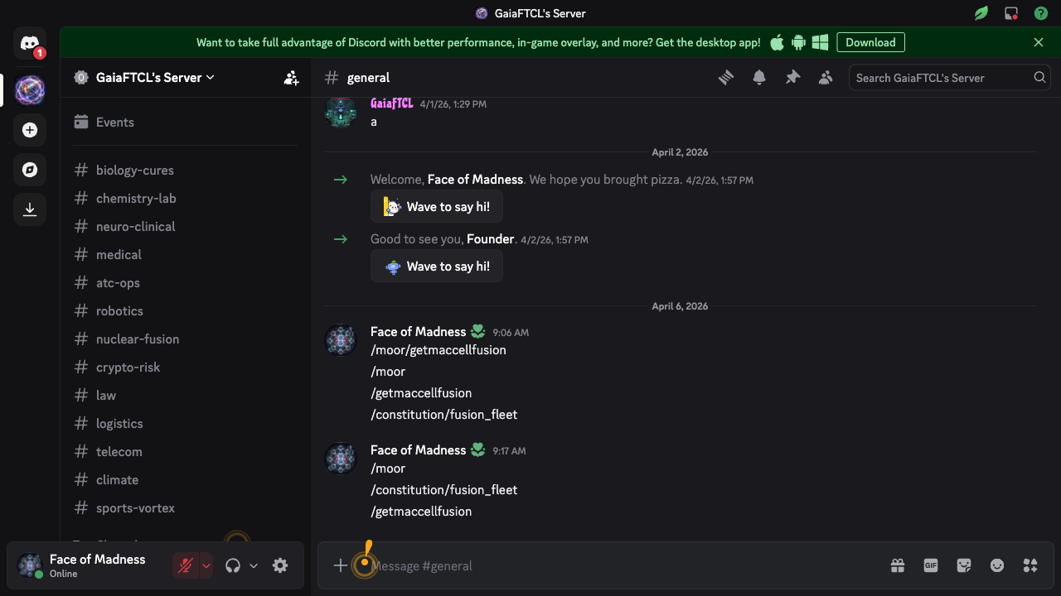
/Users/richardgillespie/Documents/FoT8D/GAIAOS/evidence/fusion/LATEST_SCREENSHOTS/fusion-dashboard.png
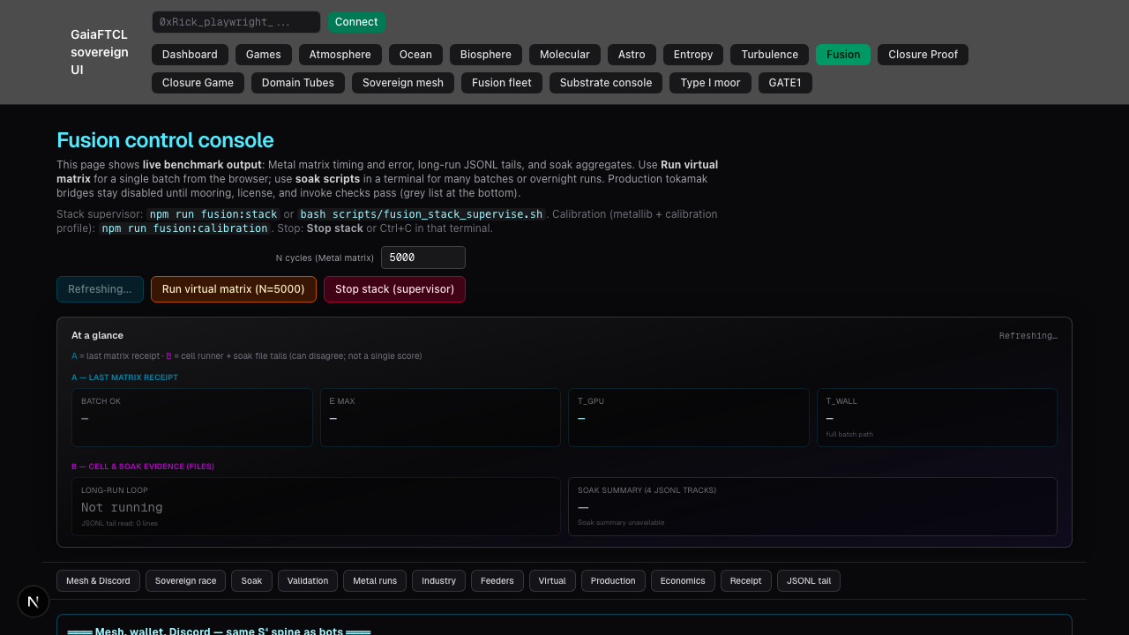

Dual-User Convergence
Witness: /Users/richardgillespie/Documents/FoT8D/GAIAOS/evidence/discord/dual_user/20260406T131721Z/DUAL_USER_WITNESS.json
User A source=None release_id=None
User B source=None release_id=None
Convergence ms=78
Criteria: release_id_match=False | source_diversity=False | lt_2s=True
/Users/richardgillespie/Documents/FoT8D/GAIAOS/evidence/discord/dual_user/20260406T131721Z/user-a-moorer.png

/Users/richardgillespie/Documents/FoT8D/GAIAOS/evidence/discord/dual_user/20260406T131721Z/user-b-observer.png


