-> Unzip the install file.

-> Go inside the Gaiandb_install\gaiandb_install subdirectories.

-> Double click on launchGaianServer.bat to launch the gaiandb federation server (that's it ! )
if it works, the last line in th eDOS windows shoudl say "GaianNode started for Derby network server on port: 1527"
This gaiandb is configured to access a local CSV file datafile.dat. It has also some pre-configured IP access to my gaiandb and simon's gaiandb but commented out as we need to start our server first if you want to access them.

Initial TEST with flat file :
To test with a basic SQL query :
-> Double click on ‘testGaianDB.bat’ – this executes a SQL statement against derby which queries GAIANDB ‘LT0’ (= logical table 0)
If it works, you should get some records back like this ( these are records from your local datafile.dat file )

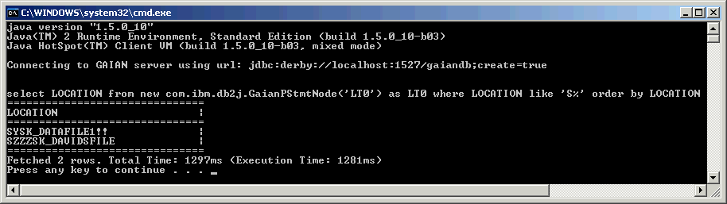

More complicated Test with csv flat file + DB2 :

If you have a local db2 on your machine or another machine change in the gaiandb_config.properties (our registry) the following lines to add a new data source to the federation

LT0_N2_CONNECTION=DB2 -- make sure to uncomment this one

DB2_DRIVER=com.ibm.db2.jcc.DB2Driver
DB2_URL=jdbc:db2://localhost:50000/sample <---- put the right url here. if your DB is local no changes are required
DB2_USR=??? <---- put your local db2 username here instead of ???
DB2_PWD=??? <---- put your local db2 password here instead of ???

To test this, run the ‘testGaianDB.bat’ file again, this should produce more results, taken from your DB2’s default “sample” database.

More complicated test with others machines:
If you want to add another machine, install GAIANDB on it, or contact someone else who has it already. They need to give you their hostname or IP address that you will have to change in
a derby connection configuration such as:

DERBYmachine2_DRIVER=org.apache.derby.jdbc.ClientDriver
DERBYmachine2_URL=jdbc:derby://9.145.44.225:1527/gaiandb
DERBYmachine2_USR=usr
DERBYmachine2_PWD=pwd

You would also need to reference this new connection as a new node under logical table LT0:
LT0_N1_CONNECTION=DERBYmachine2

Testing with automatic discovery of other GaianDB servers
If you’d like to test the automatic GaianDB server discovery, duplicate this install on another machine in the same subnetwork.
Start the other server as well as yours, both servers should be able to federate each other a few seconds after they start (increase LOG level to MORE for instance in property file to see the details)
After executing the same query again (using ‘testGaianDB.bat’), you should see more test results. (it's easier to tell what the provenance of the result rows is if you change the data in the datafile.dat files on each machine)

