1. Open the Miketex setting
2. Then go to the “roots” tab and check the show Miktex-maintained root directories as illustrated in the following figure

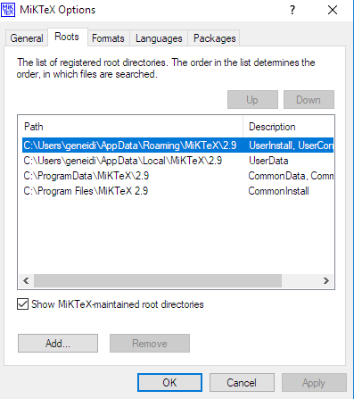

You can install the fonts under the user configuration path.

In the example illustrated in the above figure is the C:\Users\geneidi\AppData\Roaming\MiKTeX\2.9.

Then select the fonts directory and under the C:\Users\geneidi\AppData\Roaming\MiKTeX\2.9\fonts\truetype\ms\verdana directory copy the -verdana fonts (\*.ttf) that you find in verdana-font directory

In the above mentioned procedure is assumed that using the Miketex package manager you have installed the verdana package