**Scenario:**

As an automation candidate, you have been asked to start scripting the following steps:

1. Open the browser
2. Enter the URL <http://practice.automationtesting.in/>
3. Click on My Account Menu
4. Enter registered username in username textbox
5. Enter password in password textbox
6. Click on login button
7. User must successfully login to the web page
8. Click on Myaccount link
9. Click on Orders link
10. User must view their orders on clicking orders link

**Note:**

* The advertisement is popup sometimes, so you can skip or deal with it in your script

**Option #1:**

* Use the simple pre-built framework in the attachment *(the .zip file)*
* Follow the README.md file to setup
* There is a demo test for your reference
* You can modify or add anything to help your work more elegant and robust

*The framework structure in option #1:*

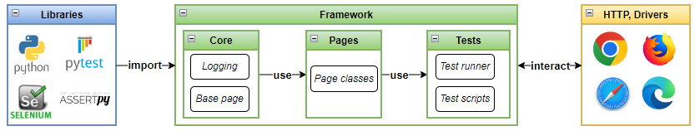

**Option #2:**

* You can use your own frameworks *(Instructions of how to set up and run the test should be given in a README file)*

**Requirements:**

* Programming Language: Python
* Duration: 1 day *(It just takes half-day to complete)*
* The candidate should put the code into a new public GitHub / Gitlab repo
* Submit the results before deadlines