**Documentation**

**InstantScoresNewsApp**

**Version 1.0 approved**

**Prepared by Gaina Alexandru**

**Petrea Paul-Alberto**

**Mazureac Ruben**

**Turcu Andrei**

**Grupa 1308B**

***Copyright © 2025 by INSTANTSCORESNEWS Team. Permission is granted to use, modify, and distribute this document.***

# Table of Contents

Contents

Table of Contents 2

Revision History 2

1. Introduction 3

1.1 Purpose 3

1.2 Document Conventions 3

1.3 Intended Audience and Reading Suggestions 3

1.4 Product Scope 4

1.5 References 4

2. Overall Description 4

2.1 Product Perspective 4

2.2 Product Functions 4

2.3 User Classes and Characteristics 5

2.4 Operating Environment 6

2.5 Design and Implementation Constraints 6

2.6 User Documentation 6

2.7 Assumptions and Dependencies 7

3. External Interface Requirements 8

3.1 User/Admin Interfaces 8

4. System Features 12

5. Other Nonfunctional Requirements 14

5.1 Performance Requirements 14

5.2 Safety Requirements 14

5.3 Security Requirements 14

5.4 Software Quality Attributes 14

5.5 Business Rules 15

6. Help module: InstantScoreNews - Ghid de utilizare 15

Modul Administrator 17

Modul Utilizator 18

# Revision History

|  |  |  |  |
| --- | --- | --- | --- |
| **Name** | **Date** | **Reason For Changes** | **Version** |
| InstantScoresNewsApp | 30.05.2025 | Initial version | 1.0 |

# Introduction

## Purpose

### This Software Requirements Specification (SRS) document defines both the functional and non-functional requirements for InstantScoresNewsApp, version 1.0. The application is a real-time sports score tracking system focused exclusively on football. It is available on both mobile and web platforms and aims to deliver live scores, in-game events, and push notifications to users.

### The purpose of this document is to provide a clear and comprehensive understanding of how the application will function and how it will be implemented. This specification will guide the development, testing, and deployment phases and ensure the alignment of technical decisions with business goals.

## Document Conventions

### This document follows the IEEE standard for software requirement specifications. The following conventions are used:

* + Font: Times New Roman; size 12 for body text and size 14 bold/underline for headings;

### Requirement identification: Each requirement is uniquely identified where applicable;

### Writing style: Third person, passive voice, formal language, and grammatically correct structure;

### Terminology: Consistent use of application-specific terms (e.g., Match Form, Event Form, Push Notifications, etc.).

## Intended Audience and Reading Suggestions

### *This SRS is intended for following audience:

### Developers: To understand the technical and functional goals of the application;

### Testers: To extract test cases and validate application behavior against specifications;

### Clients: To verify that the software aligns with business objectives.

### *The structure of this SRS is:

### Introduction and Product Overview – purpose and scope of the application;

### System Description – describes the product implementation;

### Functional Requirements – core functions of the software;

### Interfaces – describes system interaction with the users.

### *Recommended reading order:

### All readers should begin with Section 1 (Introduction) and Section 2 (Overall Description) to gain a general overview of the system.

### Developers and testers should focus on Section 3 (External Interface Requirements) and Section 4 (System Features) for detailed technical specifications.

### Non-functional requirements and additional constraints are covered in Section 5 and are relevant for quality assurance, risk assessment, and deployment planning.

## Product Scope

### **InstantScoresNewsApp** is a cross-platfor. Its primary objective is to provide instant access to live football data, enabling users to remain informed and engaged with ongoing football matches.

### *The key objective of the software includes:

• Sending push notifications for important match events (e.g., goals, red cards, substitutions);

• Allowing user account management (registration and login);

• Providing an administrative interface for managing matches and event data;

• Ensuring a fast, intuitive, and responsive user experience on both web and mobile platforms.

## References

* IEEE Std 830-1998 – IEEE Recommended Practice for Software Requirements Specifications

# Overall Description

## Product Perspective

**InstantScoresNewsApp** is a newly developed, standalone software application that does not extend or replace any existing system. It has been designed from the ground up to provide real-time football match scores, game events, and push notifications to users across both web and mobile platforms.

Unlike existing solutions (e.g., Flashscore), this application offers a simplified and efficient user experience with features tailored for both casual users and football enthusiasts. The application supports both administrative and user roles and includes real-time communication functionality through a notification system.

### *A simplified architecture of the system includes the following:

### Web Interface;

### Notification Service;

## Product Functions

### InstantScoresNewsApp provides the following major functionalities:

### *Live Scores and Match Tracking:

### Show real-time football match scores and status updates (e.g., start, end, ongoing);;

### Present live event details: goals, red/yellow cards, substitutions.

### *Push Notifications:

### Notify users of critical events such as goals, red cards, match start/end;

### Notifications are triggered by admin-side input using the Observer design pattern.

### *User Accounts:

### Allow users to register, login, and manage their credentials;

### Authenticate sessions and manage access levels (User/Admin).

### *Admin Pannel:

### Enables match/event creation, update, and removal;

### Supports match management and event correction (e.g., cancel events, fix scores).

### *Match Results:

### Display a historical match results.

## User Classes and Characteristics

### The following user classes have been identified for InstantScoresNewsApp. Each class has specific usage and feature needs.

### *Casual Users:

### Description: Users who open the app occasionally to check scores;

### Frequency: Moderate;

### Technical expertise: Basic;

### Features used:

### Live scores;

### Real-time statistics for ongoing matches;

### Notifications;

### Importance: Medium – their satisfaction provides popularity for the app.

### *Active Football Fans:

* Description: Users who follow matches closely and check the app multiple times per day.
* Frequency: High;
* Technical expertise: Basic;
* Features used:

### Live scores;

### Real-time statistics for ongoing matches;

### Notifications;

### Importance: High - they are the target audience of InstantScoresNewsApp.

### *Admins:

### Description: Internals who manage content, monitor system behavior, update scores and perform support tasks;

### Frequency: High;

### Technical expertise: High;

### Features used:

### Admin dashboard;

### Importance: High - essential for the good functionality of the application.

## Operating Environment

### InstantScoresNewsApp is designed to operate in a cross-platform environment, supporting both mobile and web platforms. It includes the following:

### *Client-side (Front-end environment)

### Mobile devices:

### Platforms: Android 11+ and iOS 15+;

### Devices: Smartphones and tablets;

### Web browsers:

### Supported Browsers: Chrome, Firefox, Brave, Edge, Opera, Safari (latest versions for all browsers mentioned);

### Responsive web design for mobile and desktop compatibility (to do);

### *Server-side (Back-end environment)

### Operating systems: Windows 11 (latest version);

### Visual Studio 2022 (latest version)

### The system is designed to respect constraints and privacy permissions of the OS systems it operates on, regarding push notifications and data updates.

## Design and Implementation Constraints

* User must have a name between min 3 and max 16 characters;
* Password is required, cannot be null;
* Source code must respect programming conventions of C#;
* Interface must be easy to use by any user without technical experience.
* System must respect privacy constraints (e.g., push permission requests).

## User Documentation

### *Quick Start Guide (in-app version):

### Overview of features and basic navigations;

### *User Manual:

### Detailed guide on using the app and troubleshooting potential errors that may occur;

### *Tutorials:

### Step-by-step tutorials for new users upon first launch;

### *FAQ section:

### In-app answers to common questions and troubleshooting guidance.

## Assumptions and Dependencies

### Users will have access to stable internet connections in order to receive real-time updates for ongoing football events;

### The app assumes that the target audience have modern smartphones that meet the minimum storage and perform requirements of smoothly using our application;

### We assume our company will not lose privileges to operate on Google Play/App Store in the nearest future;

### We assume that our target audience is surely using one of the browsers that our app is operating on (Chrome, Firefox, Edge, Safari, Opera, Brave).

### Push notification services will remain available.

### We assume there will be no legal requirements regarding our permissions to use data from real football events.

# External Interface Requirements

## User/Admin Interfaces

The application provides multiple user interfaces designed for simplicity and efficiency. There are separate components for regular users and administrators:

1.SignIn form:

All new users can create a new free account.

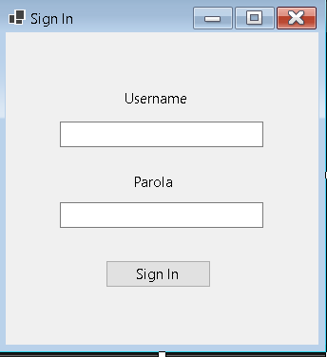

• Fields:

* Username (Textbox)
* Password (Textbox)

• Action:

* Submit button for account creation

*2. Login form:*

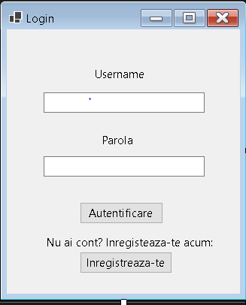

• Fields:

* Username (Textbox)
* Password (Textbox)

• Actions:

* Login button to validate credentials
* Link to registration page for new users

*3. Main Application Interface (InstantScoreNews Form):*

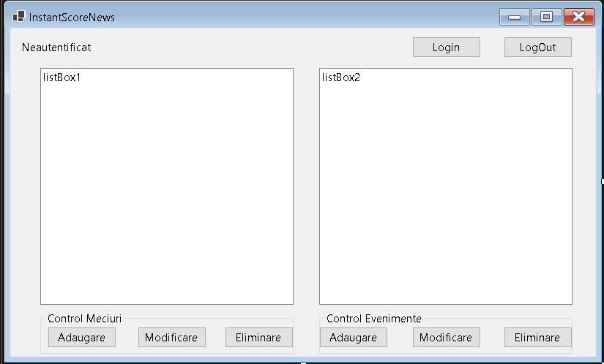

* Components:
  + Two list boxes:
    - One for displaying ongoing football matches
    - One for real-time in-game events
  + Functional buttons:
    - Login/Logout toggle
    - Admin-specific buttons for managing matches and events

**Admin Functional Areas:**

* Match Control Panel**:**
  + Add match
  + Modify match score
  + Delete outdated match
* Event Control Panel:
  + Add real-time event (goal, card, substitution)
  + Modify incorrect event entries
  + Remove canceled or incorrect events

*4. Event form:*

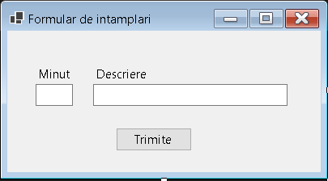

• Text fields:

* Match minute
* Event description

• Button:

* Submit the event

*5. Match form:*

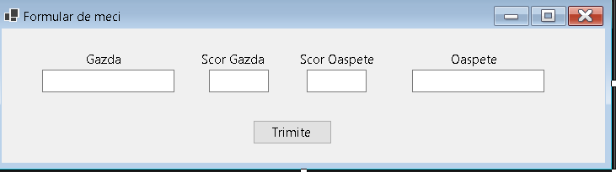

• Text fields:

* Two fields for team names
* Two fields for team scores

• Button:

* Submit match to be added to live list
  1. **Hardware Interfaces**

The application is designed to run on modern consumer hardware and requires only basic input/output devices:

* **Input**:
  + Mouse or touchscreen (click, scroll, select)
  + Keyboard (text input for login, registration, admin control)
* **Output**:
  + Display monitor or mobile screen (standard resolution supported)

There is no need for external hardware peripherals.

* 1. **Software Interfaces**
* A laptop with Windows operating system (Windows 10 or later).

The entire application runs locally on the user's machine. No internet connection, server, or external services are required.

* 1. **Communications intefaces**

No external communication is used.

* The application does not require an internet connection
* All features work offline, directly on the user's device
* No client-server architecture, push notifications, or API calls are involved

All interactions happen locally within the browser environment.

# System Features

# This section describes the main system features of ****InstantScoresNewsApp****, focusing on functional behavior from the user's and admin's perspective.

* 1. **User login / registration:**

**Description:**  
Allows users to register a new account or log into the system using existing credentials.

**Stimulus/Trigger:**  
User selects either "Register" or "Login" from the application home screen.

**Inputs:**

* Username
* Password

**Outputs:**

* Registration: Confirmation message and redirection to the login screen
* Login:
  + On success: Redirected to the main dashboard (InstantScoreNews view)
  + On failure: Error message for invalid credentials

**Functional Logic:**

* Validate input fields (length, format)
* Check credentials against the database
* Generate a token on successful login
* Handle session storage securely

**Exceptions:**

* Invalid username or password → show error message
* Empty fields → prompt user to complete inputs
  1. **Admin modifying matches and events:**

**Description:**  
Admins can create, update, and delete matches and associated events in real time.

**Stimulus/Trigger:**  
An admin logs in and accesses the Match/Event Control Panels.

**Inputs:**

* Team names and scores (for match management)
* Match minute and event description (for event management)

**Functional Categories:**

* **Add Match**: Adds a new match to the match list
* **Update Match**: Changes score or team details
* **Delete Match**: Removes a match from the system
* **Add Event**: Registers a new in-game event (goal, card, substitution)
* **Update Event**: Fixes incorrect event details
* **Delete Event**: Removes invalid/canceled events

**Functional Logic:**  
Admin changes trigger database updates and push notifications to users via Observer Pattern.

**Exceptions:**

* Invalid input: prompt for correction
* Trying to modify a finished match: action not allowed
  1. **Push notifications:**

**Description:**  
Automatically notifies users in real time when events or matches are added or updated by admins.

**Stimulus/Trigger:**  
An admin adds or updates a match or event.

**Functional Logic:**

* Backend uses the Observer design pattern
* On update, a message is sent to the notification system

**Outputs:**

* In-app banners or mobile push messages for events like:
  + Match started
  + Goal scored
  + Red card issued
  + Match ended

**Exceptions:**

* User opted out of notifications: no message sent
* Network issues: retry with backoff, fallback to storing local notification queue

# Other Nonfunctional Requirements

## Performance Requirements

* The system shall support at least 1000 concurrent users without noticeable degradation in performance;
* The average notification time for an event/match that recently got uploaded should be <2 seconds;
* The login process shall complete < 1.5 seconds;

## Safety Requirements

* The system must backup data of all users every 24 hours to prevent data loss;
* In case of system failure, application goes in read-only mode for both user / admin;
* Users cannot override matches / events uploaded by admins.

## Security Requirements

* Users need a strong password built with numbers and characters such as: $, %, #, &;
* Users MUST not share their password with anyone to prevent account loss;
* **Passwords are stored hashed and salted** (never in plain text).
* InstantScoresNewsApp will never send e-mails or notifications asking for your credentials;
* The system will comply with GDPR regarding data privacy and user consent.

## Software Quality Attributes

* **Availability**: The system shall maintain continuous availability with failover strategies in place.
* **Usability**:
* New users must be able to register and complete onboarding (tutorial + login) within **2 minutes**.
* Interfaces must be intuitive, requiring minimal learning for casual use.
* **Maintainability**:
* The codebase must be modular and documented to allow future enhancements without major rewrites.
* **Portability**:
* The application shall run consistently across:
  + Android and iOS devices (as native or PWA)
  + Modern desktop and mobile browsers (Chrome, Edge, Firefox, Safari, Opera, Brave)
* **Scalability**:
  + The system architecture must allow scaling to support increased traffic during popular football events (e.g., World Cup).

## Business Rules

* Only administrators may:
  + Add, modify, or delete matches and match events;
  + Send mass notifications;
  + Ban or warn users who behave disruptively.
* Users may deactivate their account only after a minimum of 24 hours since creation.
* Notificationservices are opt-in and require explicit consent during registration.
* All content must remain appropriate and sports-related, or it will be removed by admin review.

# Help module: InstantScoreNews - Ghid de utilizare

Bine ai venit în aplicația **InstantScoreNews**! Acest ghid îți explică cum să utilizezi aplicația pentru a controla meciurile și evenimentele sportive în timp real.

## Interfața principală

## 

În fereastra principală a aplicației, sunt afișate două secțiuni principale:

* **Control Meciuri** – pentru gestionarea listei de meciuri (adăugare, modificare, ștergere)
* **Control Evenimente** – pentru gestionarea evenimentelor asociate meciurilor (ex: goluri, cartonașe, etc.)

În partea de sus, se află secțiunea de autentificare:

* **Login** – se folosește pentru autentificare
* **LogOut** – devine activ după autentificare și permite ieșirea din cont
* **Statusul utilizatorului** – afișează dacă ești autentificat sau nu (în exemplu: "Neautentificat")

Pentru a putea edita meciurile și evenimentele, trebuie mai întâi să te autentifici.

## Autentificare

Pentru a te autentifica, urmează acești pași:

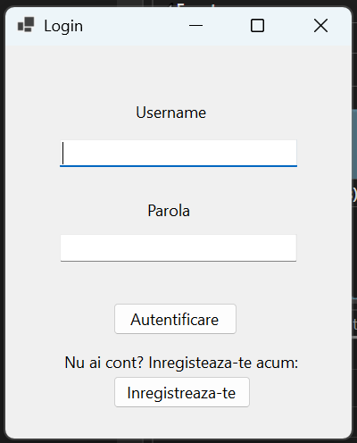

## Instrucțiuni pentru accesul în sistem

### Nivel de administrator

* Conectează-te introducând numele de utilizator „admin” și parola „admin” în câmpurile corespunzătoare.
* Apasă butonul **Login** pentru autentificare.
* După autentificarea cu succes, vei avea acces la funcționalități de administrare, inclusiv posibilitatea de a adăuga, modifica și șterge meciuri și evenimente.

### Nivel de utilizator obișnuit

* Dacă ai deja un cont, conectează-te introducând datele aferente în câmpurile corespunzătoare.
* 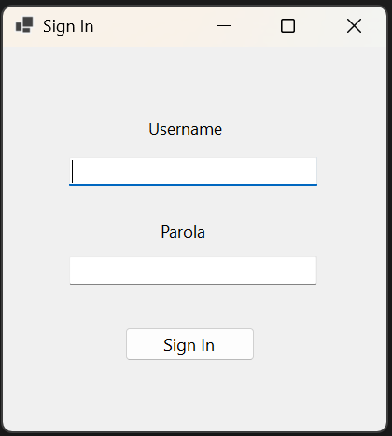Dacă nu ai un cont, apasă butonul **Înregistrează-te**, completează formularul cu informațiile necesare și apasă **Sign in** pentru a-ți crea contul.
* Cu un cont de utilizator obișnuit, poți doar vizualiza meciurile și evenimentele, fără posibilitatea de a le edita.
* La conectare, vei primi notificări pop-up cu evenimentele adăugate în perioada în care ai fost offline.

După autentificare, statusul utilizatorului se va schimba în "Autentificat" și vei avea acces la butonul de LogOut.

# Modul Administrator

Dacă ai acces ca administrator, aplicația InstantScoreNews îți oferă posibilitatea completă de a gestiona meciurile și evenimentele din sistem.

## Interfața administratorului

În această stare, aplicația indică **"Bine ai venit, admin!"** și permite utilizarea tuturor butoanelor:

### Butoane disponibile

* **Login** – butonul rămâne activ pentru a permite autentificarea unui alt cont (opțional).
* **LogOut** – deconectează utilizatorul curent (admin).

### Secțiunea "Control Meciuri"

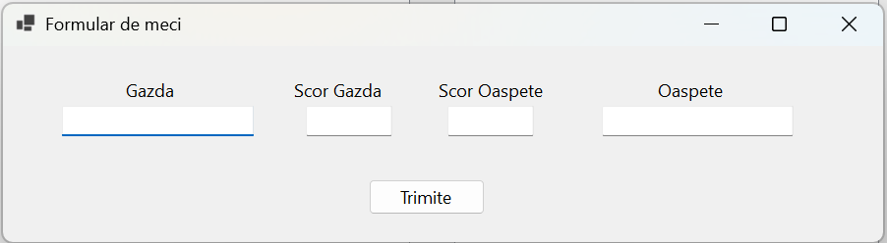

* **Adăugare** – deschide o fereastră unde poți introduce detalii despre un meci nou (echipe, scor; cu mențiunea gazdă/oaspete).
* **Modificare** – permite editarea unui meci selectat din listă.
* **Eliminare** – șterge meciul selectat din listă. Atenție: operațiunea este definitivă.

### Secțiunea "Control Evenimente"

* **Adăugare** – deschide o fereastră pentru adăugarea unui eveniment la un meci (ex: gol, fault, schimbare; cu mențiunea minutului).
* **Modificare** – editează un eveniment existent.
* **Eliminare** – șterge un eveniment selectat.

### Listă meciuri

În partea stângă apare lista meciurilor curente. Poți selecta unul pentru a-l modifica sau a-i adăuga evenimente.

### Listă evenimente

În partea dreaptă va fi afișată lista evenimentelor asociate meciului selectat. Dacă lista e goală, înseamnă că nu a fost selectat niciun meci sau nu există evenimente înregistrate.

# Modul Utilizator

Ca utilizator obișnuit (non-admin), aplicația InstantScoreNews îți oferă acces în modul de vizualizare și notificare. Nu ai permisiuni de modificare.

## Diferențe față de administrator

* Nu poți adăuga, modifica sau șterge meciuri și evenimente.
* Butoanele **Adăugare**, **Modificare** și **Eliminare** sunt dezactivate (afișate ca gri).
* Poți vedea lista meciurilor și evenimentelor în timp real, fără să le poți edita.

## Notificări live

După autentificare, vei primi ferestre pop-up de notificare care anunță în timp real:

* Startul unui meci
* Marcarea unui gol
* Schimbări sau cartonașe
* Finalul unui meci

Aceste notificări apar automat pe ecran, fără ca tu să trebuiască să interacționezi cu aplicația.

### Exemplu de notificare

### 

1. **Diagrams:**
   1. **Activity diagram:**

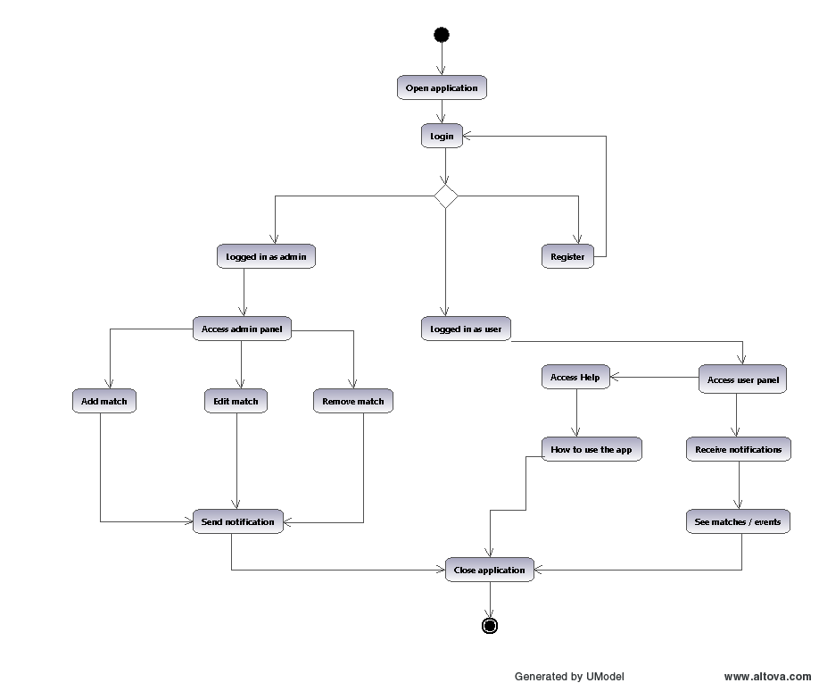

* 1. 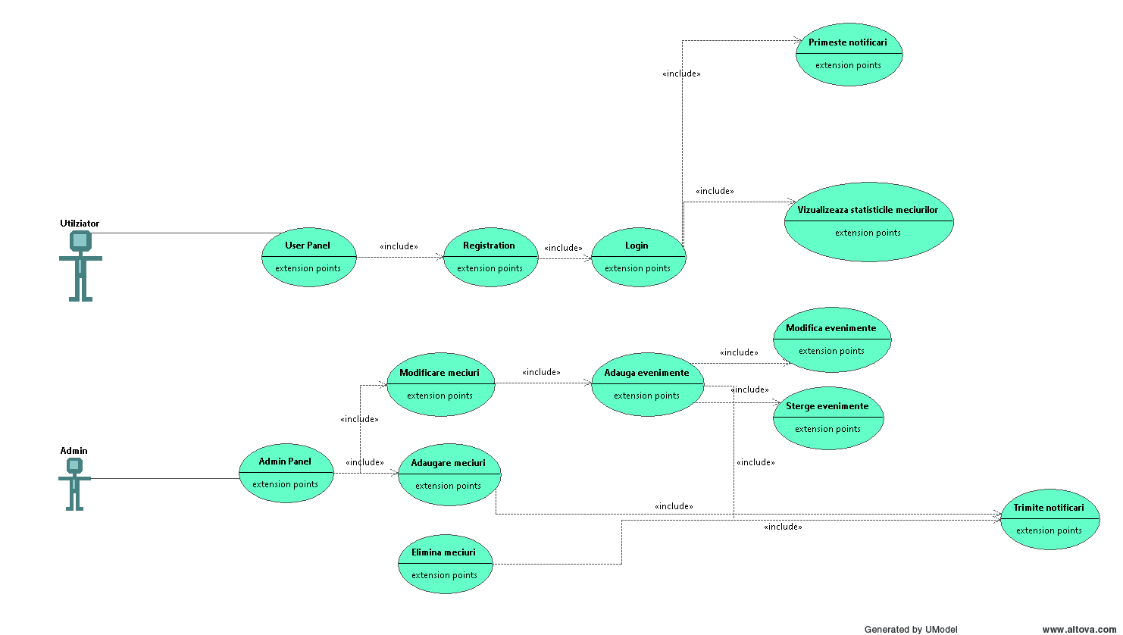**UseCase Diagram:**
  2. **Sequence Diagram:**

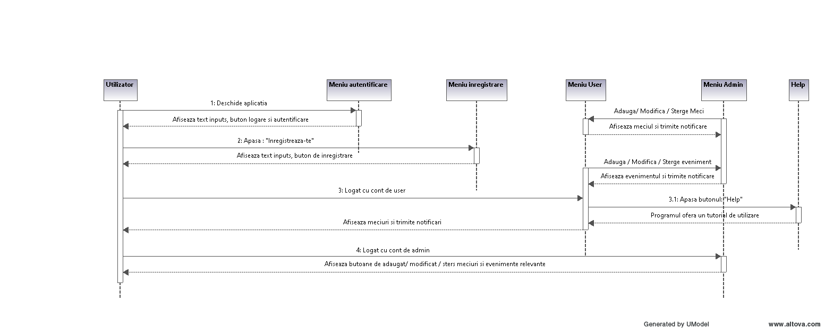

* 1. **Class Diagram:**

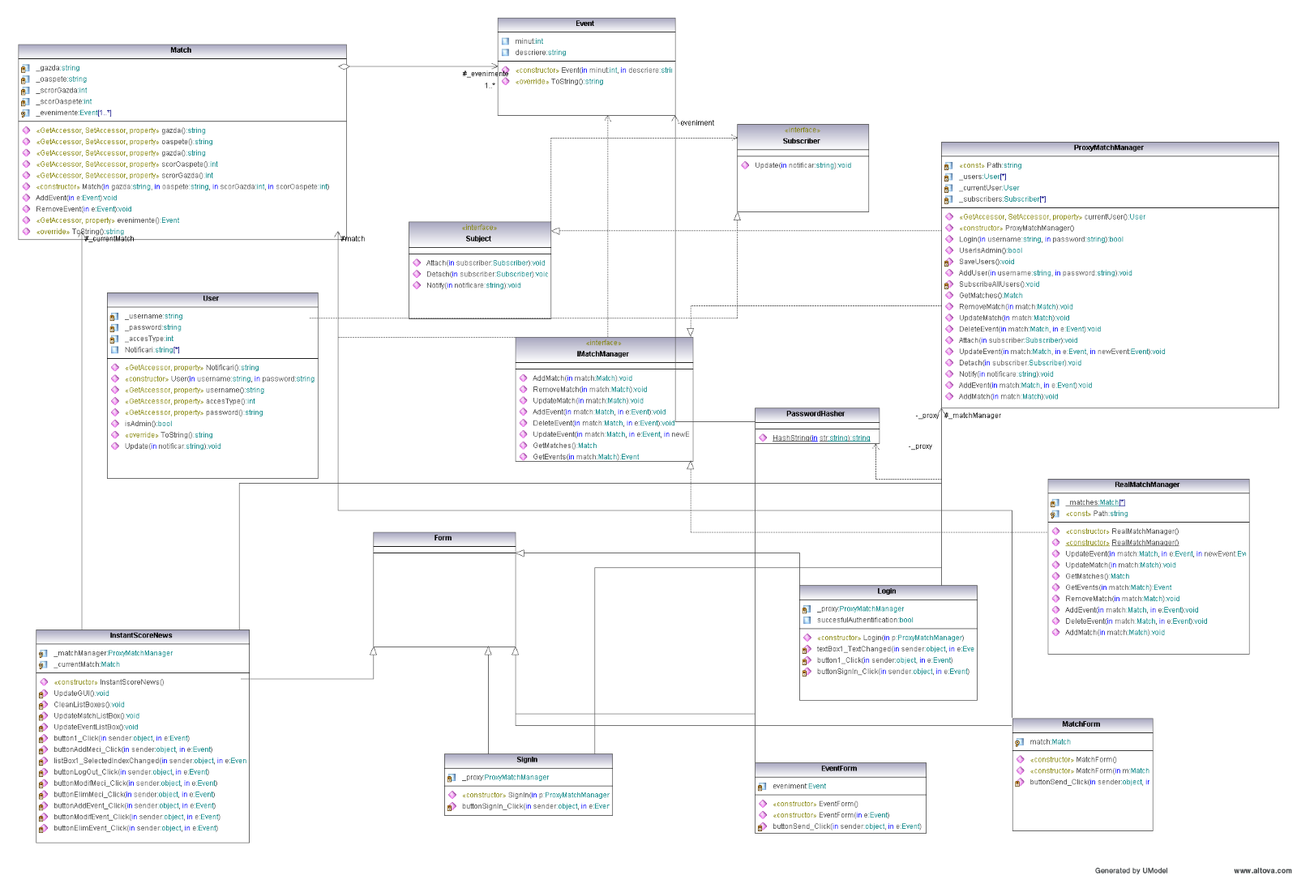

**Lista cu ce a lucrat fiecare:**

Mentiuni:

* fiecare a tratat exceptiile intalnite in librariile la care a lucrat
* fiecare a comentat codul propriu
* fiecare a respectat standarul de scriere impus in lab.2
* fiecare a contribuit la testele inregistrate pe parcurs

Gaina Alex:

* Interfata+ codul aferent
* libraria MatchManagerLib

Petrea Paul-Alberto:

* documentatie
* diagrame
* libraria MatchStats

Mazureac Ruben:

* documentatie
* help (HelpNDoc + Doxygen)+ implementarea lui in gui

Turcu Andrei:

* libraria ObserverLib
* libraria PasswordHasher
* libraria UserLibrary