**Study**

2.a:

* **Boolean** is the type of a variable which only has 2 possible value: True and False. Examples of **Boolean expression**: **10 == 2** ;  **3 >= 3** ; **8 != (2 * 4)**.
* Flow chart is a graphic representation which describes the sequence of functions of a computer programme.
* Ex:

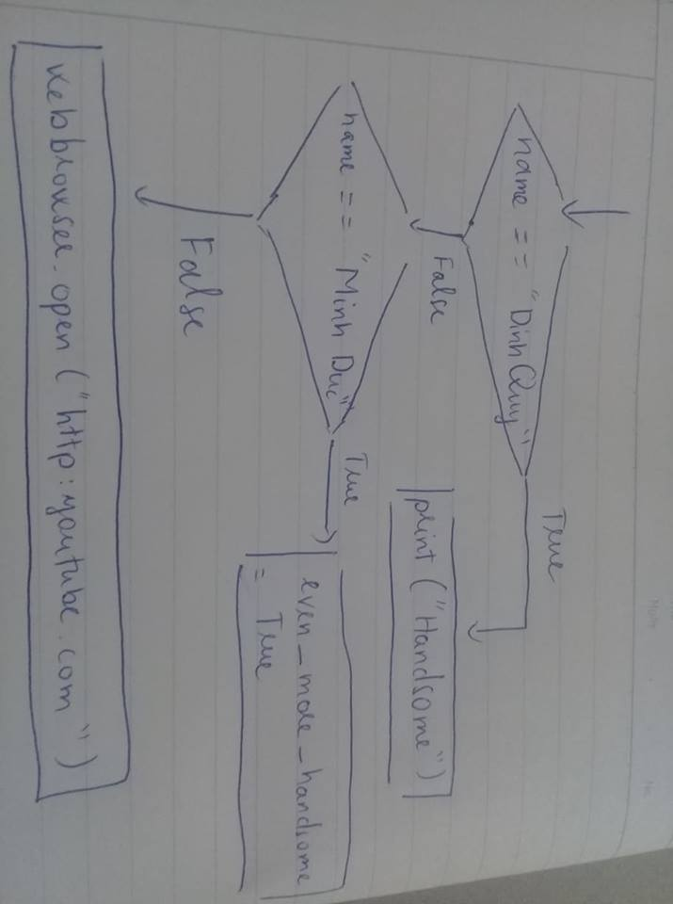

* Nested conditional is the conditional which is nested within another conditional.
* Ex: **If 0 < x :**

**If x < 10:**

**print(“Hello”)**

2.b:

* A nested list is a list which is nested within another list.
* A list can contain both integers and strings.