STUDENT NAME: GAIRE ANANTA PRASAD

STUDENTID:M24W0272

1. Code for “Euclid’s Reciprocal Divide and conquer” to find to GCD using while loop.

1. Output

1. Flow chart for “Euclid’s Reciprocal Divide and conquer”

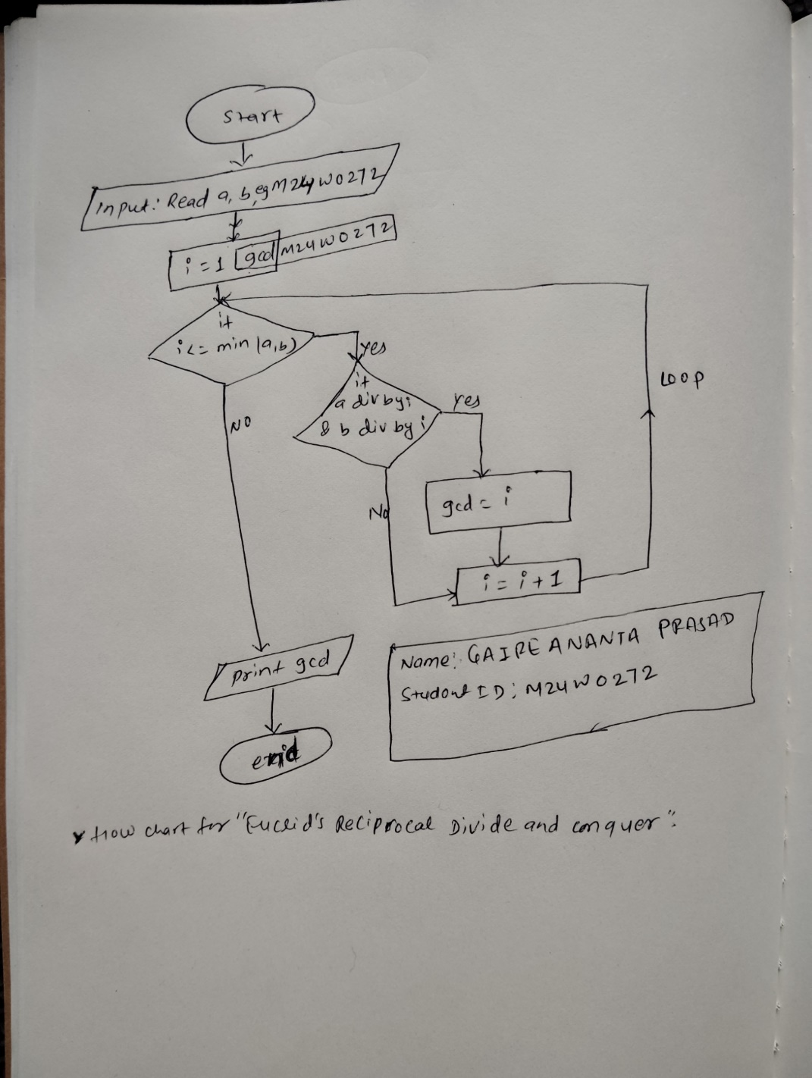

1. Pseudocode for “Euclid’s Reciprocal Divide and conquer”

