Insurance Documentation

Here are the APIs and their corresponding URLs :

### **User Registration API**

Purpose: This API allows users to register by providing a username and password. It checks if the username already exists and registers the user if the provided data is valid.

* URL: /register
* Method: POST
* Sample Input:{

"username": "example_user",

"password": "password123"

* Success Response (Status Code: 201){

"message": "User registered successfully"

* Failure Responses (Status Code: 400):

{

"message": "Username already exists"

{

"message": "Invalid registration data"

}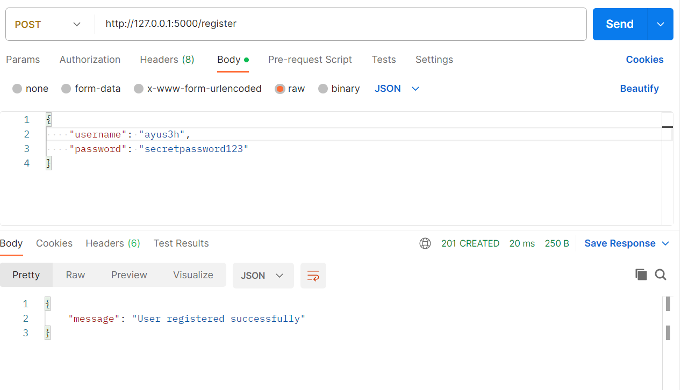

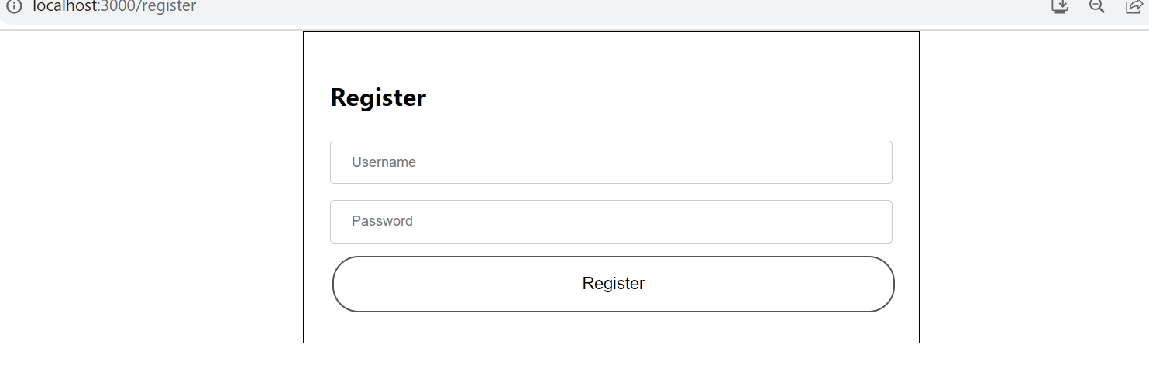

**User Login and Token Generation API**

Purpose**:** This API allows users to log in by providing a username and password. If the provided credentials are valid, it generates an access token for the user**.**

* URL: /login
* Method: POST
* Sample Input:

{

"username": "example_user",

"password": "password123"

Success Response (Status Code: 200):

{

"access_token": "<access_token>"

}

* Failure Response (Status Code: 401):

{

"message": "Invalid credentials"

}

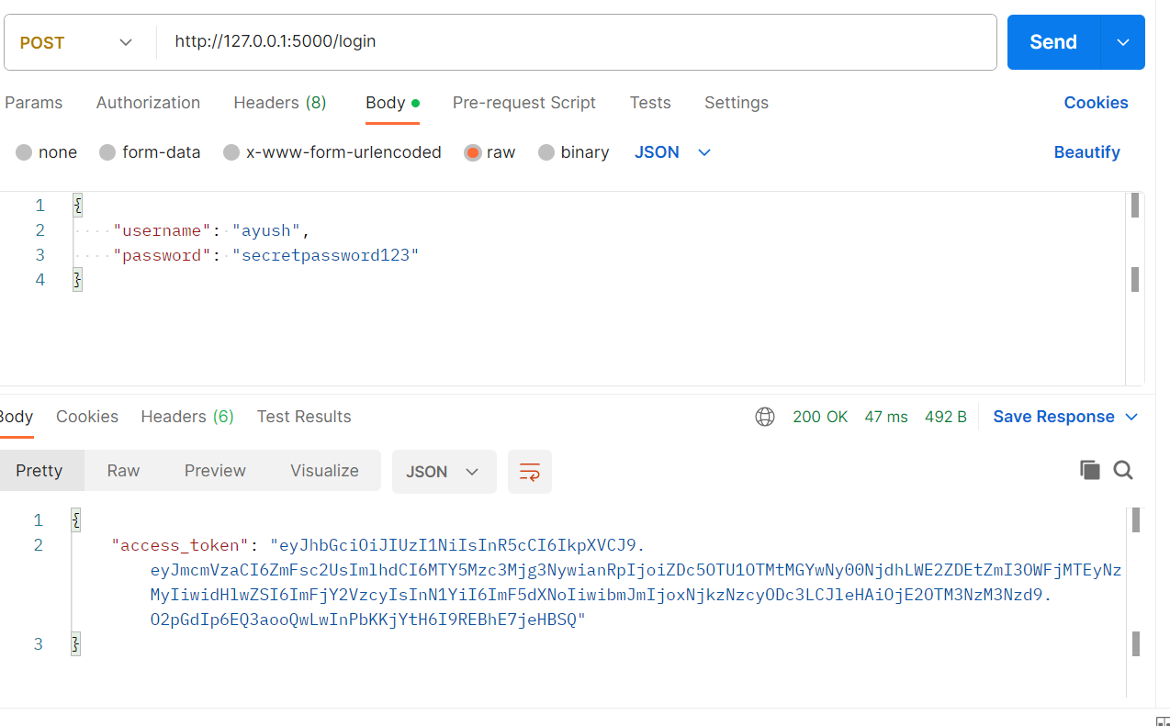

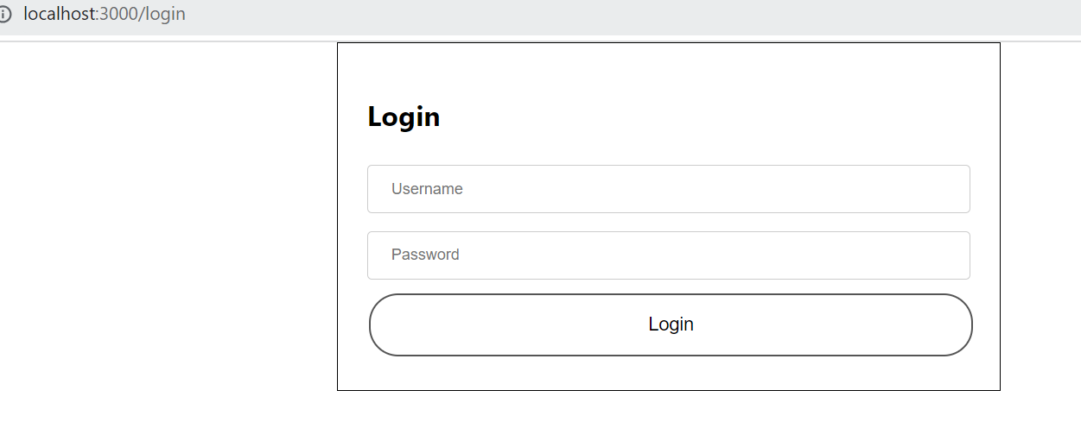

### **Add Insurance API**

Purpose: This API calculates the total cost of insurance based on user-provided data, including user age, user amount, partner information, and children's information. It uses a CSV file containing insurance rates to make the calculation.

* URL: /addInsurance
* Method: POST
* Sample Input
* Access Token Required

{"userAge": 35,

"userAmount": "amount1",

"hasPartner": true,

"partnerInfo": {

"age": 40,

"amount": "amount2"

},"children": [ {

"age": 10,

"amount": "amount3" },

{

"age": 8,

"amount": "amount4"

}

]

}

* Success Response (Status Code: 200):

"123.45" // Total insurance cost

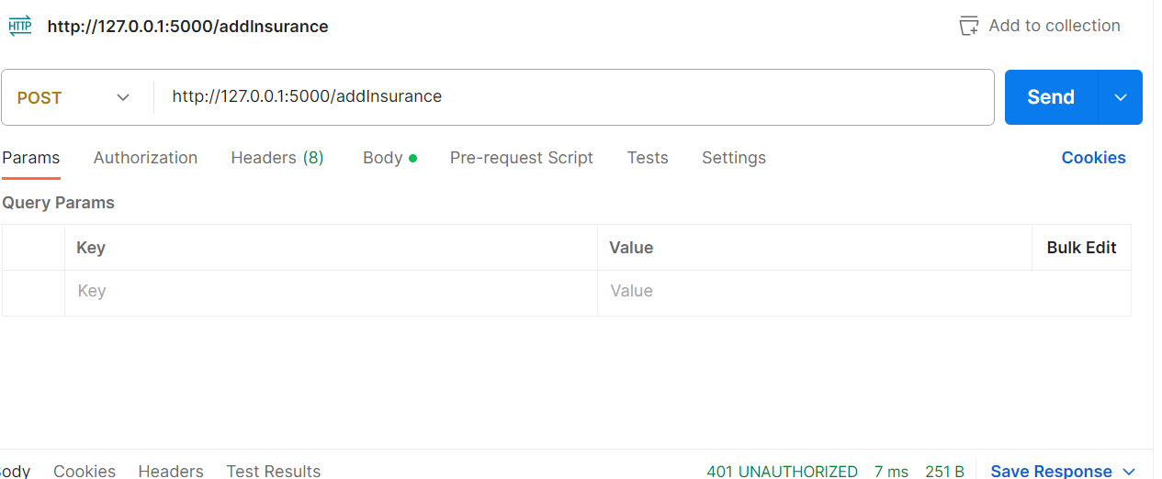

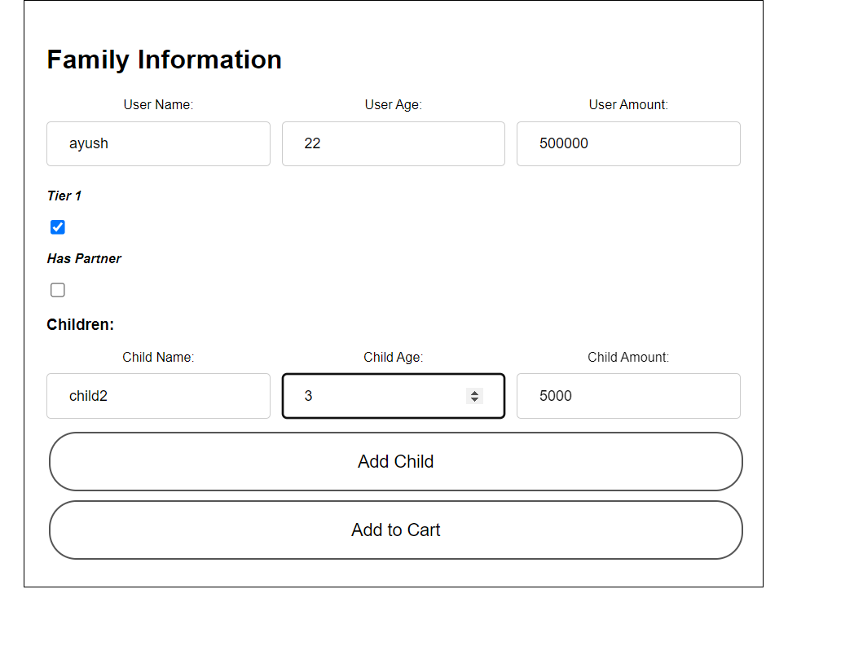

### **Buy Insurance API**

Purpose: This API represents a placeholder for purchasing insurance. It does not perform any actual purchase but serves as a demonstration endpoint.

* URL: /buy-insurance
* Method: POST
* Sample Input: Any valid JSON input
* Success Response (Status Code: 200):
* Access Token Required
* "Buy successful"

