Low Level Design Template

DMT/AD06/TMP

Project Code
Project Name | Elib Management System

Prepared/Modified by | Role | Date of Preparation
Prachiti Gawad | Analyst | 14/01/2019
Reviewed by | Role | Date of Review
Saaili Kashyap | Analyst | 15/01/2019
Approved by | Role | Date of Approval
Circulation List |  | Version Number of the template:1.0
Version Number | <version No >

Table of Contents

1. Description Of The Unit 3
2. References 4
3. Dependencies / Assumptions 5
4. Class Diagrams 6
5. Sequence Diagrams 7
6. Design Components 8
6.1 List Of UI Components 8
6.2 List Of Design Classes 8
7. Re-Usable Routines/Components 9
8. Messages 10
9. Configuration Files 11
10. Crud Matrix Table 12
11. Data Mapping Matrix 13
12. Action Flow Matrix 14
13. Stored Procedures 15
14. Program Specification / Pseudo Code 16
REVISION HISTORY OF THE WORK PRODUCT 17

Description Of The Unit
< describe the functionality of the unit. >

References
<Write the relevant References referred to prepare the LLD>

Dependencies / Assumptions
<describe dependencies and assumptions that are relevant to coding of the unit. Mention the dependencies and assumptions related to FDA regulatory requirements >

Class Diagrams

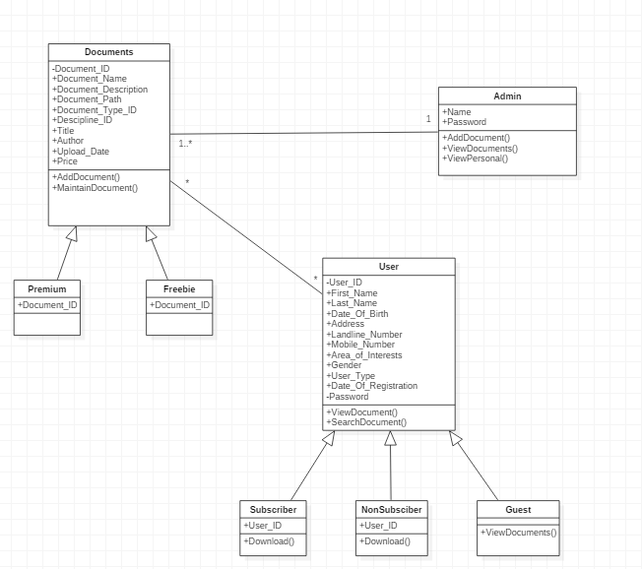

Sequence Diagrams

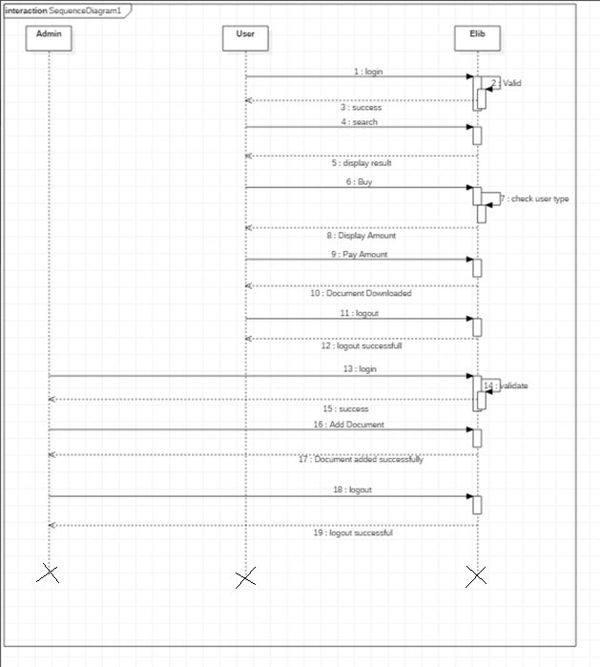

Design Components

List Of UI Components

List Of Design Classes

Re-Usable Routines/Components
<provide references to the re-usable routines, copybooks and templates used by the unit>

Messages
<describe what are relevant messages which has to be displayed in this program unit>

#. | Type | Message Text
1. | <Warning/Information/Validation/Error>

Configuration Files
<< Provide complete list of configuration files that will be required during deployment of the application. This list will comprise of all the XML files, resource files packaged within application deployment>>

File Name | Path | Description

Crud Matrix Table

# | Table Name | Create | Read | Update | Delete

Data Mapping Matrix
<identify data-mapping matrix pertinent to screen or report data items. Provide details of the base table or column, screen item name, length, calculations and validations.>

Action Flow Matrix
<identify the action flow matrix detailing all actions and triggers associated with the unit. Provide details of processing and the enabled conditions>

Stored Procedures
<describe what are Stored Procedures Pertaining to this program unit >

# | Stored Procedure Name  (with Description) | Input/Out Parameters | Type | Size
1.

Program Specification / Pseudo Code
<specify processing details of the unit >

REVISION HISTORY OF THE WORK PRODUCT
<to be maintained by projects>

# | Date | Version # | Section Changed | Details of changes made | Approved By
1
2

