1. Enable docker-ce repo using dnf config-manager

Command:

**$ sudo dnf config-manager --add-repo=https://download.docker.com/linux/centos/docker-ce.repo**

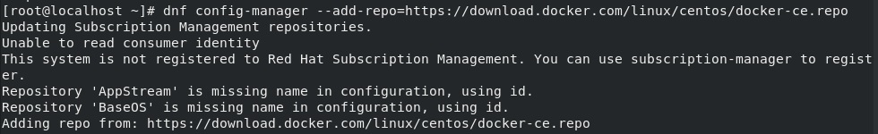

1. Install docker using : **sudo dnf install docker-ce –nobest**

To install specific stable version : **$ sudo dnf install docker-ce-3:18.09.1-3.el7**

1. Check status of docker process using : **systemctl status docker** or **systemctl enable docker** (service is permanently enabled, starts during boot)

To start the service : **systemctl start docker**

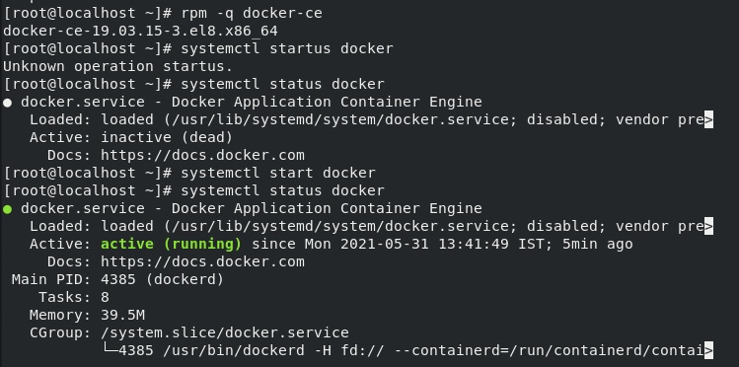

1. Pull the centos image using: **docker pull centos** (pulls the latest image)

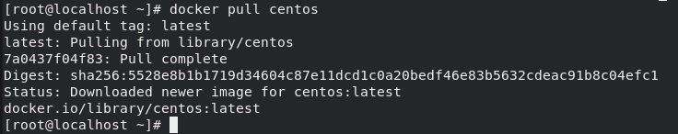

1. Stop the system firewall : **systemctl stop firewalld**
2. Start a container : **docker run -it name pycontainer centos:latest**

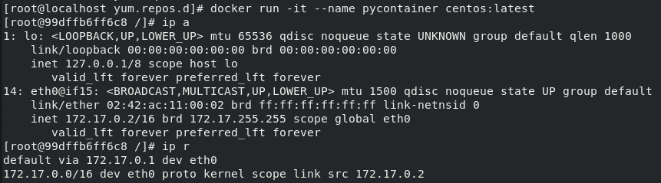

1. Yum is preconfigured with the AppStream and BaseOS repos, therefore we can directly install python using yum : **yum install python38**

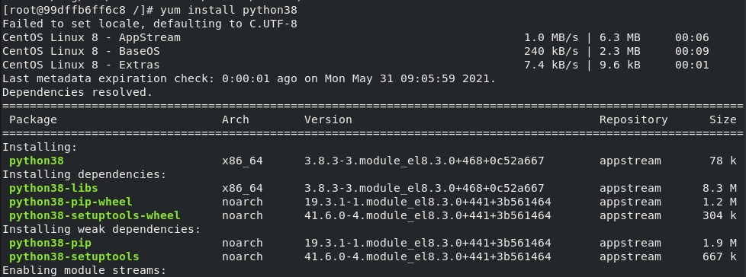

1. Open a new terminal tab of host and run docker cp to copy required python files : **docker cp <src_path> pycontainer:<dest_path>**

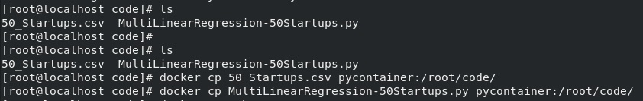

1. Install any required python libraries in the container terminal using pip3 : **pip3 install <library>**

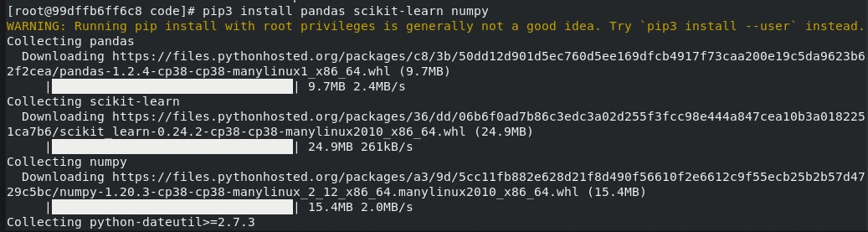

1. Run the python program using python3 : **python3 <file.py>**

