**CLASH Product Description CS411w Lab1**

**Charles Stafford- Blue/Purple Team**

**Old Dominion University**

Table of Contents

1 Introduction 3

2 Product Description 4

2.1 Key Product Features and Capabilities 4

2.2 Major Hardware and Software Components 6

3 Identification of Case Study 8

4 Prototype Description 8

4.1 Prototype Hardware and Software Architecture 11

4.2 Prototype Features and Capabilities 11

4.3 Prototype Development Challenges 12

Glossary 13

References 14

# Figures:

Figure 1: Process Flow 6

Figure 2: Hardware Requirements 7

Figure 3: Prototype MFCD 11

# Tables:

Table 1: Real World Product vs Prototype 10

# 1 Introduction

Reading speed and comprehension for ESL students is a major issue at schools all across the nation. In 2004, there were nearly 5 million ESL students enrolled in public schools in the United States. Of these students, only 18.7 percent of them were either performing at or above an average academic level. Because of this, ESL students have up to a 400% higher chance to drop out of school when compared to English speaking students. (McKeon)

The current teaching process for ESL is very basic. The professor writes a sentence on a white board, and manually parses it, pointing out all the parts of speech. This is a slow and tedious process, and is not optimal for all learning styles.

There is a different way to teach English, by using Lexical Bundles. Lexical Bundles are groups of words that are often found together. When we read these “bundles,” we don’t read each word one at a time, instead, we read them as a single word. An example would be, “Would you mind,” or “What is it.” (Tremblay)

CLASH intends to increase both reading comprehension and reading speed by creating a speed reading program that uses Lexical Bundles. Through the use of Lexical Bundles, it has been demonstrated that students increased their reading comprehension and reading. CLASH will bring this learning method to the ESL student’s classroom and home computer, allowing them to learn using Lexical Bundles at their own pace.

CLASH will be a web based application designed to increase the reading speed and comprehension of ESL, or English as a second language, students. The application will consist of two modules connected by a website. The first module, COLRS, or Colored Organized Lexical Recognition Software, will take user inputted text and parse out the different parts of speech found in the text. The module will then color all the parts of speech in the text to help with reading comprehension. The second module, Slash Reader, will read user inputted text, and turn the text into a series of lexical bundles (a group of words that we subconsciously associate with each other), demarked with slashes, to help ESL students increase their reading speeds.

# 2 Product Description

CLASH is designed to help ESL professors in their goal of preparing ESL students for their college courses. CLASH will consist of two modules, COLRS, and Slash Reader, which will be accessed through a web page. COLRS will focus on parsing sentences, and coloring parts of speech, while Slash Reader will focus on increasing reading speed through the use of Lexical Bundles.

COLRS will help students with the difficult task of identifying the various parts of speech in a sentence. Many languages have defined sentence structure where verbs and nouns can be easily identified either by their placement a sentence, or by their endings. Through the color coding the traditional 8 parts of speech, ESL students will find it easier to locate and understand English grammar.

Slash Reader will focus more on reading speed and comprehension. Slash Reader will read through documents like a normal speed reader, but instead of going one word at a time, it will show entire Lexical Bundles at once. By showing entire thought groups at once, users will have a higher comprehension of the text, than if they were using a traditional reader.

# 2.1 Key Product Features and Capabilities

CLASH will be a web-based application that will allow users to improve their reading comprehension, by breaking up sentences into lexical bundles. It will also parse the sentence, and color code all the Parts of Speech present. CLASH features can be accessed using a standard web browser. Through the application’s user interface, users can control the speed at which lexical bundles are displayed. Parts of speech can be viewed in a separate part of the user interface.

The product features individual password-controlled user logins with three different types of user roles. These roles include Administrator, Instructor, and Student. The Student will be able to control their reading speed, type of view, and which available document to view. The Instructor will include the Student user capabilities plus more. The Instructor will be able to add/remove Students as users and select the documents available to be viewed by the Students. The application allows for the Instructor to view activity data for the Student users. This activity data will include the student’s current reading speed, and the amount of time spent on the site. The Instructor will be able to upload documents to the server to be parsed, edit files, and delete documents on the server. The instructor will also have the ability to add Student Accounts to the server, either by bulk or individually. The Administrator has all the capabilities of the Instructor plus the ability to add/remove Instructor Accounts.

CLASH’s most unique feature will be its Slash Reader function, where it will render lexical bundles. Unlike most speed reading software, which goes through a loaded text one word at a time, CLASH will print full thought groups to the screen. This will improve comprehension, and while leaving the reading speed unaffected. There is the ability to pause and change the display speed. CLASH will include a text parser that is able to automatically identify parts of speech, and color them accordingly, allowing for easy identification. It will also allow instructor review of the parsed text, to ensure accuracy. CLASH will be able to save usage data, allowing instructors to review student progress, and fine tune their lectures accordingly. CLASH is the first web-based speed reader specifically designed for use in ESL instruction. Instructors can have documents available to the students at their appropriate level. By focusing on ESL students, CLASH will give students and instructors a powerful tool to increase reading speed and comprehension.

(This space intentionally left blank)

# Figure 1: Process Flow

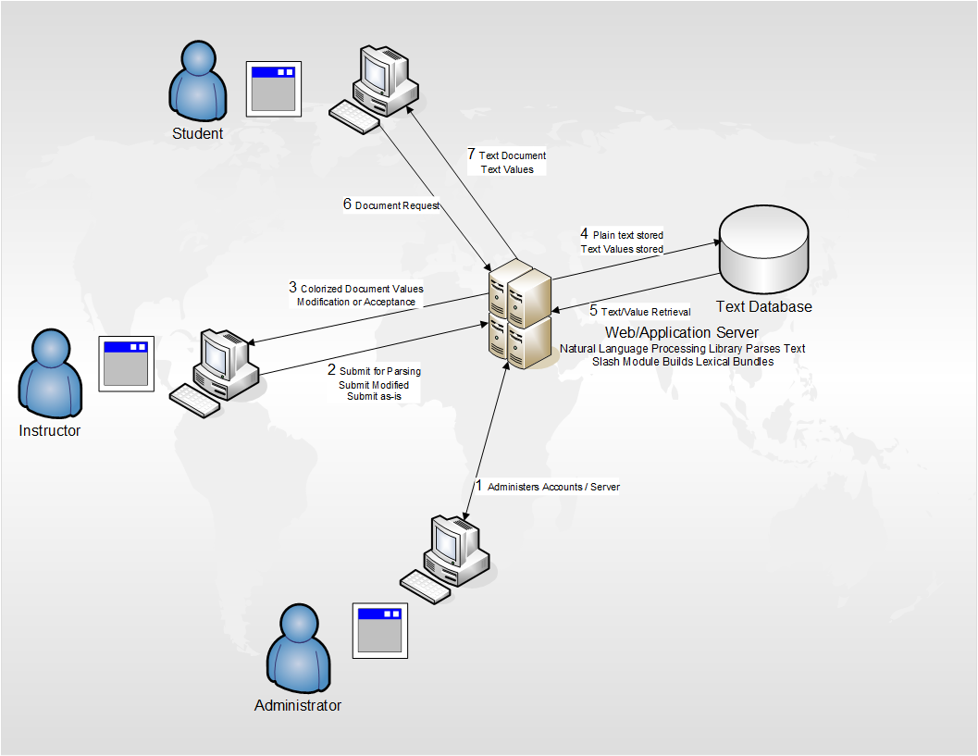

(CS 411w Blue/Purple Group)

# 2.2 Major Hardware and Software Components

CLASH will be a web based program hosted from a central server, and accessed from any of the major web browsers. CLASH has only a few hardware requirements. Namely, a server with a connected database for the server component of the program, and a device connected to the Internet capable of opening a browser for the client side.

The COLRS module will use an open source python script called NLTK(or Natural Language Tool Kit) to parse the user’s input. COLRS will take the output of this script, and will convert it to a more readable and color coded format. The final output will be two files, consisting of a text stream and a set of tags pointing to all the parts of speech in the document.

The Slash Reader module will take the two files from COLRS, and will read through the tags and text stream, marking the Lexical Bundles. Slash Reader will add a new tag to the tag list showing where the Lexical Bundles or “Slashes” are. This module will be supplemented by an exception list with the most common or recurring Lexical Bundles.

The Web Page portion of the program will take the streaming and tagging files from the server, and present it to the reader. There will be 2 modes: COLRS, and Slash Reader. COLRS will render the Parts of Speech to the screen, and color code them. Slash Reader will take the lexical bundles, and print them to the screen at a user defined speed.

# Figure 2: Hardware Requirements

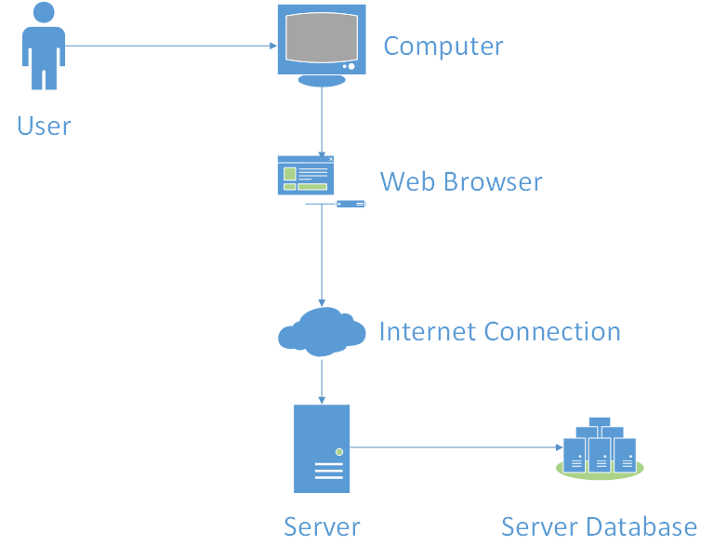

(CS 411w Blue/Purple Group)

As Figure 2 shows, there will be no special hardware requirements for Clash. All it will need is a web server. The application itself will be a Single Page Application, or SPA, hosted on an Ubuntu Server using MySQL, and Node.js. The program will be built using Javascript, like most SPA’s.

# 3 Identification of Case Study

Before ESL students at Old Dominion University are allowed to take their major classes, they have to demonstrate a minimum level of English aptitude. So, if an ESL student has trouble with English, they can very swiftly find themselves falling behind, with their education visa swiftly running out. If an ESL student cannot graduate in 4 years, they will be forced to leave without a degree. ESL education is critical if a foreign student is to graduate on time.

CLASH was commissioned by Mr. Greg Raver-Lampman, from the ODU English Language Center (ELC), because of the lack of software directly targeted at ESL students and instructors. In fact, at the moment, CLASH will be the only software designed to increase comprehension and reading speed for ESL students. The ELC will serve as the test group for the first implementation of the project. However, CLASH is aimed at a much larger audience. It is the goal of Raver-Lampman to get universities all across Virginia using this software.

# 4 Prototype Description

CLASH’s prototype will be built around the SPA template. SPA, or Single Page Application, is a web based application that has a single page, where all the functionality of the application is accessible from menus without reloading. SPA’s are traditionally built using Javascript, as are all of its functional components. The web page will be an SPA, built around Javascript, and it will communicate with the CLASH server to render the needed information. CLASH will be using MySQL for the Database, and will be using Node.js as the server application.

The reason CLASH will be using SPA is to create as accessible of a website as possible. Placing the entire application on a single page keeps the user interface relatively clean and easy to use. Non-tech savvy users should be able to navigate the site as well as anyone else, and that means a concerted effort to keep the user interface as simple and easy to understand as possible.

The prototype simply cannot have every feature of the real world product. There is simply too little time to do everything on the wish list. Instead of hap-hazardly introducing half-finished features, the prototype will be a scaled down version of the final product.

The main differences between the final product and the prototype will be the lack of a more advanced POS tagging system, lack of integration with ODU servers (and the lack of real enrollment data that implies), limited student metrics, and the lack of a true “homework” mode.

One of the major hurdles for the project will be the lack of access to ODU enrollment data. CLASH will avoid this problem by implementing a user management system for instructors. This management system will allow instructors to add and remove users from the database, and can be used en-masse through the use of .csv files. The Administrator will be able to add and remove instructors, and instructors’ files depending on the situation.

(This space intentionally left blank)

# Table 1: Real World Product vs Prototype

|  |  |  |
| --- | --- | --- |
| **Features** | **Real World Product** | **Prototype** |
| Parsing Capabilities | Ability to Parse different kinds of documents | Ability to parse text copy and pasted in text block |
| Text Modification | Ability to modify and store previously parsed documents | Ability to modify and store previously parsed documents |
| Color Capabilities | Ability to color chosen parts of speech using a JSON format and JavaScript functions. | Ability to color chosen parts of speech using a JSON format and JavaScript functions. |
| Slashing Capabilities | Ability to identify Lexical Bundles through the inserting of slashes. | Ability to identify Lexical Bundles through the inserting of slashes. |
| Displaying Lexical Bundles in a single bundle form | Ability to speed up, slow down and pause Lexical Bundles being displayed. | Ability to speed up, slow down and pause Lexical Bundles being displayed. |
| Exception list | Lists of commonly used expressions that would otherwise be incorrectly handled by the SLASH Algorithm. | Lists of commonly used expressions that would otherwise be incorrectly handled by the SLASH Algorithm. |
| Login interface | User Authentication in a stand-alone environment | User Authentication in a stand-alone environment |
| Student Data Reporting | Tracks individual and collective student progress. To include words per minute, total time and total Lexical Bundles. Data to be stored in database. Displayed in graphs and statistics. | Limited basic student metrics will be available such as Lexical Bundles per Minute. |
| Homework Mode | Instructors have the ability to remove coloring of words and have students correctly identify the part of speech. | Not Included. |
| Administrative Privileges | Administrators are able to edit, add, or remove users and saved documents in the system. | Administrators are able to edit, add, or remove users and saved documents in the system. |
| SLASH Document Viewing Mode | Ability to view documents with slashes inserted and SLASH Reader. | Ability to view documents with slashes inserted and SLASH Reader. |

(CS 411w Blue/Purple Group)

# 4.1 Prototype Hardware and Software Architecture

CLASH’s prototype hardware architecture will be a Virtual Machine hosted by an ODU server. MySQL and Node.js will be installed on the VM, to allow the server to communicate with the software components. The server’s operating system will be Ubuntu. The backend of the server will require NLTK, which will interface with Node.js, which in turn will communicate with the MySQL database. Node.js will also run the SPA that will be seen on the client’s browser, and will receive raw text, and send back parsed text to the client.

Figure 3: Prototype MFCD

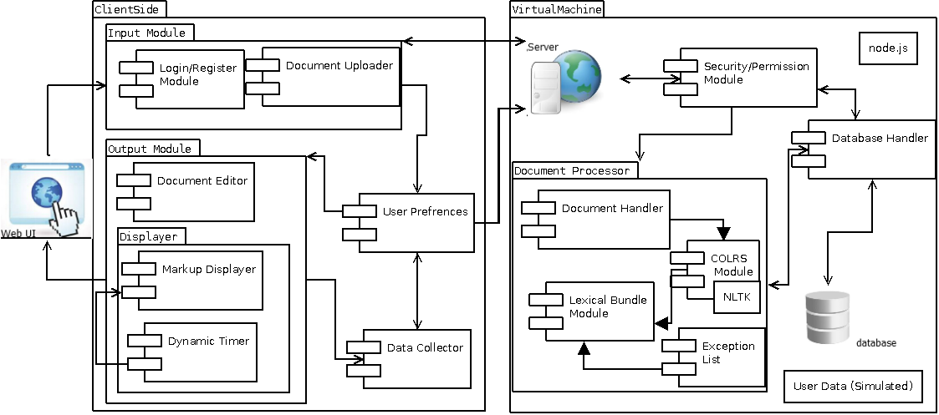

(CS 411w Blue/Purple Group)

# 4.2 Prototype Features and Capabilities

The CLASH prototype will be able to parse sentences, identifying both the Parts of Speech, and the Lexical Bundles of the sentence. The program shall render Parts of Speech as colorized words, each part of speech being a different color. The program will render Lexical Bundles in a speed reading format. Bundles will be shown on the screen at a user determined pace, starting from the beginning of the document. There will be a basic reporting system in place, instructors will be able to query individual student’s current Bundle reading speed, as well as the number of files the student has accessed.

The goal of this prototype is for it to be used as a Proof of Concept. It will be tested by a class of ESL students, against a control, to determine if the project is feasible. If students using the program demonstrate an increased reading speed, and higher reading comprehension, then the project can be considered a success. In order to the lower risk of failure, the scope of the prototype is very small. If a part of the prototype is not working as intended, it can be focused on in detail, without sacrificing quality.

# 4.3 Prototype Development Challenges

CLASH will have to pass several hurdles before it is ready to be released. First of all, NLTK needs to be linked in with Node.js with a custom program. Then the actual web application needs to be written.

CLASH also needs to easy to use. Creating a simple and accessible interface will require a lot of iterations. Often UI mock ups that look good on the drawing board will simply not work in the final product. Creating a pleasant looking, and useful interface will be critical.

CLASH will face serious project management issues. The CS411W group working on CLASH is actually a merger of CS410 Blue and Purple groups. The team working on this project is far larger than the standard 411 group, and will face unique challenges.

The biggest challenge for the project will be producing accurate Lexical Bundles. If CLASH cannot accurately and reliably create Lexical Bundles, the project will be a complete failure. This problem cannot be completely solved. NLTK is not a perfect program, and does have errors and bugs. It is unable to parse noun-noun interactions, like Banana Pudding, where banana(a noun) is used as an adjective for pudding.

# Glossary

**CLASH** - Color Lexical Analysis algorithm and Slash Handler

**COLRS** – Colored Organized Lexical Recognition Software

**Slash Reader**- The Lexical Bundle renderer

**ELC** – English Learning Center

**ESL** – English as second language

**IBT** – International benchmark test

**JSON** – JavaScript Object Notation

**Lexical Bundle** – a group of words that occur repeatedly together within the same register

**MFCD –** Major Functional Component Diagram

**NLTK** – a suite of libraries and programs for symbolic and statistical natural language processing (NLP) for the Python programming language.

**Node.js** – an open source, cross-platform runtime environment for server-side and networking applications.

**POS** – Parts of Speech

**SPA** – single page application, is a highly responsive web application that fits on a single page and does not reload as the web page changes states.

**Ubuntu** – a Debian-based Linux operating system.

**VM** – Virtual Machine

# References

McKeon, D. (n.d.). Research Talking Points on English Language Learners. Retrieved December 11, 2014.

Tremblay, A., Derwing, B., Libben, G., & Westbury, C. (2011, January 15). Processing Advantages of Lexical Bundles: Evidence From Self-Paced Reading and Sentence Recall Tasks. Retrieved December 10, 2014.

Mikowski, M., & Powell, J. Single Page Applications. Manning Publications 2014.

CS 411w Blue/Purple Group. [www.cs.odu.edu/~411blue/](http://www.cs.odu.edu/~411blue/)