|  |  |
| --- | --- |
| **Project Case** |  |
| COMP6051 | COMP6051016 | COMP6051049  Web Programming |
| **Computer Science** | **E242-COMP6051-LA01-00** |
| ***Valid on*** *Even Semester Year 2023/2024* | **Revision 00** |

1.      Kelompok tidak diperkenankan untuk:

*Members of the group are prohibited from:*

·         Melihat sebagian atau seluruh jawaban kelompok lain,

*Seeing a part or the whole answer from other groups,*

·         Menyadur sebagian atau seluruh jawaban dari buku, catatan, video, dan jenis referensi lainnya,

*Retell a part or the whole answer from books, notes, videos, and other references,*

·         Menyadur sebagian atau seluruh jawaban dari internet,

*Retell a part or the whole answer from the internet,*

·         Mengumpulkan jawaban yang tidak sesuai dengan tema soal,

*Submitting an answer with a different theme from the given case,*

·         Melakukan tindakan yang menyebabkan jawaban dicontek oleh orang lain atau kelompok lain, baik disengaja maupun tidak disengaja,

*Doing action that could result the answer being copied by someone or other groups, intentionally or unintentionally,*

·         Melakukan tindakan kecurangan lainnya.

*Committing other dishonest actions.*

2.      Jika kelompok terbukti melakukan tindakan seperti yang dicantumkan pada butir ke-1, maka nilai mahasiswa dan/atau kelompok yang melakukan kecurangan, baik menyontek atau dicontek, akan dinolkan sesuai dengan peraturan yang berlaku.

*If it has been proven that a group has committed dishonest actions outlined in point 1 above, the whole  groups related to the incident, regardless of which one copies or has their answer copied, will be issued a score of zero according to the regulation.*

3.      Jawaban yang dapat diterima dan dinilai adalah jawaban yang dikumpulkan sebelum batas waktu yang telah ditentukan.

*The answer must be submitted before the designated deadline to be accepted and graded,*

4.      Jawaban akan dinilai berdasarkan teknik atau metode yang diajarkan pada kelas praktikum dengan menggunakan software yang sudah ditentukan.

*The scoring will be based on the materials taught during the practicum classes using the designated software. Using different software than requested may result in your answer not being graded.*

5.      Jika Anda tidak membaca peraturan ini, maka Anda dianggap sudah membaca dan menyetujuinya.

*By taking this exam, you agree to these regulations, regardless of whether you have read it or not.*

6.      Persentase penilaian untuk matakuliah ini adalah sebagai berikut:

*The score will be distributed as follows:*

|  |  |  |
| --- | --- | --- |
| **Tugas Mandiri**  *Assignment* | **Proyek**  *Project* | **UAP**  *Final Exam* |
| - | 100% | - |

7.      Perangkat lunak yang digunakan pada matakuliah ini adalah sebagai berikut:

*This course uses the following software:*

|  |
| --- |
| **Software**  *Software* |
| Laravel Framework 9 (Latest)  PHP Composer 2.1.5  PhpStorm 2021.1.4  Visual Studio Code  Web Browser (Google Chrome)  XAMPP 8.0.7 |

**8.** Ekstensi file yang harus dikumpulkan untuk matakuliah ini adalah sebagai berikut:

*Your answers must be in the following file extensions:*

|  |  |  |
| --- | --- | --- |
| **Tugas Mandiri**  *Assignment* | **Proyek**  *Project* | **UAP**  *Final Exam* |
| - | Laravel Folder Project (PHP, SQL, ENV, HTML, CSS, SCSS, JSON, HTACCESS, ARTISAN, Asset Files) | - |

**9.** File yang harus dikumpulkan adalah keseluruhan jawaban beserta dengan aset yang digunakan (gambar, audio, video, dll) dan dokumentasi proyek yang berisikan link referensi aset dan penjelasan mengenai aplikasi yang dibuat (terlampir bersama dengan soal).

*Include other files that can support your project, such as: all files in your project, other files (image, audio, video, etc.) used in your project, *.doc file (documentation of your project) that contains all pages in your project, reference links of additional files (image, audio, video, etc.) used in your project, the description about how to use your application, etc.*

## Soal

*Case*

**LAlada**

**LAlada** is a renowned e-commerce dedicated to providing a comfortable online shopping experience. Due to its reputation, the transactions that must be handled daily is quite overwhelming. Furthermore, the founder of **LAlada** wants to scale up the business by building a new fresh platform. As a developer hired by the founder, you are tasked to make a website with **Laravel 9.3.10**. This website will have **three different roles** which have their own access scope on the website. The roles are **admin**, **member**, and **guest** (**non-registered user**).

1. **Login Page**

This page allows **guests** to log in to the website**.** If the user is **already logged in**, then **redirect** the user to the **Home Page**. Suppose the user **clicks** **on** the **sign-in button** with the **wrong combination** of **email** and **password**. In that case, the website will **show** an **error message**.

Otherwise, if the user enters the **right combination** of **email** and **password**, **redirect** the user to the **View Product Page**.If the user checks the “**Remember Me”** checkbox, the website will **save** the **user’s** **cookie** for **five hours**. If the user **clicks on** the “**Don’t have an account** **button?”**, **redirects** the user to the **register page**.

***\*Make sure that this page can only be accessible by unregistered users only.***

***Figure 1. Login Page***

1. **Register Page**

This page allows **guests** (**unregistered users**) to **register** themselves as **LAlada customers**. If the user is **already logged in**, then **redirect** the user to the **Home Page**.

If the user **clicks on** the **sign-up button**,each field must be **validated** according to the table below. If the user inputs **incorrect data**, then the website will **show** an **error message**. Otherwise, **redirect** the user to the **View Product Page** with a **success message**. If the user **clicks on** the **already have an account** **button**, **redirect** the user to the **Login Page**.

***\*Make sure that this page can only be accessible by unregistered users only****.*

|  |  |
| --- | --- |
| Field | Rules |
| Email Address | Must be **filled,** and **must end with “@gmail.com”** |
| Password | Must be **filled, minimum length of 5, and maximum length of 255** |
| Confirm Password | Must be **filled** and must **match the value of the Password** field |

***Figure 2. Register Page***

1. **Create Product Page**

This page is only accessible for the **admin** to **add new products** to the website. Several **fields** are **displayed** to the admin to be **filled in**. **Admin** can input image files using the **drag-and-drop features** for **the product image**. The **product category** can be chosen using **select-option**. The category options are **obtained from the category saved in the database**. Each field will be **validated** according to the table below. If the user inputs **incorrect data**, then the website will **show** an **error message**. **Otherwise**, **redirect** the user to the **View Product Page** with a **success message**.

***\*Make sure that this page can only be accessible by admin only****.*

|  |  |
| --- | --- |
| Field | Rules |
| Product Name | Must be **filled** and **contains minimum 5 characters** |
| Product Price | Must be **filled** and **must be more than 0** |
| Product Description | Must be **filled** and **less than or equal to 255 characters** |
| Product Sale Price | Must be **filled** and **must be more than 0** |
| Product Image | Must be **filled** and **only accept .jpg, .png, and .jpeg files** |
| Product Category | Must be **chosen** with the given option |

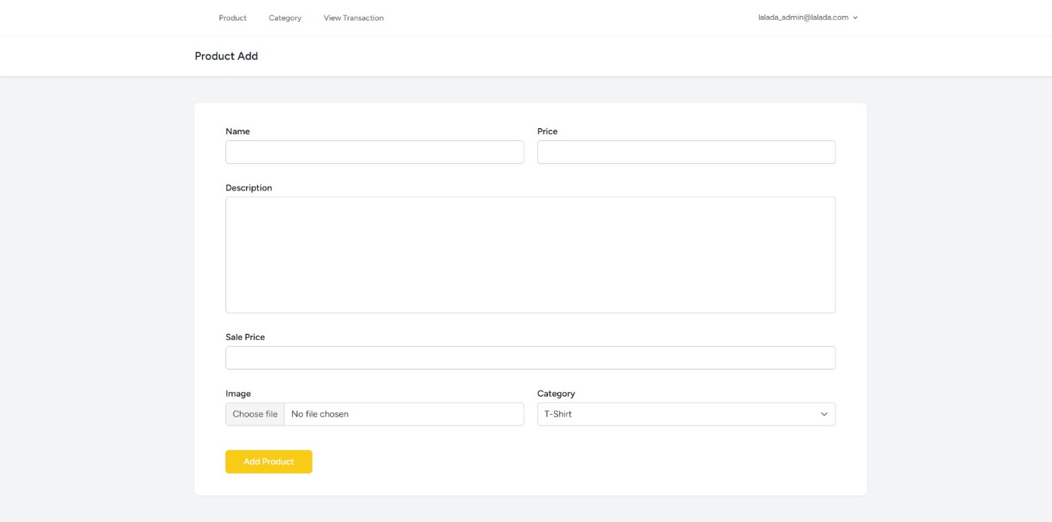

***Figure 3. Create Product Page***

1. **Update Product Page**

This page is only accessible for the **admin** to **update the existing product** on **LAlada**. Display the field along with the **product data** selected by the **admin**. The **SKU field** is **non-editable**. **Admin** can input files using the **drag-and-drop features** for **the product image**. Each field will be **validated** according to the table below. If the user inputs **incorrect data**, then the website will **show** an **error message**. Otherwise, **redirect** the user to the **View Product Page** with a **success message**.

***\*Make sure that this page can only be accessible by admin only****.*

|  |  |
| --- | --- |
| Field | Rules |
| Product Name | Must be **filled** and **contains minimum 5 characters** |
| Product Price | Must be **filled** and **must be more than 0** |
| Product Description | Must be **filled** and **less than or equal to 255 characters** |
| Product Sale Price | Must be **filled** and **must be more than 0** |
| Product Image | Must be **filled** and **only accept .jpg, .png, and .jpeg files** |
| Product Category | Must be **chosen** with the given option |

***Figure 4. Update Product Page***

1. **View Product Page**

This page is accessible to **all users**, but with a few minor differences. This page allows users to **view all products** available in **LAlada**. This page will be using **pagination** with **8 products** for each page. If the user clicks on the **Read More** in **product card**, user will be **redirected to** the **Product Detail Page**. Below each **product card**, there is an **Add to Cart** button for **members** and **guests**. If a **guest** clicks the button, **redirect** the **guest** to **Login Page**. Then, if a **member** clicks the button,the product will automatically **be inserted to cart with a quantity of 1** and the button will be changed to **Update to Cart** button. For **admin**, there is a **delete product** and **update product** button. If the **admin** clicks the **delete product** button, **display** a **confirmation dialog** and **delete the product** if the member confirms it. If the **admin** clicks the **update product** button, **redirect** the **admin** to **Update Product Page**.

There is a **Product** button and a **Category** button in the **navigation bar** that can be accessed by **all users** and there is a **View Transaction** button that can only be accessed by **admin**. For a **guest**, **display** a **Login** and **Register** button. Then, for a **member** or an **admin**, **display** a **Logout** button. The **Logout** button will **redirect** the user back to **Login Page**. There is a **My Cart** floating button in the bottom right side of the website for **guests** and **members**. If a **guest** clicks the button, **redirect**the **guest** to **Login Page**. If a **member** clicks the button, **redirect** the **member** to **Cart Page**.

There is also a **search bar** on this page which allows **all users** to search for a product based on the **product name**. If there is no **products** with the desired name, **display** a message showing “**No Product**”.

***\*Make sure that this page can be accessible to all types of users****.*

***Figure 5. View Product Page (Guest)***

***Figure 6. View Product Page (Member)***

***Figure 7. View Product Page (Member, Product already in cart)***

***Figure 8. View Product Page (Admin)***

1. **Create Category Page**

This page is only accessible for the **admin** to **add new category** to the website. Several **fields** are **displayed** to the admin to be **filled in**. Each field will be **validated** according to the table below. If the user inputs **incorrect data**, then the website will **show** an **error message**. **Otherwise**, **redirect** the user to the **View Category Page** with a **success message**.

***\*Make sure that this page can only be accessible by admin only****.*

|  |  |
| --- | --- |
| Field | Rules |
| Category Name | Must be **filled** and **contains minimum 5 characters** |
| Category Description | Must be **filled** and **less than or equal to 255 characters** |

***Figure 9. Create Category Page***

1. **Update Category Page**

This page is only accessible for the **admin** to **update the existing category** on **LAlada**. Display the field along with the **category data** selected by the **admin**. Each field will be **validated** according to the table below. If the user inputs **incorrect data**, then the website will **show** an **error message**. Otherwise, **redirect** the user to the **View Category Page** with a **success message**.

***\*Make sure that this page can only be accessible by admin only****.*

|  |  |
| --- | --- |
| Field | Rules |
| Category Name | Must be **filled** and **contains minimum 5 characters** |
| Category Description | Must be **filled** and **less than or equal to 255 characters** |

***Figure 10. Update Category Page***

1. **View Category Page**

This page is accessible to **all users**, but with a few differences for **admin**. This page allows users to **view all categories of products** available in **LAlada**. This page will be using **pagination** with **8 products** for each page. Each **category card** has a **See Products** button below it. When the button is clicked, **display** **all products in the category** using **pagination** with **8 products for each page**. The products displayed for each user role will have the same button as the products in the **View Product Page**. For **admin**, there is a **delete category** button and an **update category** button below the **See Products** button. If the **admin** clicks the **delete category** button, **display** a **confirmation dialog** and **deletes the category and every product in the category** if the member confirms it. If the **admin** clicks the **update category** button, **redirect** the **admin** to **Update Category Page**.

There is an **Add Category** button available for **admin role**. If an **admin** clicks the button, **redirect** the **admin** to **Add Category Page**. There is also a **search bar** on this page which allows **all users** to search for a product based on the **product name**. If there are no **categories** with the desired name, **display** a message showing “**No Category**”.

***\*Make sure that this page can only be accessible to all types of users***.

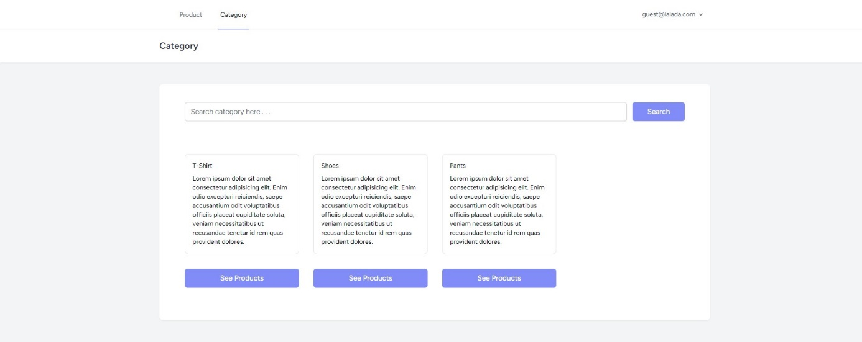

***Figure 11. View Category Page (Guest)***

***Figure 12. View Category Page (Member)***

***Figure 13. View Category Page (Admin)***

1. **Product Detail Page**

This page is accessible to **all users**. This page **displays products details** based on the product that has been clicked on the **View Product Page**. The information displayed on this page is the **product image**, **product name**, **product price**, **product sale price**, and **product description**.

***\*Make sure that this page can be accessible to all types of users****.*

***Figure 14. Product Detail Page***

1. **Cart Page**

This page is only accessible to **members**. This page displays the product and the quantity of each product that has been added by the member.

There is a **trash** button at the top right side of the **product card**. If a **member** clicks the button, **display** a **confirmation dialog** and **delete the product from the user cart** when the member confirms it. There is quantity input which can be edited by the member. If the member wants to update the quantity, they must edit the quantity and click the **Update Cart** button.

If the **member** clicks the **Checkout** button, **display** a **confirmation dialog** with the total price. Once the **checkout process is completed**, **delete every products in the cart**.

***\*Make sure that this page can only be accessible to registered members only***.

***Figure 15. Cart Page***

1. **View All Transactions Page**

This page is only accessible for **admin** to **view** **all transaction history** happened in **LALAda**. Display the **transaction date**, **order number**, and the **total amount of price** for each transaction. Each transaction has a **View Detail** button. If the **admin** clicks this button, **redirect** the **admin** to the **Transaction Detail Page**.

***\*Make sure that this page can only be accessible by admin only****.*

***Figure 16. View All Transactions Page***

1. **View Transaction Detail Page**

This page is only accessible for **admin** to **view the transaction detail**s based on the transaction that has been clicked on the **View All Transactions Page**. The information displayed on this page is the **product image**, **product name**, **product sale price**, **product description**, and **transaction date**.

***\*Make sure that this page can only be accessible by admin only****.*

***Figure 17. View Transaction Detail Page***