
HEALTHCARE SALES & PURCHASE ANALYTICS
Project Report
Data-driven analysis of pharmacy sales, purchasing, products, categories and operational KPIs
Prepared using the supplied healthcare.xlsx dataset

1. Executive Summary
This project analyzes a healthcare/pharmacy transaction dataset containing 42,649 sales records and 1,093 purchase records covering transactions from 02 Jan 2023 to 31 Dec 2024. The analysis focuses on sales performance, purchasing activity, product and category contribution, staff performance, supplier concentration, GST and business KPIs.
Across the sales dataset, total net sales are ₹7,150,609.17, generated from 17,046 bills. Purchase transactions total ₹3,595,099.30. The strongest sales category is Respiratory with ₹1,832,714.50, while Salbutamol Inhaler is the leading individual product with ₹959,412.43 in net sales.
The results show a business with relatively stable annual sales between 2023 and 2024, but with significant concentration in a few healthcare categories and products. These insights can support inventory planning, supplier management, sales monitoring and management reporting.

2. Project Objectives
- Measure overall sales and purchasing performance.
- Identify monthly and annual sales trends.
- Determine the highest-performing healthcare categories and products.
- Compare sales contribution across staff members.
- Understand supplier purchasing concentration.
- Review GST collected on sales and GST associated with purchases.
- Develop actionable recommendations for inventory and business performance management.

3. Dataset Description
Dataset | Records | Key Fields
weekly_sales | 42,649 | Bill No, Date, Customer, Staff, Product, Category, Qty, MRP, GST, Net Amount
weekly_purchase | 1,093 | GRN No, Date, Supplier, Product, Category, Qty, Purchase Price, GST, Total Amount
summary | Pivot/KPI outputs | Monthly sales, monthly purchase, GST, category, quarter and top-product summaries
Dashboard | Dashboard sheet | Workbook dashboard area

4. Tools & Analytical Approach
- Microsoft Excel workbook used as the primary data source.
- Data was reviewed using structured transaction tables and aggregated business measures.
- Pivot-style summaries were used to analyze month, quarter, category and product performance.
- The analysis emphasizes Net Amount for sales and Total Amount for purchasing.
- Charts were created to communicate trends and ranking results clearly.

5. Key Performance Indicators
KPI | Value
Total Net Sales | ₹7,150,609.17
Total Purchases | ₹3,595,099.30
Sales GST | ₹748,666.64
Purchase GST | ₹337,501.74
Sales Quantity | 127,775 units
Purchase Quantity | 90,459 units
Unique Bills | 17,046
Unique Customers | 16
Products | 25
Categories | 13
Staff | 4
Suppliers | 6

6. Annual Sales Performance
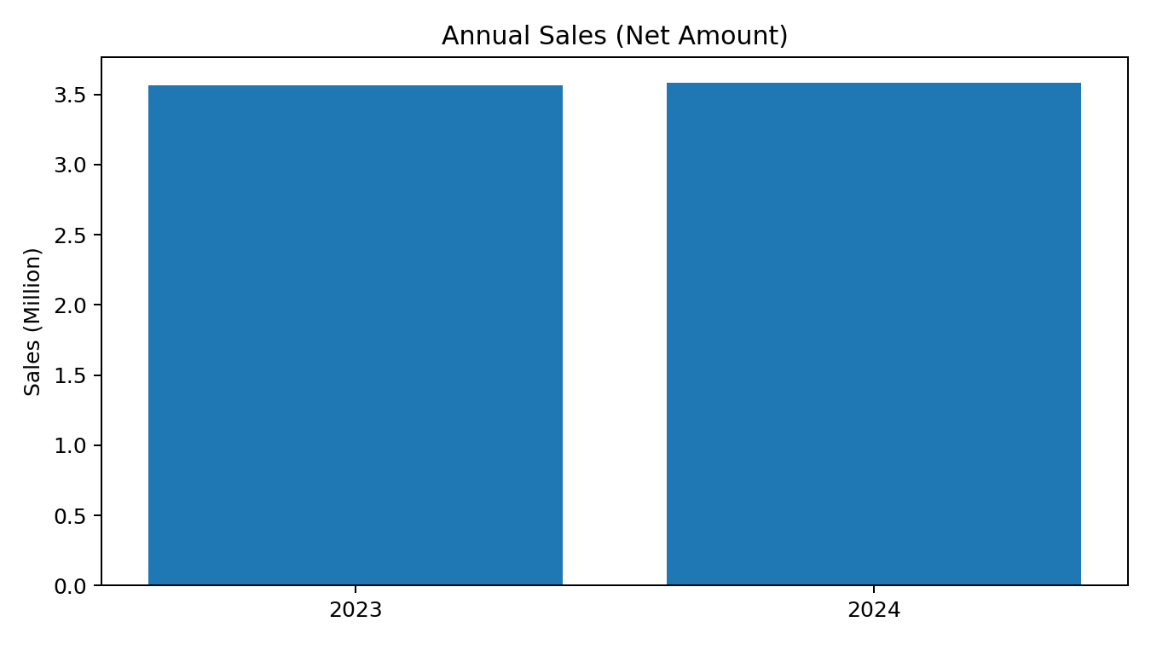
Sales increased from ₹3,565,091.20 in 2023 to ₹3,585,517.97 in 2024, representing a year-on-year change of 0.57%. This indicates broadly stable sales performance across the two-year period.

7. Monthly Sales Trend
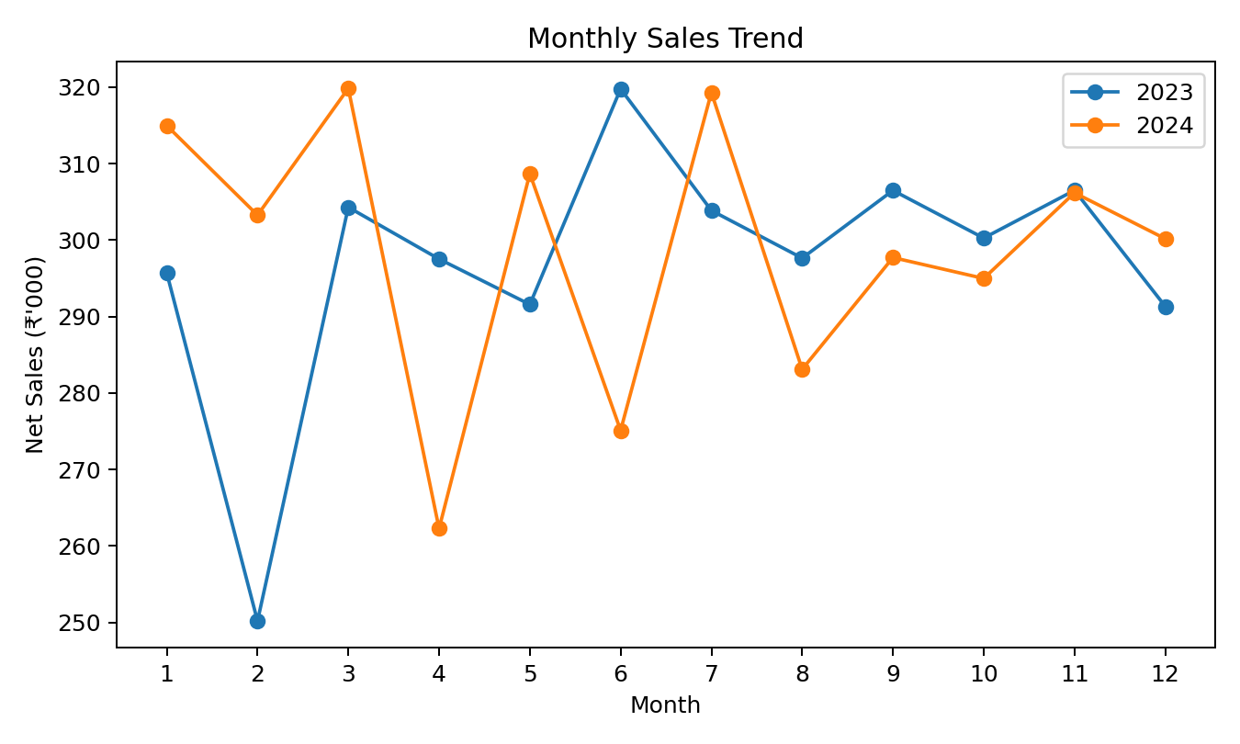
2023: highest monthly sales occurred in June (₹319,754.77); lowest occurred in February (₹250,194.05).
2024: highest monthly sales occurred in March (₹319,826.00); lowest occurred in April (₹262,280.52).

8. Category-wise Sales Analysis
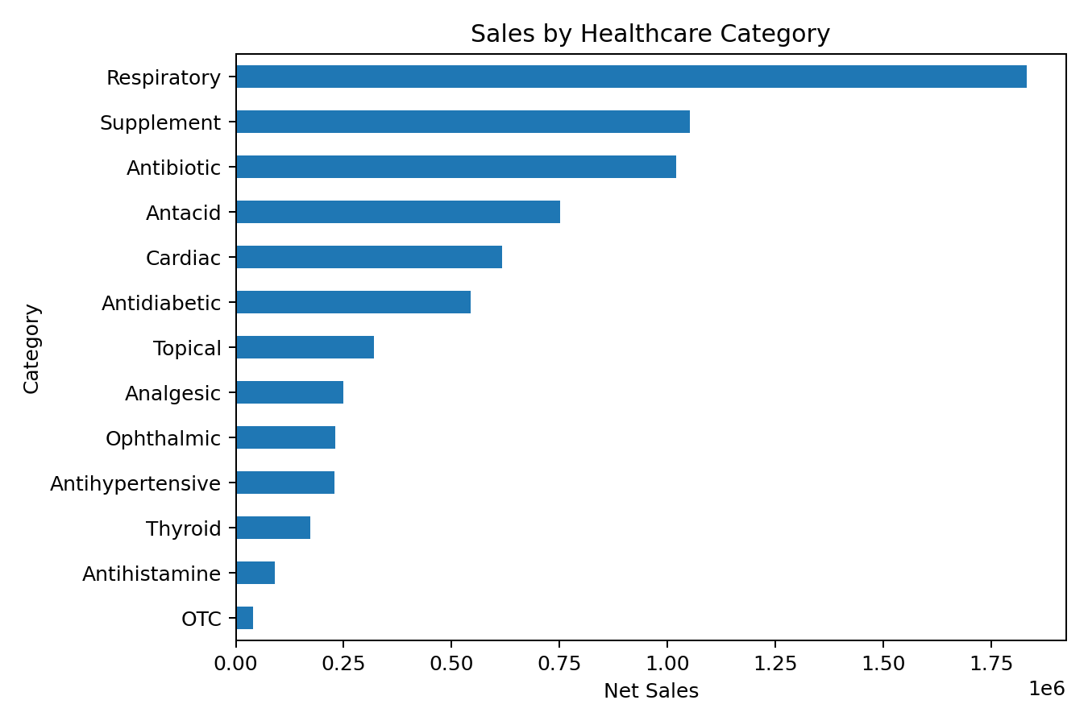
The Respiratory, Supplement, and Antibiotic categories are the top three contributors and together account for 54.61% of total net sales. This concentration suggests that inventory availability and demand forecasting for these categories should receive priority.
Rank | Category | Net Sales | Share
1 | Respiratory | ₹1,832,714.50 | 25.63%
2 | Supplement | ₹1,052,731.63 | 14.72%
3 | Antibiotic | ₹1,019,685.64 | 14.26%
4 | Antacid | ₹751,002.35 | 10.50%
5 | Cardiac | ₹617,581.33 | 8.64%
6 | Antidiabetic | ₹544,324.34 | 7.61%
7 | Topical | ₹320,418.28 | 4.48%
8 | Analgesic | ₹249,062.39 | 3.48%

9. Top Product Analysis
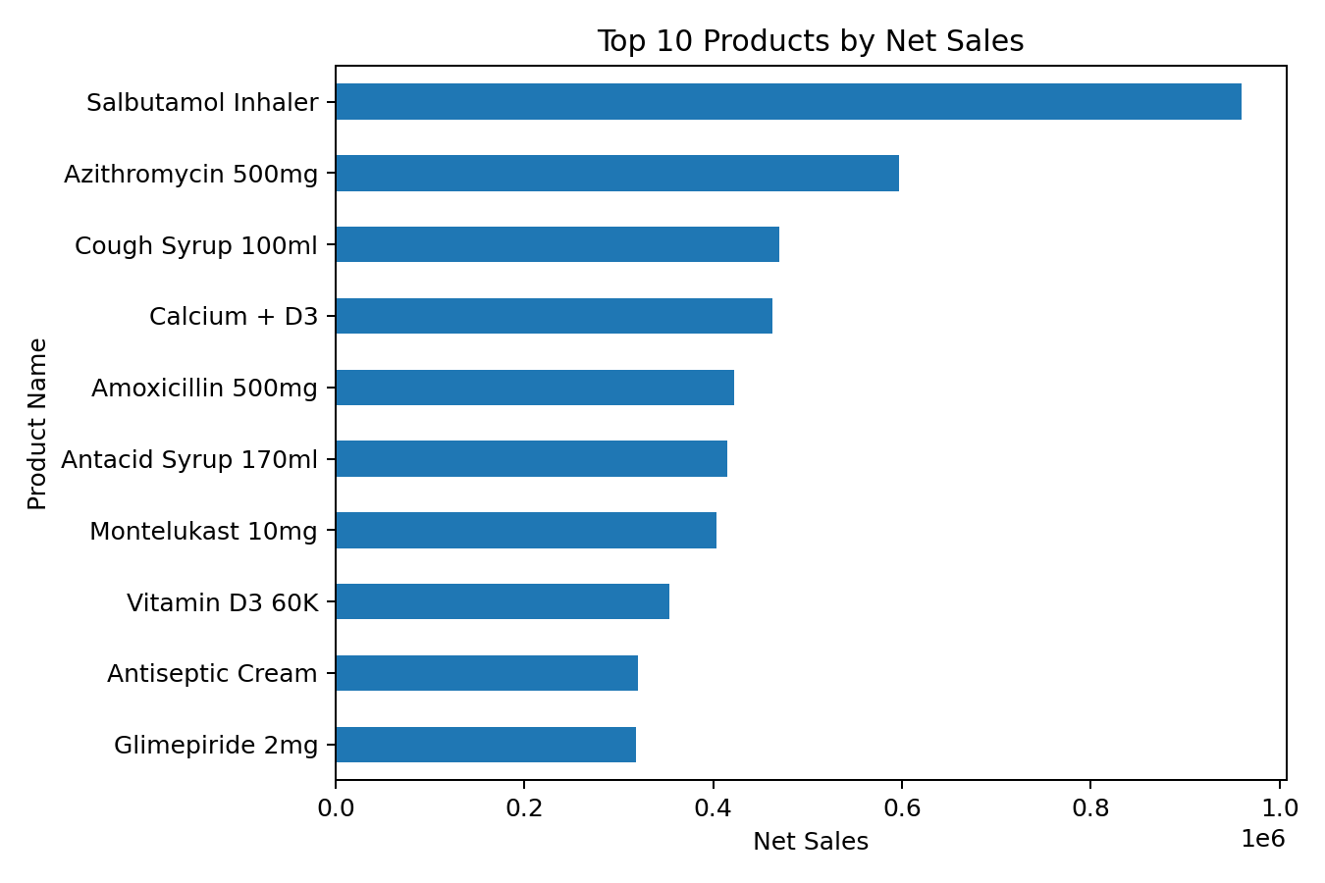
Rank | Product | Net Sales | Share of Total
1 | Salbutamol Inhaler | ₹959,412.43 | 13.42%
2 | Azithromycin 500mg | ₹596,970.11 | 8.35%
3 | Cough Syrup 100ml | ₹469,921.48 | 6.57%
4 | Calcium + D3 | ₹462,908.67 | 6.47%
5 | Amoxicillin 500mg | ₹422,715.53 | 5.91%
6 | Antacid Syrup 170ml | ₹414,895.92 | 5.80%
7 | Montelukast 10mg | ₹403,380.59 | 5.64%
8 | Vitamin D3 60K | ₹353,966.23 | 4.95%
9 | Antiseptic Cream | ₹320,418.28 | 4.48%
10 | Glimepiride 2mg | ₹318,259.78 | 4.45%
Salbutamol Inhaler is the highest-selling product. The top five products contribute 40.72% of total sales, highlighting the importance of maintaining adequate stock levels for fast-moving products.

10. Staff Sales Performance
Rank | Staff | Net Sales | Share
1 | Ravi | ₹1,831,471.20 | 25.61%
2 | Arjun | ₹1,791,387.17 | 25.05%
3 | Priya | ₹1,768,218.18 | 24.73%
4 | Meena | ₹1,759,532.62 | 24.61%
Staff sales are comparatively distributed across the four employees. The leading staff member contributes 25.61% of sales, while the lowest contributes 24.61%. This relatively balanced distribution can support consistent operational coverage.

11. Purchase & Supplier Analysis
The purchase dataset contains 182 goods-receipt transactions across 6 suppliers, with total purchase value of ₹3,595,099.30.
Rank | Supplier | Purchase Value | Share
1 | Sri Balaji Medicals | ₹718,800.51 | 19.99%
2 | Sun Pharma Distributors | ₹718,248.70 | 19.98%
3 | Karnataka Pharma Dist | ₹654,223.73 | 18.20%
4 | Cipla Direct | ₹612,818.22 | 17.05%
5 | Medplus Wholesale | ₹459,980.38 | 12.79%
6 | Alkem Pharma Dist | ₹431,027.76 | 11.99%
The largest supplier by purchase value is Sri Balaji Medicals, representing 19.99% of total recorded purchases. Supplier concentration should be monitored to reduce disruption risk and improve negotiating power.

12. GST Analysis
Recorded sales GST totals ₹748,666.64, while recorded purchase GST totals ₹337,501.74. The difference between these two figures should not automatically be treated as the final tax payable because actual GST liability depends on applicable input-tax credit rules, tax periods, adjustments and accounting treatment.

13. Important Data Observation
The supplied workbook contains a summary sheet with a separate KPI/pivot section whose totals do not match the full raw sales and purchase tables. For example, the summary section reports a sales total of ₹668,154.22, whereas the full weekly_sales table totals ₹7,150,609.17. Therefore, this report uses the complete raw transaction tables for the primary analysis and treats the existing summary values as a separate pre-calculated/filtered analysis. This distinction should be documented if the report is used for academic or business submission.

14. Recommendations
- Prioritize inventory planning for Respiratory, Supplement and Antibiotic categories because they contribute the largest sales volumes.
- Use reorder thresholds for top-selling products such as Salbutamol Inhaler and Azithromycin 500mg.
- Monitor expiry dates and batch-level stock, especially for products with slower movement.
- Review supplier concentration and negotiate volume-based pricing with major suppliers.
- Track monthly sales using a consistent dashboard to identify seasonal peaks and dips early.
- Separate operational dashboards from filtered/pivot extracts so management KPIs always reconcile to the source data.
- Add gross-margin analysis using a clearly defined cost-of-goods measure before making profitability decisions.

15. Limitations
- The dataset does not provide a complete accounting ledger, so profitability should not be inferred solely from sales and purchase totals.
- The summary sheet appears to contain filtered/pivoted figures that do not reconcile with the full raw tables.
- Customer-level analysis is limited to the fields available in the workbook.
- No external market, competitor or demographic data was included.

16. Conclusion
The Healthcare Sales & Purchase Analytics project demonstrates how transaction-level healthcare data can be transformed into practical management insights. With 42,649 sales records and 1,093 purchase records, the analysis identifies stable annual sales, high-value categories, fast-moving products, staff contribution and supplier concentration. The findings provide a strong foundation for inventory planning, sales monitoring and future Power BI/Excel dashboard development.

17. Suggested Project Title for Resume
Healthcare Sales & Purchase Analytics Dashboard
Analyzed healthcare sales and purchase transactions to identify sales trends, top-performing products, category contribution, supplier concentration and GST KPIs using Excel-based data analysis and dashboard reporting.

