1. Clone an Object

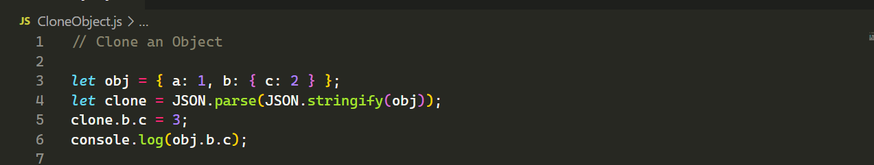

Output:

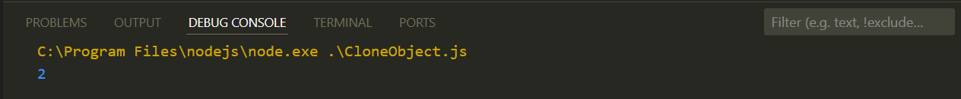

1. Merge Two Objects

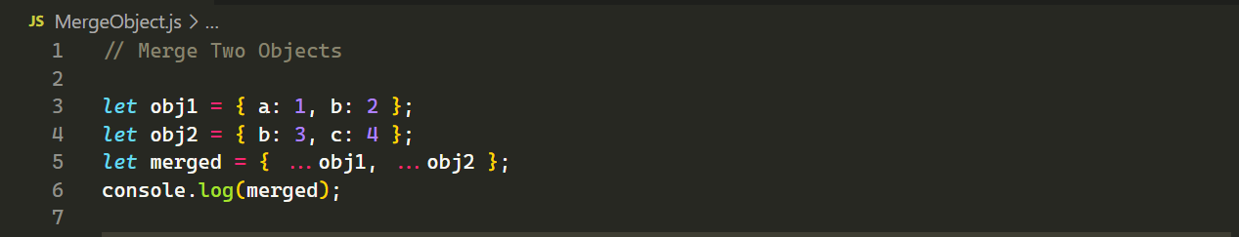

Output:

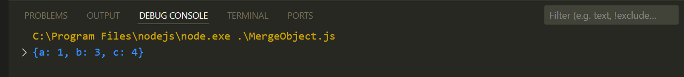

1. Check if Property Exists in Object

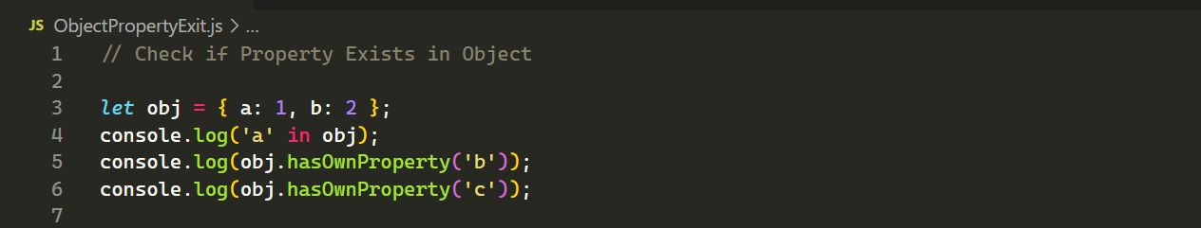

Output:

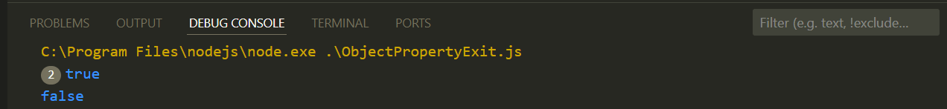

1. Freeze an Object

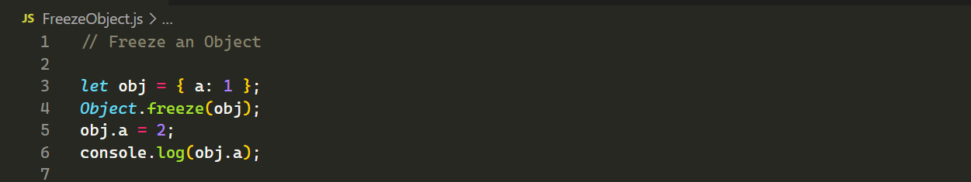

Output:

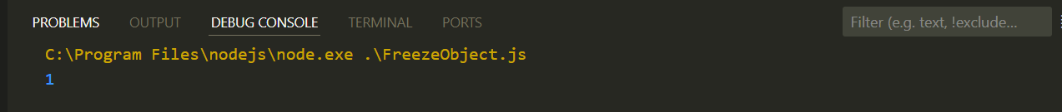

1. Deep Clone an Object

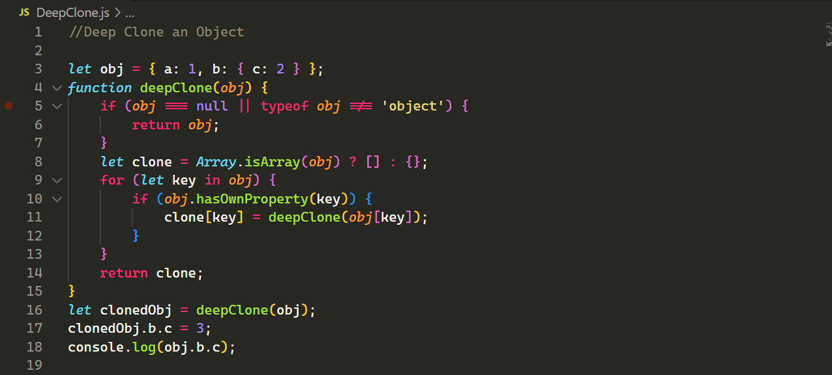

Output:



1. Convert Object to Query String

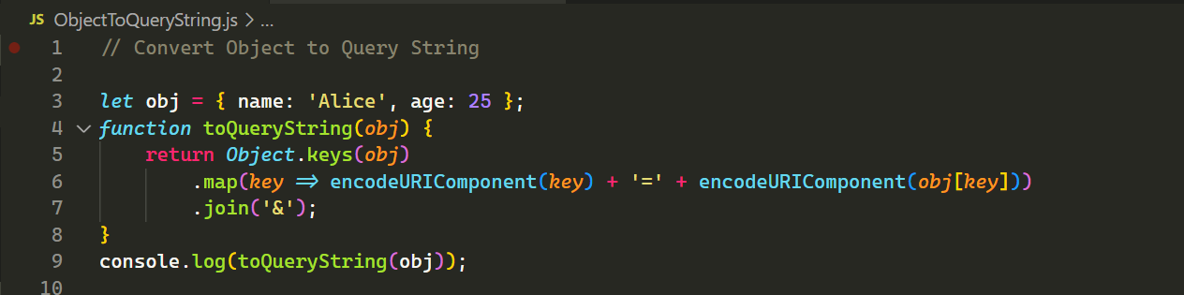

Output:

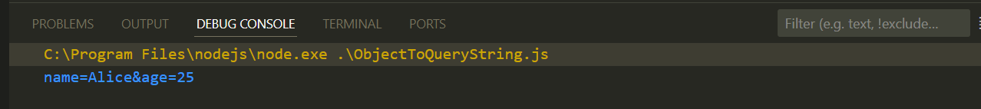

1. Sum of All Values in an Object

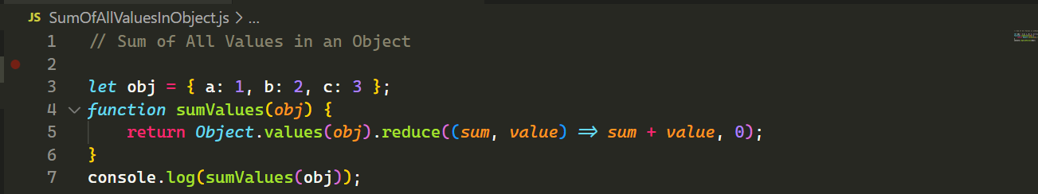

Output:

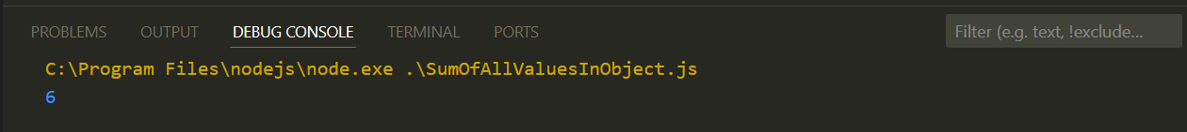

1. Filter Object Properties Based on Condition

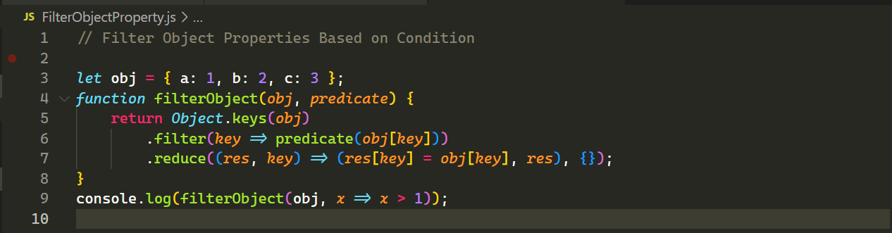

Output:

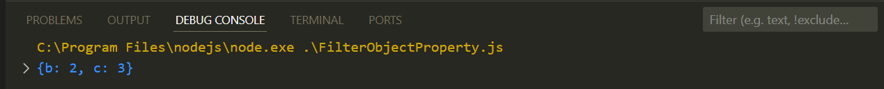

1. Convert Array of Objects to Object with Keyed Properties

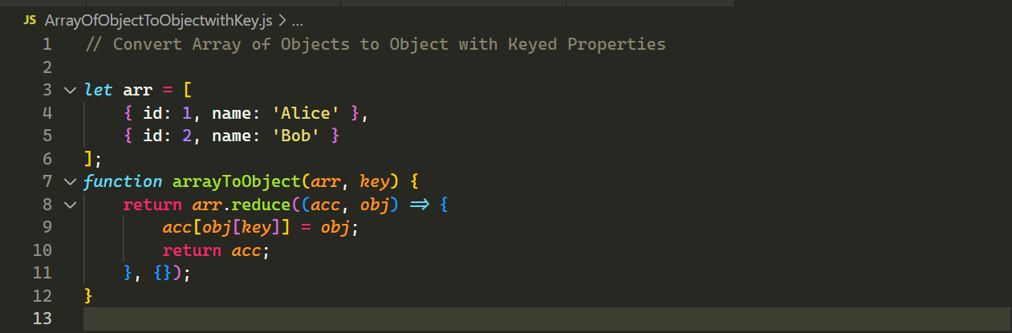

Output:



1. Destructure Nested Object



Output:

