Secure Data Entry Web Application using Amazon EC2 and Amazon RDS

1. Project Objective
To build a secure 2-tier web application where a web server hosted on Amazon EC2 allows users to enter data through a web form, and the submitted data is securely stored in an Amazon RDS MySQL database placed in private subnets.

2. AWS Services Used
- Amazon EC2 (Virtual Server)
- Amazon RDS (Managed MySQL Database)
- Amazon VPC (Networking)
- Security Groups (Firewall)
- Internet Gateway
- Route Tables

3. Architecture Overview
User → EC2 (Apache + PHP) → RDS (MySQL)
• EC2 is placed in a Public Subnet.
• RDS is placed in Private Subnets.
• Database is not publicly accessible.
• Security Groups restrict access between EC2 and RDS.

4. Networking Design (Updated & Corrected)
VPC Design:
• 1 Public Subnet (for EC2)
• 2 Private Subnets (for RDS - required in different Availability Zones)
RDS requires a DB Subnet Group containing at least 2 subnets in different Availability Zones, even for Single-AZ deployment.

5. Route Table Configuration (Correct Design)
Public Route Table (for Public Subnet - EC2):
• 10.0.0.0/16 → local
• 0.0.0.0/0 → Internet Gateway
Private Route Table (for Private Subnets - RDS):
• 10.0.0.0/16 → local
Private subnets do NOT have a route to the Internet Gateway.
Public and Private subnets must use separate route tables for security.

6. Implementation Steps Summary
Step 1: Create VPC with required subnets.
Step 2: Create DB Subnet Group with 2 private subnets.
Step 3: Launch RDS (Public Access = No).
Step 4: Launch EC2 in Public Subnet.
Step 5: Install Apache, PHP, and MySQL client.
Step 6: Connect EC2 to RDS and create database/table.
Step 7: Deploy PHP data entry form.
Step 8: Test application from browser.

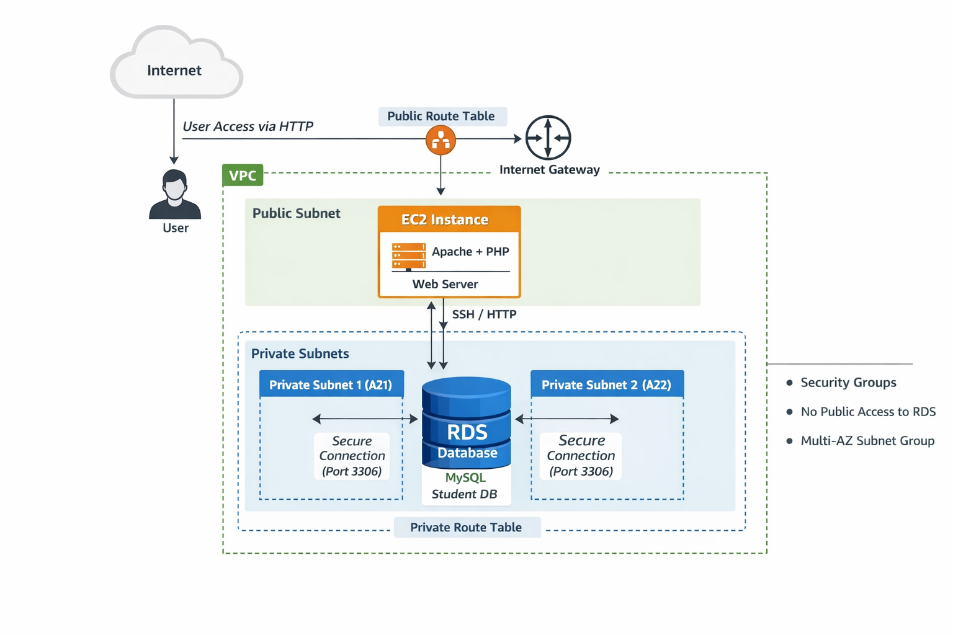

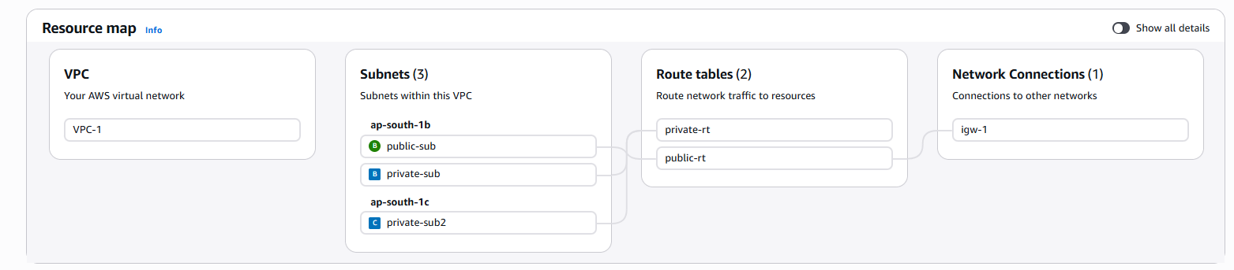
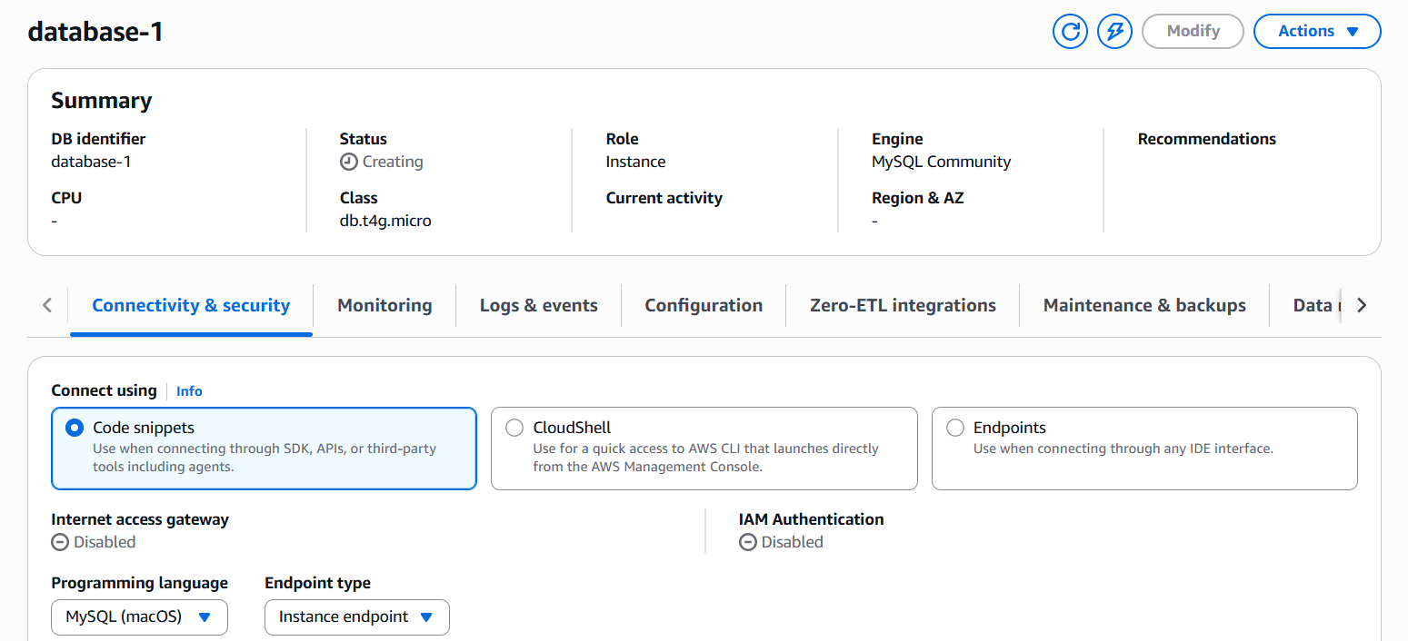

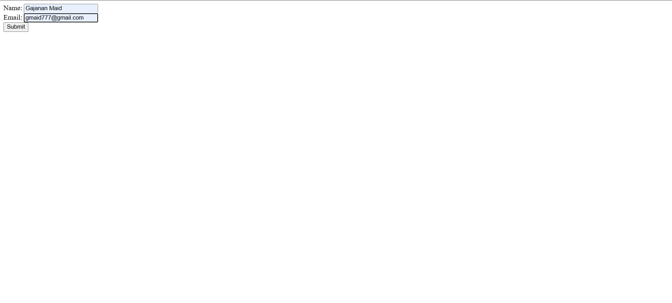

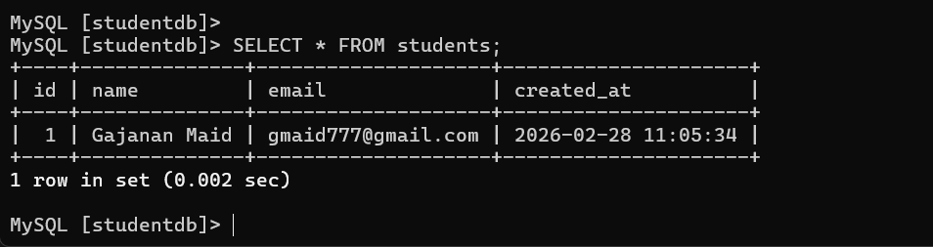

7. Security Best Practices Implemented
• RDS placed in private subnets.
• Public access disabled for RDS.
• Security Group allows MySQL (3306) only from EC2 Security Group.
• EC2 allows only HTTP (80) and SSH (22).
• Strong database credentials used.

8. Challenges Faced
• RDS connection timeout due to Security Group misconfiguration.
• Understanding difference between Public and Private subnets.
• Route table association confusion.
• Requirement of 2 subnets for RDS subnet group.

9. Conclusion
This project demonstrates the deployment of a secure 2-tier architecture on AWS using EC2 and RDS. It provides practical understanding of VPC networking, subnet isolation, route tables, and database security. By separating public and private resources and configuring route tables properly, the application ensures secure communication between the web server and database. This project builds a strong foundation for advanced cloud and DevOps architectures such as Load Balancers, Auto Scaling, and Multi-AZ deployments.

