# Vector Borne Disease Search Engine

## User Manual

1. Double click on the (.exe) file. OR Open the VBD Search Engine File

[.exe] files can be only used in Windows Operated Systems.

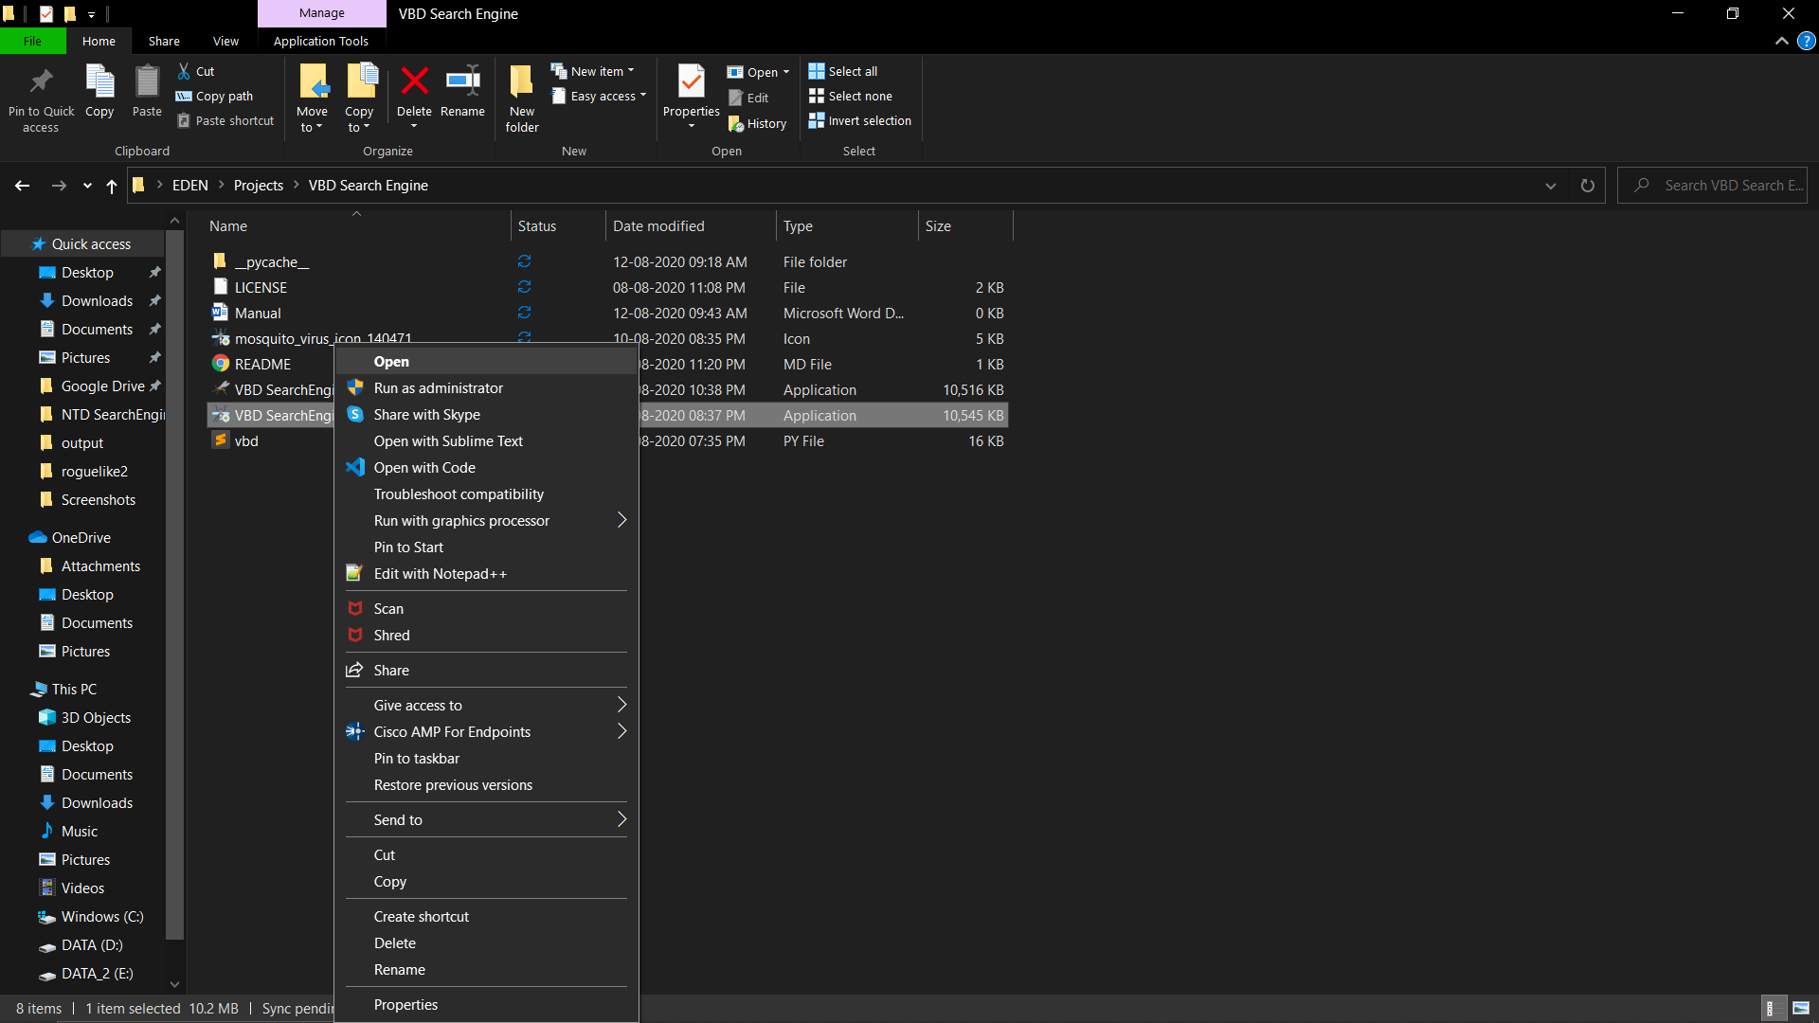

1. A window like console will be opened as shown below. Press **ENTER** to Begin.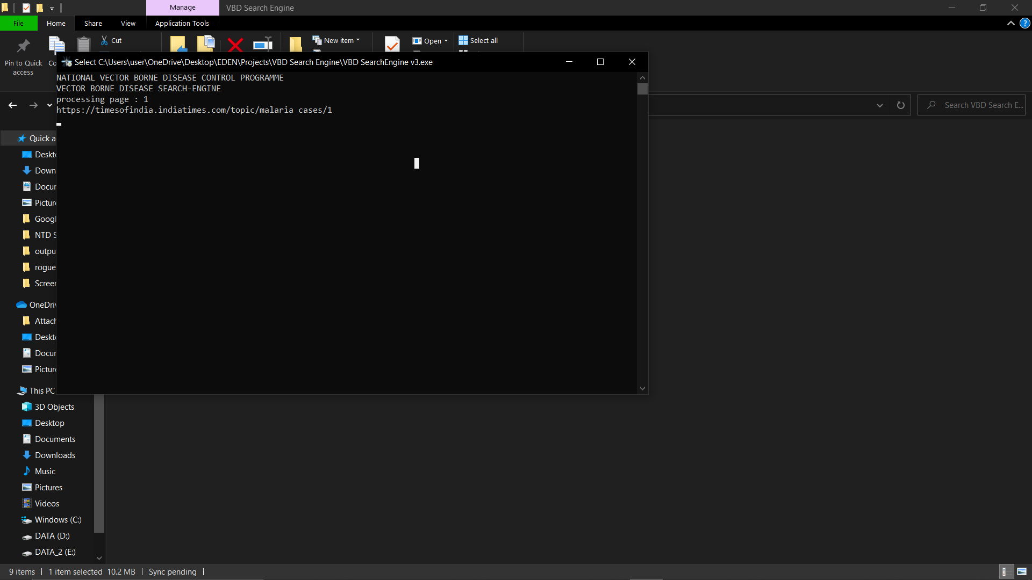
2. Wait for 6-7 minutes. The news results are being gathered.

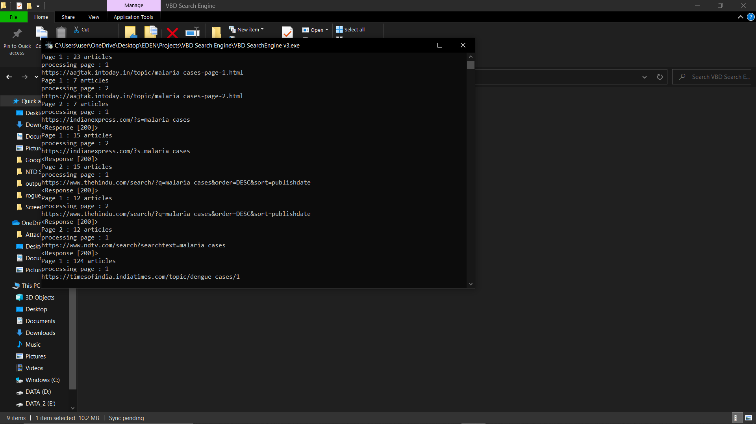

1. After the program has stopped its execution. A new CSV file will be created in the same folder as shown below with name “NEWS YYYY-MM-DD.csv” format. Don’t worry CSV files are just like Excel sheets rather the former is much easier to parse than the latter.

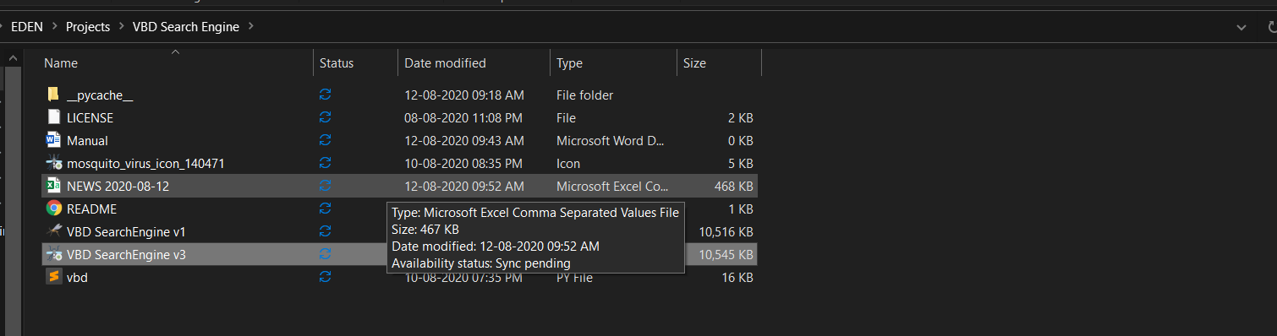

1. Open the file and you will see something as shown below. Click in the “**Data Tab”** in the menu

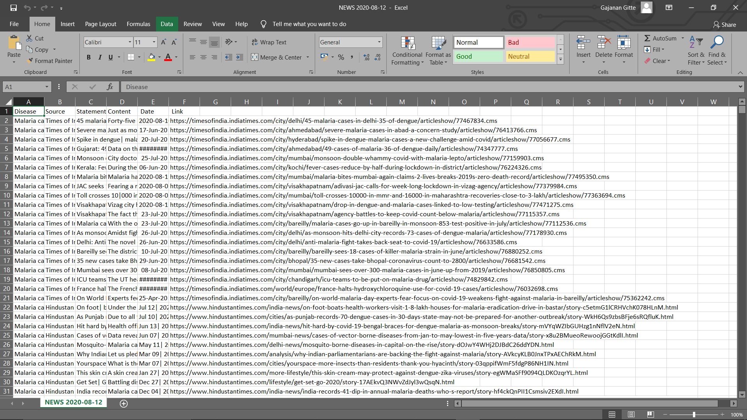

1. Click on “From Text” to import External Data.

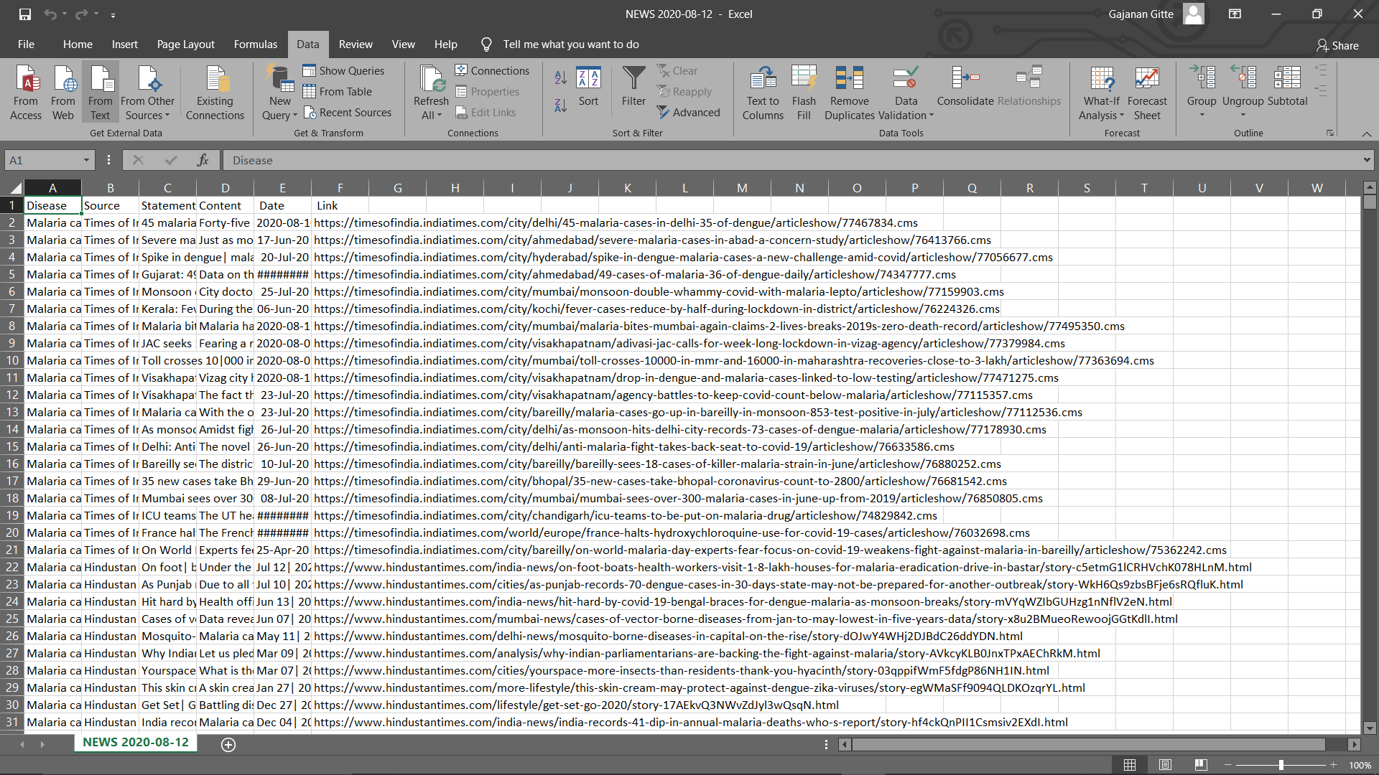

1. Open the recently created file.

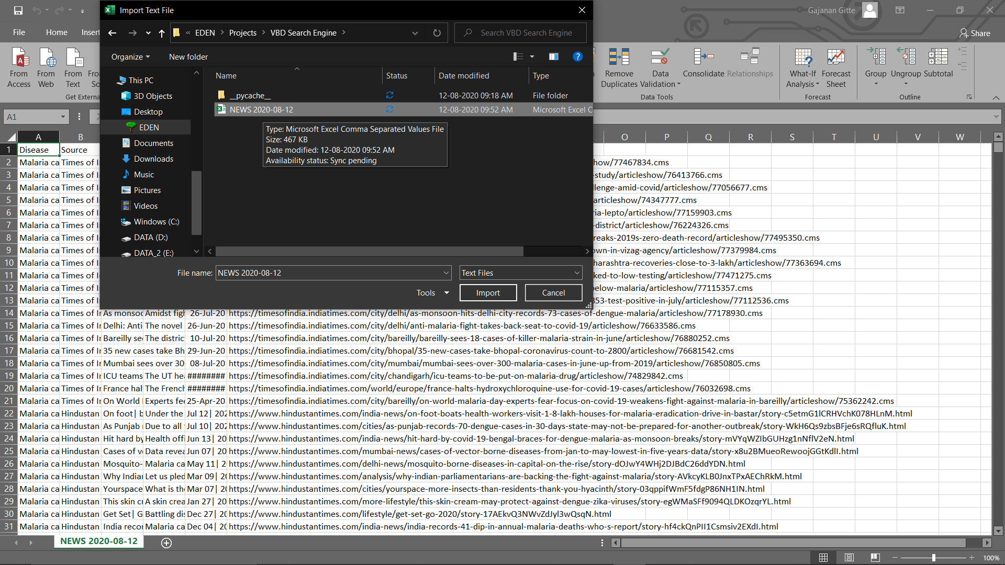

1. **IMPORTANT:** Select **Delimited** and File Origin as **65001: Unicode (UTF-8)**

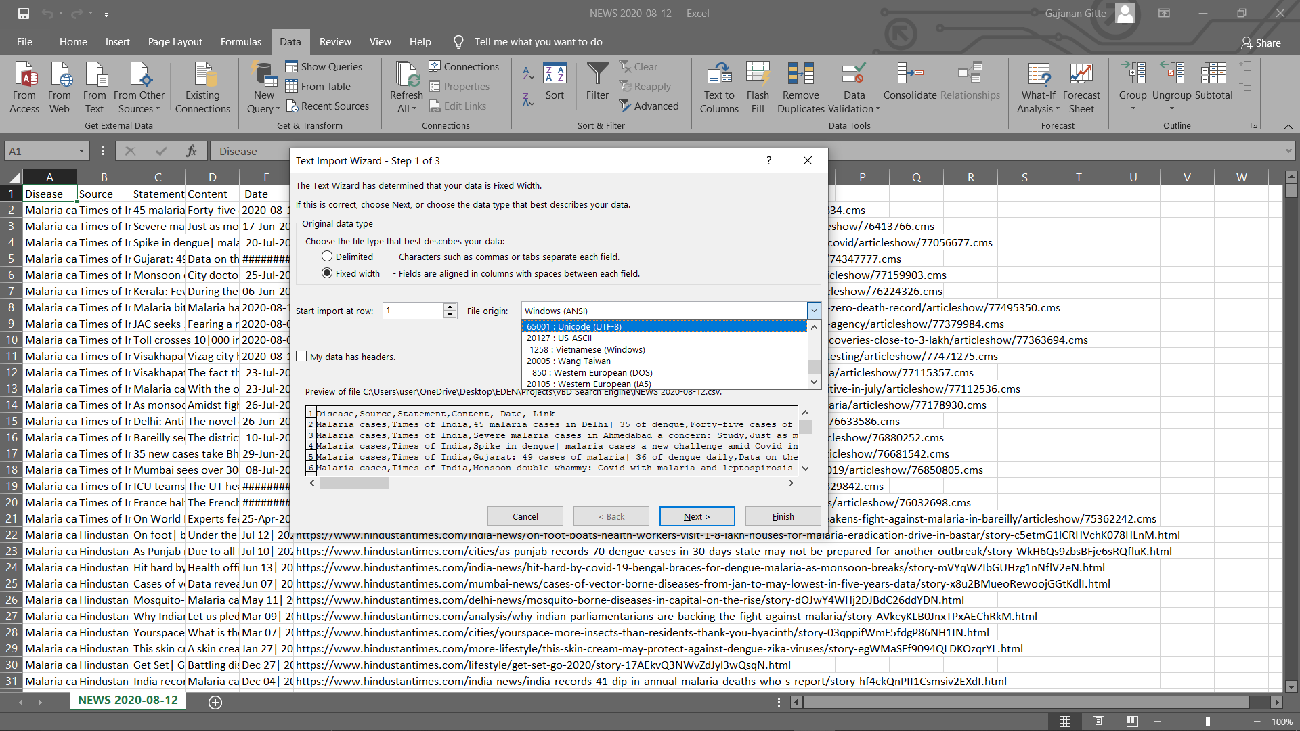

Select 65001: Unicode (UTF-8)

1. The newer format choices will look like :

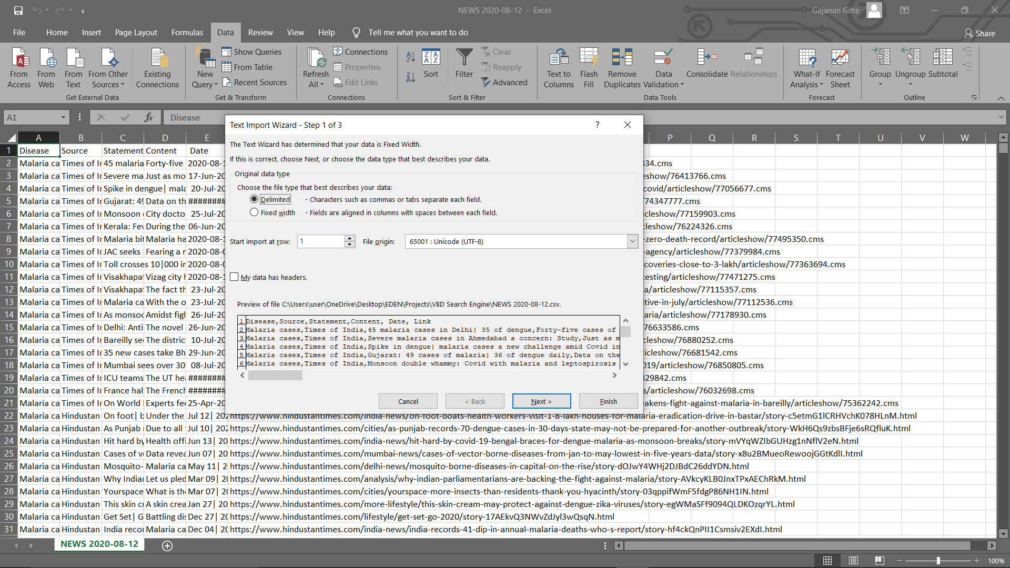

1. **IMPORTANT: Select Comma as Delimiter. Then press next**

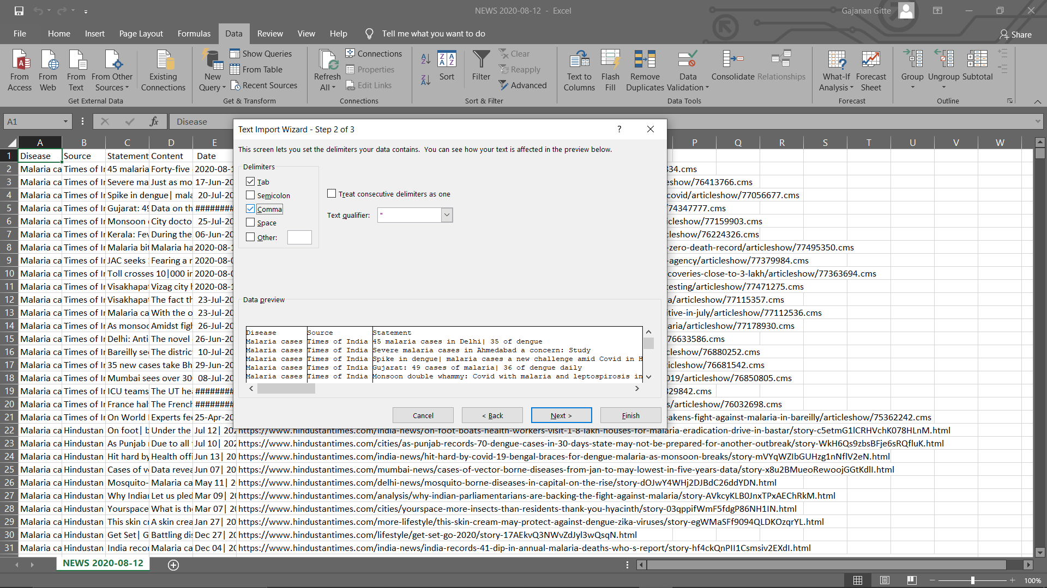

1. Keep on pressing “Next”/ “OK”. Your file is parsed and can be read in both English and Hindi now.

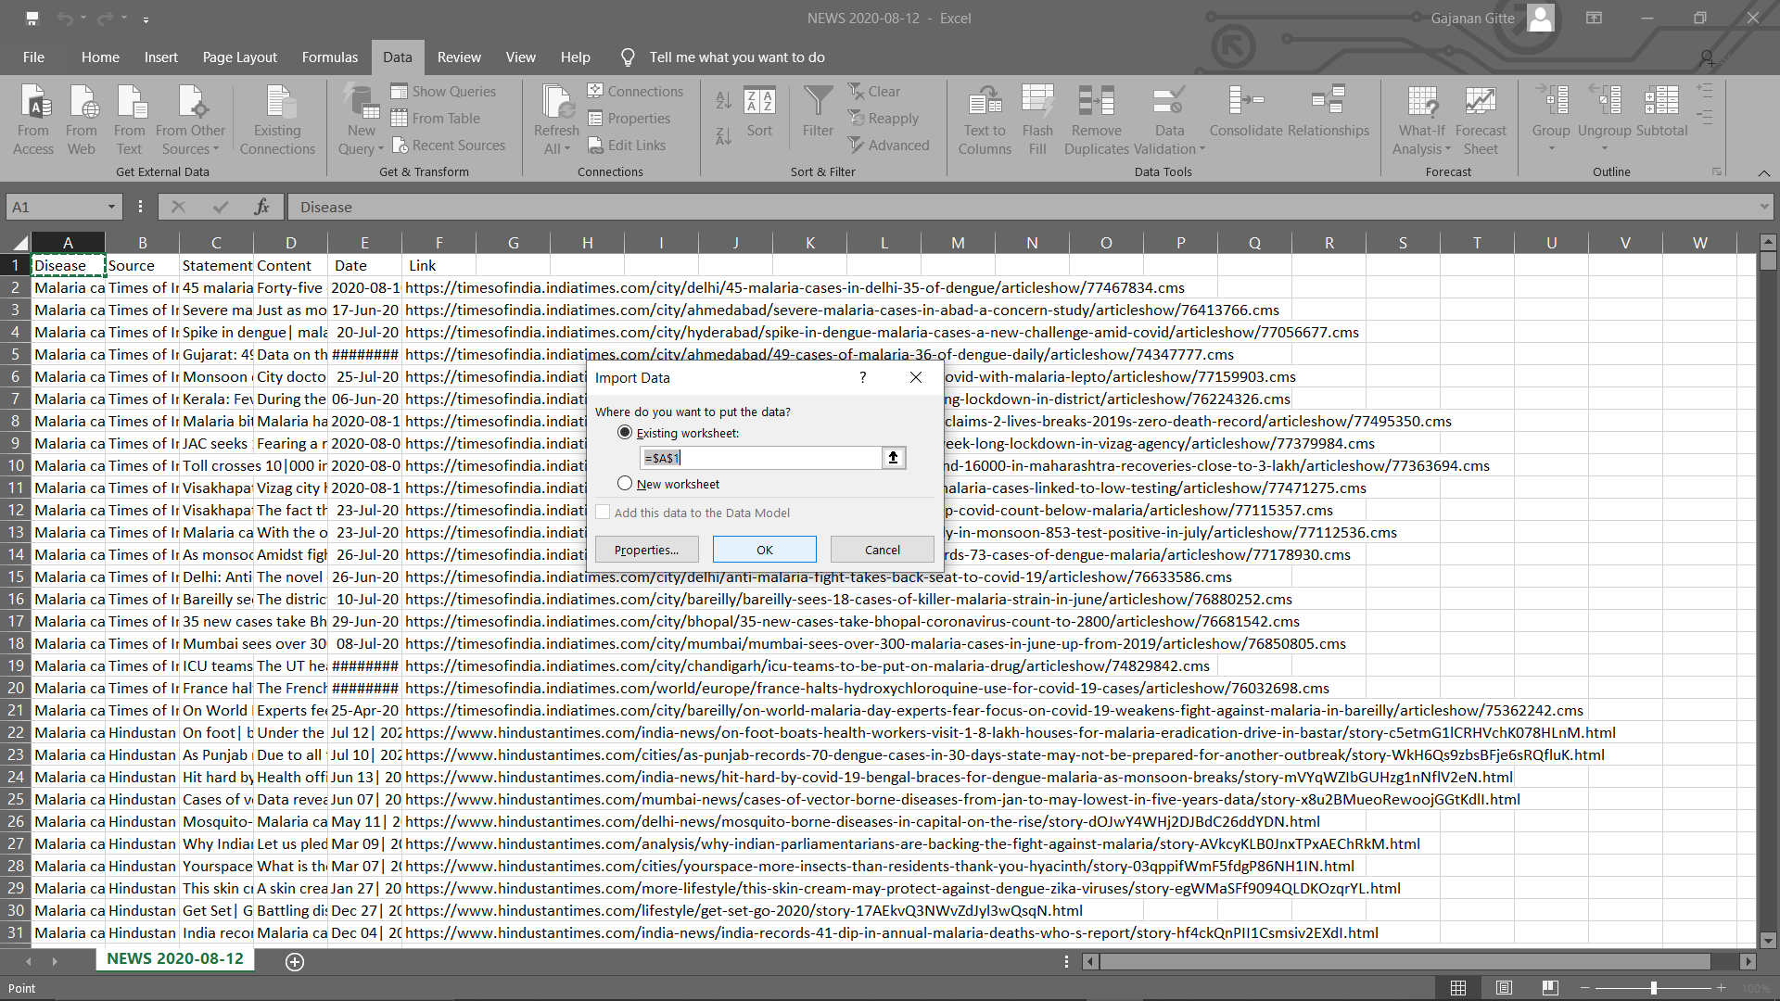

**Variables**:

1. Malaria Cases
2. Malaria Deaths
3. Malaria Outbreak
4. Dengue Cases
5. Dengue Deaths
6. Dengue Outbreak
7. Japanese Encephalitis Cases
8. Japanese Encephalitis Deaths
9. Japanese Encephalitis Outbreak

**News Sites:**

1. The Hindu
2. The Indian Express
3. AAJ TAK- **HINDI**
4. NDTV
5. Times of India
6. Hindustan Times