**Practical no.01**

AIM: write a program in cpp,to print hello word

#include<iostream.h>

#include<conio.h>

void main()

{

clrscr();

cout<<"Hello Word";

getch();

}

**Output:-**

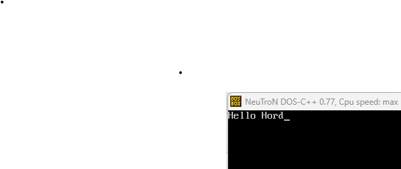

**Practical no.02**

AIM: write a program in cpp ,to print the value of variable

#include<iostream.h>

#include<conio.h>

void main()

{

clrscr();

int a,b=10,c;

a=20;

cout<<"the value of variable a:"<<a<<endl;

cout<<"the value of variable b:"<<b<<endl;

cout<<"enter the value of c variable:"<<endl;

cin>>c;

cout<<"the value of variable c:"<<c;

getch();

}

**Output:-**

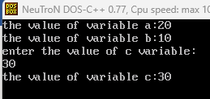

**Practical no.03**

AIM: write a program in cpp, to find the size of variable

#include<iostream.h>

#include<conio.h>

void main()

{

clrscr();

int i;

float f;

double d;

char c;

cout<<"the size of variable i=:"<<sizeof(i)<<"byte"<<endl;

cout<<"the size of variable f=:"<<sizeof(f)<<"byte"<<endl;

cout<<"the size of variable d=:"<<sizeof(d)<<"byte"<<endl;

cout<<"the size of variable c=:"<<sizeof(c)<<"byte";

getch();

}

**Output:-**

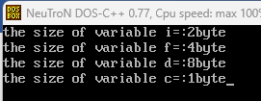

**Practical no.04**

AIM: write a program in cpp , to print ASCII code of variable

#include<iostream.h>

#include<conio.h>

void main()

{

clrscr();

char a;

cout<<"enter the any character value"<<endl;

cin>>a;

cout<<"ASCII value of "<<a<<" is"<<int(a);

getch();

}

**Output:-**

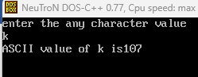

**Practical no:05**

AIM: write a program in cpp ,to perform arithmetic operation

#include<iostream.h>

#include<conio.h>

void main()

{

clrscr();

int a,b,add,sub,mul;

float div;

cout<<"enter the value of a and b:"<<endl;

cin>>a>>b;

add=a+b;

cout<<"addition="<<add<<endl;

sub=a-b;

cout<<"substraction="<<sub<<endl;

mul=a*b;

cout<<"multiplication="<<mul<<endl;

div=a/b;

cout<<"divition="<<div;

getch();

}

**Output:-**

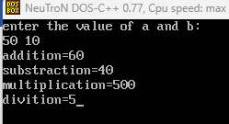

**Practical no.06**

AIM: write a program in cpp , to swaping the value of using third variable

#include<iostream.h>

#include<conio.h>

void main()

{

clrscr();

int a,b,c;

cout<<"enter the value of a and b:"<<endl;

cin>>a>>b;

cout<<"value of a and b befor swaping is:"<<a<<" & "<<b<<endl;

c=a;

a=b;

b=c;

cout<<"value of a and b after swaping is:"<<a<<" & "<<b;

getch();

}

**Output:-**

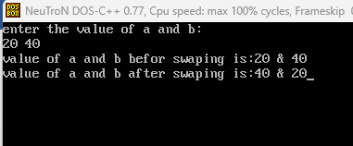

**Practical no.07**

AIM: write a program in cpp , to swaping the value whithout using third variable

#include<iostream.h>

#include<conio.h>

void main()

{

clrscr();

int a,b;

cout<<"enter the value of a and b:"<<endl;

cin>>a>>b;

cout<<"value of a and b befor swaping is:"<<a<<" & "<<b<<endl;

a=a+b;

b=a-b;

a=a-b;

cout<<"value of a and b after swaping is:"<<a<<" & "<<b;

getch();

}

**Output:-**

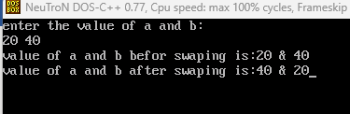

**Practical no.08**

AIM: write a program in cpp,to find area of circule

#include<iostream.h>

#include<conio.h>

void main()

{

clrscr();

float r,a;

cout<<"enter the value of radius :"<<endl;

cin>>r;

a=3.14*r*r;

cout<<"area of circule is:"<<a;

getch();

}

**Output:-**

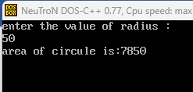

**Practical no.09**

AIM: write a program in cpp,to find simple intreste

#include<iostream.h>

#include<conio.h>

void main()

{

clrscr();

int p,r,t;

float si;

cout<<"enter the value of principal :"<<endl;

cin>>p;

cout<<"enter the value of rate:"<<endl;

cin>>r;

cout<<"enter the value of time:"<<endl;

cin>>t;

si=p*r*t/100;

cout<<"simple intrest is="<<si;

getch();

} **Output:**

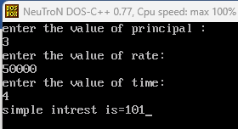

**Practical no.10**

AIM: write a program in cpp ,to calculate percentage of 5 subject

#include<iostream.h>

#include<conio.h>

void main()

{

clrscr();

int CPP,CN,MTCS,DS,NA,t;

float per;

cout<<"enter the marks of CPP:"<<endl;

cin>>CPP;

cout<<"enter thr marks of computer network:"<<endl;

cin>>CN;

cout<<"enter the marks of mathematical technics in computer science:"<<endl;

cin>>MTCS;

cout<<"enter the marks of data structure:"<<endl;

cin>>DS;

cout<<"enter the marks of numerical ability:"<<endl;

cin>>NA;

t=CPP+CN+MTCS+DS+NA;

cout<<"total="<<t<<endl;

per=(t)/5;

cout<<"percentage="<<per;

getch();

}

**Output:-**

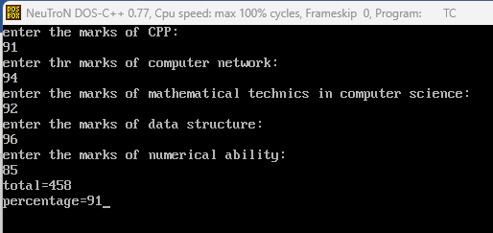

**Practical no.11**

AIM:- write a program in cpp , to check the eligibal for voting or not.

#include<iostream.h>

#include<conio.h>

void main()

{

clrscr();

int age;

cout<<"enter your age:";

cin>>age;

if(age>=18)

{

cout<<"your age :"<< age<<" you are eligibal for voting.";

}

else

{

cout<<"your age :"<<age<<" you are not eligibal for voting.";

}

getch();

}

**Output:-**



**Practical no.12**

AIM:- write a program in cpp,to check given number is even or odd.

#include<iostream.h>

#include<conio.h>

void main()

{

clrscr();

int num;

cout<<"enter value for number:";

cin>>num;

if(num%2==0)

{

cout<<"you enter is:"<<num<<" the number is even";

}

else

{

cout<<"you enter is:"<<num<<"the number is odd";

}

getch();

}

**Output:-**



**Practical no.13**

AIM:- write a program in cpp , to check pass or fail.

#include<iostream.h>

#include<conio.h>

void main()

{

clrscr();

int marks;

cout<<"enter the marks of student:";

cin>>marks;

if(marks>=35)

{

cout<<"you are PASS";

}

else

{

cout<<"you are FAIL";

}

getch();

}

**Output:-**





**Practical no.14**

AIM:- write a program in cpp,to print “computer science” word in 5 times using for loop.

#include<iostream.h>

#include<conio.h>

void main()

{

clrscr();

int n;

for(n=1;n<=5;n++)

{

cout<<"computer science"<<endl;

}

getch();

}

**Output:-**

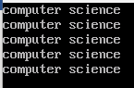

**Practical no.15**

AIM:- write a program in cpp,to print the “computer science” word in 5 times using while loop.

#include<iostream.h>

#include<conio.h>

void main()

{

clrscr();

int n=1;

while(n<=5)

{

cout<<n <<" computer science"<<endl;

n++;

}

getch();

}

**Output:-**

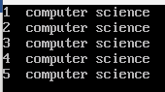

**Practical no.16**

AIM:- write a program in cpp , to print “computer science ” word in 5 times using do while loop.

#include<iostream.h>

#include<conio.h>

void main()

{

clrscr();

int n=1;

do

{

cout<<n <<" computer science"<<endl;

n++;

}

while(n<=5);

getch();

}

**Output:-**

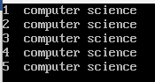

**Practical no.17**

AIM:- write a program in cpp,to print number from 1 to 10 using for loop.

#include<iostream.h>

#include<conio.h>

void main()

{

clrscr();

int n;

for(n=1;n<=10;n++)

{

cout<<n<<endl;

}

getch();

}

**Output:-**



**Practical no.18**

AIM:- write a program in cpp,to print number from 1 to 10 using while loop.

#include<iostream.h>

#include<conio.h>

void main()

{

clrscr();

int n=1;

while(n<=10)

{

cout<<n<<endl;

n++;

}

getch();

}

**Output:-**



**Practical no.19**

AIM:- write a program in cpp to print number from 1 to 10 using do while loop.

#include<iostream.h>

#include<conio.h>

void main()

{

clrscr();

int n=1;

do

{

cout<<n<<endl;

n++;

}

while(n<=10);

getch();

}

**Output:-**



**Practical no.20**

AIM:- write a program in cpp , to print all ASCII code using for loop.

#include<iostream.h>

#include<conio.h>

void main()

{

clrscr();

int n;

for(n=0;n<=255;n++)

{

cout<<"ASCII code of "<<char(n)<<" "<<n;

}

getch();

}

**Output:-**

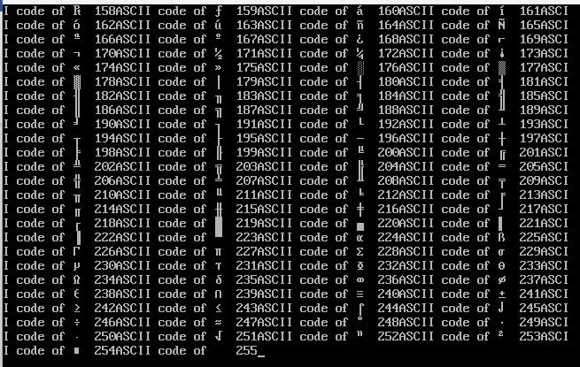

**Practical no.21**

AIM:- write a program in cpp , to demonstrate function.

#include<iostream.h>

#include<conio.h>

void add()

{

int a,b,c;

cout<<"enter the value of a and b:";

cin>>a>>b;

c=a+b;

cout<<"addition of "<<a<<" and "<<b<<" =\t"<<c;

}

void main()

{

clrscr();

add();

getch();

}

Output:-



**Practical no.22**

AIM:- write a program in cpp , to demonsrate call by value.

#include<iostream.h>

#include<conio.h>

void add(int x,int y)

{

int a;

a=x+y;

cout<<"addition of two number:"<<a<<endl;

}

void main()

{

clrscr();

add(5,20);

add(2,6);

getch();

}

Output:-



**Practical no.23**

AIM:- write a program in cpp , to demonstrate call by reference.

#include<iostream.h>

#include<conio.h>

void add(int *x,int *y)

{

int a;

a=*x+*y;

cout<<"addition of two number:"<<a<<endl;

}

void main()

{

clrscr();

int x=10,y=20;

add(&x,&y);

getch();

}

Output:-



**Practical no.24**

AIM:- write a program in cpp , to demonstrate inline function.

#include<iostream.h>

#include<conio.h>

void add(int x,int y)

{

int a;

a=x+y;

cout<<"addition of two number "<<x<<" and "<<y<<"= "<<a<<endl;

}

void main()

{

clrscr();

int x,y;

cout<<"enter the value of x and y:"<<endl;

cin>>x>>y;

add(x,y);

getch();

}

Output:-

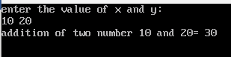

**Practical no.25**

AIM:- write a program in cpp , to demonsrate default argument.

#include<iostream.h>

#include<conio.h>

void add(int x,int y,int z=10)

{

int a;

a=x+y+z;

cout<<"addition "<<a<<endl;

}

void main()

{

clrscr();

add(5,20,50);

add(5,20);

add(1,5);

getch();

}

Output:-

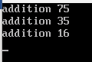

**Practical no.26**

AIM:- write a program in cpp , to demonstrate three defaulte argument.

#include<iostream.h>

#include<conio.h>

void add(int x=80,int y=5,int z=10)

{

int a;

a=x+y+z;

cout<<"addition "<<a<<endl;

}

void main()

{

clrscr();

add();

add(5,20);

add(1,5);

getch();

}

Output:-

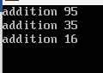

**Practical no.27**

AIM:- write a program in cpp , to demonstrate function overloading.

#include<iostream.h>

#include<conio.h>

void add(int x,int y)

{

int z;

z=x+y;

cout<<"addition of two number:"<<z<<endl;

}

void add(float a,float b,float c)

{

float d;

d=a+b+c;

cout<<"addition of two number:"<<d<<endl;

}

void main()

{

clrscr();

//add();

add(15,20);

add(1,5,8);

getch();

}

Output:-

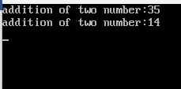

**Practical no.28**

AIM:- write a program in cpp , to demonstrate class and object.

#include<iostream.h>

#include<conio.h>

class student

{

public:

int id; //data member

float f;//data member

};

void main()

{

clrscr();

student s1;//creating object of student

s1.id=6140;

s1.f=5.6;

cout<<s1.id<<endl;

cout<<s1.f<<endl;

getch();

}

Output:-

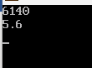

**Practical no.29**

AIM:- write a program in cpp , to demonstrate class and object (inside the function).

#include<iostream.h>

#include<conio.h>

class student

{

int roll;

char name[20];

float fee;

public:

void BCS()

{

cout<<endl<<"i am BCS class student"<<endl;

}

void display()

{

cout<<"enter your roll number:";

cin>>roll;

cout<<endl<<"enter your name:";

cin>>name;

cout<<endl<<"enter your fees:";

cin>>fee;

cout<<endl<<"***********************"<<endl;

cout<<"roll:"<<roll<<"\t"<<"name:"<<name<<"\t"<<"fee:"<<fee;

}

};

void main()

{

clrscr();

student s;

s.display();

s.BCS();

getch();

}

Output:-

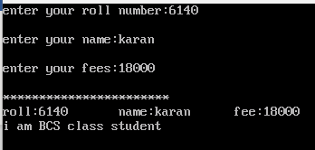

**Practical no.30**

AIM:- write a program in cpp , to demonstrate class and object (out side of the function).

#include<iostream.h>

#include<conio.h>

class marks

{

int cpp,cn,dsa;

public:

void getmark();

void displaymark();

};

void marks::getmark()

{

cout<<"enter the marks of cpp:";

cin>>cpp;

cout<<"enter the marks of cn:";

cin>>cn;

cout<<"enter the marks of dsa:";

cin>>dsa;

}

void marks::displaymark()

{

cout<<"cpp marks: "<<cpp<<"\t";

cout<<"cn marks: "<<cn<<"\t";

cout<<"dsa marks: "<<dsa<<"\t";

}

void main()

{

clrscr();

marks m;

m.getmark();

m.displaymark();

getch();

}

Output:-

