Oozie Assignment_1:

Job.properties

cat>>Job.properties
nameNode=hdfs://localhost:54310
jobTracker=localhost:54311
oozie.libpath=${nameNode}/user/oozie/share/lib
oozie.wf.application.path=${nameNode}/user/${user.name}/workflows
appPath=${nameNode}/user/${user.name}/workflows

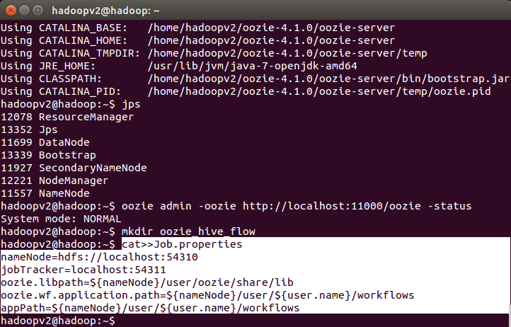
Workflow.xml

<workflow-app name="DemoOozie" xmlns="uri:oozie:workflow:0.1">

<start to="demo-hive"/>

<action name="demo-hive">

<hive xmlns="uri:oozie:hive-action:0.2">

<job-tracker>${jobTracker}</job-tracker>

<name-node>${nameNode}</name-node>

<job-xml>${appPath}/hive-site.xml</job-xml>

<configuration>

<property>

<name>oozie.hive.defaults</name>

<value>${appPath}/hive-site.xml</value>

</property>

<property>

<name>hadoop.proxyuser.oozie.hosts</name>

<value>*</value>

</property>

<property>

<name>hadoop.proxyuser.oozie.groups</name>

<value>*</value>

</property>

</configuration>

<script>create_table.hql</script>

</hive>

<ok to="end"/>

<error to="end"/>

</action>

<end name="end"/>

</workflow-app>

create_table.hql

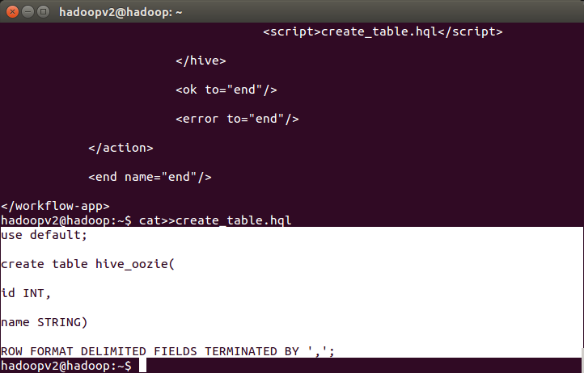
Now we will see the step by step procedure to run a Hive-Oozie job.
- Create a directory and keep the above 3 files (Job.properties, workflow.xml, and create_table.hql) in it.

Created directory copied files into it :

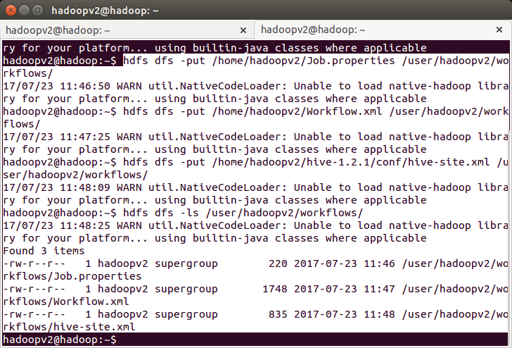

Once done, you can run your Oozie job by using the below command.sudo -u oozie oozie job -oozie http://127.0.0.1:11000/oozie -config job.properties -run

