Loading Data Into HBase Using PIG Scripts.

DATASET
Please refer the description for the above data set containing seven columns named as:
StudentName, sector, DOB, qualification, score, state, randomName.
We will be copying the data set in to HDFS which will be further loaded into Hbase.

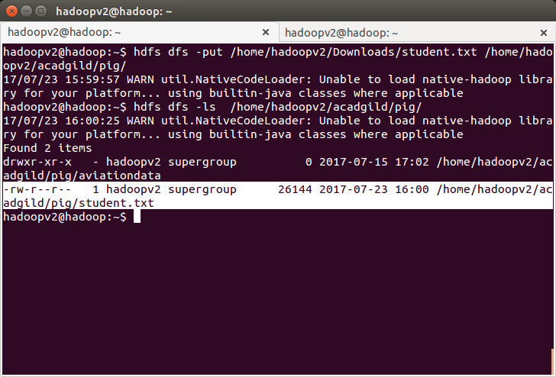
We will be including few jar files of HBase to the Pig classpath.

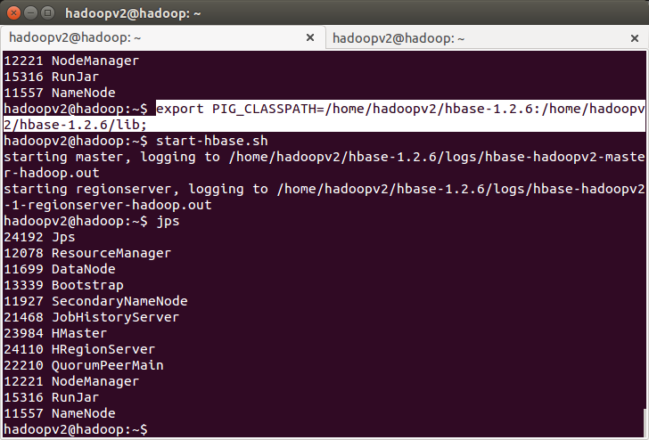
We will now start HBase shell and create a table.
We only need this table as skeleton so PIG can Store data inside this by referring the table name.

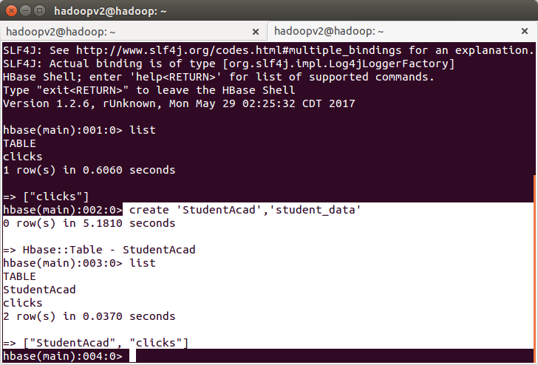

We can come out from HBase by typing exit and switch to PIG grunt shell.
Once we are inside PIG mode we can load data from HDFS to Alias relation.

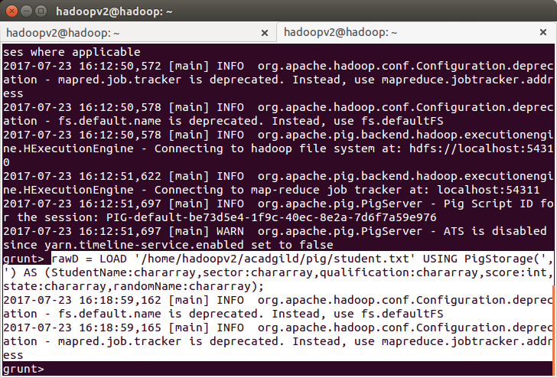
Now we can transfer the data inside HBase by STORE command.
We need to ensure that we give the correct name for table name created inside HBase. Also the parameters should be kept in mind to avoid mistake.

rawD = LOAD '/user/hadoop/pig/student.txt' USING PigStorage(',') AS (StudentName:chararray,sector:chararray,qualification:chararray,score:int,state:chararray,randomName:chararray);

STORE rawD INTO 'hbase://StudentAcad' USING org.apache.pig.backend.hadoop.hbase.HBaseStorage('student_data:StudentName student_data:sector student_data:qualification student_data:score student_data:state student_data:randomName');

