Transactions in Hive
..........................................................................................................

I have executine all commands from HUE for practice.

Row-level Transactions Available in Hive 0.14
Let’s perform some row-level transactions available in Hive 0.14. Before creating a Hive table that supports transactions, the transaction features present in Hive needs to be turned on, as by default they are turned off.
The below properties needs to be set appropriately in hive shell , order-wise to work with transactions in Hive:

set hive.support.concurrency = true;
set hive.enforce.bucketing = true;
set hive.exec.dynamic.partition.mode = nonstrict;
set hive.txn.manager = org.apache.hadoop.hive.ql.lockmgr.DbTxnManager;
set hive.compactor.initiator.on = true;
set hive.compactor.worker.threads = 2

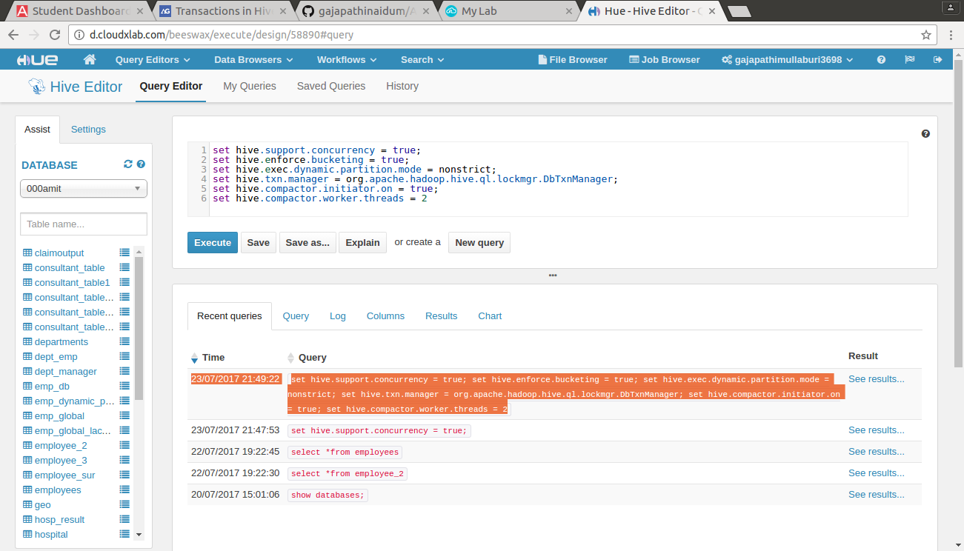

Creating a Table That Supports Hive Transactions

CREATE TABLE college(clg_id int,clg_name string,clg_loc string) clustered by (clg_id) into 5 buckets stored as orc TBLPROPERTIES('transactional'='true');

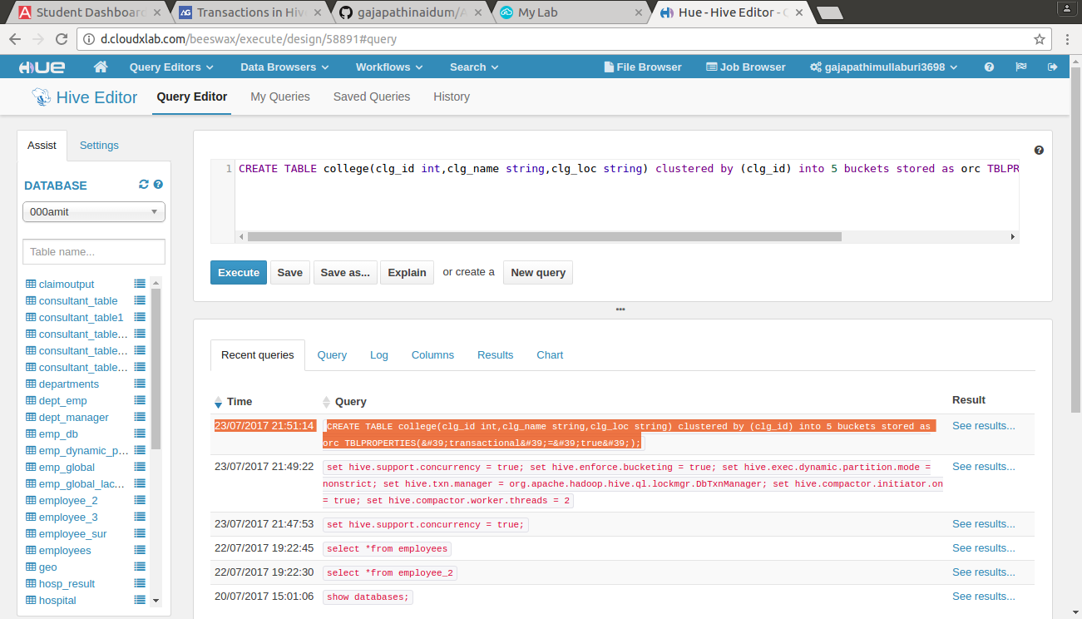

Inserting Data into a Hive Table

INSERT INTO table college values(1,'nec','nlr'),(2,'vit','vlr'),(3,'srm','chen'),(4,'lpu','del'),(5,'stanford','uk'),(6,'JNTUA','atp'),(7,'cambridge','us');
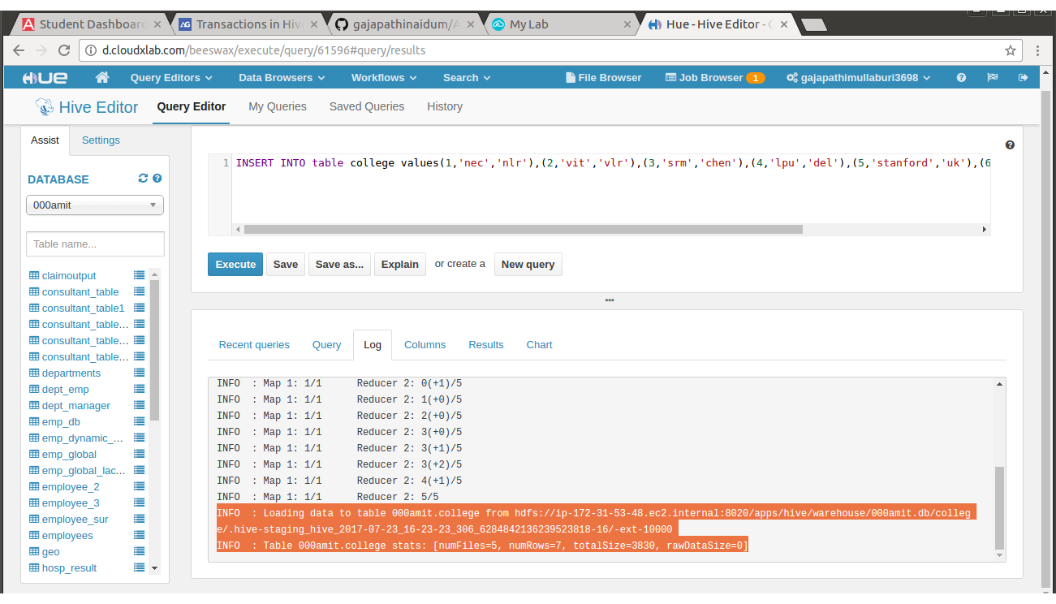
The contents of the table can be viewed using the command select * from college

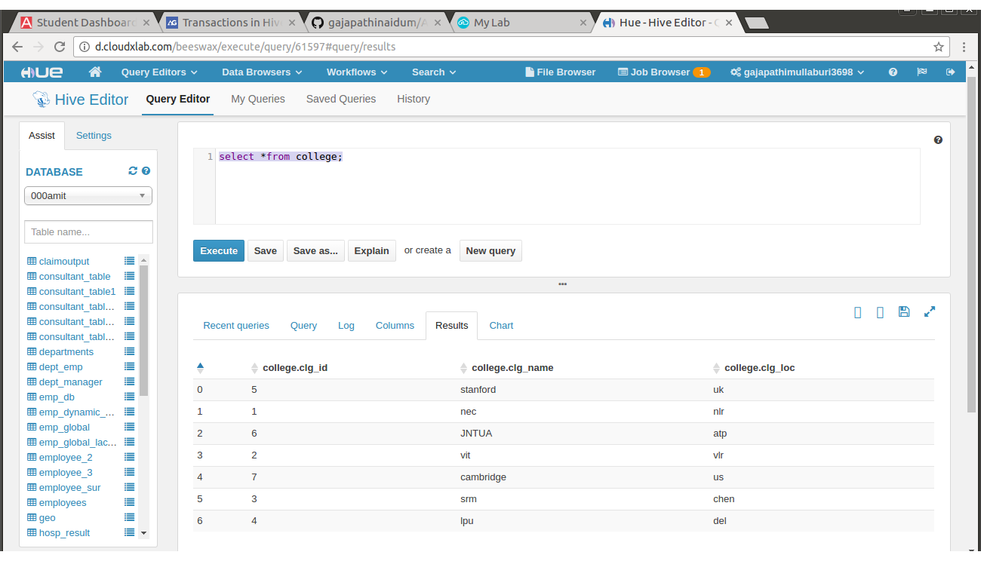

From the above image, we can see that the data has been inserted successfully into the table.
Now if we try to re-insert the same data again, it will be appended to the previous data as shown below:
INSERT INTO table college values(1,'nec','nlr'),(2,'vit','vlr'),(3,'srm','chen'),(4,'lpu','del'),(5,'stanford','uk'),(6,'JNTUA','atp'),(7,'cambridge','us');

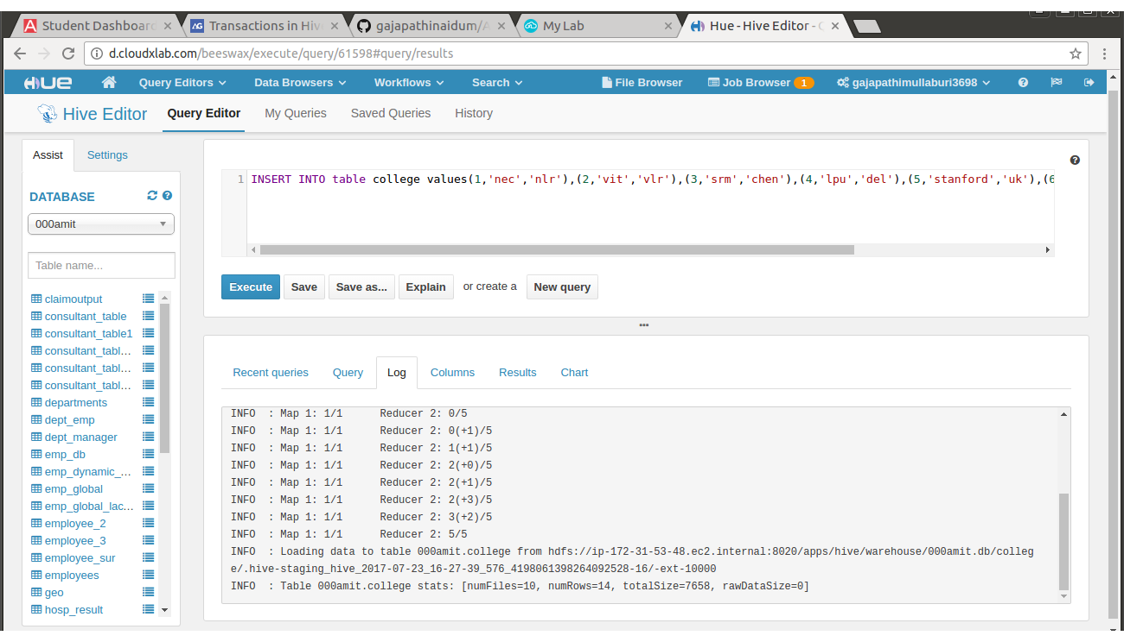

Now, we have successfully inserted the data into the Hive table.
The contents of the table can be viewed using the command select * from college
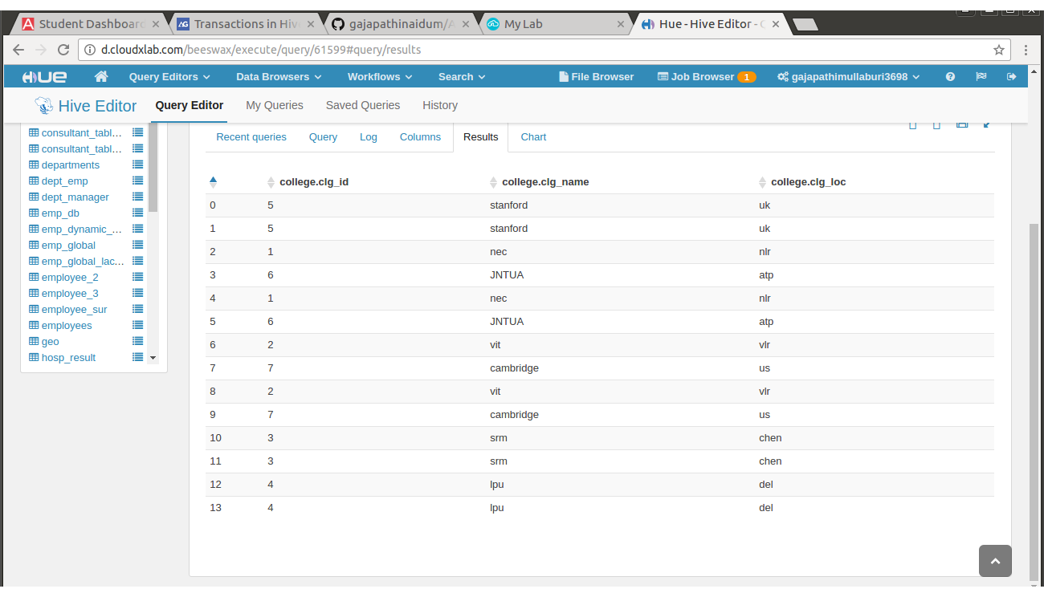
From the above image, we can see that the data has been inserted successfully into the table.
Now if we try to re-insert the same data again, it will be appended to the previous data as shown below:

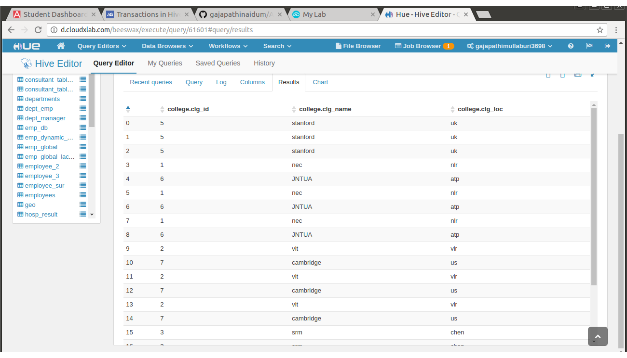

Updating the Data in Hive Table

UPDATE college set clg_id = 8 where clg_id = 7;

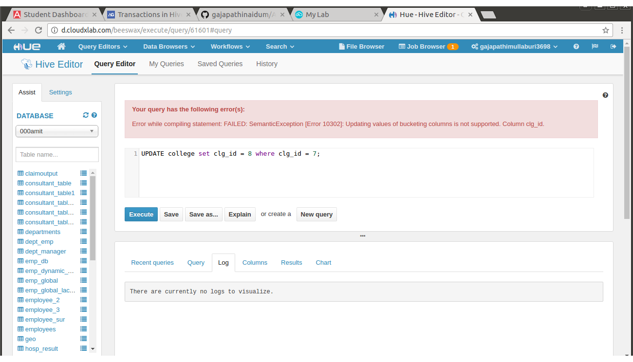
From the above image, we can see that we have received an error message. This means that the Update command is not supported on the columns that are bucketed.
In this table, we have bucketed the ‘clg_id’ column and performing the Update operation on the same column, so we have go the error
FAILED: SemanticException[Error 10302]: Updating values of bucketing columns is not supported. Column clg_id
Now let’s perform the update operation on Non bucketed column

UPDATE college set clg_name = 'IIT' where clg_id = 6;

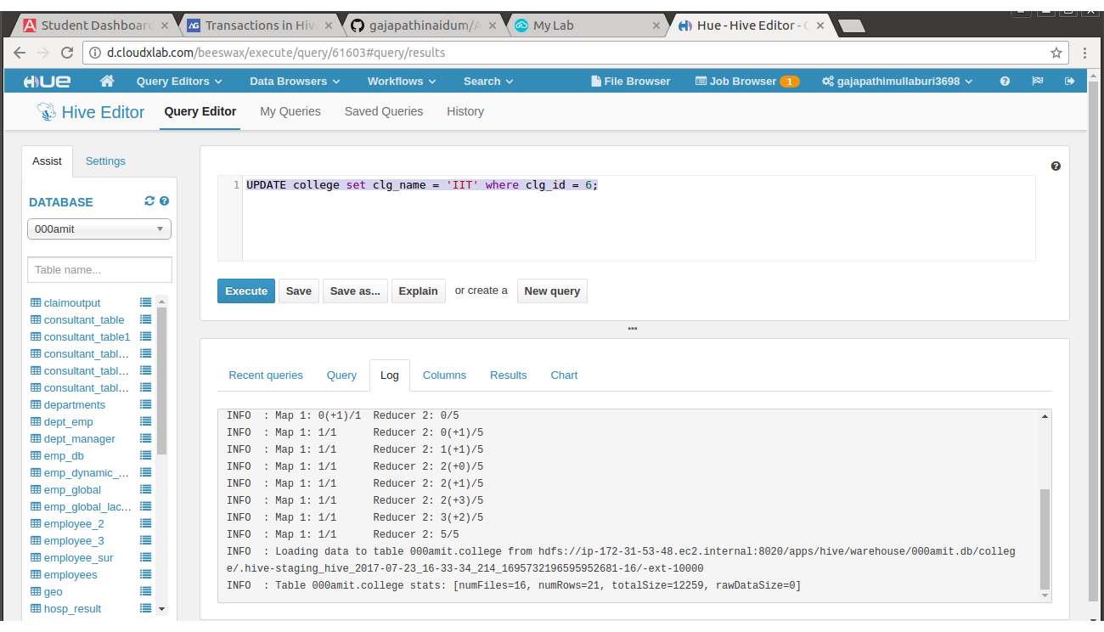
We have successfully updated the data.
The updated data can be checked using the command select * from college.
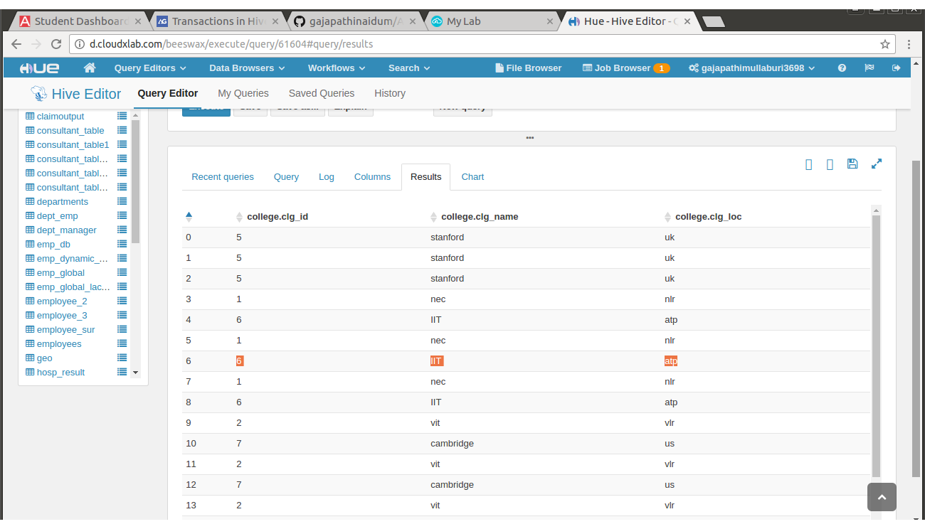

We can see that the data has been updated successfully.
Now let’s perform the Delete operation on the same table.

Deleting a Row from Hive Table

delete from college where clg_id=5;

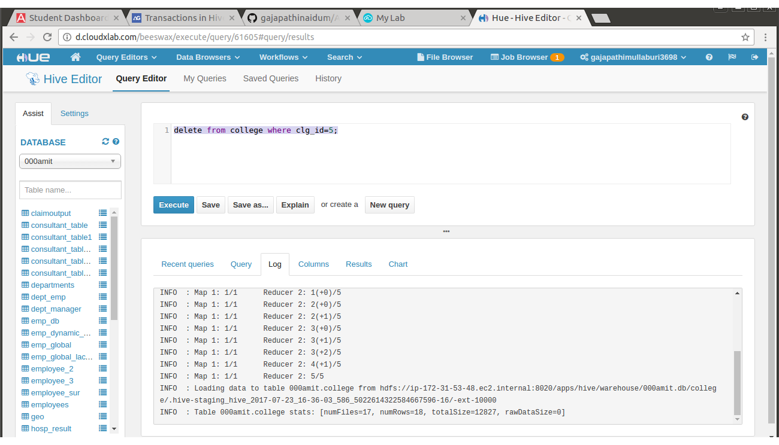
We have now successfully deleted a row from the Hive table. This can be checked using the command select * from college.
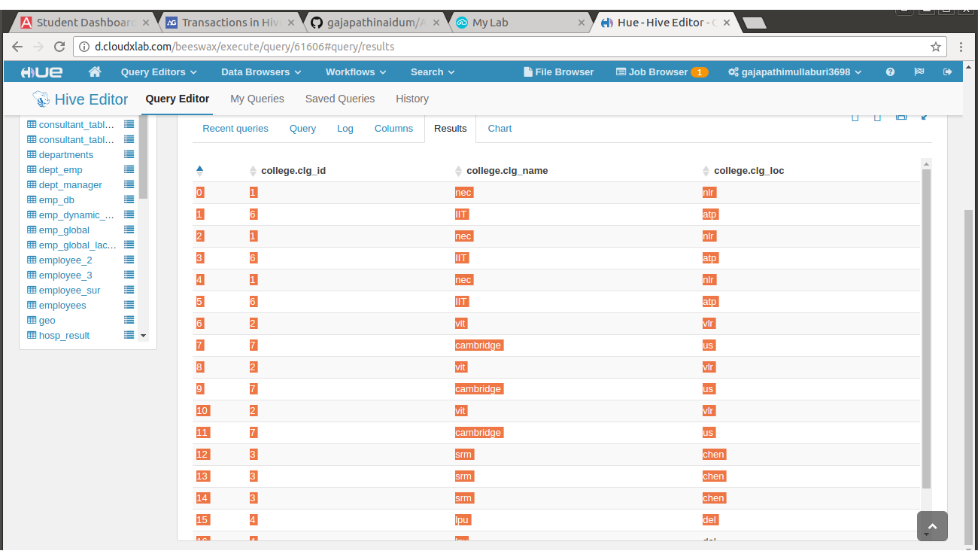
We have successfuly deleted clg_id=5 from table.

