Task 1:

Checking directory available or not .

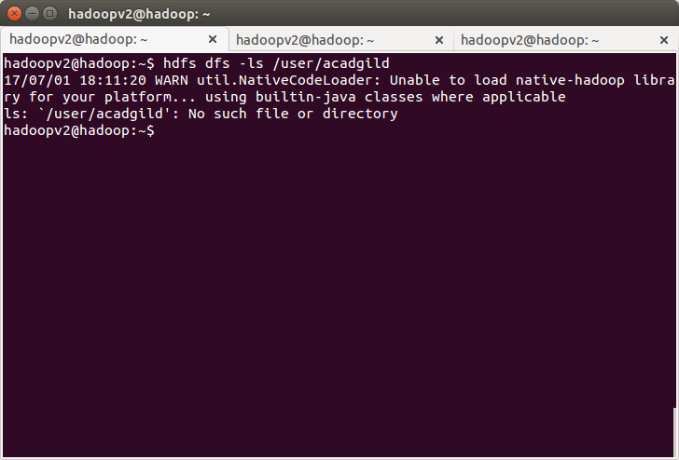
Creating directory:
i have created folder hadoop under /home/hadoopv2 since my machine name is hadoopv2 and practising in my own setup.
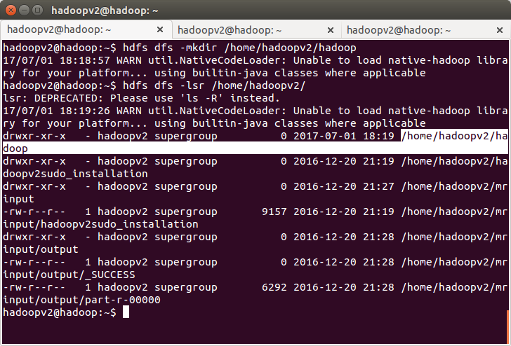
Task 2:

creating word-count.txt file.

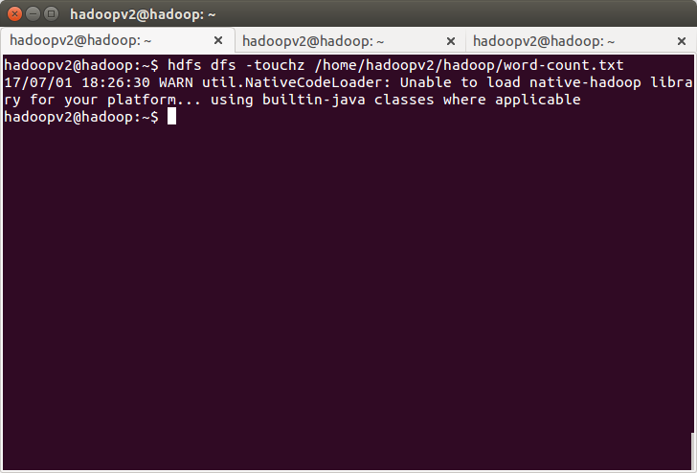
Entering text from terminal
