Task 3:

creating file max-temp.txt file in local and writting data into file.
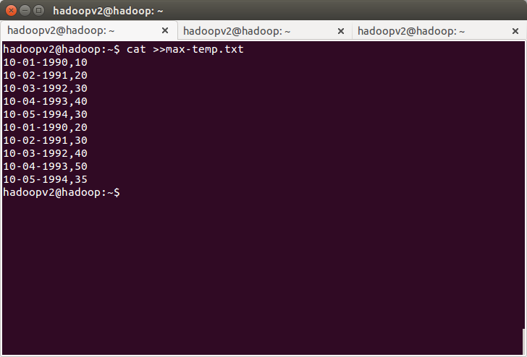
Moving file local to hdfs:

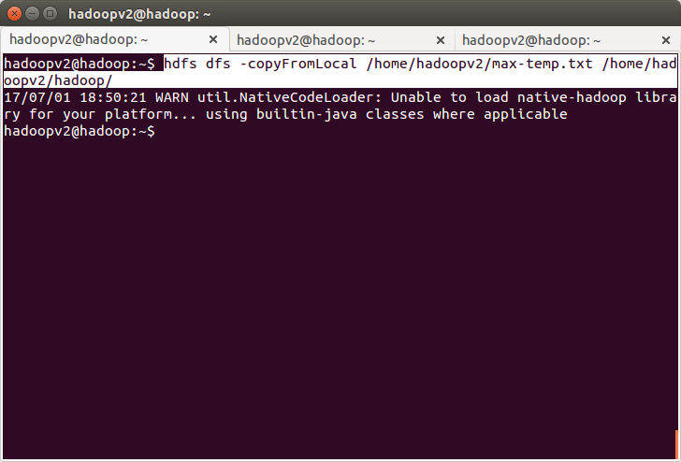
Task 4:
changing the file permissions

