Hbase Assignment2:

Problem 1: create table clicks with column family 'hits' such that it should able to store 5 values:

create 'clicks', {NAME => 'hits', VERSIONS => 5}

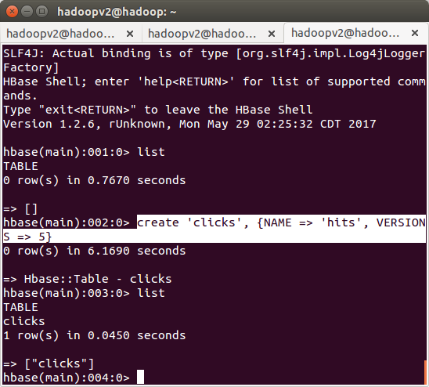
Problem 2:

Adding and updating records:

adding data:
put 'clicks' ,'199.20.201.33','hits:site','3'
put 'clicks' ,'199.20.201.34','hits:site','4'

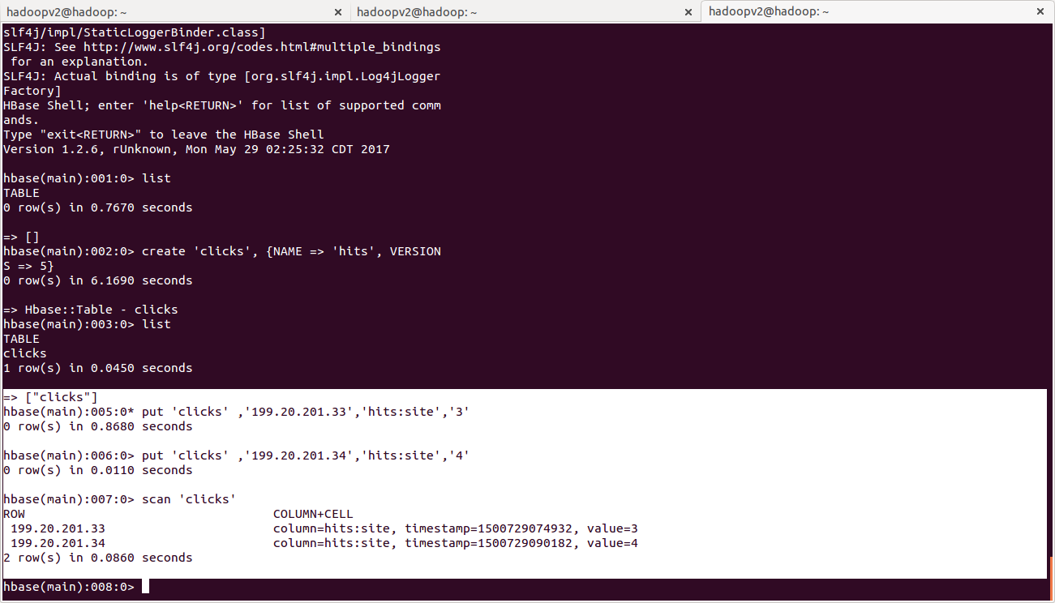

Updating data:

hbase(main):008:0> put 'clicks','199.20.201.33','hits:site','5'
0 row(s) in 0.0150 seconds

hbase(main):009:0> put 'clicks','199.20.201.33','hits:site','6'
0 row(s) in 0.0080 seconds

hbase(main):010:0> put 'clicks','199.20.201.33','hits:site','7'
0 row(s) in 0.0070 seconds

hbase(main):011:0> put 'clicks','199.20.201.33','hits:site','8'
0 row(s) in 0.0060 seconds
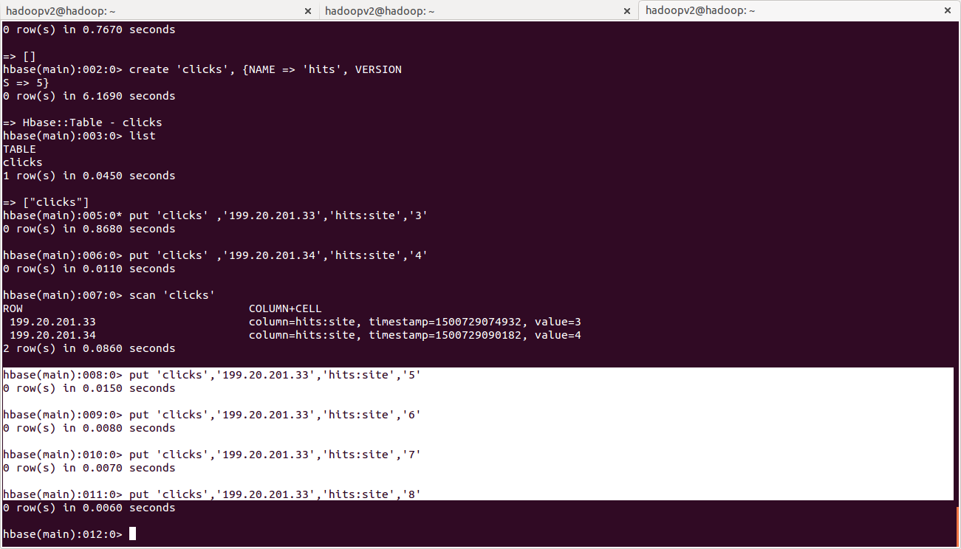

selecting all versions of data:

scan 'clicks', {VERSIONS => 5}

