Hive Assignment_6.1:

Creating DB custom:
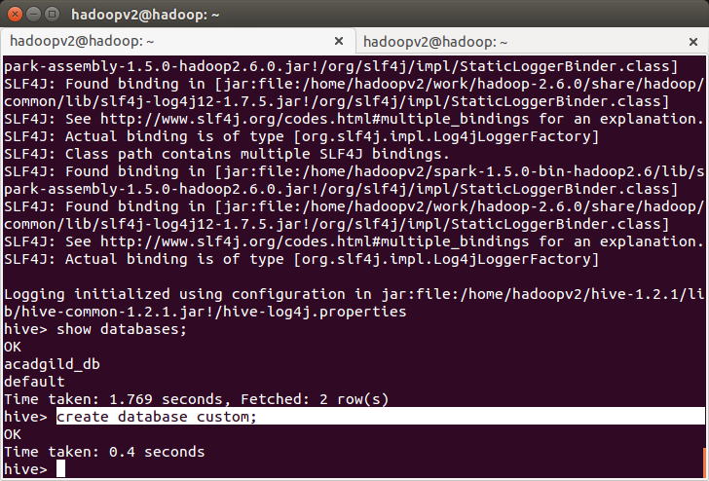
creating temprature_data table and loading data into table
