Hive Assignment 6.2:
.............................................................
1.Fetch date and temprature from temprature_data where zip code is greater than 300000 and lessthan 399999

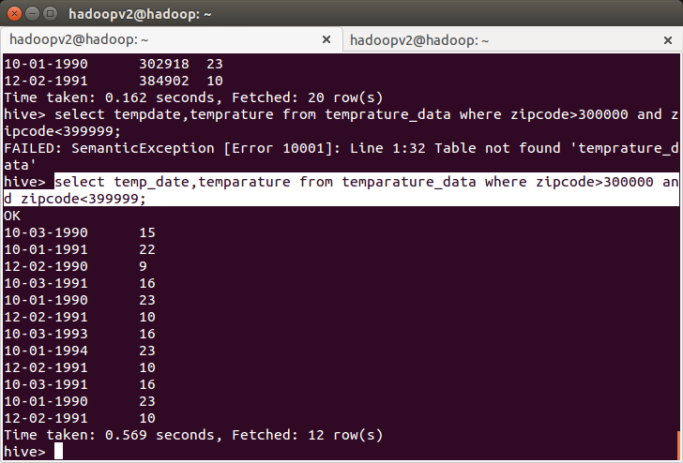
2.calculate maximum temparature corresponding to every year from temperature_data table.

select substring(temp_date,7),max(temparature) from temparature_data group by substring(temp_date,7);

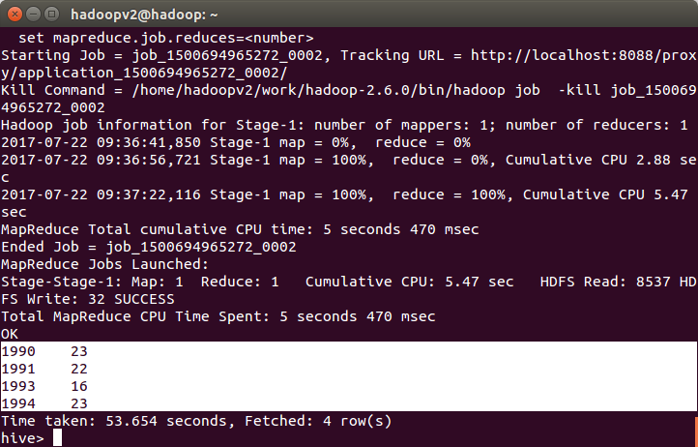
3. Calculate maximum temprature from temprature table corresponding those years which have atleast 2 entries in the table.

select substring(temp_date,7),max(temparature) from temparature_data group by substring(temp_date,7) having count(cast(substring(temp_date,7) as int))>=2;

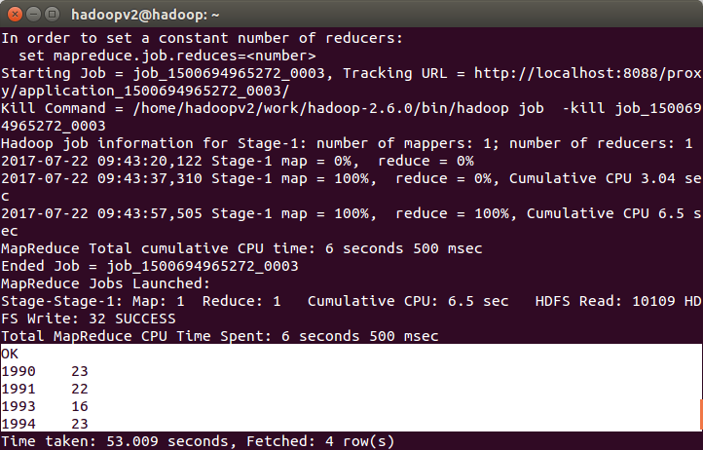
4. Create view on top of last quesry and name it temprature_data_vw.

create view temprature_data_vw as select substring(temp_date,7),max(temparature) from temparature_data group by substring(temp_date,7) having count(cast(substring(temp_date,7) as int))>=2;

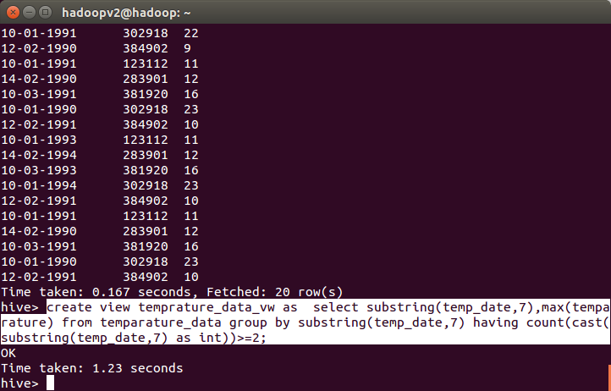
select *from temprature_data_vw ;

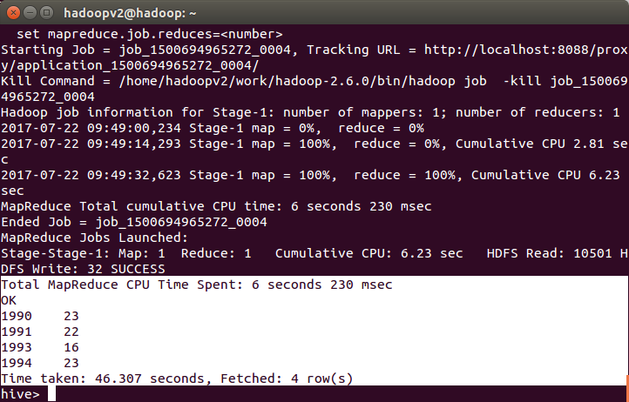
5.Export data from temprature_data_vw to local file system such that each file is '|' delemitted.

INSERT OVERWRITE LOCAL DIRECTORY '/home/hadoopv2/temp_data.txt'
ROW FORMAT DELIMITED fields terminated by '|'
SELECT * FROM temprature_data_vw;

