Hive operations Assignment_7.1:

create table employee(name string,skill string,id int,loc string) row format delimited fields terminated by ',';

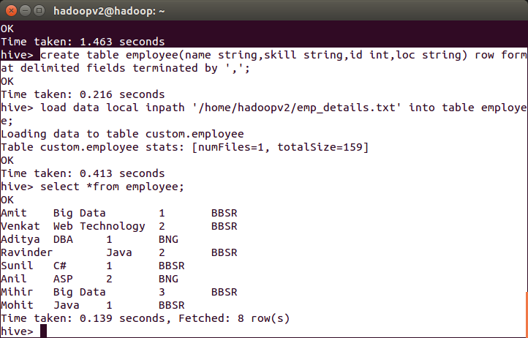

Problem: calculate number of employees corresponding to each skill from the table employee :

select skill,count(name) from employee group by skill;

