Hive Operations Assignment7_1:

problem : calculate number of employees corresponding to each skill from table employee which is loaded in demo:

create table athlete_data(name String,age int,country String,year int,
closing_data String,sport String,gold_medals int,silver_medals int,
bronze_medals int,total_medals int)
ROW FORMAT SERDE 'org.apache.hadoop.hive.serde2.OpenCSVSerde'
WITH SERDEPROPERTIES (
"separatorChar" = "\t",
"quoteChar" = "'",
"escapeChar" = "\\"
)
STORED AS TEXTFILE;

load data local inpath '/home/hadoopv2/Downloads/olympix_data.csv' into table athlete_data;

1. Write a Hive program to find the number of medals won by each country in swimming.

select country,sum(total_medals) as Total_Medals from athlete_data where sport='Swimming' group by country;

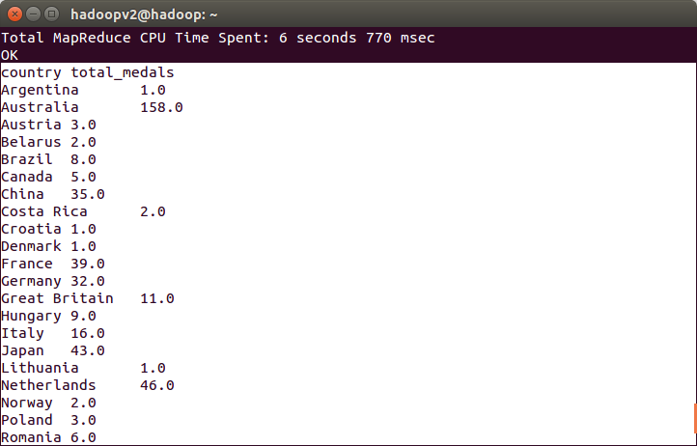

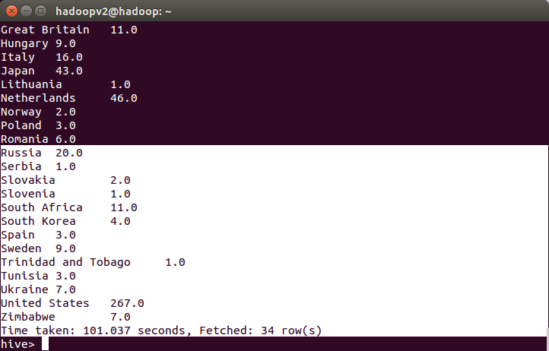
2. Write a Hive program to find the number of medals that India won year wise

select year,sum(total_medals) from athlete_data where country='India' group by year;

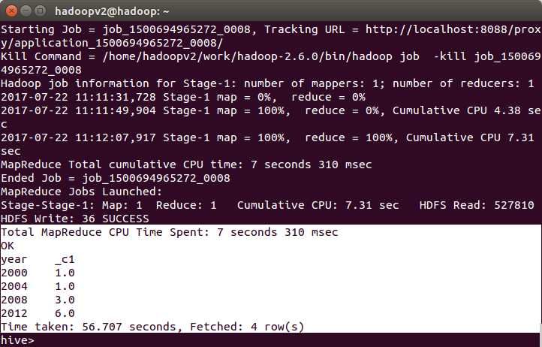
3. Write a Hive Program to find the total number of medals each country won.

select country,sum(total_medals) as Total_Medals from athlete_data group by country;

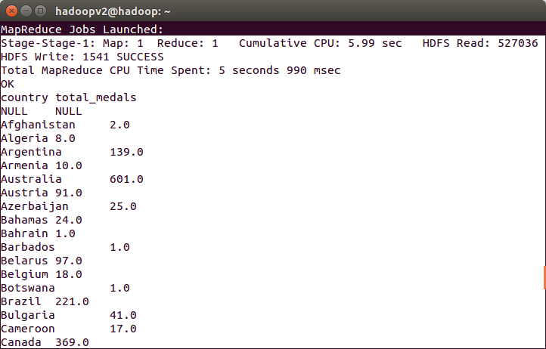

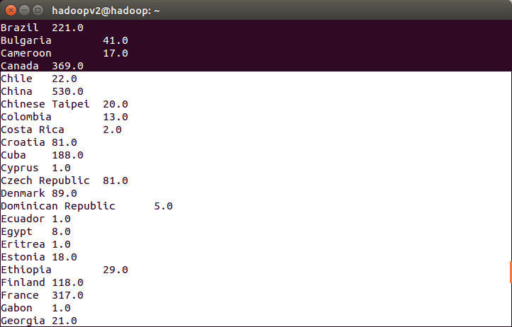

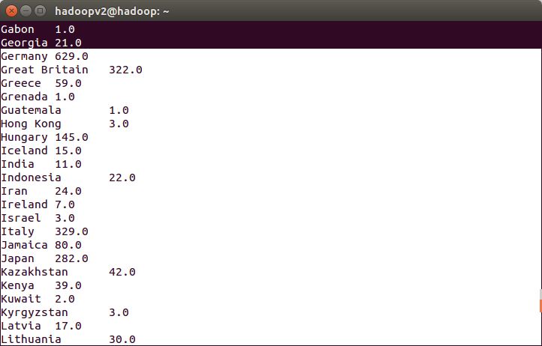

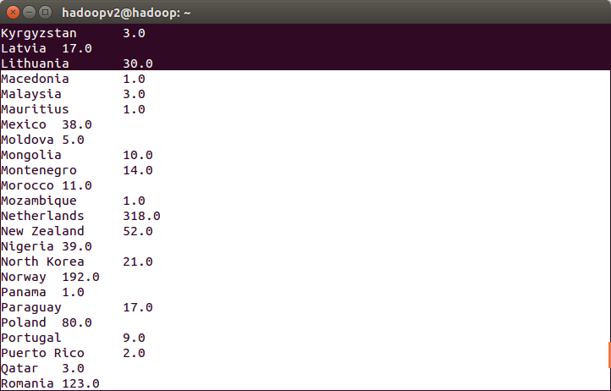

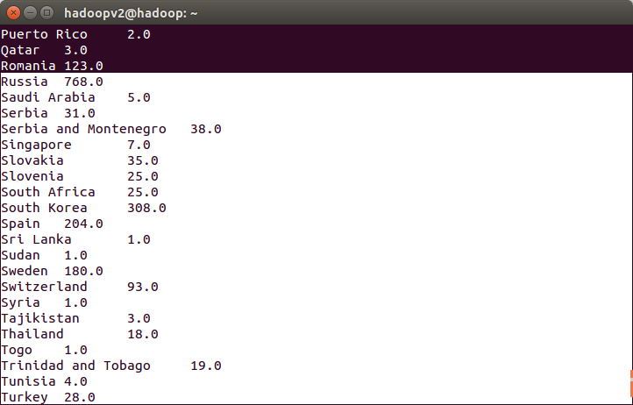

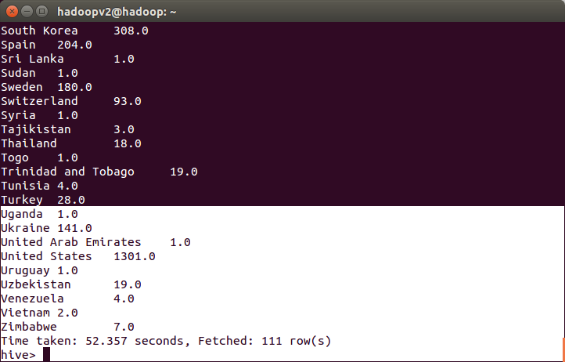

4. Write a Hive program to find the number of gold medals each country won.

select country,sum(gold_medals) as Total_Gold_Medals from athlete_data group by country;

