Advanced Hive_8.1:

CREATE EXTERNAL TABLE IF NOT EXISTS emp (
emp_no int,
ename string,
job string,
mgr_id int,
date_of_joining string,
salary int,
bonus int,
dept_no int)
ROW FORMAT DELIMITED
FIELDS TERMINATED BY ','
LINES TERMINATED BY '\n'
NULL DEFINED AS '00'
STORED AS TEXTFILE;

emp data(prepared own data set):

7369,SMITH,CLERK,7902,17-DEC-1980,800,\000,20
7499,ALLEN,SALESMAN,7698,20-FEB-1981,100,300,30
7521,WARD,SALESMAN,7698,22-FEB-1981,1250,500,30
7566,JONES,MANAGER,7839,2-APR-1981,2975,\000,20
7654,MARTIN,SALESMAN,7698,28-SEP-1981,1250,1400,30
7698,BLAKE,MANAGER,7839,1-MAY-1981,2850,\000,30
7782,CLARK,MANAGER,7839,9-JUN-1981,2450,\000,10
7788,SCOTT,ANALYST,7566,09-DEC-1982,3000,\000,20
7839,KING,PRESIDENT,\000,17-NOV-1981,5000,\000,10
7844,TURNER,SALESMAN,7698,8-SEP-1981,1500,0,30
7876,ADAMS,CLERK,7788,12-JAN-1983,1100,\000,20
7900,JAMES,CLERK,7698,3-DEC-1981,950,\000,30
7902,FORD,ANALYST,7566,3-DEC-1981,3000,\000,20
7

1. Get a list of employees who receive a salary less than 100, compared
to their immediate employee with higher salary in the same unit

select e.*
from (select e.*, max(salary) over (partition by dept_no) as maxsalary
from emp e
) e
where e.maxsalary-e.salary<100;
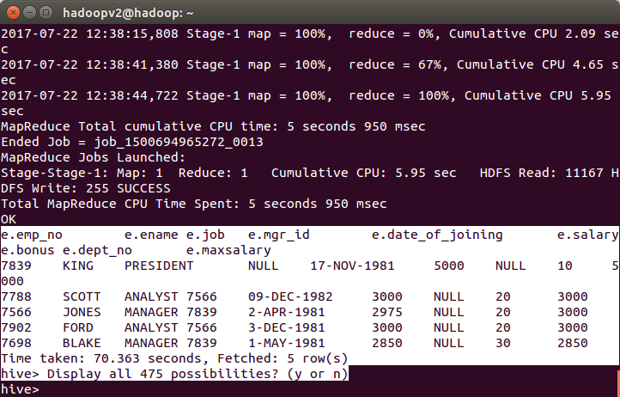

2.List of all employees who draw higher salary than the average salary
of that departmen

select e.*
from (select e.*, avg(salary) over (partition by dept_no) as avgsalary
from emp e
) e
where e.salary > e.avgsalary;

