Starting pig in local mode:

pig -x local

a.Top 5 employees with highest rating:

1.emp = LOAD '/home/hadoopv2/employee_details.txt' USING PigStorage(',') as ( id:int, name:chararray, sal:int, rating:int);
2.empOrder = order emp by rating,name;
3.top5Employees = LIMIT empOrder 5;
4.finalResult = FOREACH top5Employees generate id,name;
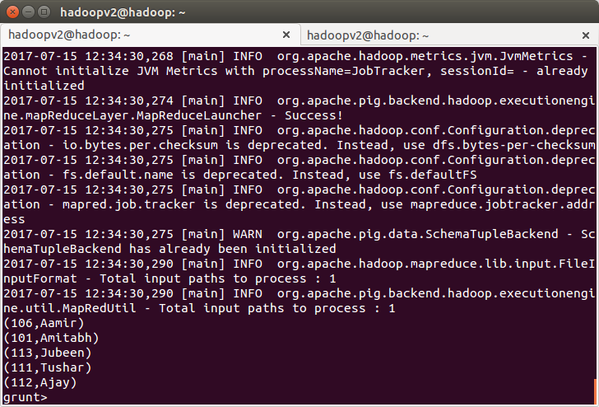
b)Top3 employees with highest salary:

1.emp = LOAD '/home/hadoopv2/employee_details.txt' USING PigStorage(',') as ( id:int, name:chararray, sal:int, rating:int);
2.empOddempid = FILTER emp by id%2!=0
3.empSalOrder = order empOddempid by sal desc,name
4.top5Employees = LIMIT empSalOrder 3;
5.finalResult = FOREACH top5Employees generate id,name;
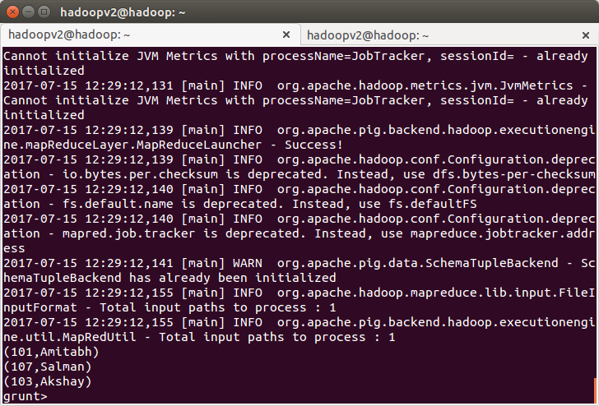
c)Employees with maximum expense:

1.emp = LOAD '/home/hadoopv2/employee_details.txt' USING PigStorage(',') as ( id:int, name:chararray, sal:int, rating:int);
2.emp_exp = LOAD '/home/hadoopv2/employee_expenses.txt' as ( id:int, expense:int);

3 join_tables = JOIN emp by id,emp_exp by id;
4 max_expense = ORDER join_tables by expense DESC,name;
5 maxExpenseEmployee = LIMIT max_expense 1;
6 final_reult = FOREACH maxExpenseEmployee generate emp::id,emp::name;

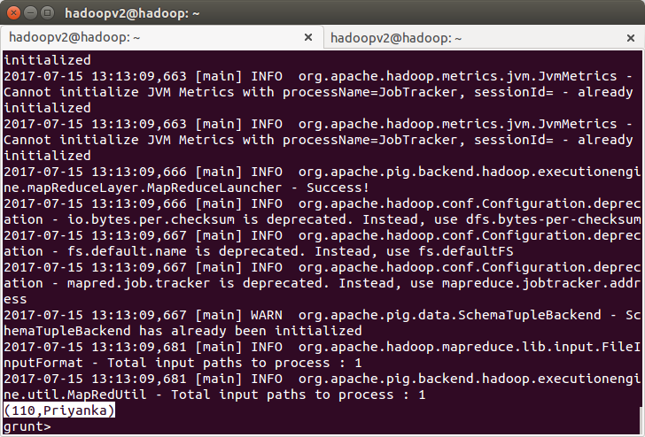
d)List of employees having entries in Employess expenses file:
1.emp = LOAD '/home/hadoopv2/employee_details.txt' USING PigStorage(',') as ( id:int, name:chararray, sal:int, rating:int);
2.emp_exp = LOAD '/home/hadoopv2/employee_expenses.txt' as ( id:int, expense:int);
3.join_tables = JOIN emp by id,emp_exp by id;
4.emp_entries = FOREACH join_tables generate emp::id,emp::name;
5.final_result = DISTINCT emp_entries;

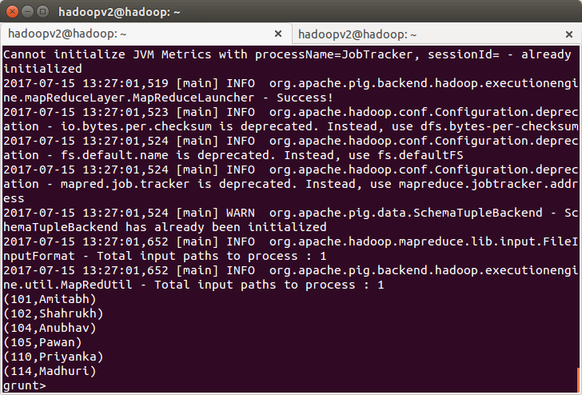
e)List of employees not having entries in Employess expenses file:
1.emp = LOAD '/home/hadoopv2/employee_details.txt' USING PigStorage(',') as ( id:int, name:chararray, sal:int, rating:int);
2.emp_exp = LOAD '/home/hadoopv2/employee_expenses.txt' as ( id:int, expense:int);
3.join_tables = JOIN emp by id LEFT OUTER,emp_exp by id;
4.filter_emp = FILTER join_tables BY emp_exp::id is null;
5. final_result = FOREACH filter_emp generate emp::id,emp::name;
