Aviation-data-analysis

Problem Statement 1
Find out the top 5 most visited destinations.
In relation A, we are loading the dataset using CSVExcelStorage

In relation B, we are generating the columns that are required for processing and explicitly typecasting each of them.

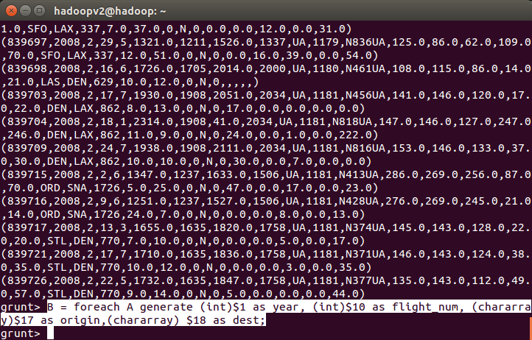
In relation C, we are filtering the null values from the “dest” column.
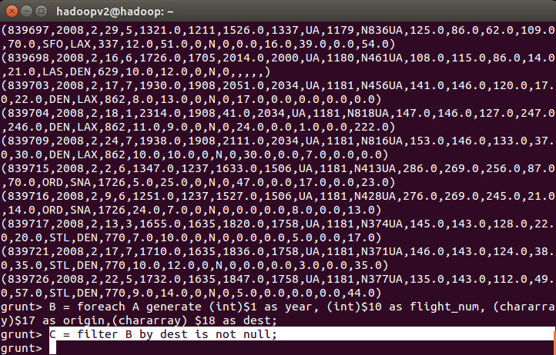
In relation D, we are grouping relation C by “dest.”
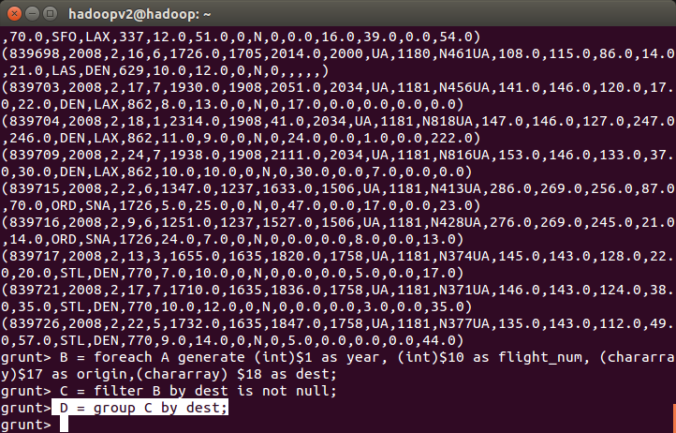
In relation E, we are generating the grouped column and the count of each
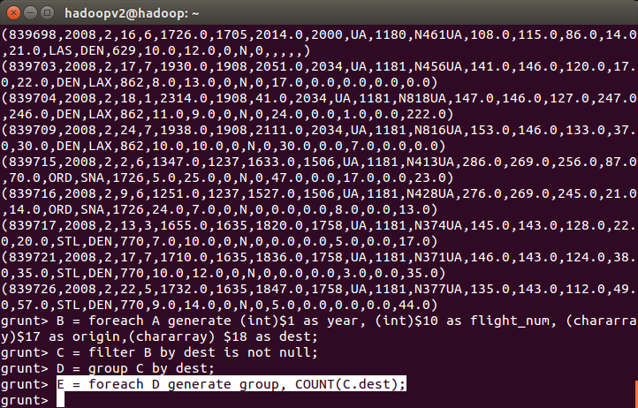
Relation F and Result is used to order and limit the result to top 5.
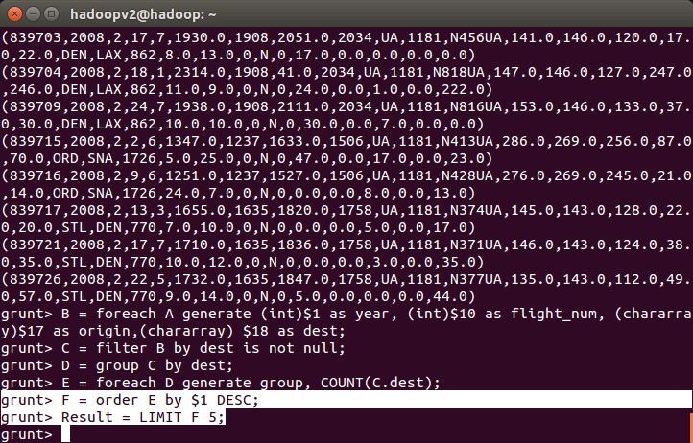
In relation A1, we are loading another table to which we will look-up and find the city as well as the country.
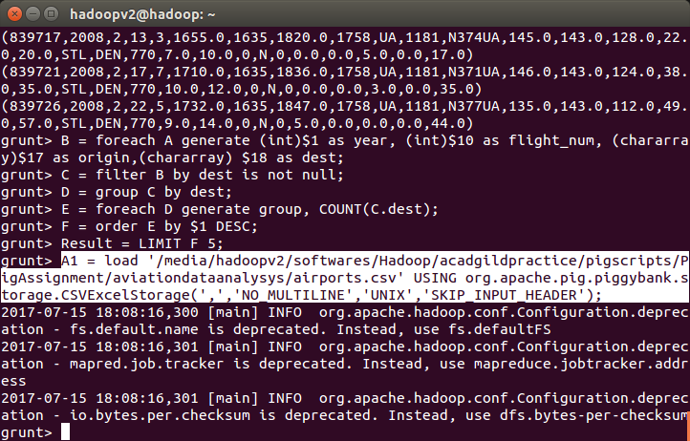
In relation A2, we are generating dest, city, and country from the previous relation.
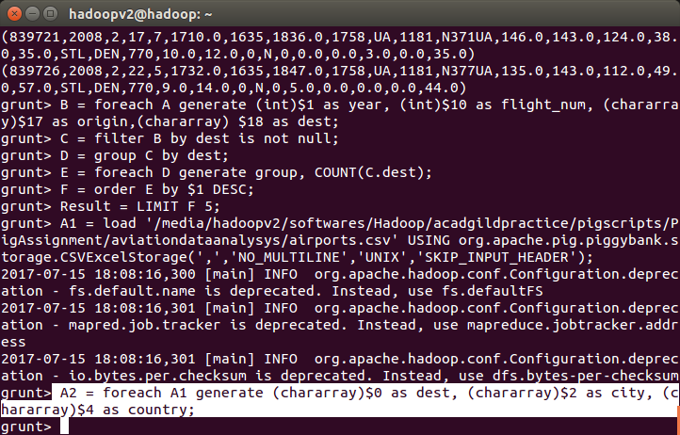
In relation joined_table, we are joining Result and A2 based on a common column, i.e., “dest”
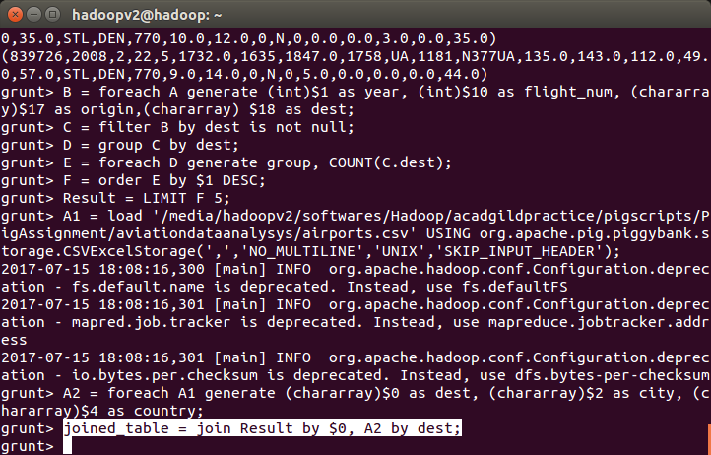
Finally, using dump, we are printing the result.
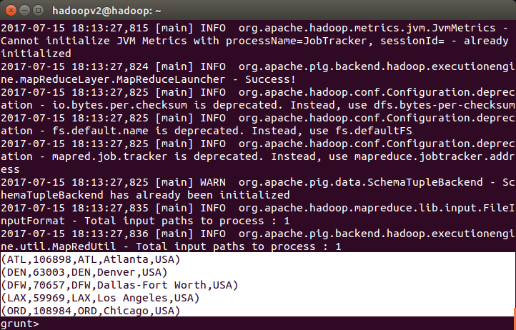

Problem Statement 2
Which month has seen the most number of cancellations due to bad weather?
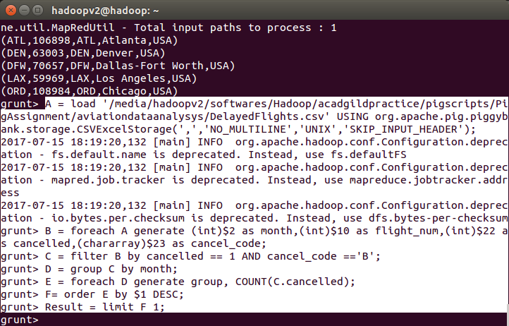
In relation A, we are loading the dataset using CSVExcelStorage because of its effective technique to handle double quotes and header.
In relation B, we are generating the columns which are required for processing and explicitly typecasting each of them.
In relation C, we are filtering the data based on cancellation and cancellation code, i.e., canceled = 1 means flight have been canceled and cancel_code = ‘B’ means the reason for cancellation is “weather.” So relation C will point to the data which consists of canceled flights due to bad weather.
In relation D, we are grouping the relation C based on every month.
In relation E, we are finding the count of canceled flights every month
Result is for ordering and finding the top month based on cancellation.


Problem Statement 3
Top ten origins with the highest AVG departure delay
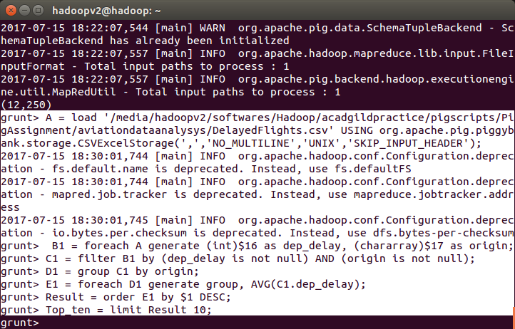
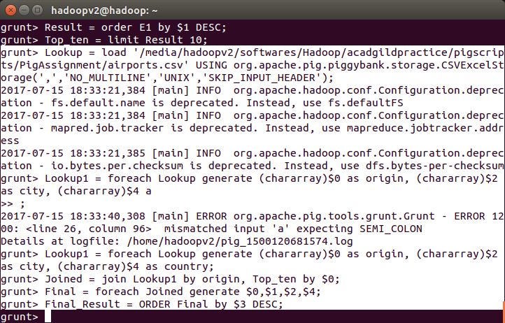
Explanation of first 3 lines are the same as explained in the previous 2 problem statements.
In relation C1, we are removing the null values fields present if any.
In relation D1, we are grouping the data based on column “origin.”
In relation E1, we are finding average delay from each unique origin.
Relations named Result and Top_ten are ordering the results in descending order and printing the top ten values.
These steps are good enough to find the top ten origins with the highest average departure delay.
However, rather than generating just the code of origin, we will be following a few more steps to find some more details like country and city.
In the relation Lookup, we are loading another table to which we will look up and find the city as well as the country.
In the relation Lookup1, we are generating the destination, city, and country from the previous relation.
In the relation Joined, we are joining relation Top_ten and Lookup1 based on common a column, i.e., “origin.”
In the relation Final, we are generating required columns from the Joined table.
Finally, we are ordering and printing the results.
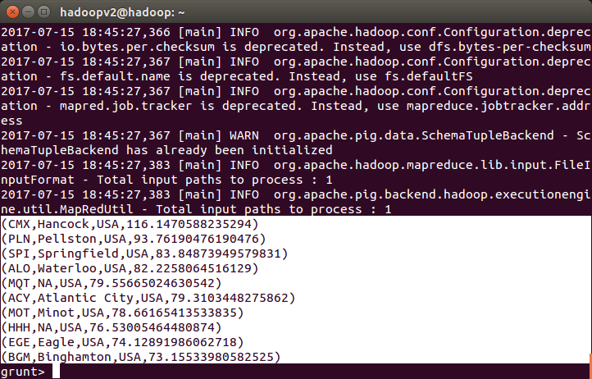

Problem Statement 4
Which route (origin & destination) has seen the maximum diversion?
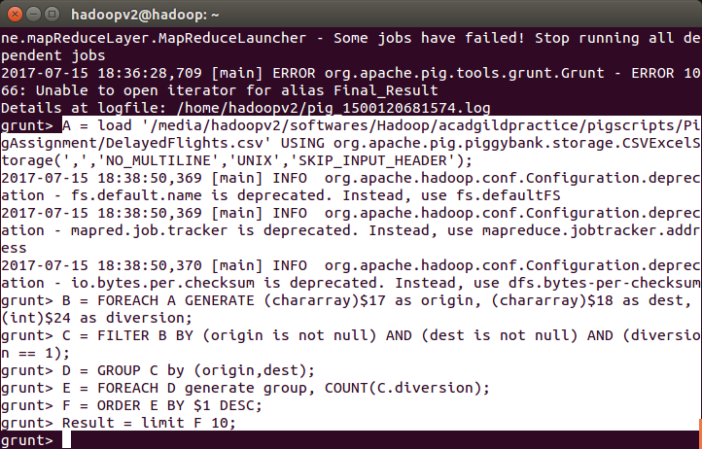
In relation A, we are loading the dataset using CSVExcelStorage because of its effective technique to handle double quotes and headers.
In relation B, we are generating the columns which are required for processing and explicitly type-casting each of them.
In relation C, we are filtering the data based on “not null” and diversion =1. This will remove the null records, if any, and give the data corresponding to the diversion taken.
In relation D, we are grouping the data based on origin and destination.
Relation D finds the count of diversion taken per unique origin and destination.
Relations F and Result orders the result and produces top 10 results.


