PIG Use Case: Pokemon Data Analysis

Ques 1: Find the list of players that have been selected in the qualifying round (DEFENCE>55).
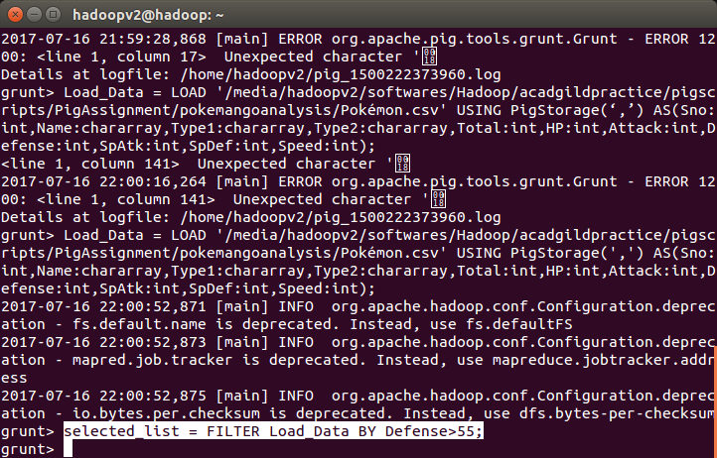
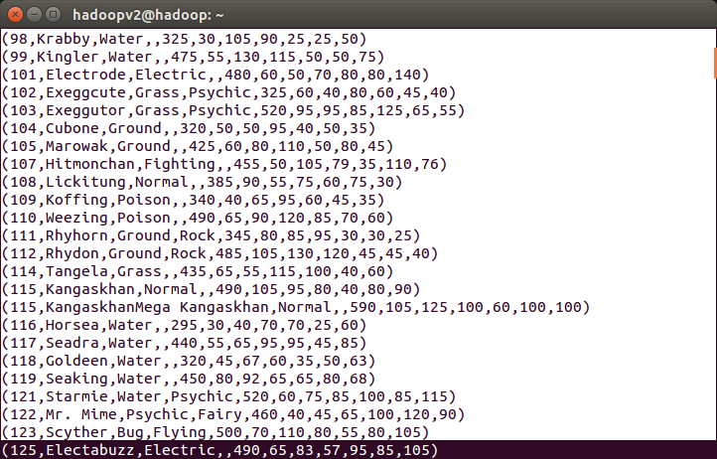

Ques 2: State the number of players taking part in the competition after getting selected in the qualifying round.

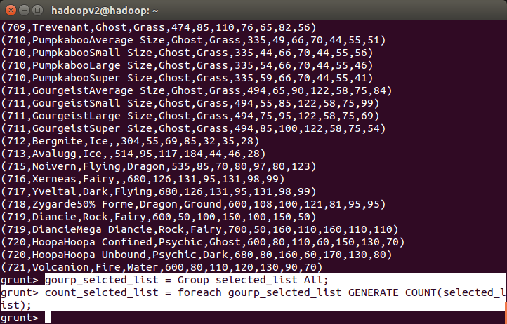
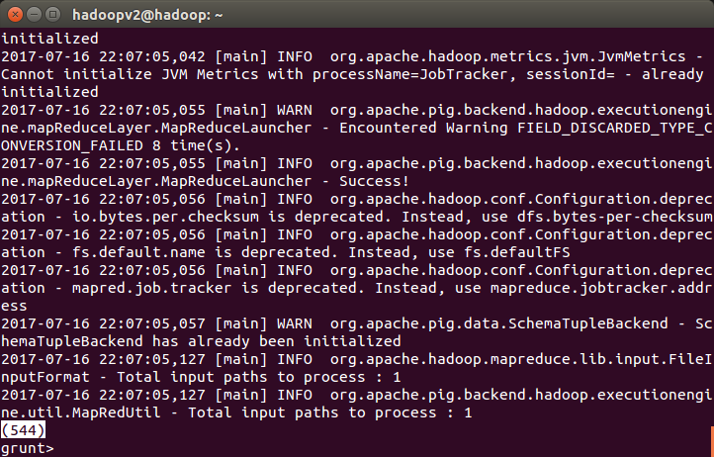
Using random() generate random numbers for each Pokémon on the selected list.
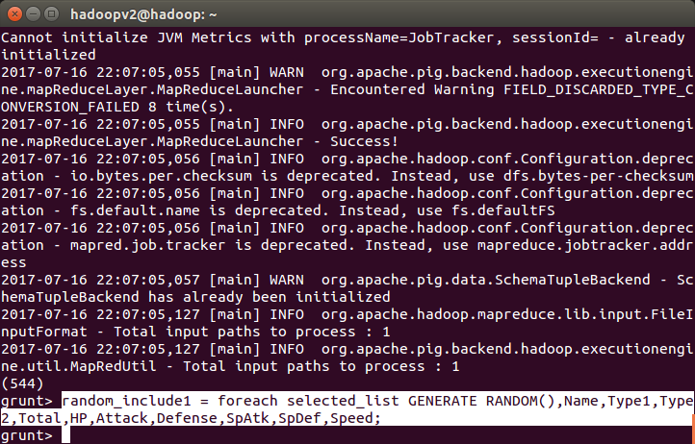

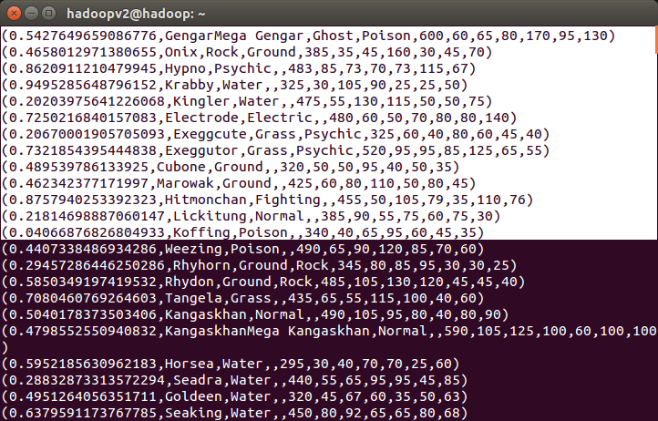
Ques 4: Arrange the new list in a descending order according to a column randomly.
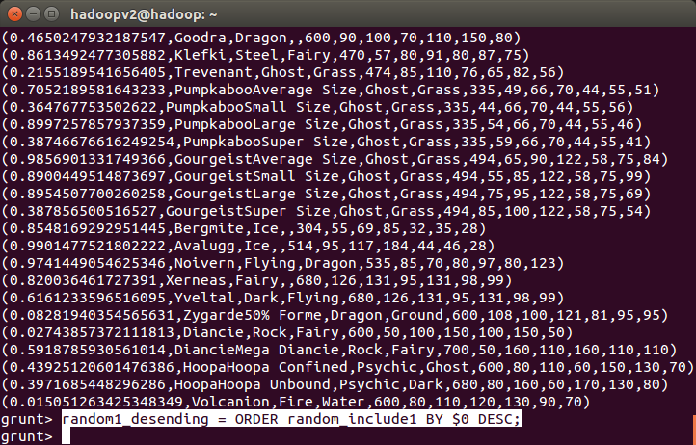

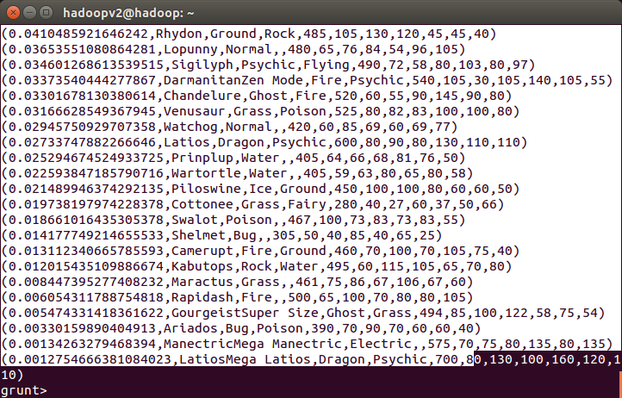
Ques 5: Now on a new relation again associate random numbers for each Pokémon and arrange in descending order according to column random.

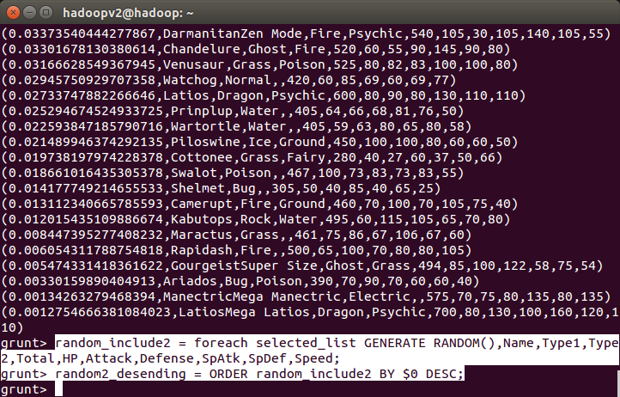
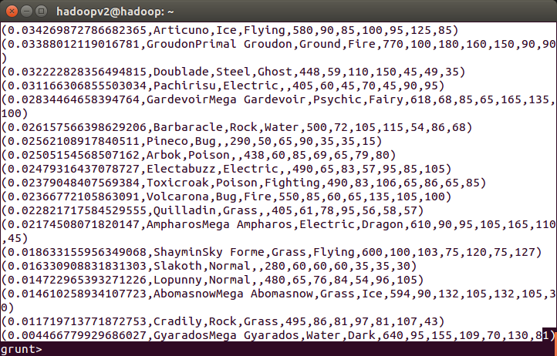
Ques: From the two different descending lists of random Pokémons, select the top 5 Pokémons for 2 different players.

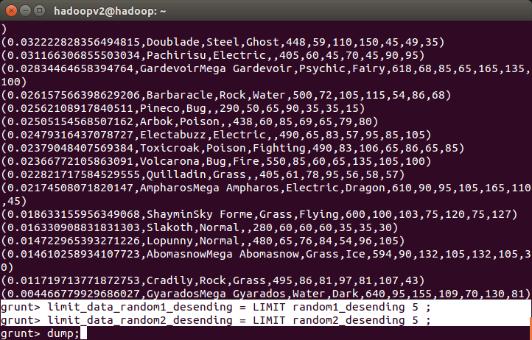
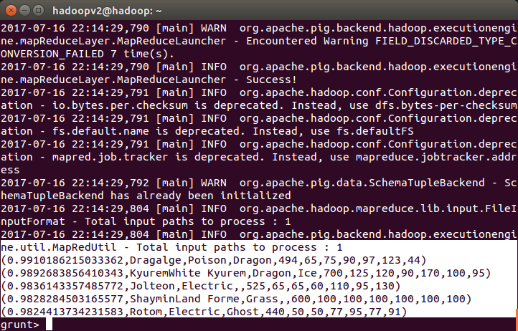
Ques: Store the data on a local drive to announce for the final match. By the name player1 and player2 (only show the NAME and HP).
