1.Pwd: Command is used to find present working directory.
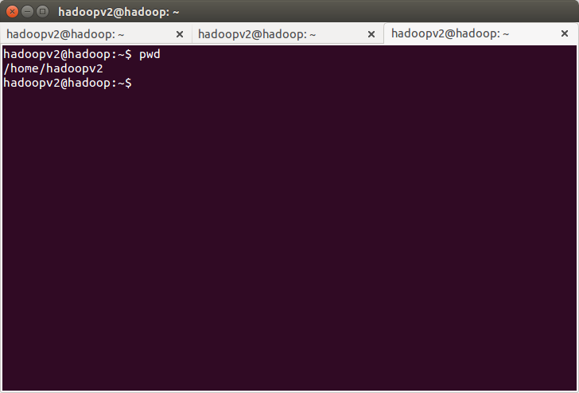
2.Vi: Vi is a virtual editor is a screen editor available on all unix systemes.it is used to write text into file/edit file.

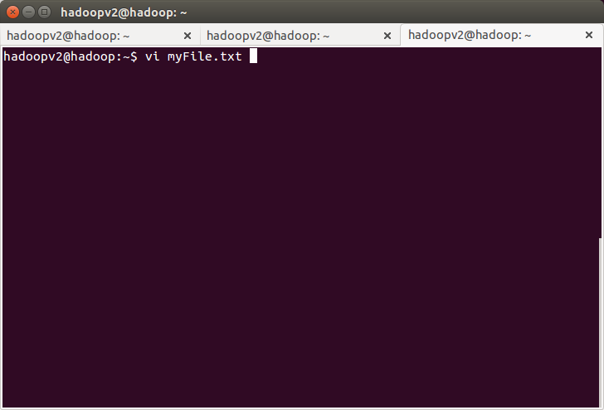
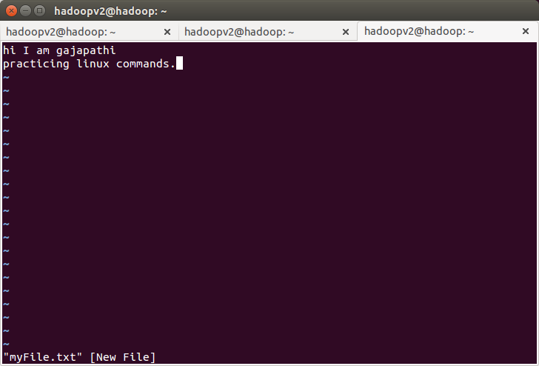
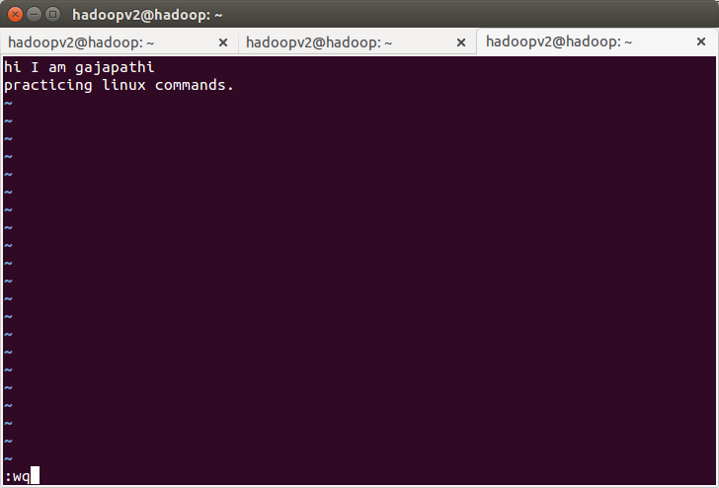
3.touch: it is used to create empty file(0 bytes).
4.mkdir : it is used create directory
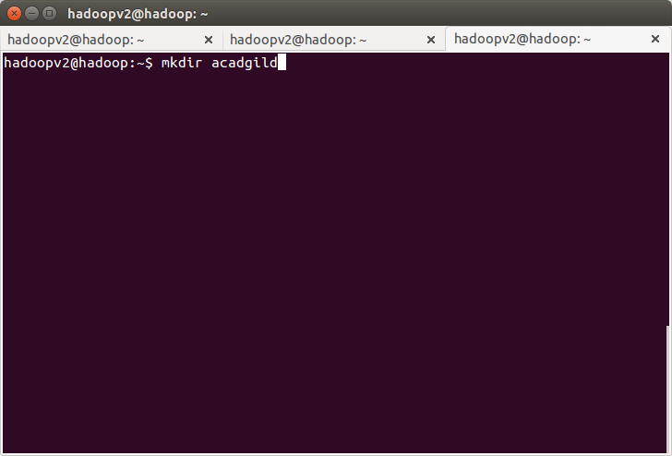
5. rm is used to remove files and directories from unix file system
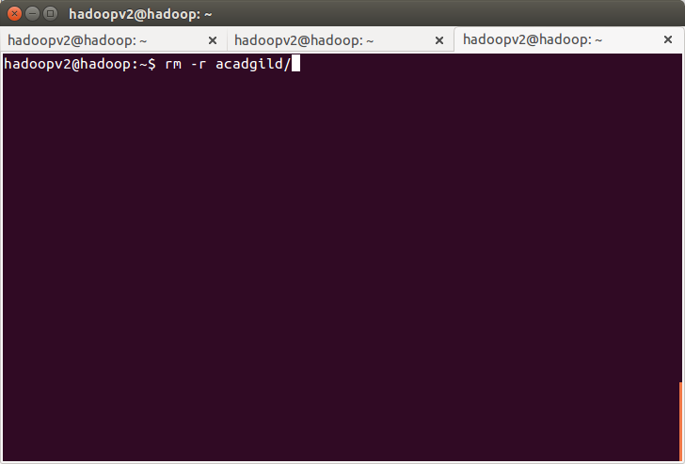
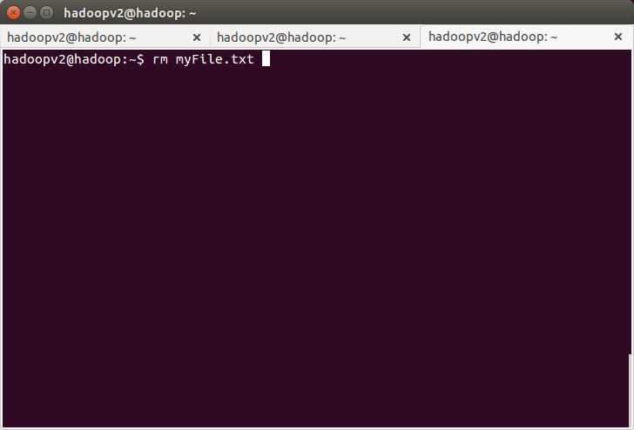
6.ls : it is used to list files/directories.
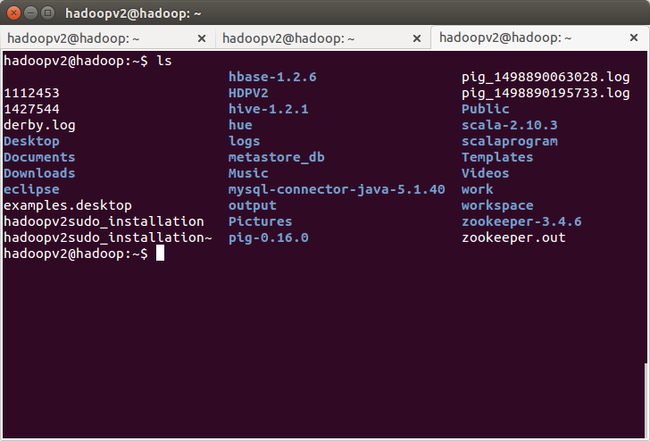
7.echo: it is used to print content.
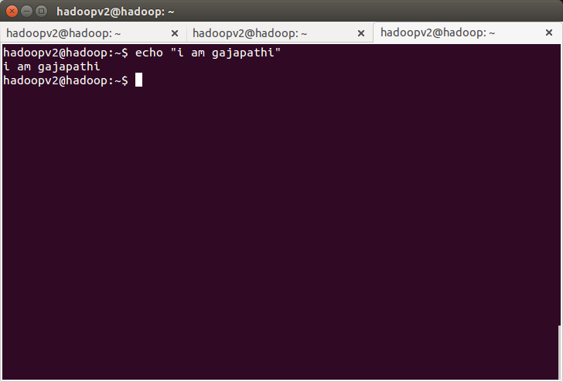
8.cat: it is used to display content from files and also it used to write data into file.
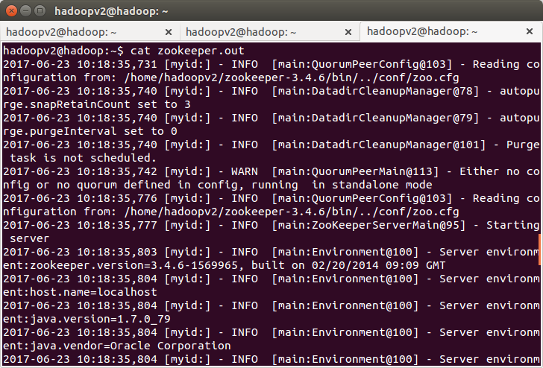

9.Who: used to find looged in users into system
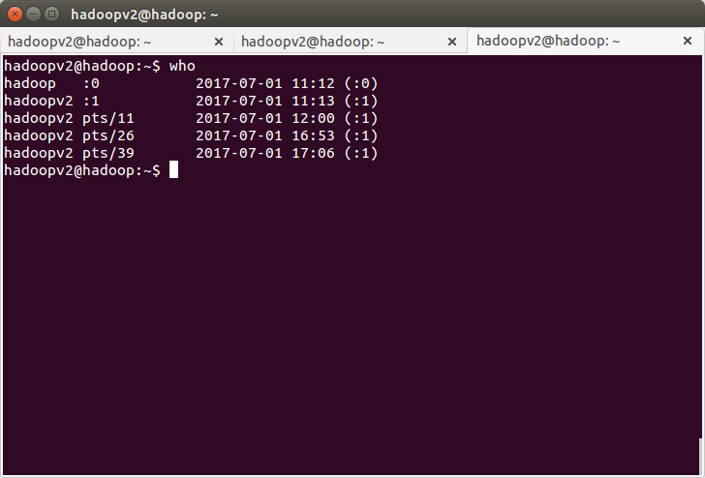
10.cd: it is used to change directory
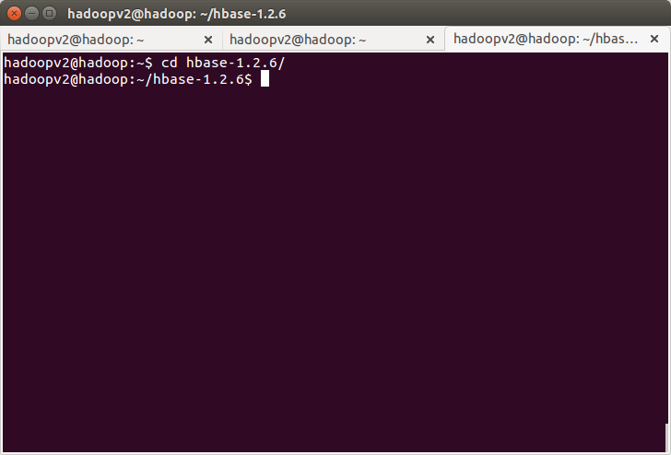
11.date: Display the current time in the given FORMAT, or set the system date.
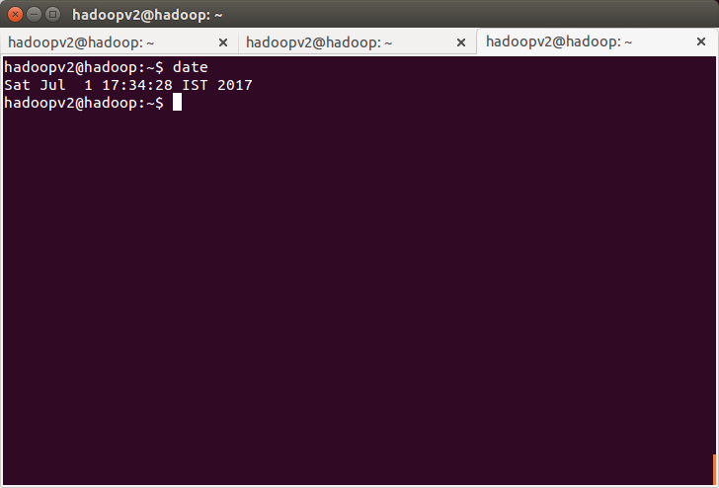
12.cal: used dispaly calendar in linux system
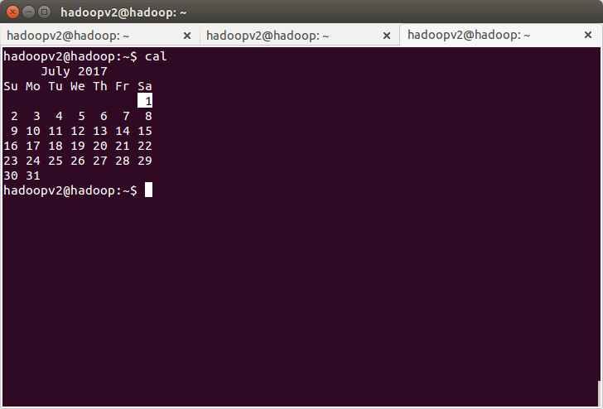
13. mv:Rename SOURCE to DEST, or move SOURCE(s) to DIRECTORY.
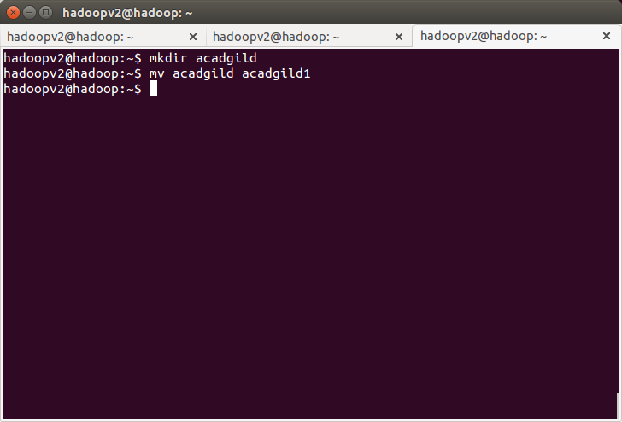
14.cp: Copy SOURCE to DEST, or multiple SOURCE(s) to DIRECTORY.

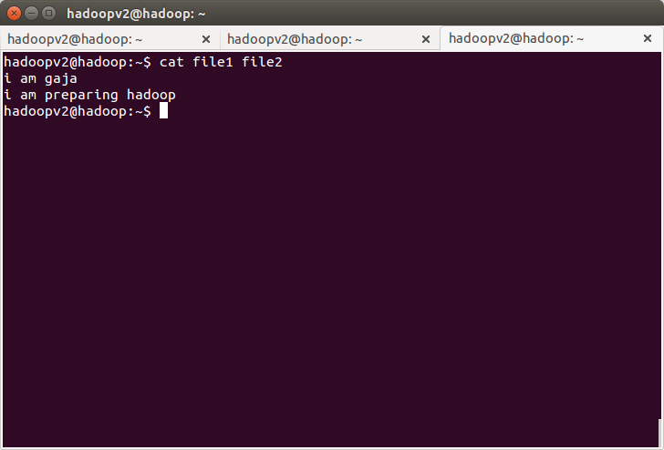
15.which: used to locate executables in the system. It allows user to pass several command namesas arguments to get their paths in the system. “which” commands searches the path of executable in system paths set in $PATH environment variable.
