USA Crime Analysis:

Write a MapReduce/Pig program to calculate the number of cases investigated under each
FBI code:

A = load '/media/hadoopv2/softwares/Hadoop/acadgildpractice/projects/Crimes_-_2001_to_present.csv' USING org.apache.pig.piggybank.storage.CSVExcelStorage(',') AS (ID:chararray,CaseNumber :chararray,Date :chararray,Block :chararray,IUCR :chararray,PrimaryType :chararray,Description :chararray,LocationDescription :chararray,Arrest: boolean,Domestic:boolean,Beat :chararray,District :chararray,Ward :chararray,CommunityArea :chararray,FBICode :chararray,XCoordinate :chararray,YCoordinate :chararray,Year :chararray,UpdatedOn :chararray,Latitude: chararray,Longitude:chararray,Location :chararray);

B = FILTER A BY FBICode is not null;

C = GROUP B BY FBICode;

D = FOREACH C GENERATE group,COUNT(B);

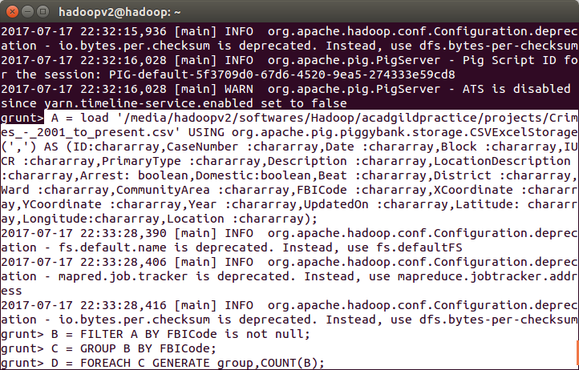
RESULT:
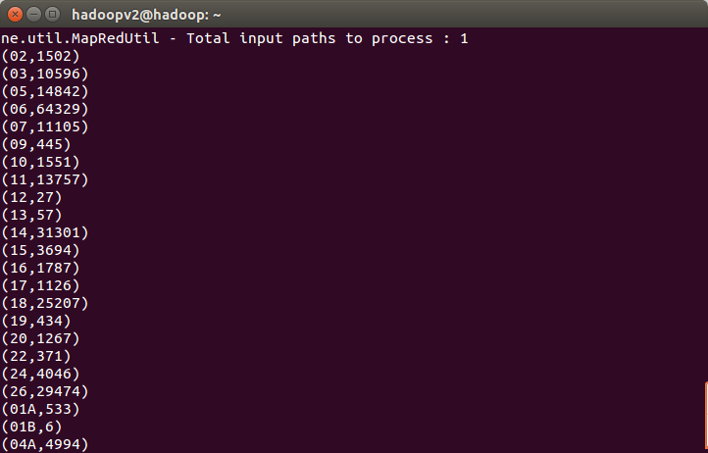
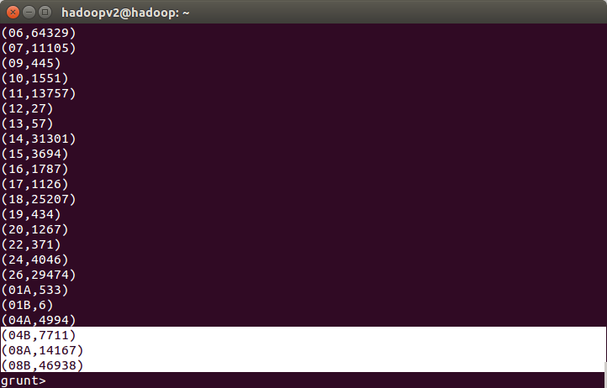

Write a MapReduce/Pig program to calculate the number of cases investigated under FBI
code 32.

A = load '/media/hadoopv2/softwares/Hadoop/acadgildpractice/projects/Crimes_-_2001_to_present.csv' USING org.apache.pig.piggybank.storage.CSVExcelStorage(',') AS (ID:chararray,CaseNumber :chararray,Date :chararray,Block :chararray,IUCR :chararray,PrimaryType :chararray,Description :chararray,LocationDescription :chararray,Arrest: boolean,Domestic:boolean,Beat :chararray,District :chararray,Ward :chararray,CommunityArea :chararray,FBICode :chararray,XCoordinate :chararray,YCoordinate :chararray,Year :chararray,UpdatedOn :chararray,Latitude: chararray,Longitude:chararray,Location :chararray);

B = FILTER A BY FBICode=='32';

DUMP B;

RESULT:

NO RECORDS FOUND

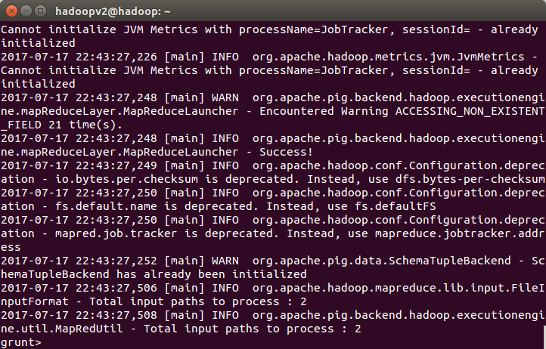

Write a MapReduce/Pig program to calculate the number of arrests in theft district wise.

A = load '/media/hadoopv2/softwares/Hadoop/acadgildpractice/projects/Crimes_-_2001_to_present.csv' USING org.apache.pig.piggybank.storage.CSVExcelStorage(',') AS (ID:chararray,CaseNumber :chararray,Date :chararray,Block :chararray,IUCR :chararray,PrimaryType :chararray,Description :chararray,LocationDescription :chararray,Arrest: boolean,Domestic:boolean,Beat :chararray,District :chararray,Ward :chararray,CommunityArea :chararray,FBICode :chararray,XCoordinate :chararray,YCoordinate :chararray,Year :chararray,UpdatedOn :chararray,Latitude: chararray,Longitude:chararray,Location :chararray);

B = FILTER A BY PrimaryType=='THEFT';
C = GROUP B BY District;
D = FOREACH C GENERATE group,Count(B);
DUMP D;

RESULT:

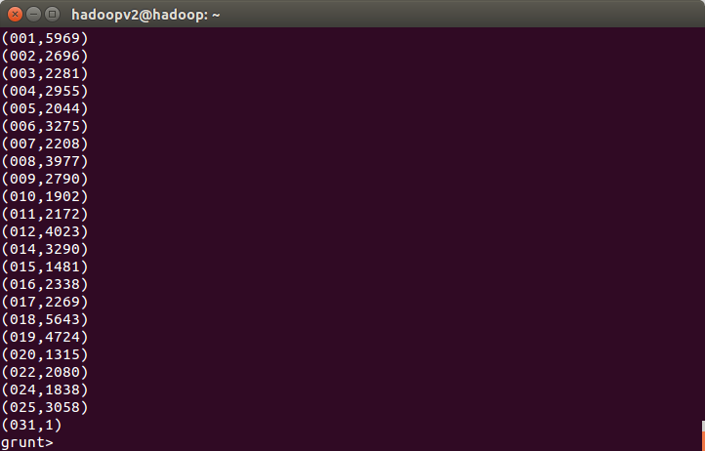

4. Write a MapReduce/Pig program to calculate the number of arrests done between October
2014 and October 2015.

A = load '/media/hadoopv2/softwares/Hadoop/acadgildpractice/projects/Crimes_-_2001_to_present.csv' USING org.apache.pig.piggybank.storage.CSVExcelStorage(',') AS (ID:chararray,CaseNumber :chararray,Date :chararray,Block :chararray,IUCR :chararray,PrimaryType :chararray,Description :chararray,LocationDescription :chararray,Arrest: boolean,Domestic:boolean,Beat :chararray,District :chararray,Ward :chararray,CommunityArea :chararray,FBICode :chararray,XCoordinate :chararray,YCoordinate :chararray,Year :chararray,UpdatedOn :chararray,Latitude: chararray,Longitude:chararray,Location :chararray);

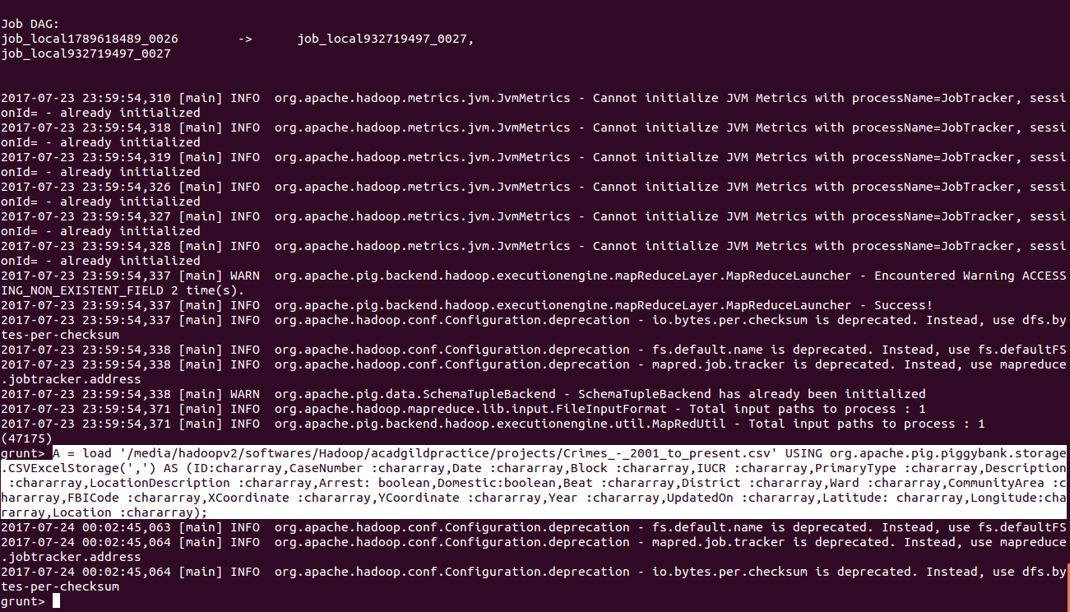
B = FILTER A by Arrest==true;

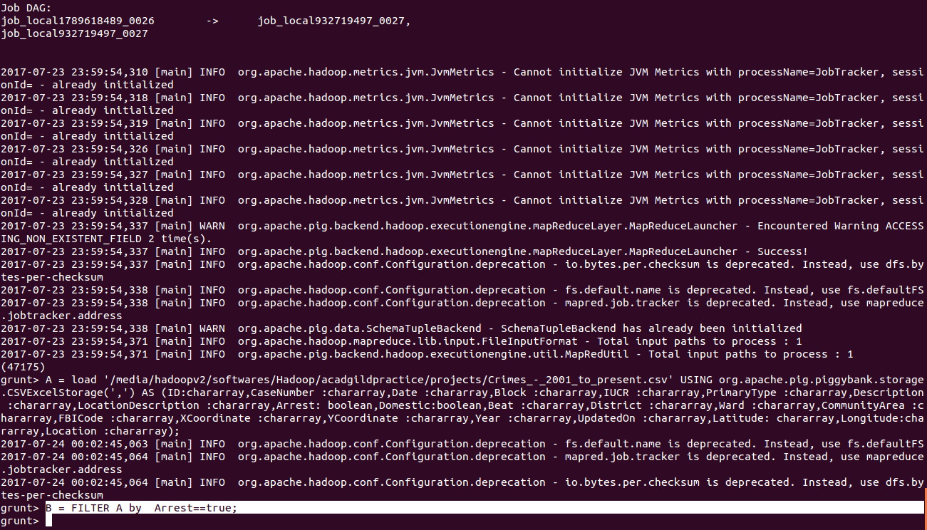
C = FOREACH B GENERATE Arrest,(int)SUBSTRING(Date, 6, 10) as Year,(int)SUBSTRING(Date, 0, 2) as month,Date;

D = FILTER C BY (Year==2014 AND month>=10);

E = FILTER C BY (Year==2015 AND month<=10);

F = UNION D,E;

G = GROUP F BY Arrest;
H = FOREACH G GENERATE COUNT(F);
DUMP H;

Result: (65028)

