Ovarian Cancer Image Segmentation
Consolidated Code and Results Report
Review of seven implemented segmentation models

1. Executive Summary
This repository implements a complete two-dimensional binary image-segmentation workflow for ovarian ultrasound images. Seven architectures are trained independently but share the same dataset loader, preprocessing rules, train-validation split, threshold, evaluation metrics, checkpoint convention, and comparison CSV. This common infrastructure makes the reported results broadly comparable across architectures.
The input is a three-channel image and the output is a one-channel binary mask. Images and masks are resized to 256 x 256 pixels. Training uses an 80/20 reproducible split, batch size 4, up to 50 epochs, learning rate 1e-4, model-specific Adam or AdamW optimization, learning-rate reduction on a Dice plateau, and early stopping after 12 epochs without Dice improvement.
Among the stored results, DS2Net has the highest Dice (0.8457) and IoU (0.7650). DeepLabV3+ has the lowest Hausdorff distance (23.97 pixels), indicating the best worst-case boundary agreement among the compared models.

2. Repository Organization
OVARIAN_CANCER/
├── common/ Shared configuration, dataset, loss, metrics, utilities
├── attention_unet/ Model, training, evaluation, prediction, smoke test
├── deeplabv3plus/ Model, training, evaluation, prediction, smoke test
├── ds2net/ Model, training, evaluation, prediction, smoke test
├── dsnet/ Model, training, evaluation, prediction, smoke test
├── segformer/ Model, training, evaluation, prediction, smoke test
├── transunet/ Model, training, evaluation, prediction, smoke test
├── unetplusplus/ Model, training, evaluation, prediction, smoke test
├── results/ Consolidated metric CSV and comparison outputs
├── compare_models.py Runs all evaluation scripts and builds comparisons
└── requirements.txt Python dependencies

3. Shared Data and Configuration Pipeline

3.1 Configuration
- Dataset path: datasets/OTU_2d/images for images and datasets/OTU_2d/annotations for masks.
- Image size: 256 x 256; batch size: 4; epochs: 50; learning rate: 1e-4.
- Reproducible 80% training and 20% validation split using random seed 42.
- Device selection priority: Apple MPS, then CUDA, then CPU.
- Prediction threshold: 0.5; early-stopping patience: 12 epochs.
- Each model has a dedicated weights/best_model.pth path and qualitative_results directory.

3.2 Dataset Loader
OvarianDataset lists JPG, JPEG, and PNG images in sorted order. For each image, it derives the mask name by appending “_binary.PNG” to the image base name. The image is read with OpenCV, converted from BGR to RGB, resized, normalized to [0,1], and transposed to channel-first format. The grayscale mask is resized, converted to a binary foreground/background array, and expanded to one channel.
Training augmentation uses horizontal flipping, rotation up to 20 degrees, and random brightness/contrast. Validation data is not augmented. The same deterministic index split is reused by training and evaluation, which prevents accidental evaluation on a different subset.

4. Loss Functions and Metrics

4.1 Training Loss
The central objective combines BCEWithLogitsLoss and Dice loss. BCE provides pixel-wise supervision, while Dice loss directly improves foreground overlap and helps with class imbalance. Models with multiple outputs use weighted deep supervision: final output + 0.4 x auxiliary-2 + 0.3 x auxiliary-3 + 0.2 x auxiliary-4. Single-output models use BCE + Dice on the final logits.

4.2 Evaluation Metrics
Metric | Meaning | Preferred direction
Dice | Overlap between predicted and ground-truth foreground masks. | Higher
IoU | Intersection divided by union of prediction and ground truth. | Higher
Precision | Fraction of predicted foreground pixels that are correct. | Higher
Recall | Fraction of actual foreground pixels detected. | Higher
Specificity | Fraction of background pixels correctly rejected. | Higher
Hausdorff distance | Largest bidirectional spatial discrepancy between mask point sets. | Lower
Hausdorff distance returns NaN when either the prediction or ground-truth mask has no foreground. Final evaluation averages metrics over validation images. The utility layer can also save per-image metrics, summary statistics, and confidence information for the more detailed evaluators.

5. Common Training Workflow
- Set Python, NumPy, PyTorch, and CUDA seeds for reproducibility.
- Create augmented training and unaugmented validation DataLoaders from the same deterministic split.
- Instantiate the selected model and move it to MPS, CUDA, or CPU.
- Run forward propagation, compute segmentation loss, backpropagate, and update weights.
- Calculate validation Dice and IoU from thresholded sigmoid outputs after every epoch.
- Use ReduceLROnPlateau in max mode to halve the learning rate when Dice stalls.
- Save model.state_dict() whenever validation Dice improves.
- Stop after 12 consecutive epochs without improvement or after 50 epochs.
Attention U-Net, DS2Net, DSNet, and U-Net++ train with deep-supervision outputs. DeepLabV3+, SegFormer, and TransUNet train from a single final output. SegFormer and TransUNet use AdamW, while the remaining models use Adam.

6. Common Evaluation and Prediction Workflow
- Load the validation subset with batch size 1 and no augmentation.
- Instantiate the architecture and load its best_model.pth checkpoint with map_location set to the active device.
- Run inference under torch.no_grad(), apply sigmoid, and threshold probabilities at 0.5.
- Calculate Dice, IoU, precision, recall, specificity, and Hausdorff distance for every image.
- Save qualitative panels showing the original image, ground-truth mask, and predicted mask.
- Average image-level metrics and update results/model_comparison.csv without duplicating model rows.
Each predict.py is a command-line single-image inference utility. It reads one image, applies the same resize and normalization, loads the trained checkpoint, creates a binary mask, and displays or saves a visualization. test_model.py is a lightweight shape/forward-pass smoke test and does not train the network.

7. Model-by-Model Code Summary

Attention U-Net
Encoder-decoder U-Net with attention gates on skip connections. The gates suppress irrelevant background features before fusion with decoder features. It returns one final mask and three auxiliary masks for deep supervision.
Trainable parameters | Optimizer | Output style | Training objective
31,389,096 | Adam | Deep supervision (4 masks) | BCEWithLogits + Dice with weighted deep supervision

DeepLabV3+
Custom convolutional encoder followed by Atrous Spatial Pyramid Pooling (ASPP). Parallel dilated convolutions capture objects at multiple scales, while a decoder fuses low-level detail with high-level context.
Trainable parameters | Optimizer | Output style | Training objective
10,116,897 | Adam | Single final mask | BCEWithLogits + Dice

DS2Net
U-Net-style encoder-decoder with DDSM and DUSM feature-selection branches, feature gates, fusion blocks, and deep-supervision outputs. It is designed to combine complementary feature transformations at every skip level.
Trainable parameters | Optimizer | Output style | Training objective
41,841,572 | Adam | Deep supervision (4 masks) | BCEWithLogits + Dice with weighted deep supervision

DSNet
U-Net-like network with multi-scale/dilated feature processing and deep supervision. It generates a final mask plus three auxiliary outputs to guide intermediate decoder layers.
Trainable parameters | Optimizer | Output style | Training objective
31,038,532 | Adam | Deep supervision (4 masks) | BCEWithLogits + Dice with weighted deep supervision

SegFormer
Transformer-based segmentation model using overlapping patch embeddings, efficient self-attention, Mix-FFN blocks, a four-stage MiT-style encoder, and a lightweight multi-scale decoder.
Trainable parameters | Optimizer | Output style | Training objective
3,712,865 | AdamW | Single final mask | BCEWithLogits + Dice

TransUNet
Hybrid CNN-transformer model. The CNN encoder extracts local patterns, a transformer bottleneck models global relationships, and the decoder reconstructs the mask using skip connections.
Trainable parameters | Optimizer | Output style | Training objective
24,634,561 | AdamW | Single final mask | BCEWithLogits + Dice

U-Net++
Nested U-Net architecture with dense skip pathways. Intermediate decoder nodes progressively reduce the semantic gap between encoder and decoder features. Deep supervision is enabled.
Trainable parameters | Optimizer | Output style | Training objective
9,159,780 | Adam | Deep supervision (4 masks) | BCEWithLogits + Dice with weighted deep supervision

8. Consolidated Results
Model | Dice | IoU | Precision | Recall | Specificity | Hausdorff
DS2Net | 0.8457 | 0.7650 | 0.8697 | 0.8622 | 0.9831 | 26.60
TransUNet | 0.8390 | 0.7580 | 0.8577 | 0.8629 | 0.9815 | 26.83
DeepLabV3+ | 0.8377 | 0.7564 | 0.8712 | 0.8449 | 0.9838 | 23.97
Attention U-Net | 0.8369 | 0.7567 | 0.8535 | 0.8690 | 0.9807 | 25.96
DSNet | 0.8340 | 0.7542 | 0.8661 | 0.8519 | 0.9827 | 26.54
U-Net++ | 0.8304 | 0.7482 | 0.8513 | 0.8584 | 0.9805 | 25.95
SegFormer | 0.8101 | 0.7173 | 0.7954 | 0.8742 | 0.9735 | 27.55
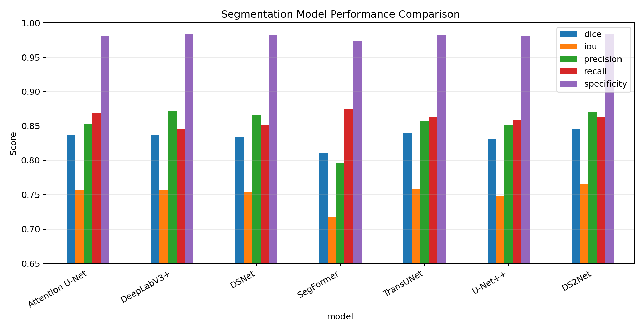

9. Interpretation of the Results
- DS2Net is the strongest overlap model, achieving the highest Dice (0.8457) and IoU (0.7650).
- DeepLabV3+ provides the best boundary result with the lowest Hausdorff distance (23.97) and also the highest precision (0.8712) and specificity (0.9838).
- SegFormer has the highest recall (0.8742), meaning it finds more true foreground pixels, but its lower precision and specificity indicate more false-positive segmentation.
- TransUNet is competitive and balanced, ranking second in Dice and IoU.
- All models achieve high specificity because background pixels dominate many medical segmentation images; Dice and IoU are more informative for foreground performance.

10. compare_models.py
The root comparison script does not retrain any model. It discovers each model’s evaluation script, launches it as a subprocess using the same Python interpreter, sets PYTHONPATH so root-level and model-local imports work, captures stdout/stderr, and extracts metrics using regular expressions. It writes evaluation logs, produces a new comparison CSV, and generates plots for higher-is-better and lower-is-better metrics. Missing metrics are retained as unavailable rather than silently fabricated.

11. Strengths of the Current Implementation
- Consistent dataset split and preprocessing across all seven models.
- Modular architecture with shared utilities and isolated model folders.
- Best-checkpoint selection based on validation Dice rather than final epoch.
- Combined overlap and pixel-level losses suitable for imbalanced segmentation.
- Quantitative and qualitative evaluation, including a boundary metric.
- Reproducible seeds and automatic device selection.
- Independent single-image prediction and model smoke-testing scripts.

12. Limitations and Recommended Improvements
- The current “test” results are computed on the validation split; a separate held-out test split or cross-validation would provide a stronger final comparison.
- Mask resizing uses OpenCV’s default interpolation. Nearest-neighbor interpolation should be used for masks to avoid introducing intermediate label values before thresholding.
- The split is image-level. If multiple images belong to the same patient, splitting should be patient-level to prevent data leakage.
- Only horizontal flip, rotation, and brightness/contrast augmentation are used. Medical-image-specific augmentation and careful ablation testing could improve robustness.
- Parameter count, inference latency, GPU memory, FLOPs, and confidence intervals are not currently included in the official comparison.
- Hausdorff distance is computed over all foreground pixels rather than extracted boundaries and is not HD95; reporting HD95 or average symmetric surface distance would be more robust to outliers.
- The repository has some variation in code style and evaluator detail across model folders. Refactoring to one generic train/evaluate runner with model adapters would reduce duplication.
- The dataset loader assumes every mask exists and follows an exact uppercase “_binary.PNG” naming pattern. Explicit existence checks and clearer error messages would improve reliability.

13. End-to-End Project Flow
Image + binary annotation → resize/normalize/augment → deterministic train-validation split → model training → Dice-based checkpoint selection → validation inference → thresholded mask → metrics + qualitative outputs → consolidated CSV and comparison graphs

14. Conclusion
The repository is a well-structured comparative segmentation study rather than seven unrelated experiments. The shared pipeline ensures that architecture is the main changing factor. DS2Net currently provides the best overall overlap, DeepLabV3+ provides the strongest precision and boundary behavior, and TransUNet offers a strong hybrid alternative. The next major methodological improvement should be a patient-level held-out test set or cross-validation, followed by efficiency measurements and statistical uncertainty reporting.

